**About the assignment:-**

**Step 1:- Create all the tables in the PostgreSQL**

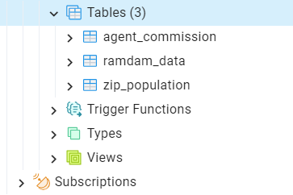

**Step 2:- Remove the Null value from the table ramdam_data table with Non Residential**

**Step 3:- Remove duplicate data from zip_population table**

**Step 4:- Extract the percentage value from the agent_commission table**

**Step 5:- Merge the ramdam_data table and zip_population table on the zip column to get the population in the ramdam_data table**

**Step 6:- Merge the ramdam_data table with agent_commission table to get the closing rate in ramdam_data table**

**Step 7:- Create a new column called profit, calculate ( sold price - listing price)**

**SQL Query:-**

| -- Update the existing table to replace "Null" with "Non Residential" in home_sub_type_1  UPDATE public.ramdam_data  SET home_sub_type_1 = 'Non Residential'  WHERE home_sub_type_1 = 'Null';  CREATE TABLE public.final_table AS(  WITH pop_help AS (  SELECT zip, population,  ROW_NUMBER() OVER (PARTITION BY zip ORDER BY population DESC) AS new_pop  FROM public.zip_population  ),  agent_help as (  SELECT  home_sub_type,  ROUND(CAST(SUBSTRING(agent_commission, '(\d+(\.\d+)?)%') AS NUMERIC) / 100,2)  AS commission_percentage  FROM public.agent_commission  ),  final_table AS (  SELECT  all_data.*,  pop.population,  agent.commission_percentage,  "sold_price" - "listing price" AS profit  FROM public.ramdam_data AS all_data  LEFT JOIN agent_help AS agent ON agent.home_sub_type = all_data.home_sub_type  LEFT JOIN pop_help AS pop ON pop.zip = all_data.zip  WHERE new_pop = 1  )  SELECT *  FROM final_table  ); |
| --- |

**Step 8:- After running the above query get a new table called final_table with all the data.**

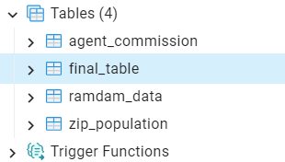

**Step 9:- Connect the Postgres database with the Power BI**

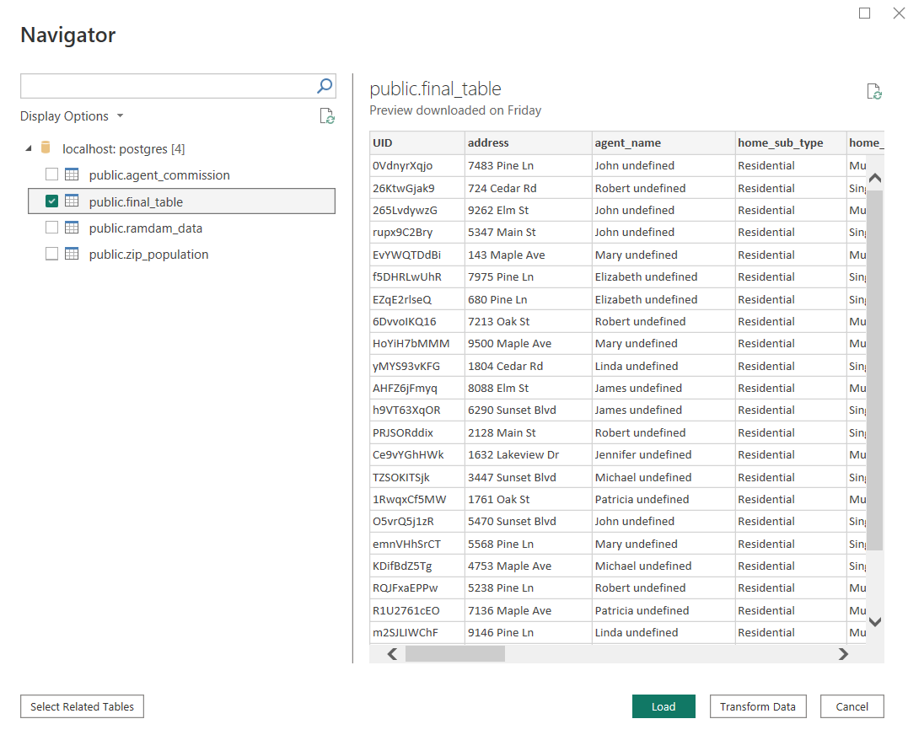

**Step 10:- Export all the dashboards into pdf.**

**Pdf link:-** [ramdam_data_insight.pdf](https://drive.google.com/file/d/1OmNhzkT_iJg_XMaVwaEUJ3LHl4_oCQ61/view?usp=sharing)

**The outcome of the task:-**

* **We can see in some cities the sold price is higher than the listing price means the property demand is high.**
* **High demand of Non residential property**
* **Property in Akron and Dayton make more profit and Columbus and Cincinnati make loss.**
* **Land and Rental properties make a profit and Residential and commercial make a loss.**
* **Patricia, Robert, and Jennifer are the top 3 Agents who make a good profit in Land, Rental, and Residential property types.**

**My learning from this task:-**

* **To know about the Property Industry.**
* **The clearing rate is applicable for both buyer and seller. For the buyer, the clearing rate is added up to the sold price, and for the seller, the clearing amount is subtracted from the sold price.**
* **The listing price is the price at which the seller demands the minimum price of the property.**