Version [1.0]
October 2018

Mobile Banking
Trust System & Software (I) Pvt. Ltd.
11/4, IT Park Rd, Parsodi, Gayatri Nagar, Pratap Nagar, Nagpur, 440022

Contents
Welcome Screen 2
Verify Mobile Number 3
Activate User Profile 4
Activate MPIN 5
Launcher Screen 6
Lock Screen 7
Main Menu 8
1. Accounts: 10
1.1 Account Details 11
1.2 Balance Enquiry: 12
1.3 Mini Statement: 13
1.4 Cheque book Request: 15
1.5 Statement Request: 16
1.6 Last 5 IMPS Transactions: 17
1.7 Show MMID: 18
2. Funds Transfer: 19
2.1 Within Bank Transfer: 20
2.2 IMPS Transfer to Mobile Phone: 22
2.3 IMPS Transfer to Account: 24
2.4 NEFT Transfer to Account: 26
2.5 Manage Beneficiaries: 28
3. Locate ATMs: 32
4. Locate Branches: 34
5. Contact Us: 36
6. About Us: 37

Welcome Screen

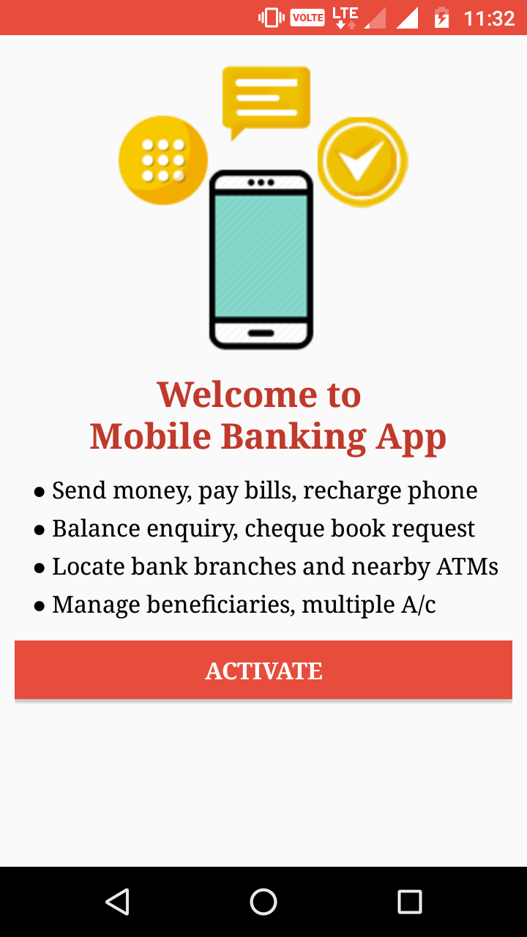
- This is the Welcome Screen, if user is not register for this app then this screen will appear.
- On click of Activate button, registration process will start by following screens.

Verify Mobile Number

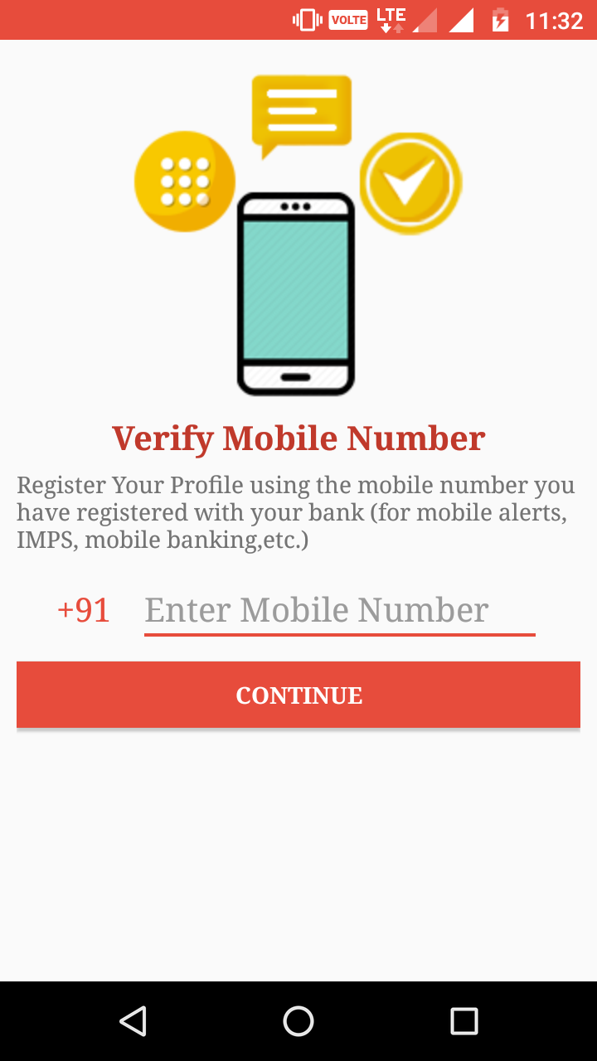
- In this screen, user need to verify mobile number.
- Enter mobile number here which link with user’s bank account & should available in the current mobile slot.
- OTP will be send to the given mobile number.
- OTP will auto read & will move user to the next screen to activate profile.

Activate User Profile

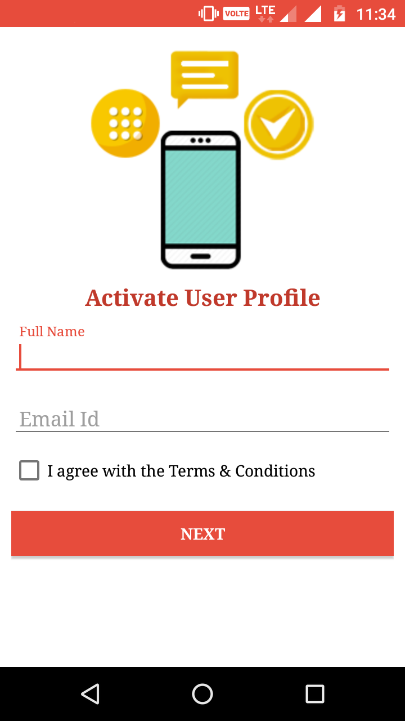
- User need to activate profile here.
- Full Name: Enter full name here.
- Email Id: This field require user’s email id.
- NEXT button will redirect user to the Activate MPIN screen.

Activate MPIN
- User need to generate MPIN here.
- Security Code: This field requires Security Code provided by bank.
- For activating MPIN, user need to enter four-digit code here.
- MPIN & Confirm MPIN digit should be same to generate MPIN successfully.
- Done button will redirect user to the Lock Screen.
- In case of user Forgot MPIN, can generate MPIN again from here.
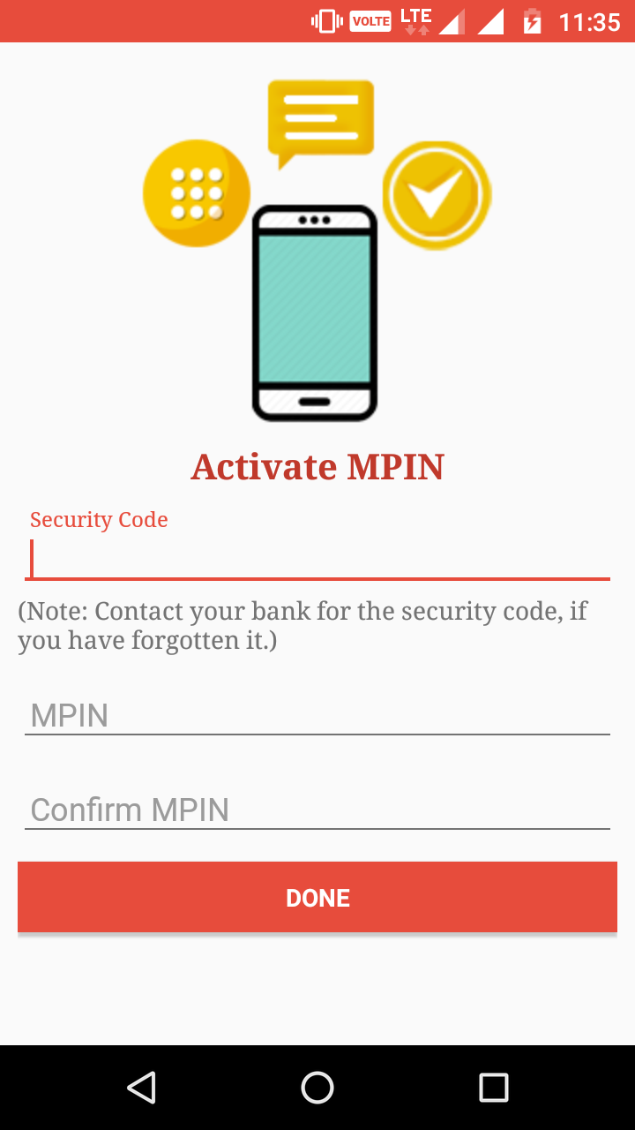

Launcher Screen

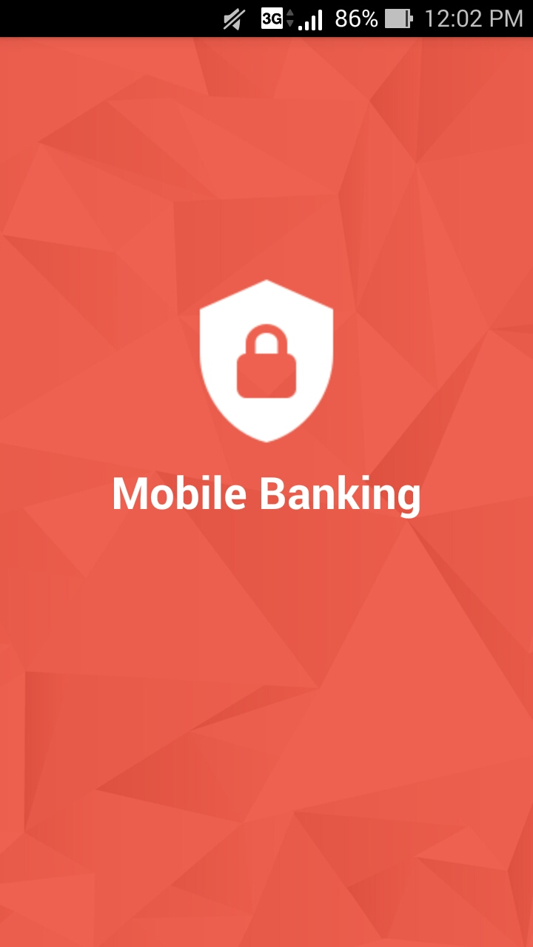
- This is the Launcher Screen, if user is already register, this screen will launch.

Lock Screen

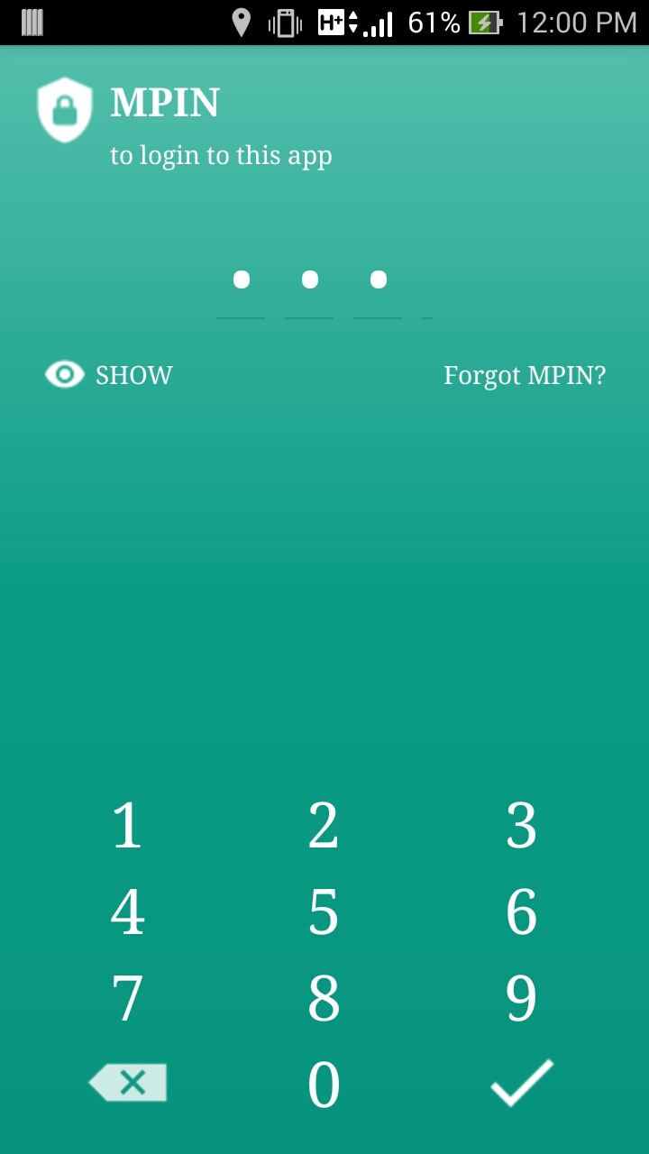
- User need to enter four digit MPIN to login for this app.
- Forgot MPIN: User can change MPIN in case of Forgot.
- Show: This button will hide or show MPIN entered above.

Main Menu
- Accounts
- Funds Transfer
- Locate ATMs
- Locate Branches
- Contact Us
- About Us
- This circular button is use to change the profile picture.
- On the right of circular button,
User name is showing.
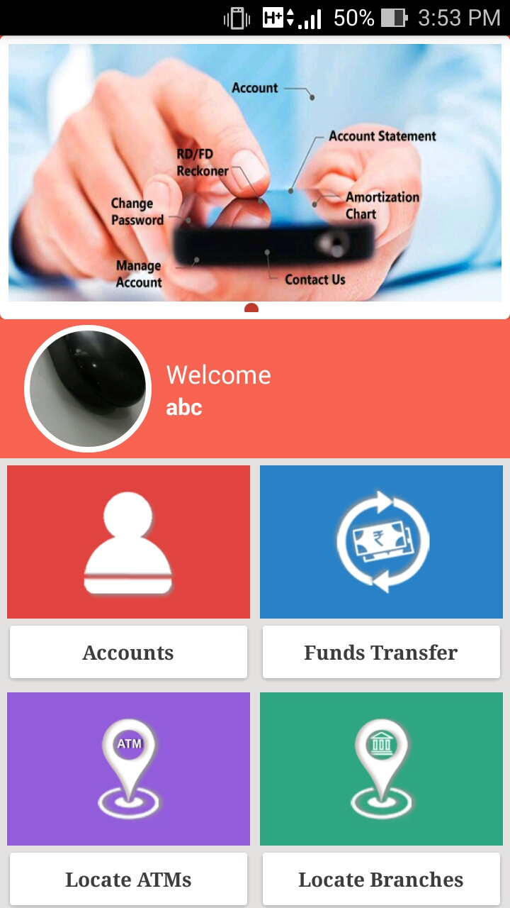
- It shows the advertisement banners.

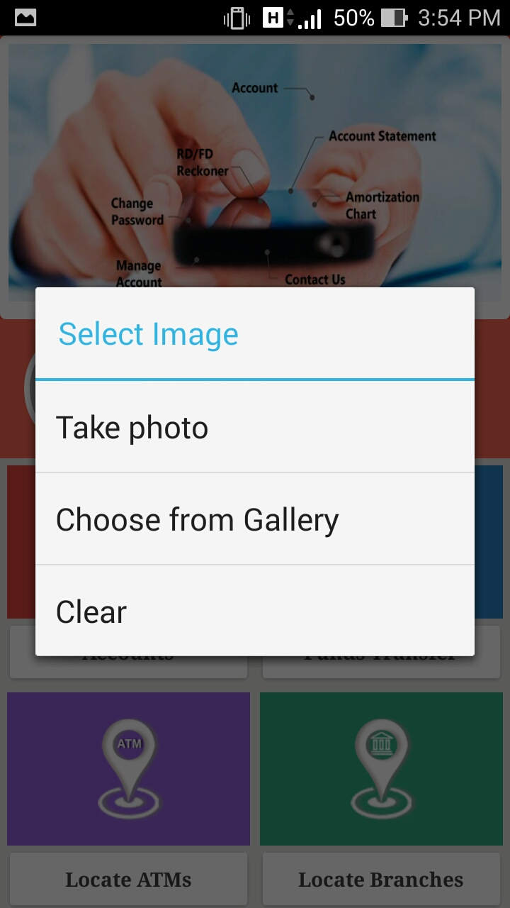
- On click of circular button, Select Image dialog is open; which allow user to change profile picture in given ways.
- Clear will remove the profile picture.

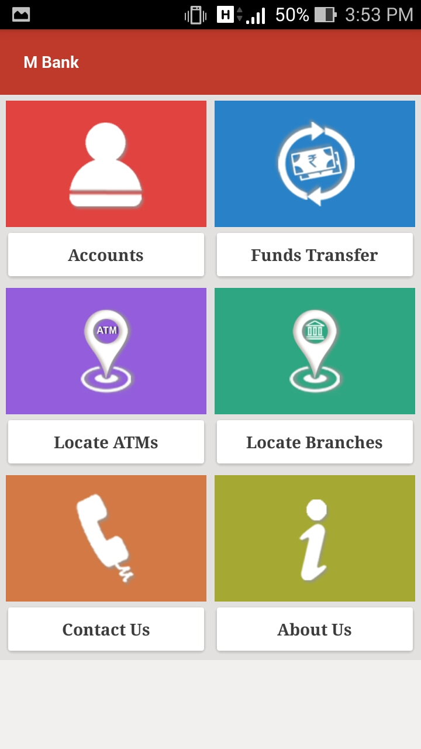
- This is the menu of MBank.

Accounts:

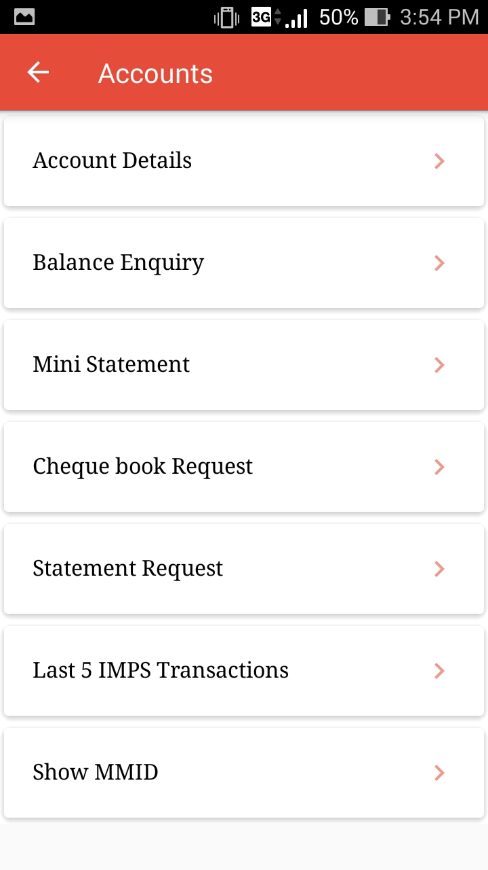
- In accounts menu all accounts related details shown.

1.1 Account Details

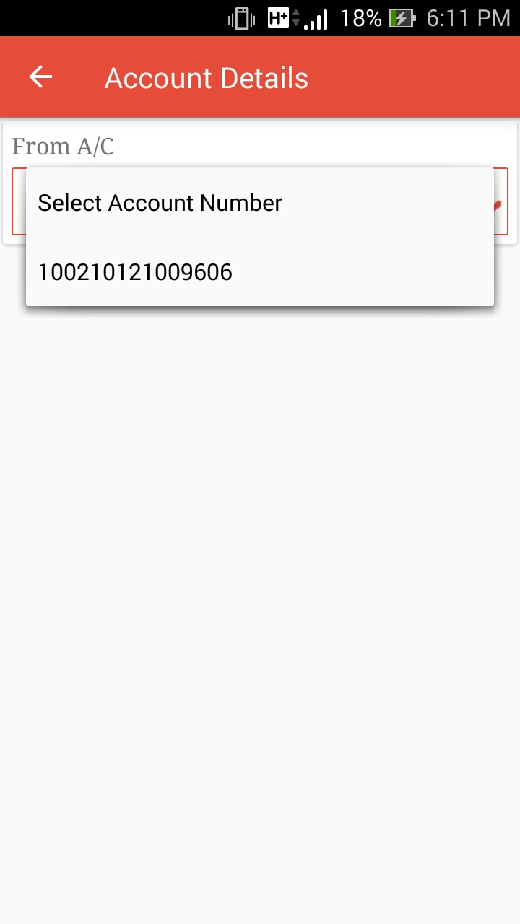
- User can select account number from the given list.

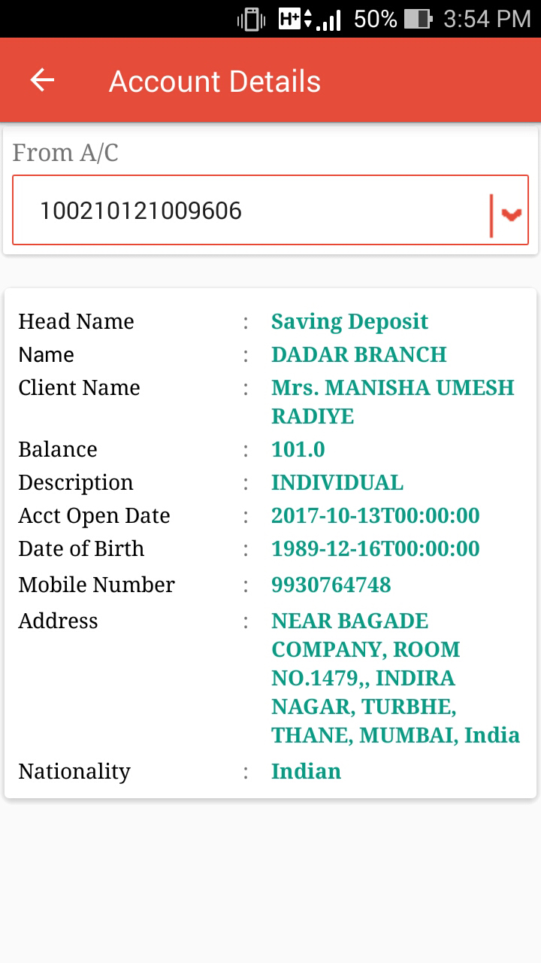
- It shows account details for the selected account number.

1.2 Balance Enquiry:

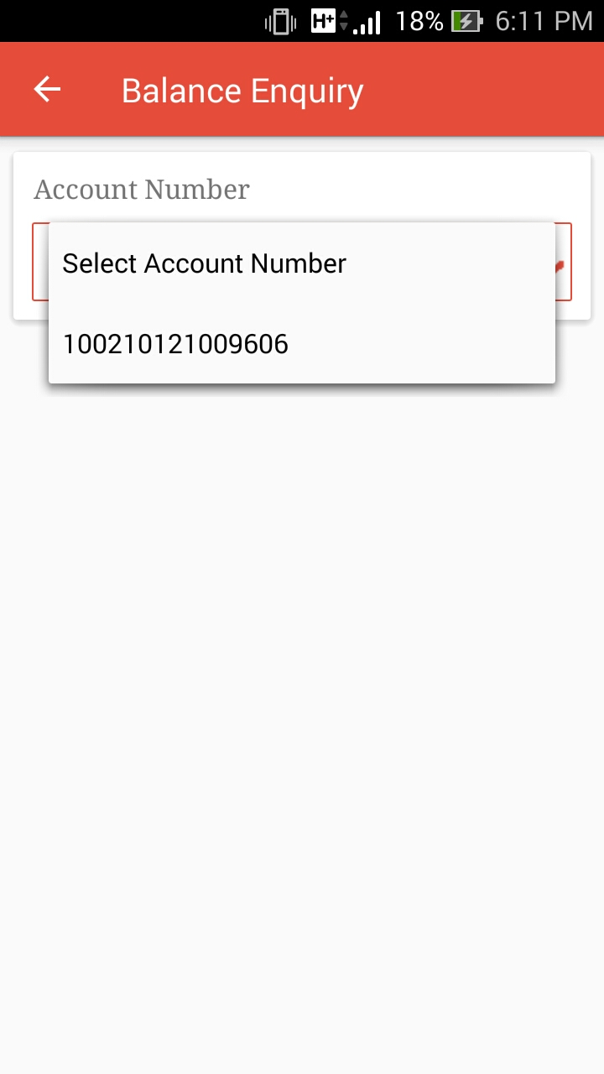
- User can select account number from the given list.

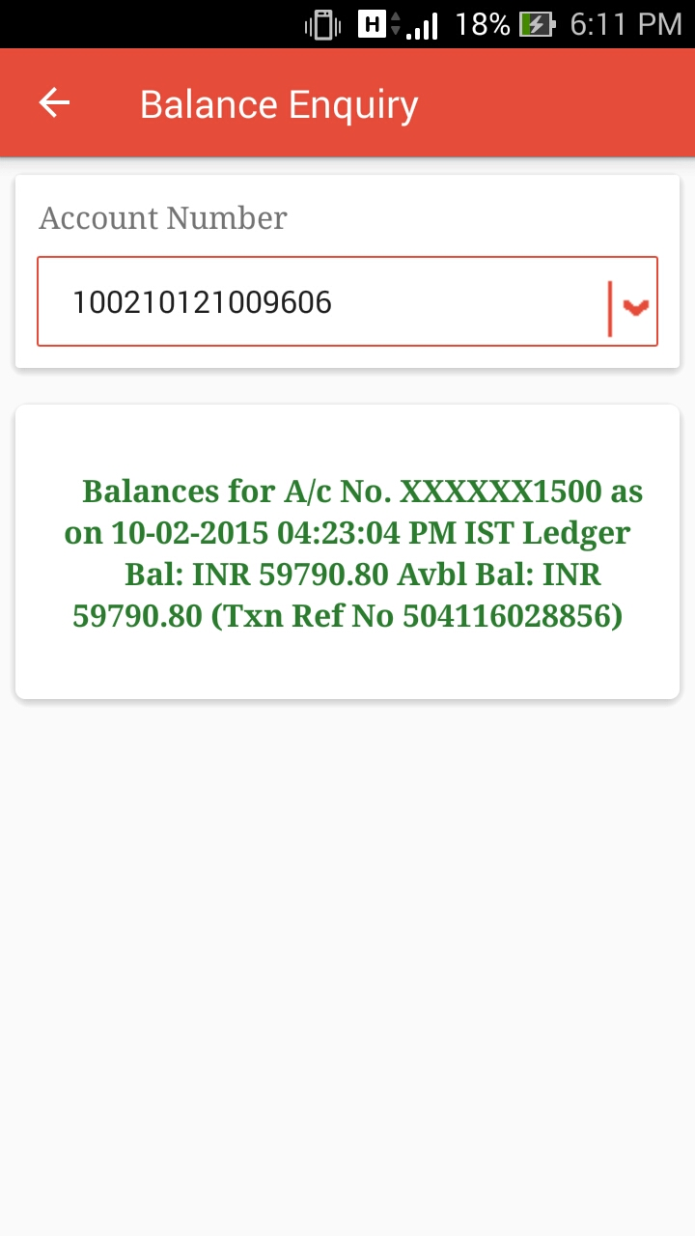
- It shows account balance for the selected account number.

1.3 Mini Statement:

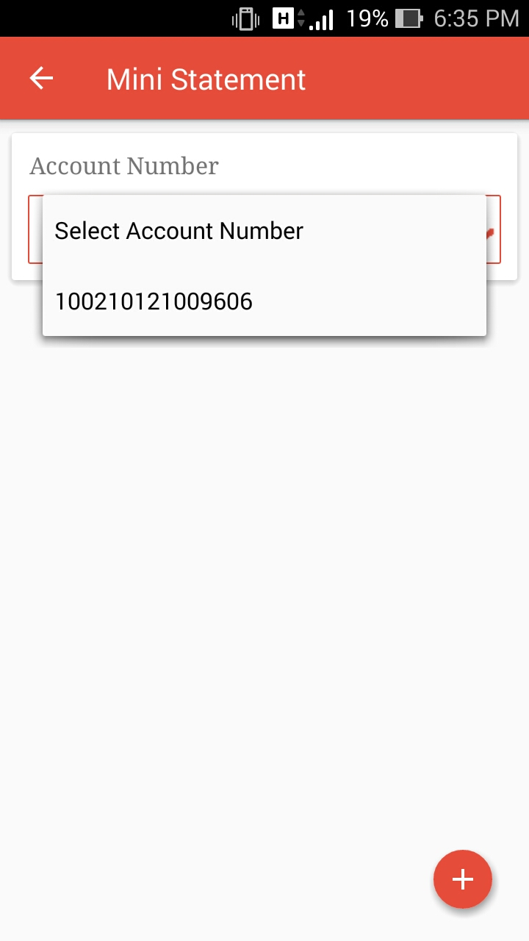
- User can select account number from the given list.

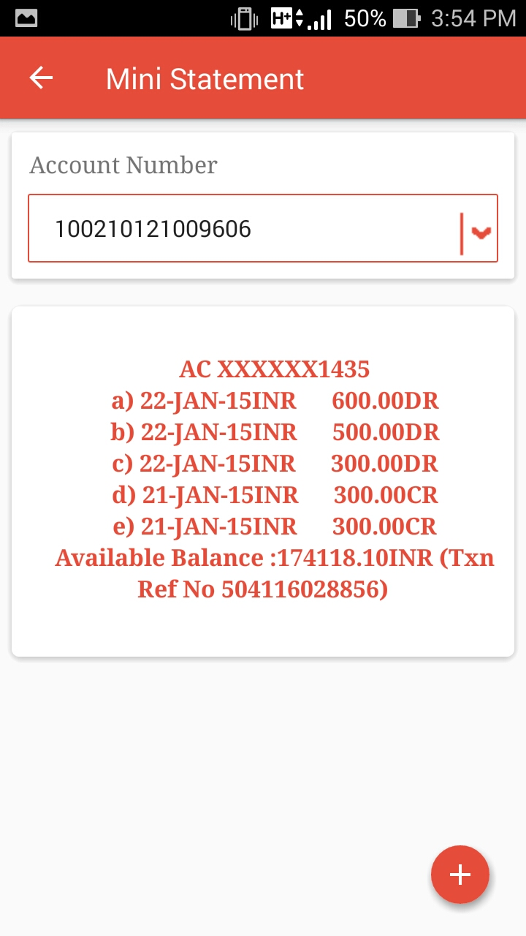
- It shows mini statement for the selected account number.

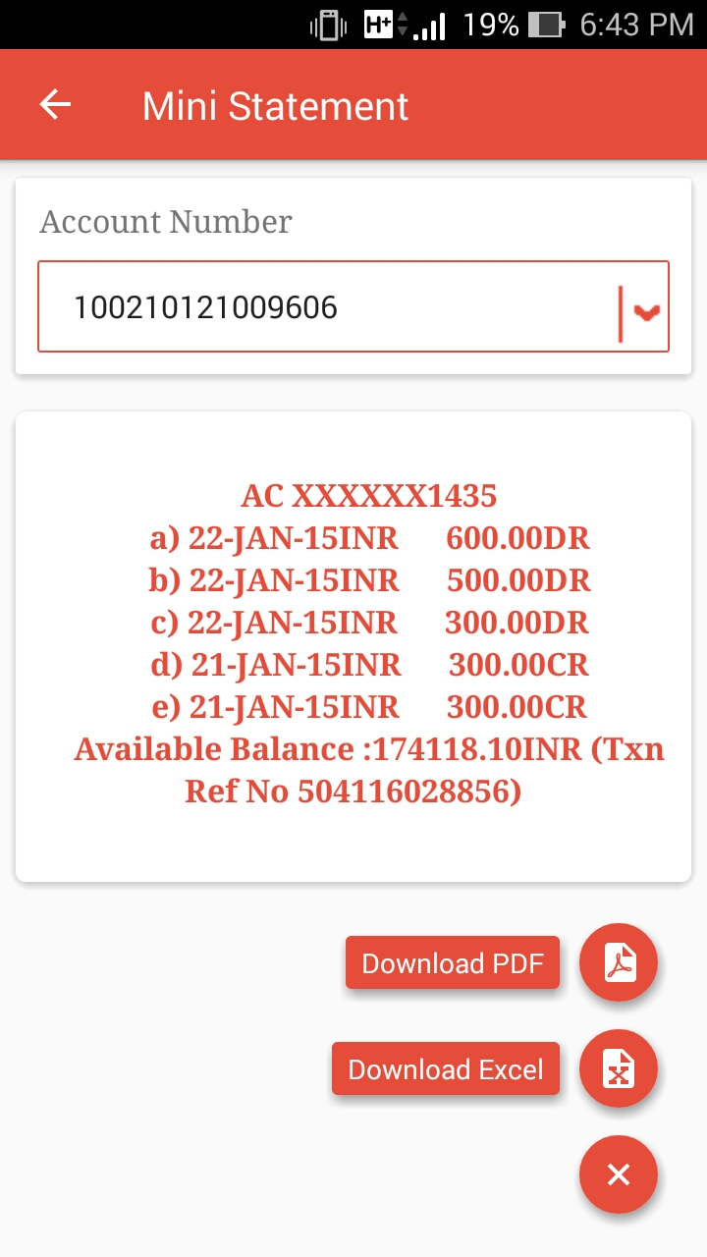
- This button is use to open or close the menu for Download PDF & Download Excel.

- Download PDF button will download mini statement in pdf format.
- Download Excel button will download mini statement in excel format.

1.4 Cheque book Request:

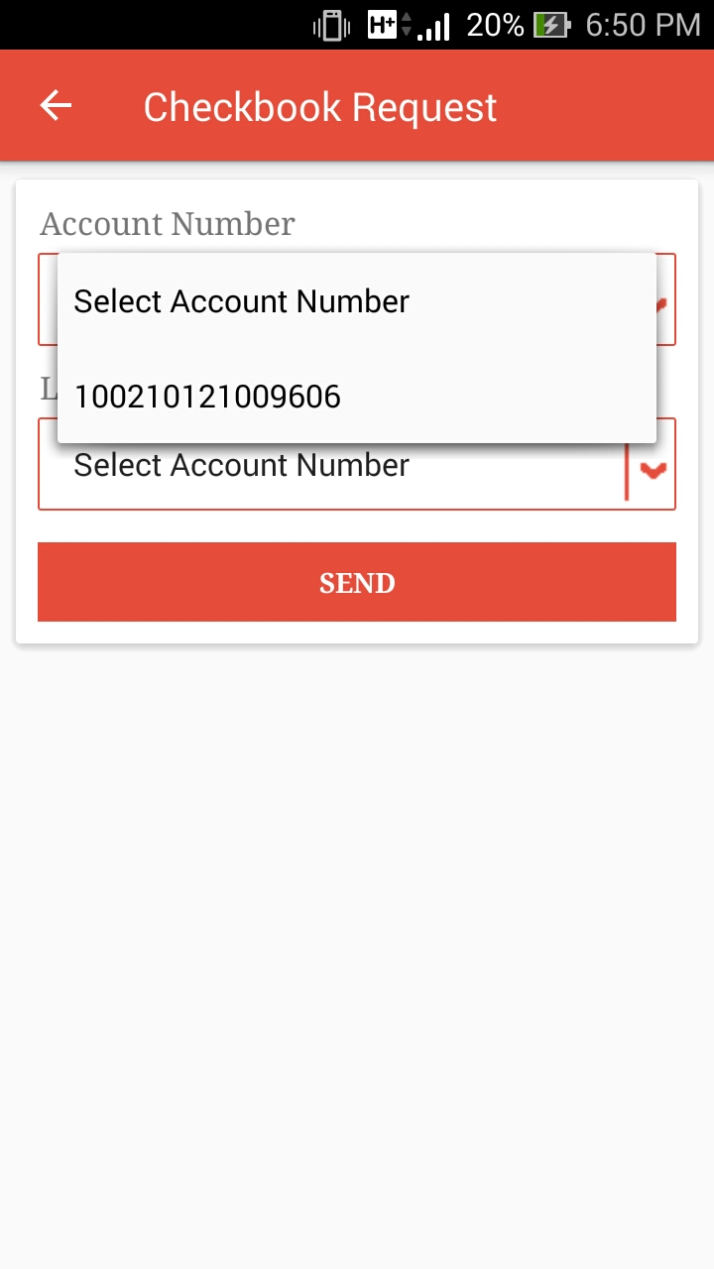
- User can select account number from the given list.

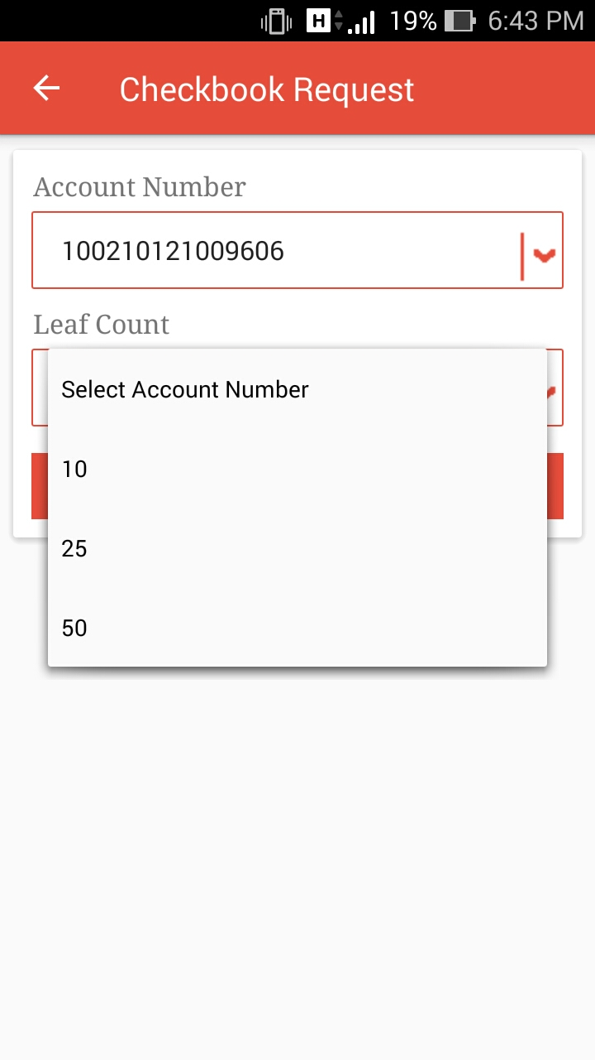
- User can select leaf count from the given list.
- On click of SEND button request for checkbook is send.

1.5 Statement Request:

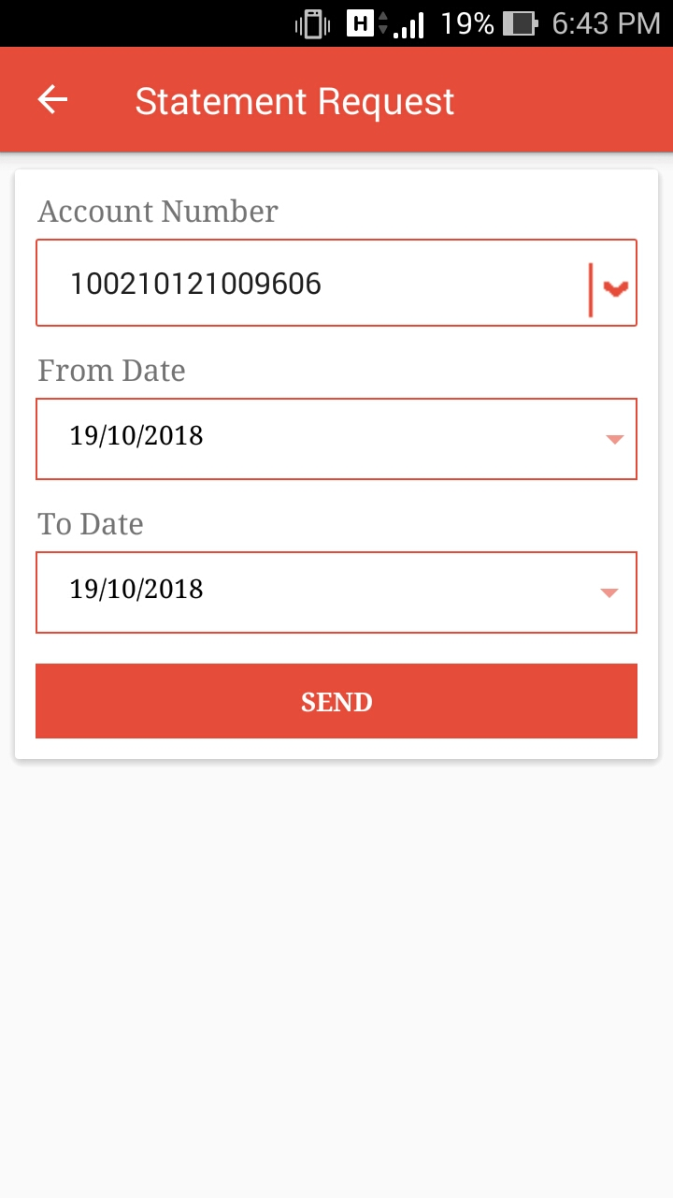
- User can select account number from the given list.

- On click of small down arrow icon calendar will open & user can set From Date & To Date.
- On click of SEND button request for statement is send.

1.6 Last 5 IMPS Transactions:

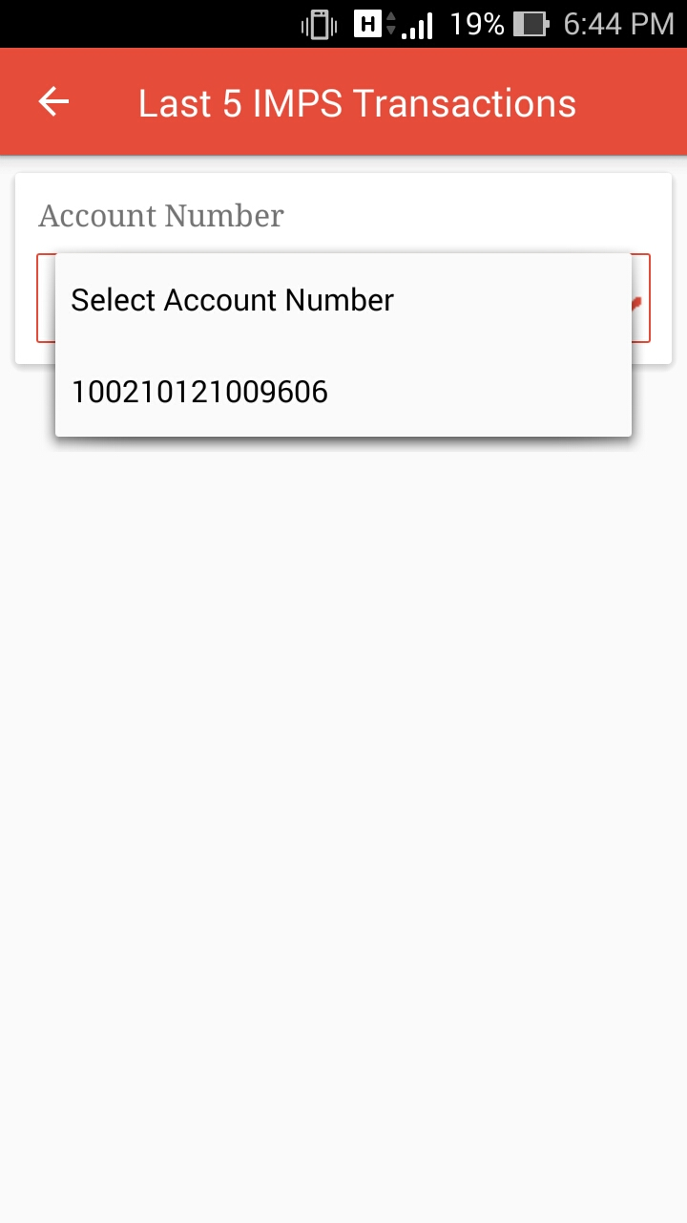
- User can select account number from the given list.

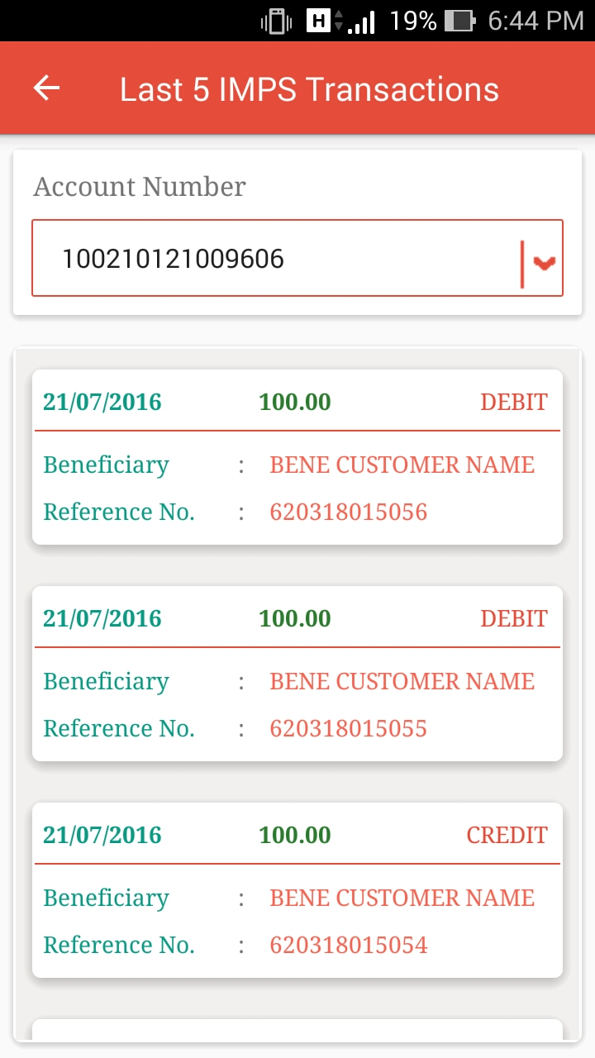
- It show the Last 5 IMPS transactions done for the selected account number.

1.7 Show MMID:

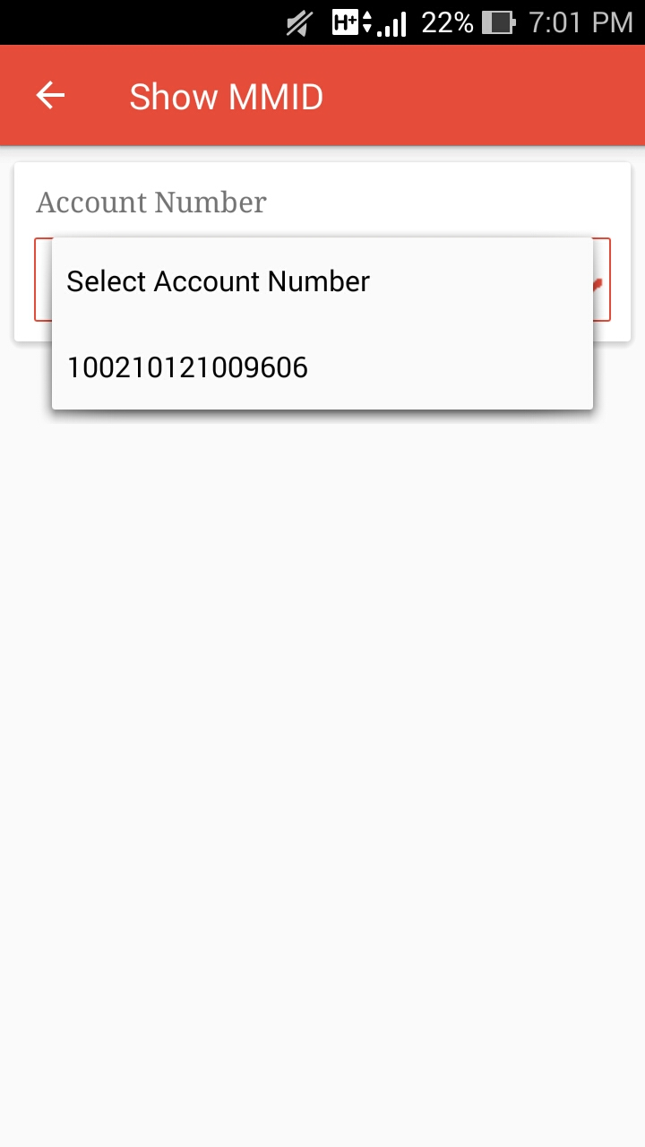
- User can select account number from the given list.

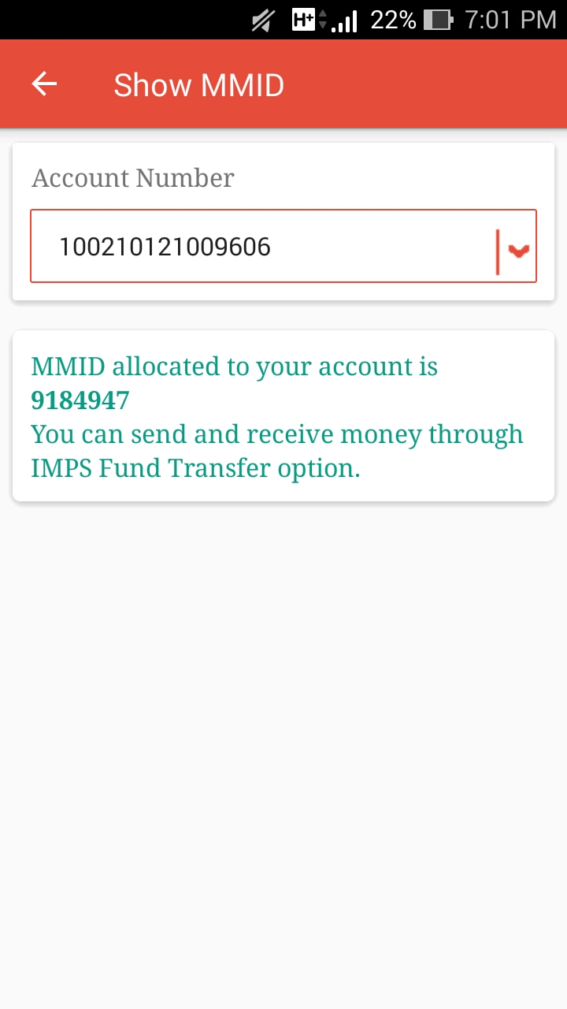
- User can get the MMID for the selected account here.

Funds Transfer:

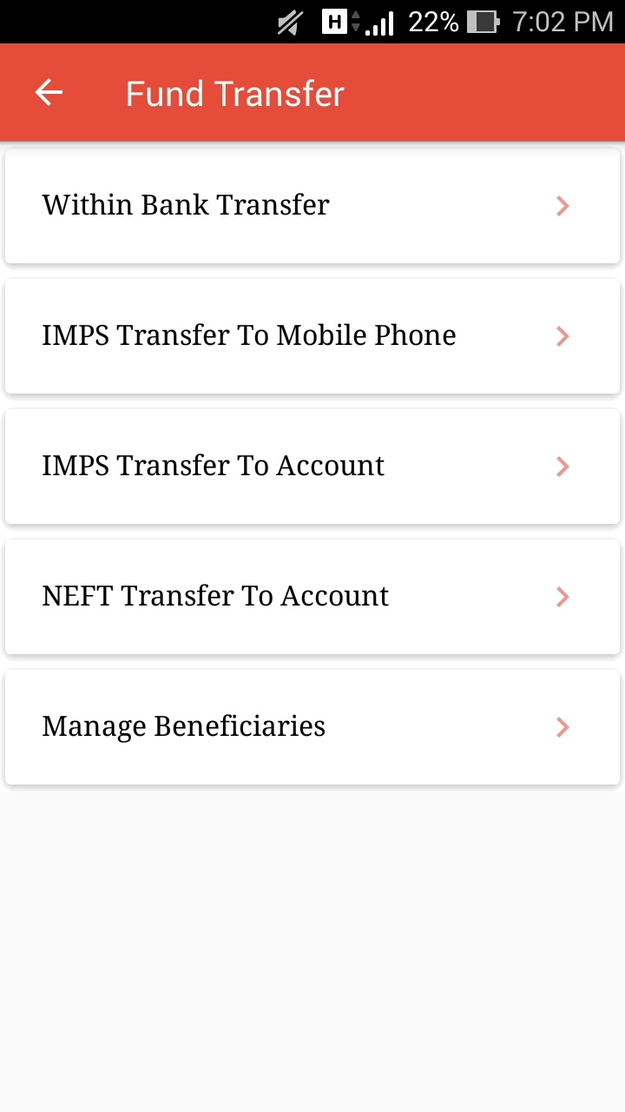
- This menu shows different way to transfer fund.

2.1 Within Bank Transfer:

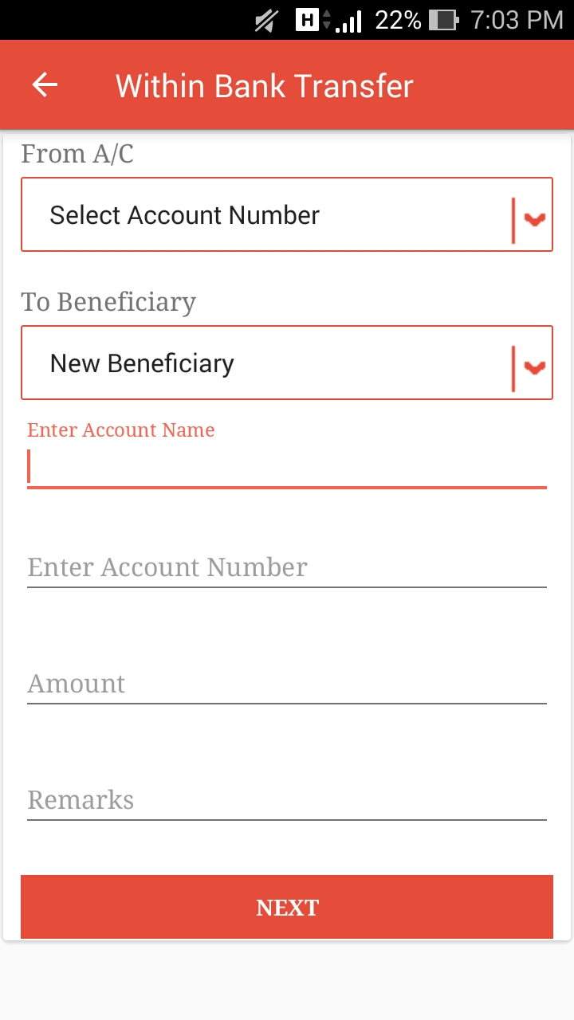
- User need to select From Account in the given list.

- User can perform transaction for new beneficiary & can perform for existing beneficiary from the given list.

- If user will select new beneficiary, he/she need to enter Account Name & Account Number.
- If user will choose existing from list then it will auto read the Account Name & Account Number.
- User need to enter amount to be send into Amount field.
- NEXT button will move user to OTP screen.
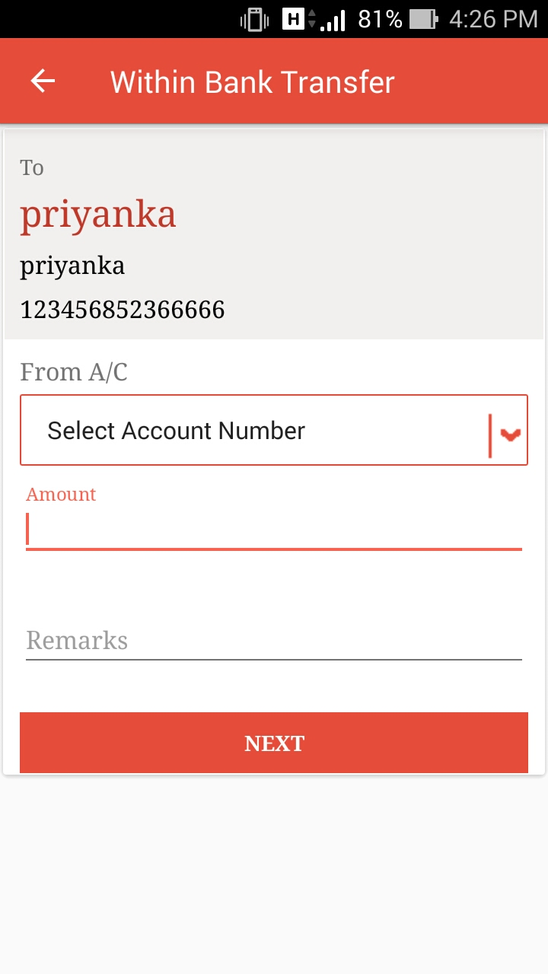

- If user will click on WITHIN button present in the Beneficiary List this screen will open with the Beneficiary Name, Account Name & Account Number that allow transferring fund Within Bank.
- User need to select From Account Number from the given list.
- User need to enter amount to be send into Amount field.
- NEXT button will move user to OTP screen.

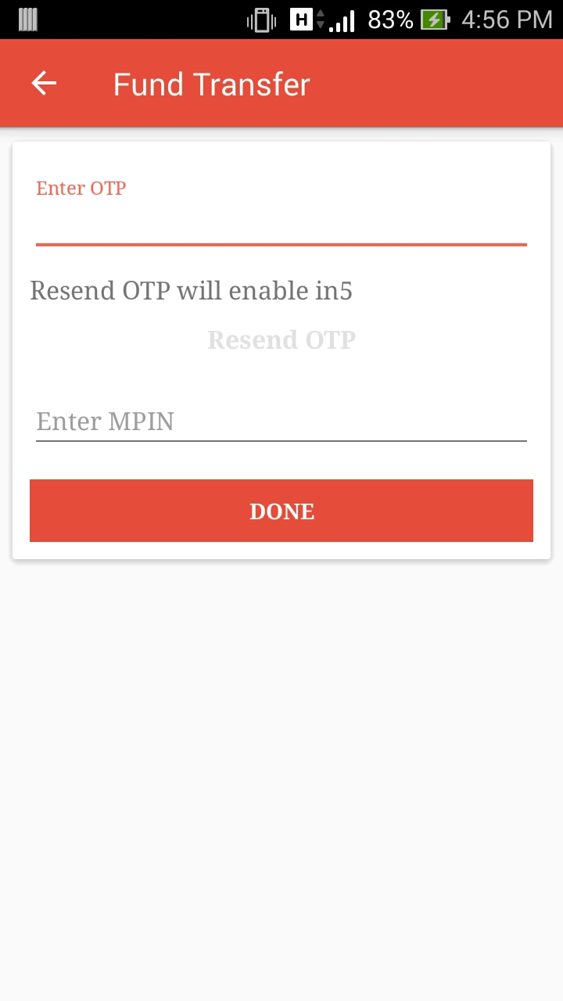
- User need to enter the OTP received into registered mobile number to perform transaction.

- Resend OTP will be enable in 20Sec. In case of user will not get OTP can be resend.

- MPIN will required here to perform transaction.

- Done Button will perform the transaction here.

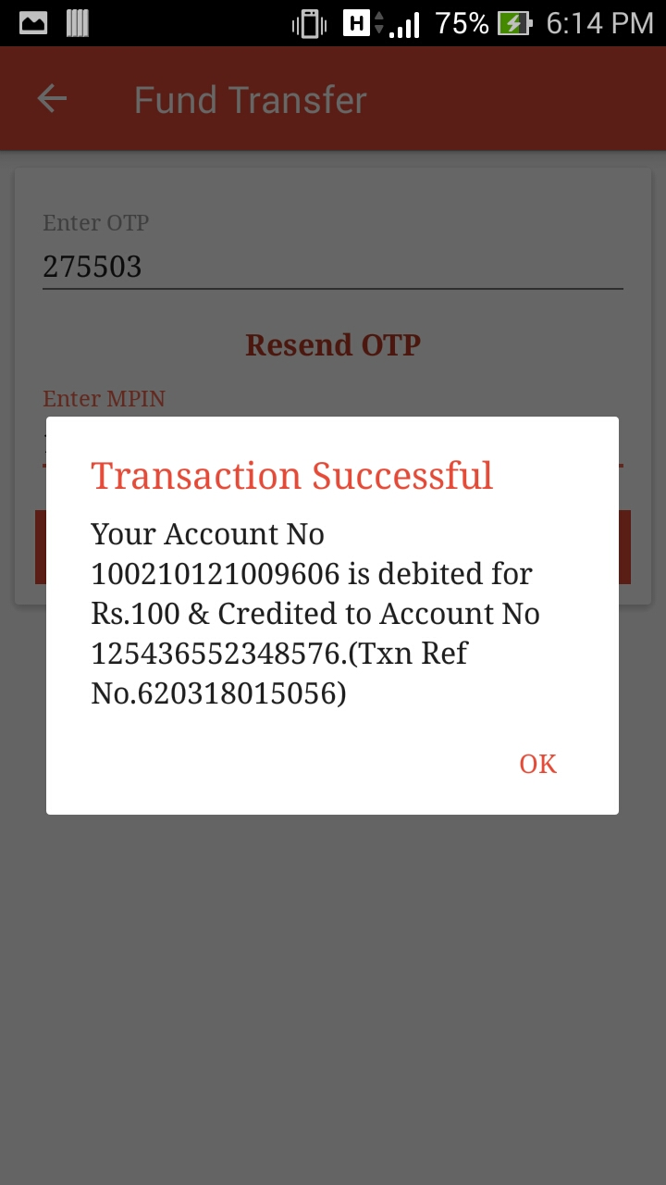
- This message will be appear after successfully fund transfer Within Bank.

2.2 IMPS Transfer to Mobile Phone:

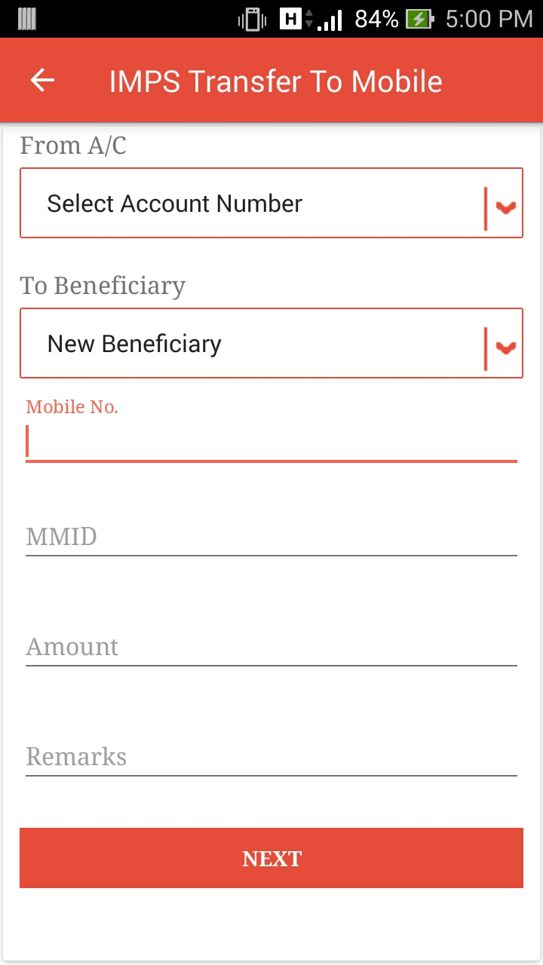
- User need to select From Account in the given list.

- User can perform transaction for new beneficiary & can perform for existing beneficiary from the given list.

- If user will select new beneficiary, he/she need to enter Mobile Number & MMID.
- If user will choose existing from list then it will auto read the Mobile Number & MMID.
- User need to enter amount to be send into Amount field.
- NEXT button will move user to OTP screen.

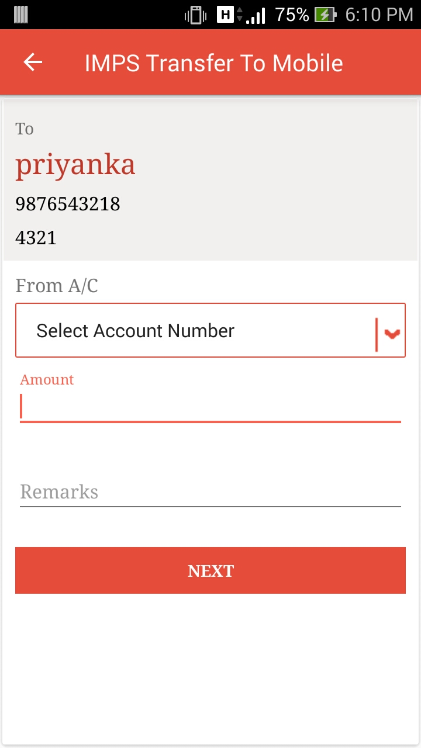

- If user will click on IMPS button present in the Beneficiary List, this screen will open with the Beneficiary Name, Mobile Number & MMID that allow transferring fund ie. IMPS to Mobile Number.
- User need to select From Account Number from the given list.
- User need to enter amount to be send into Amount field.
- NEXT button will move user to OTP screen.

- User need to enter the OTP received into registered mobile number to perform transaction.

- Resend OTP will be enable in 20Sec. In case of user will not get OTP can be resend.

- MPIN will required here to perform transaction.

- Done Button will perform the transaction here.

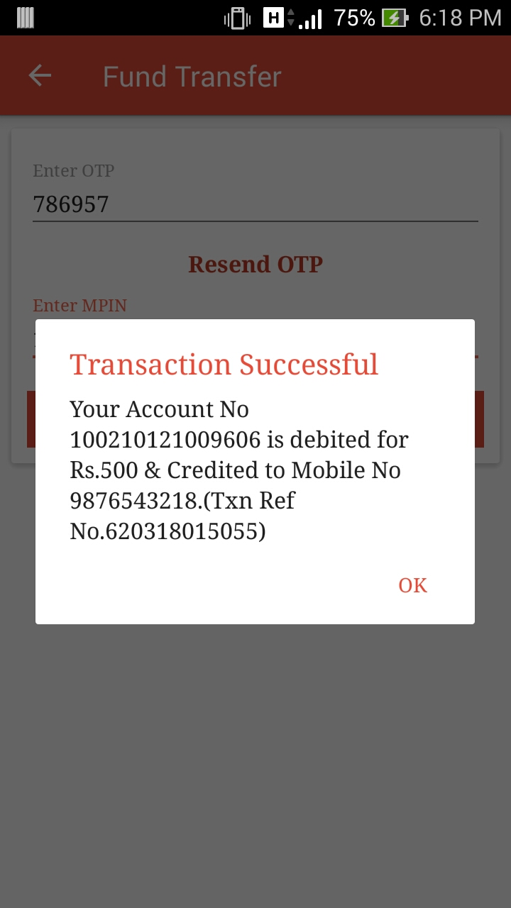
- This message will be appear after successfully IMPS fund transfer to Mobile Number.

2.3 IMPS Transfer to Account:
- User need to select From Account in the given list.

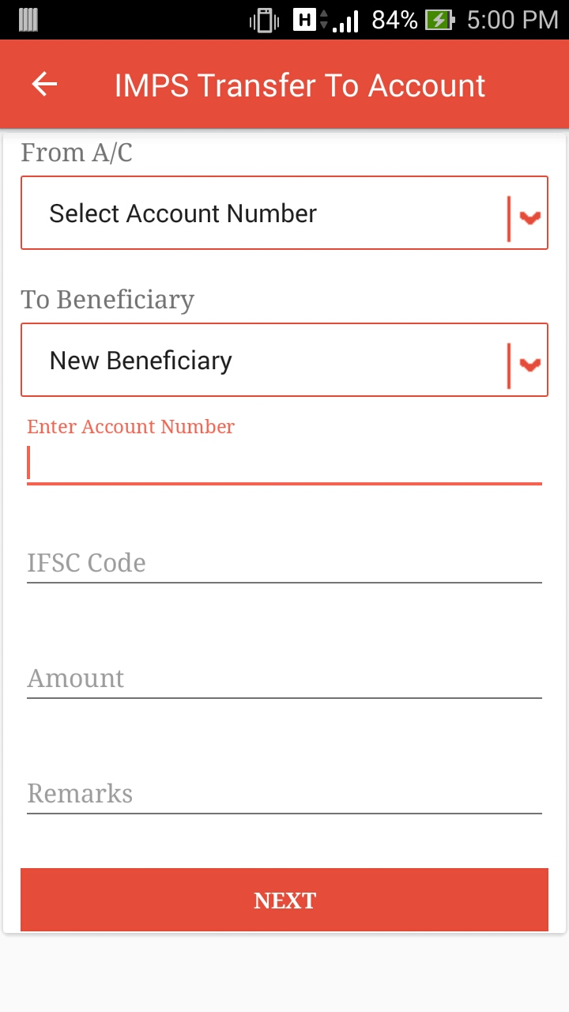
- User can perform transaction for new beneficiary & can perform for existing beneficiary from the given list.

- If user will select new beneficiary, he/she need to enter Account Number & IFSC Code.
- If user will choose existing from list then it will auto read the Account Number & IFSC Code.
- User need to enter amount to be send into Amount field.
- NEXT button will move user to OTP screen.
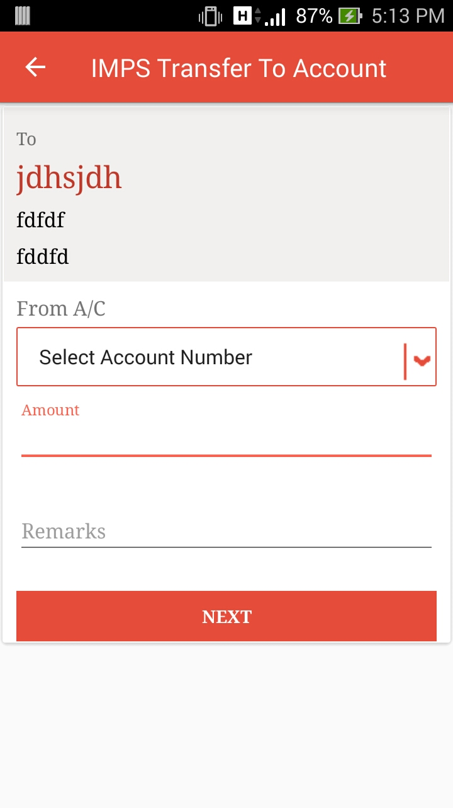

- If user will click on IMPS button present in the Beneficiary List this screen will open with the Beneficiary Name, Account Number & IFSC Code that allow to transferring fund ie. IMPS to Account Number.
- User need to select From Account Number from the given list.
- User need to enter amount to be send into Amount field.
- NEXT button will move user to OTP screen.

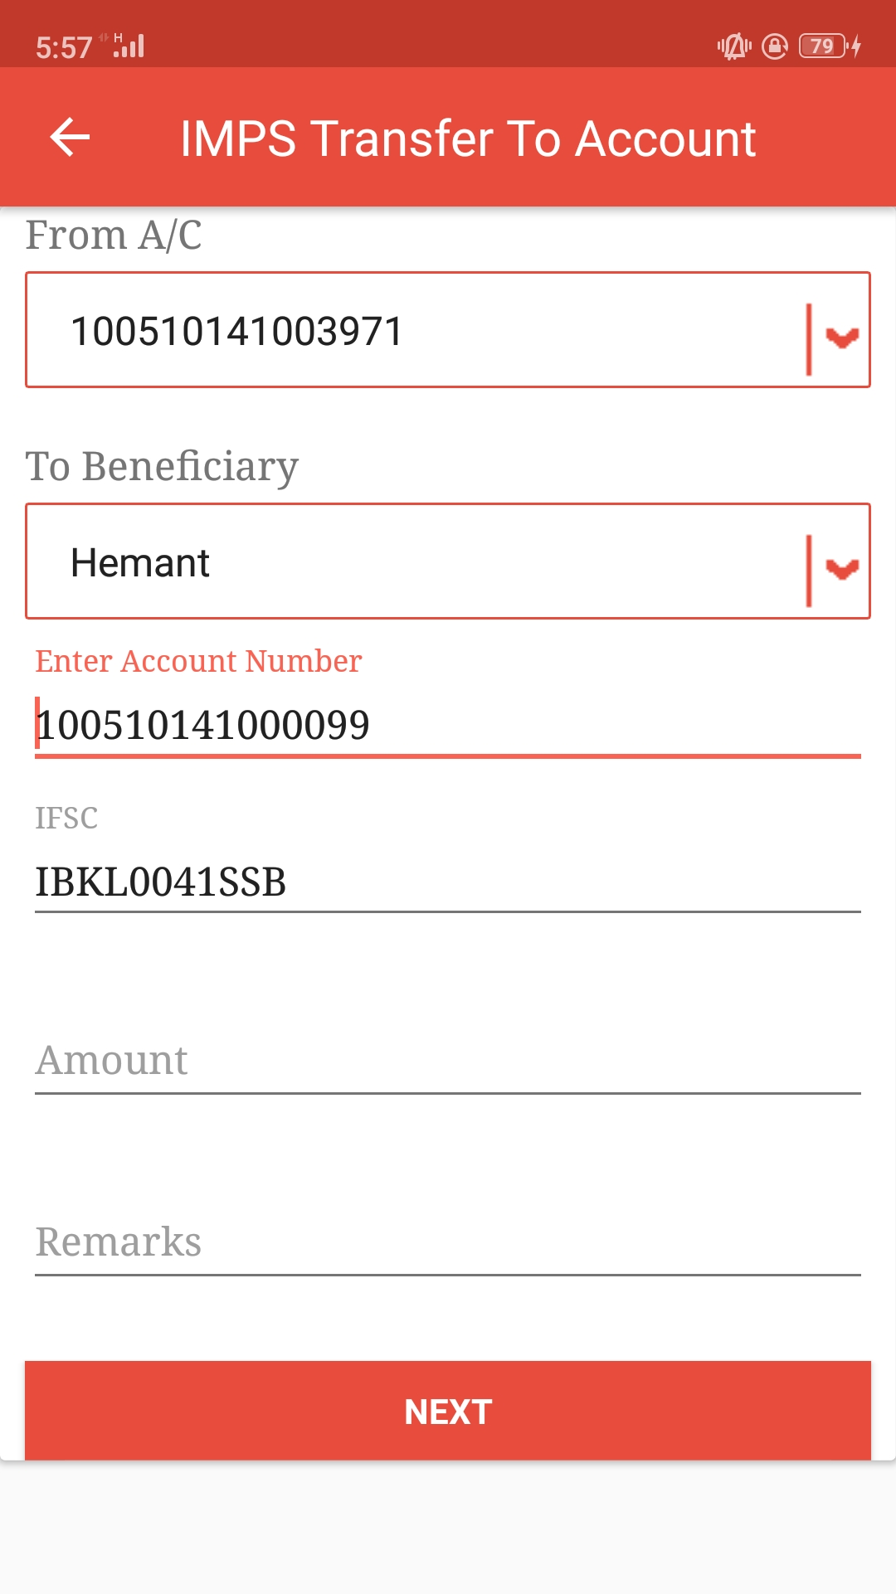

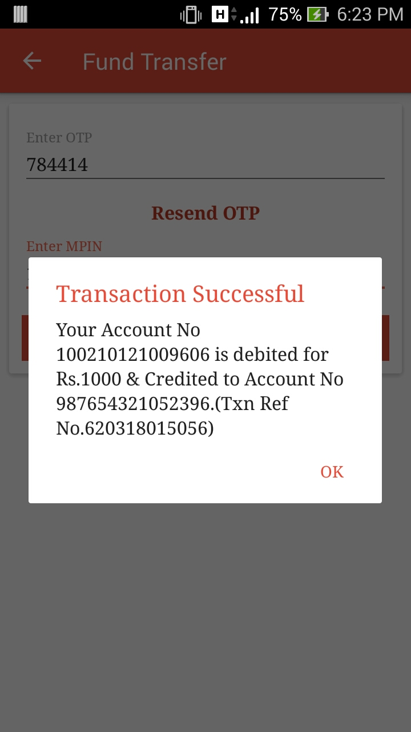
- This message will be appear after successfully IMPS fund transfer to Account Number.

- User need to enter the OTP received into registered mobile number to perform transaction.

- Resend OTP will be enable in 20Sec. In case of user will not get OTP can be resend.

- MPIN will required here to perform transaction.

- Done Button will perform the transaction here.

2.4 NEFT Transfer to Account:

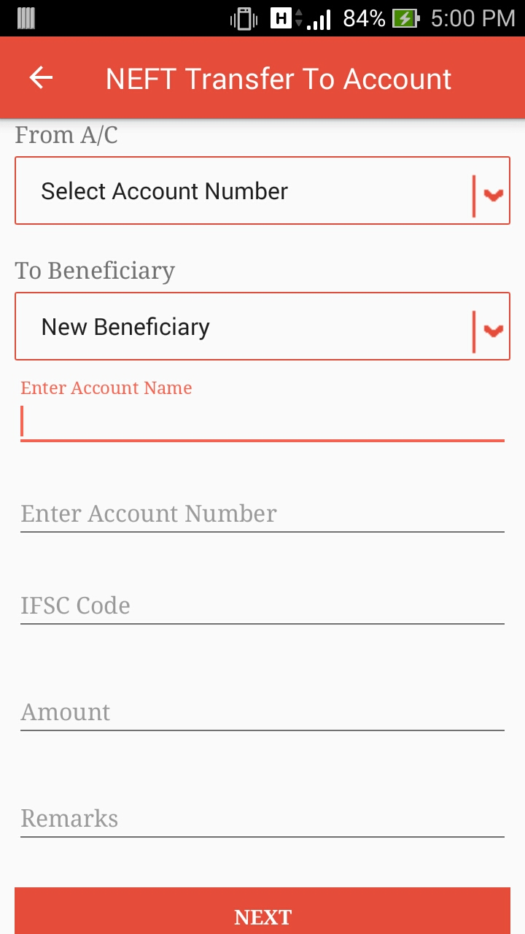
- User need to select From Account in the given list.

- User can perform transaction for new beneficiary & can perform for existing beneficiary from the given list.

- If user will select new beneficiary, he/she need to enter Account Name, Account Number & IFSC Code.
- If user will choose existing from list then it will auto read the Account Name, Account Number & IFSC Code.
- User need to enter amount to be send into Amount field.
- NEXT button will move user to OTP screen.
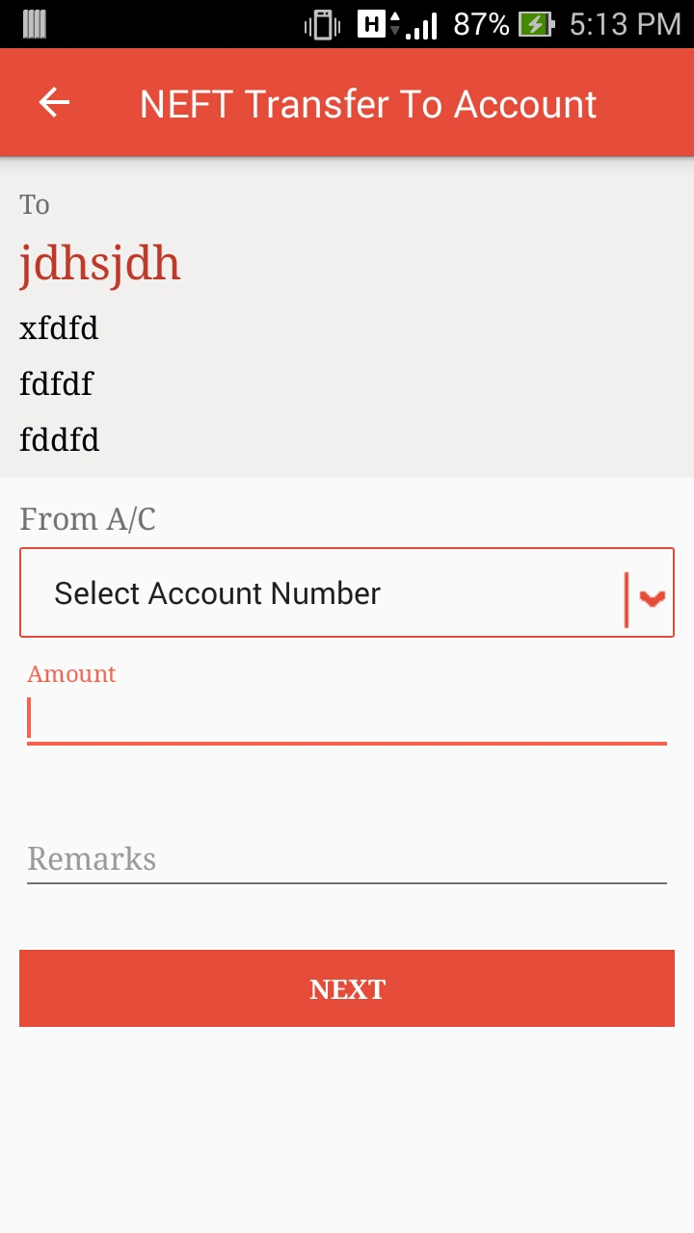

- If user will click on NEFT button present in the Beneficiary List this screen will open with the Beneficiary Name, Account Name, Account Number & IFSC code that allow to transferring fund ie. NEFT to Account.
- User need to select From Account Number from the given list.
- User need to enter amount to be send into Amount field.
- NEXT button will move user to OTP screen.

- User need to enter the OTP received into registered mobile number to perform transaction.

- Resend OTP will be enable in 20Sec. In case of user will not get OTP can be resend.

- MPIN will required here to perform transaction.

- Done Button will perform the transaction here.

2.5 Manage Beneficiaries:

- User will add beneficiary on click of this button.
- It will open Add Beneficiary Screen.

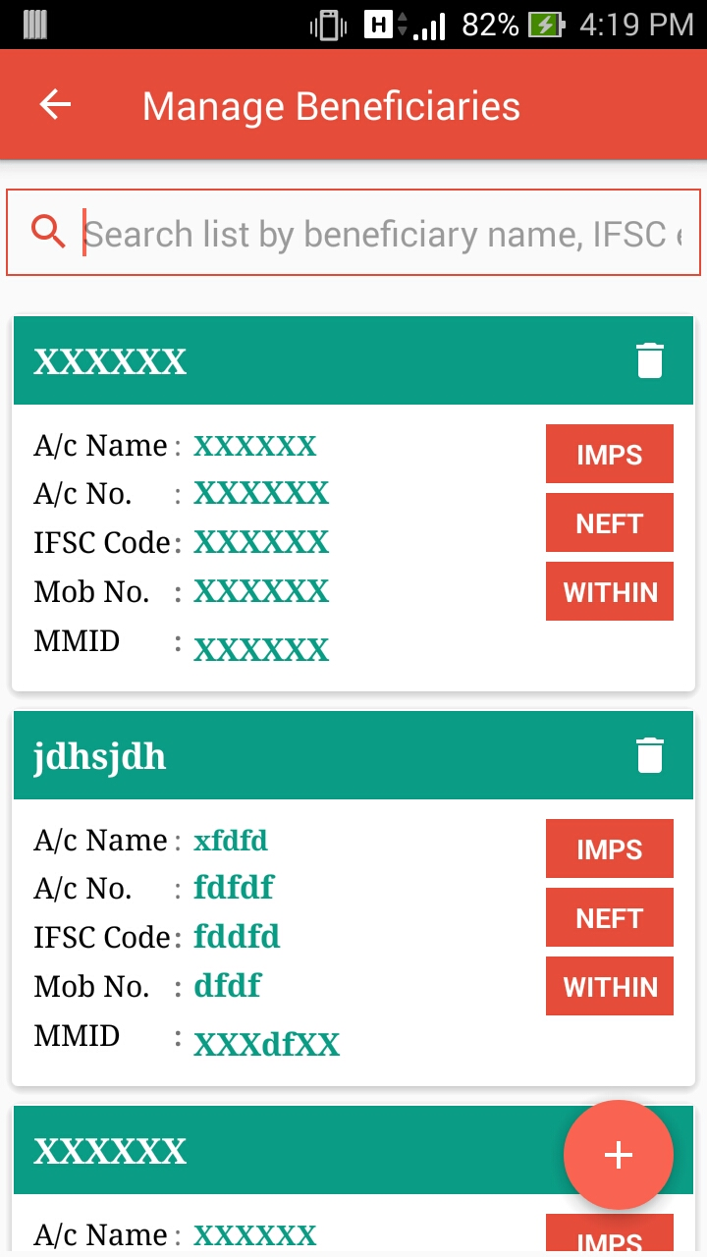
- This is Beneficiary List with beneficiary account details.
- IMPS, NEFT, WITHIN button allow performing relevant transaction & redirecting to its related screens.
- Delete button will allow removing the account from the list.

- User can filter below list via beneficiary name or IFSC code.

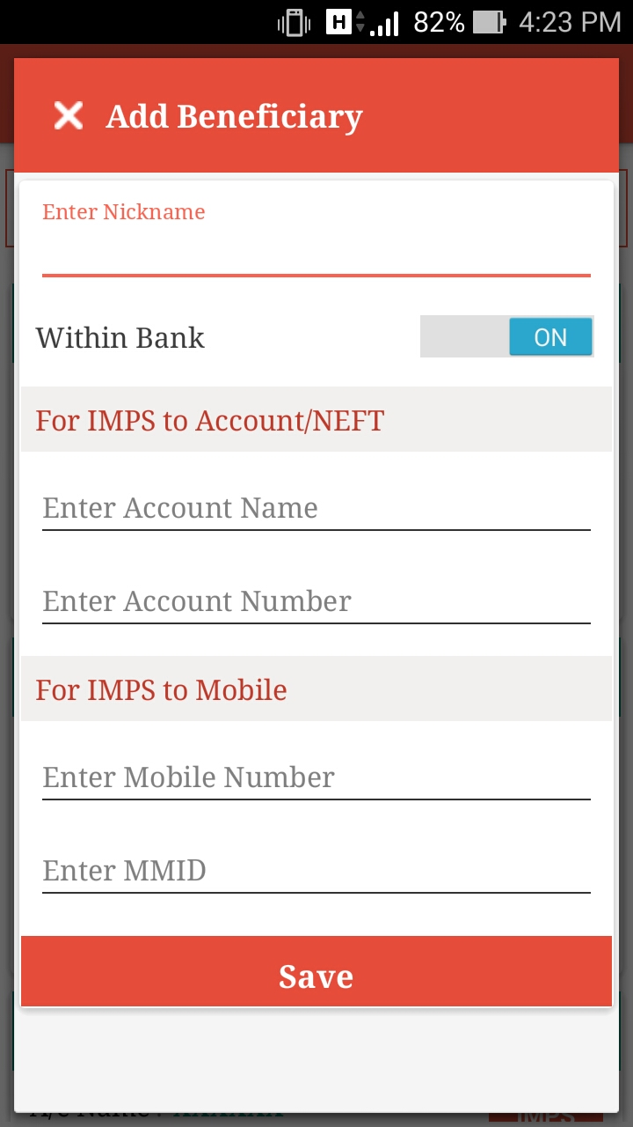
- This Screen allows user to add new Beneficiary for Within Bank, IMPS to Account, IMPS to Mobile or NEFT to Account.
- Nickname is the mandatory field here.
- If within bank is ON user need to fill all the details & it will add new beneficiary for Within Bank.

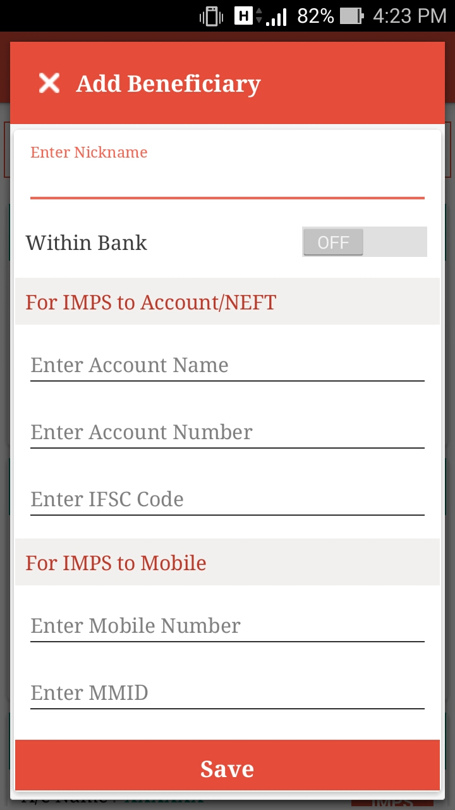
- If within bank is OFF & user enter Account Name & Account Number, IFSC Code it will add new beneficiary for IMPS to Account & NEFT to Account.
- In case user will enter Mobile Number & MMID, it will add new beneficiary for IMPS Transfer to Mobile.
- Save button will add new beneficiary.

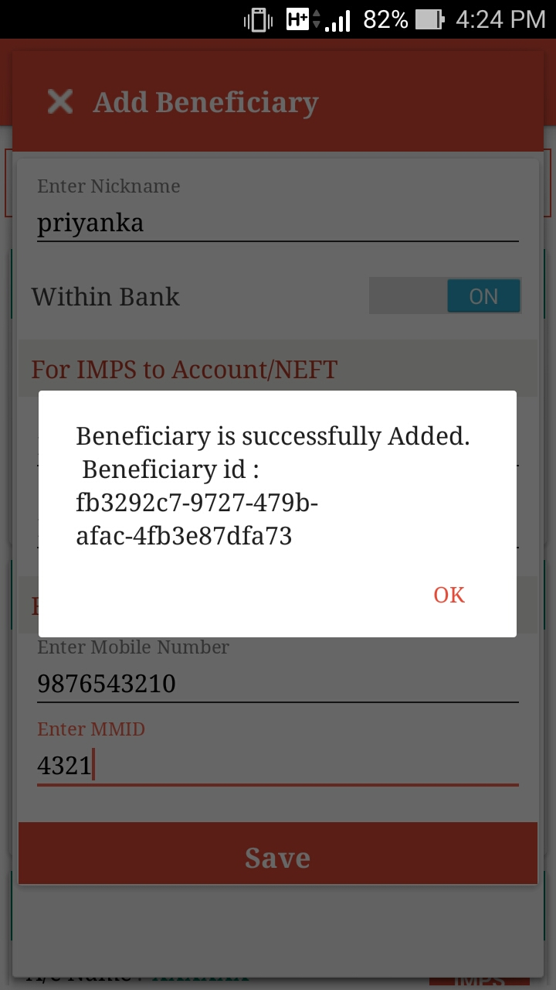
- On click of SAVE button, it will add new beneficiary & this dialog will open with the Beneficiary Id, which will, added into the list.

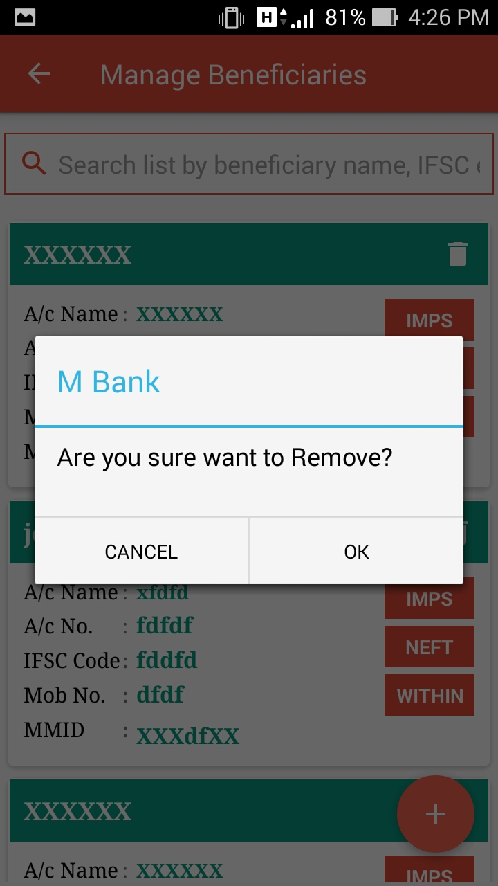
- This dialog will take confirmation from to user to delete select user or not.
- To delete beneficiary from the list user need to click on this button.

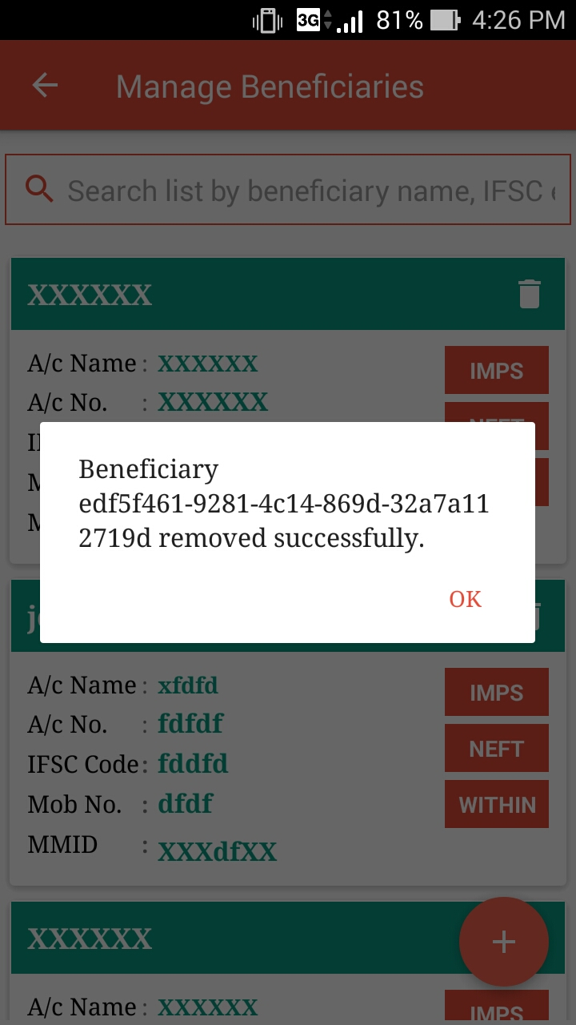
- This dialog will show the Beneficiary Id, which will, removed from the list.

Locate ATMs:
- This button shows the ATMs in google MAP available in the list.
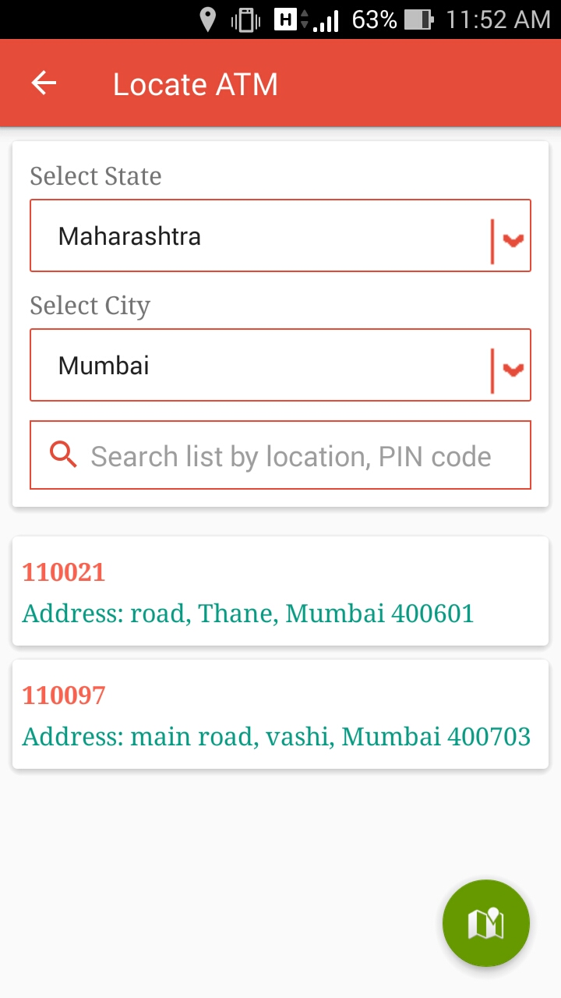
- Select State: It shows list of states.
- Select City: It shows list of cities for the selected state.
- User can filter the below list by Entering Pin Code or Location.
- User can get list of terminal code with address, according to selected state & city.

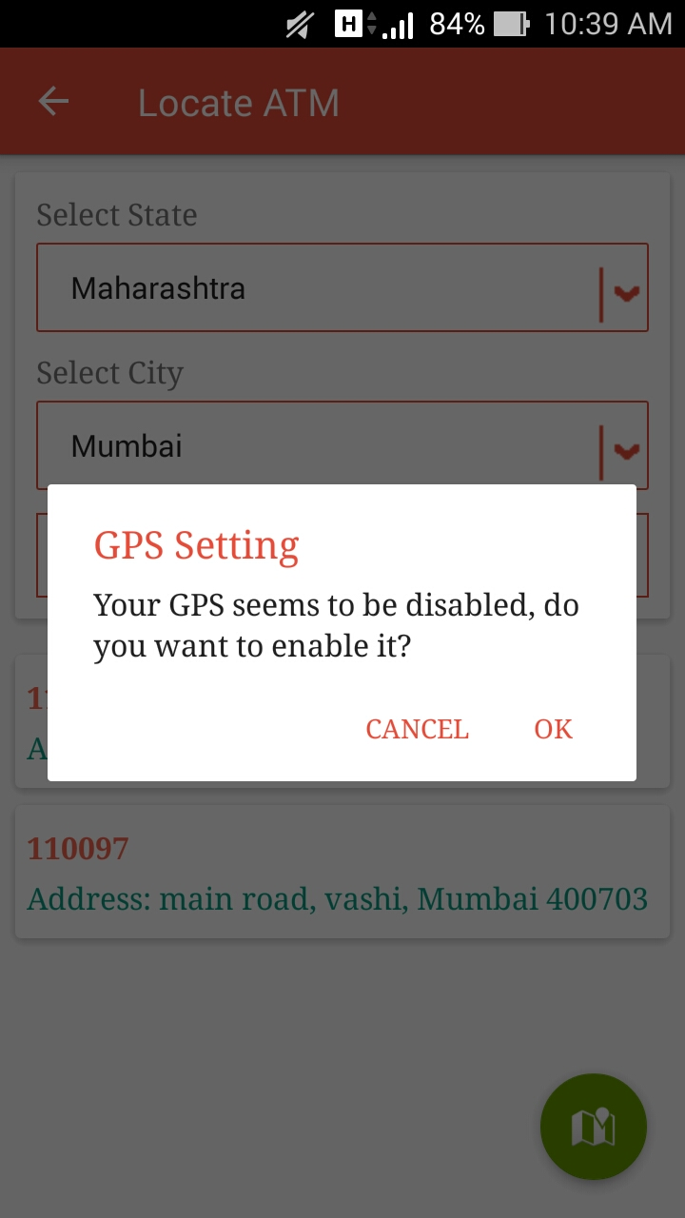
- To see the Located ATMs in google map, Location should be enable.
- In case Location is disable this dialog will occur & ask user to enable Location.

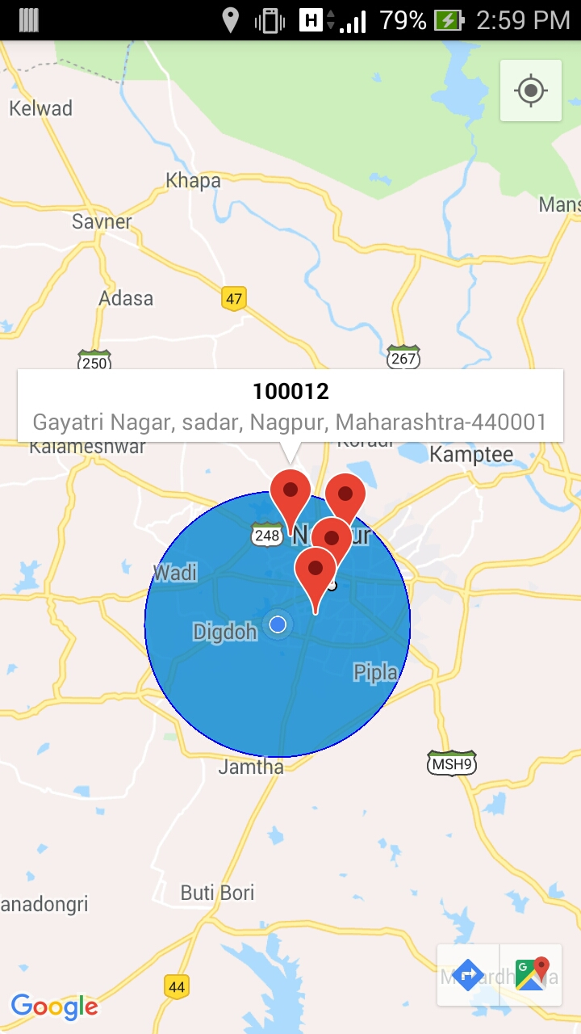
- User can see the location on google map with relevant details.
- All the location points present in the google map, available in the list of Located ATM’s.

Locate Branches:
- User can get list of branches with address, according to selected state & city.
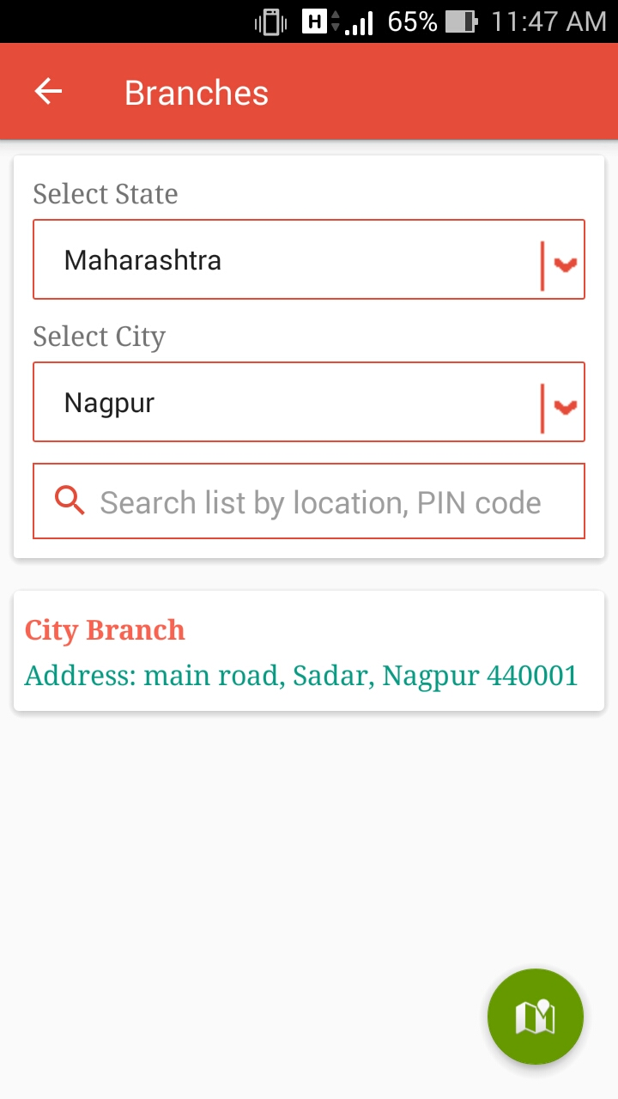
- Select State: It shows list of states.
- Select City: It shows list of cities for the selected state.
- User can filter the below list by Entering Pin Code or Location.
- This button shows the branches in google MAP available in the list.

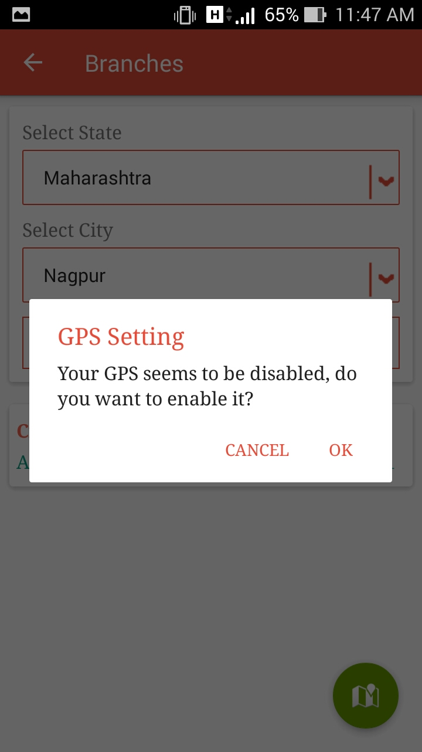
- To see the Located Branches in google map, Location should be enable.
- In case Location is disable, this dialog will occur & ask user to enable Location.

Contact Us:

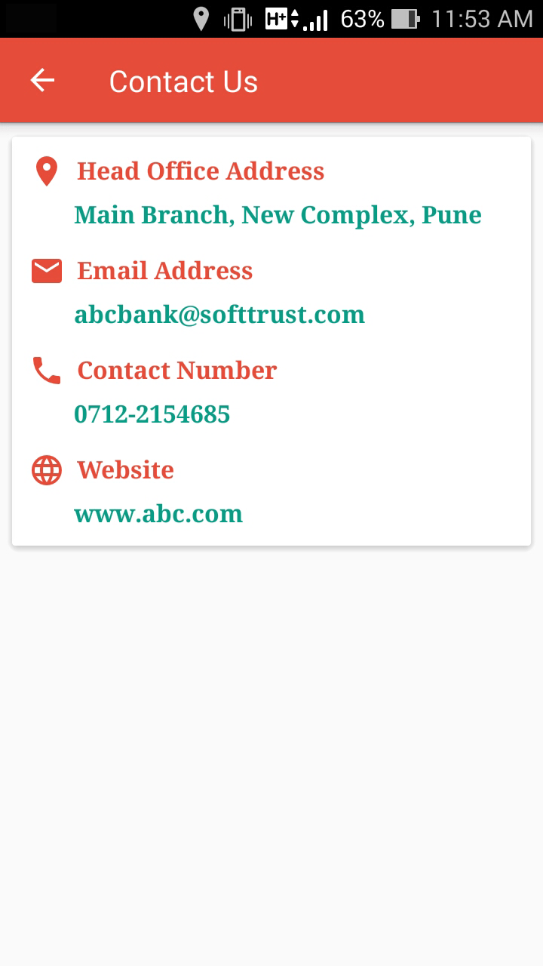
- It shows contact information for relevant branch.

About Us:


- This screen gives information about us.

