Assignment 4

Source: <https://blog.datawrapper.de/coronaviruscharts/#column-chart-worldwide>

1. Who is the audience?
   1. The primary audience is data enthusiasts, researchers and officials who are trying to understand the trend, severity and projections of the number of people getting affected, dying and recovering due to the Covid-19 virus. The seconday audience is everyone, visiting the website, who is trying to get updated on the number of people getting affected, dying and recovering due to the Covid-19 virus.
2. Strengths?
   * 1. **Overtime worldwide line chart [Viz 1.]:** The thickness of line of each country is directly correlated to the number of cases. Have references for how soon the deaths doubled in a country. Different reference slopes are given like: doubles every day, doubles every 2nd day, doubles every 3rd day, doubles every week and doubles every month.
     2. **Cases & deaths bar charts by country[Viz 2.]:** Easier to see the comparison between the number of confirmed cases and number of deaths. It gives an insight to the mortality rate. The exact number of cases are visible on hover. The exact numbers visible on hover are in contrast color to the color of the bar.
     3. **Confirmed & recovered cases map charts by country[Viz 3.]:** Geospatial visualization gives the ability to compare the activity across several locations at a glance. The size of the cluster shows how deeply an area is affected. By comparing size of the clusters of different states we can compare how affected
3. Weaknesses?
   * 1. **Overtime worldwide line chart[Viz 1.]:** All the lines are coloured in a different color. The chart stops at day 45. Since there are so many cases worldwide now, there should be more reference line for when the cases doubled in 4 days and 5 days. The visualization only shows the number of deaths in a country right now.
     2. **Cases & deaths bar charts by country[Viz 2.]:** It is difficult to get an estimation of number of people affected , died or recovered in this graph because the intervals are of 50k. Also because of this deaths are represented as a thin black line, in countries where deaths are comparatively less, which makes it difficult to see with the naked eye. Contrast colors are not used. It could be confusing to read stacked bar graph for some people. Also there is no data for recoveries in USA.
     3. **Confirmed & recovered cases map charts by country[Viz 3.]:** No zoom button. Some large clusters may overlap nearby smaller clusters. The clusters to represent number of deaths are shown at the center of number of confirmed cases and since dark colors are used to represent both clusters it is difficult to separate them. Also you have to exactly hover over the small black cluster inside to see the number of deaths. The granularity of the dot map is state wise however a county wise granularity would be better for comparison within a state.
4. My opinion: I think these visualizations are a great idea to reach more people and make them understand why flattening the curve is important. They make it easier to transmit information and convey the message.
5. What I would do differently?
   * 1. **Overtime worldwide line chart[Viz 1.]:** Make color groups of different countries[Viz 4.]. Add a filter to select specific countries for comparison [3].The y-axis intervals should be increasing by a factor of 10^2, because of the high number of cases worldwide. The first interval can be 100th case. We can add a dropdown menu to select either number of cases or number of deaths [2][Viz 4.].
     2. **Cases & deaths bar charts by country[Viz 2.]:** Have three separate horizontal bar charts for confirmed cases, deaths and recoveries placed side by side for comparizon. The exact count of all the countries will be displayed on their respective bars. [2] [Viz 5.]
     3. **Confirmed & recovered cases map charts by country[Viz 3.]:** Add a zoom in and zoom out button. Keep a common cluster for confirmed cases and deaths. On hover you can see the all information. In areas where there are multiple overlapping clusters on clicking any one of the clusters display a menu which shows the info about the biggest cluster amongst them and a left right arrow option which user can use to see information other clusters. [2][Viz 6.]

Citations:

1. <https://coronavirus.jhu.edu/map.html>
2. <https://informationisbeautiful.net/visualizations/covid-19-coronavirus-infographic-datapack/>
3. <https://ourworldindata.org/coronavirus>

Visualizations:

1. Overtime worldwide line chart  
   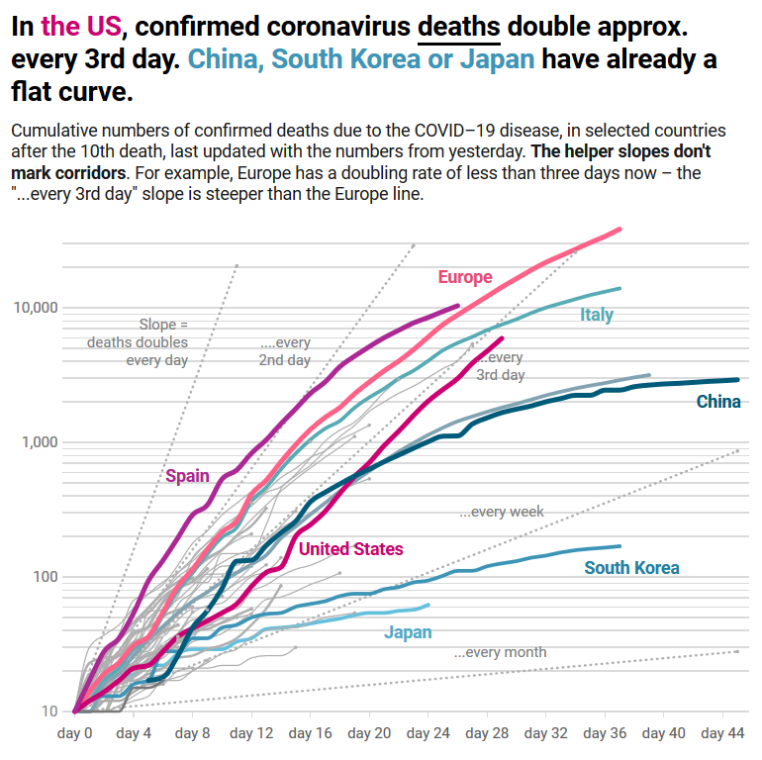
2. Cases & deaths bar charts by country  
   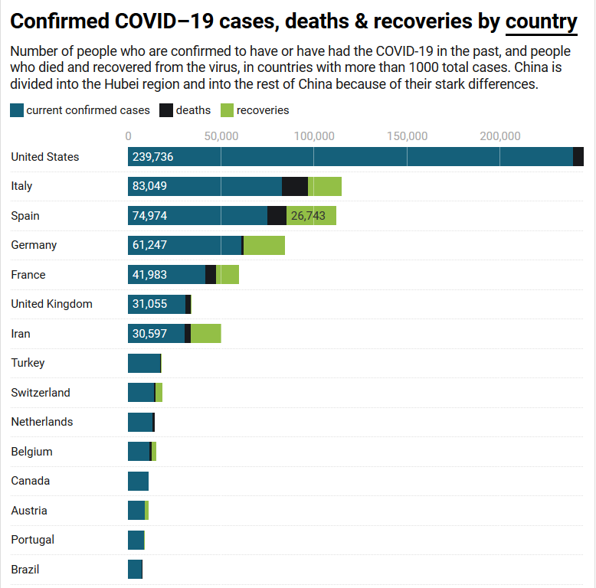
3. Confirmed & recovered cases map charts by country  
   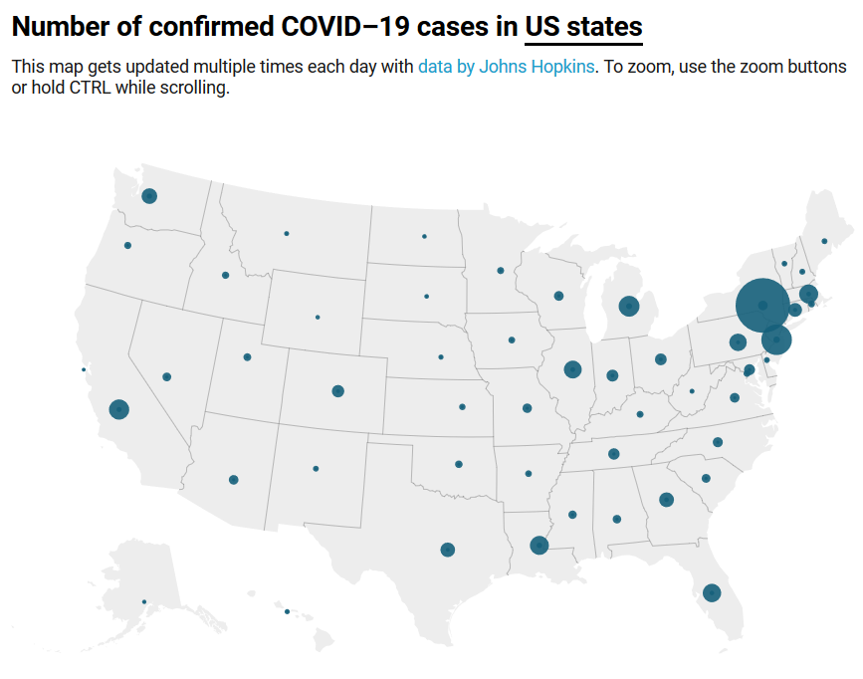
4. Coronavirus Infection Trajectories:  
   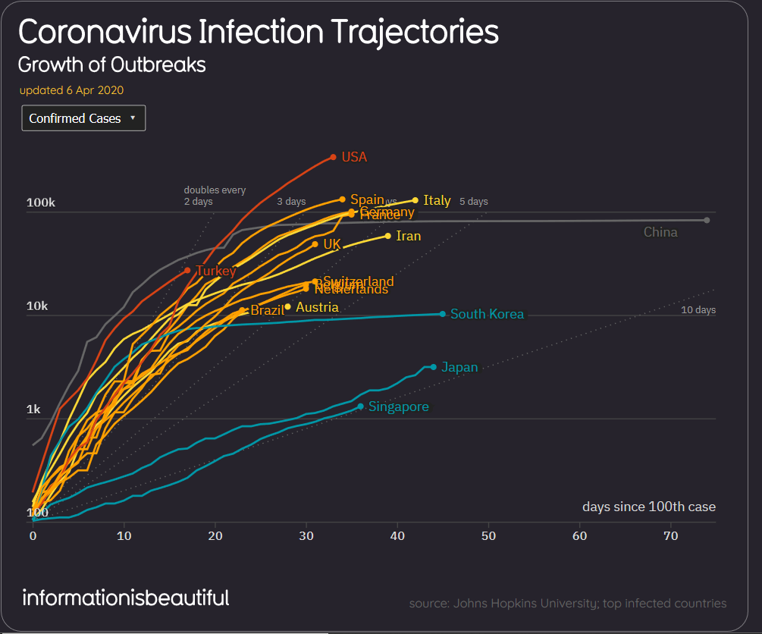
5. Cases and deaths in countries by bar chart:

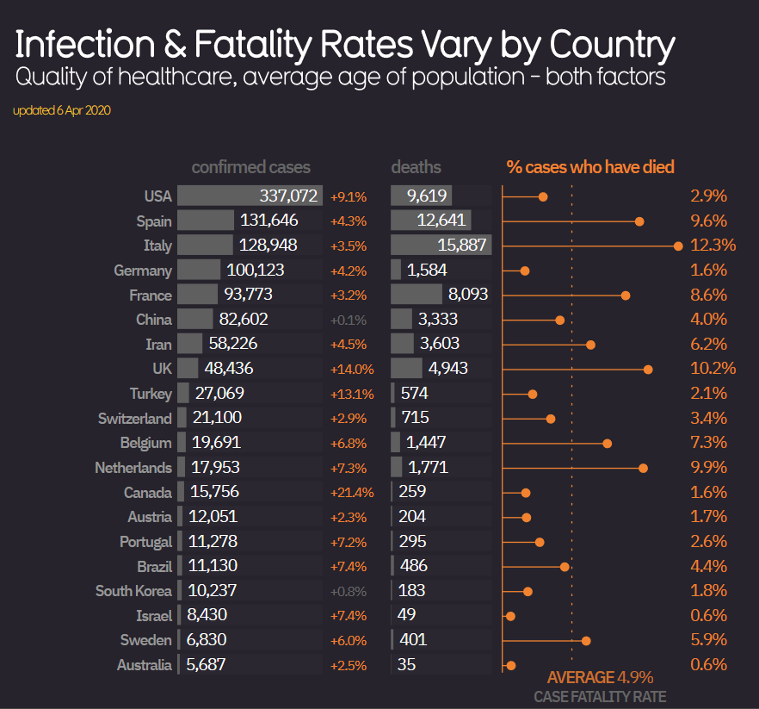

1. Menu like pop up:

