1. **Download, install and open Gephi** <http://gephi.org/>
2. Dataset: download your Facebook social network here (Netvizz app: https://apps.facebook.com/netvizz/) or use sample dataset on blackboard (football.gml or politicsblog.gml)

|  |
| --- |
| dataset:   1. airlines-sample.gexf (to test GeoLayout) 2. football.gml (to test directed network) 3. politicsblogs.gml 4. asu facebook like page network (asu_fb_like_network.gdf) 5. greys anatomy sexual relationship network (ga_edgelist.csv)   code:  network_R.R (networkvis in R) |

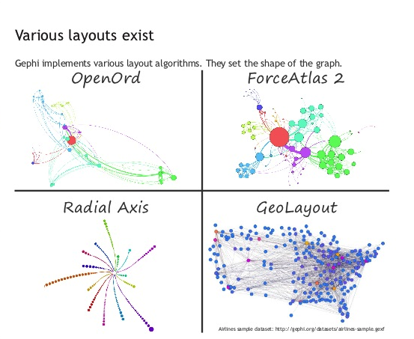

**Network layout (Layout)**

* Yifan-Hu
* Force Atlas 2
* Fruchterman-Reingold
* Geo Layout
* Circular, Radial Axis
* …

*When to use what?*

**Statistics (Statistics)**

* 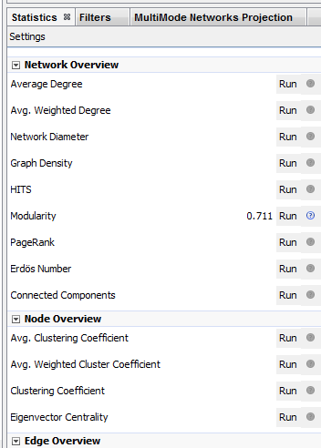Modularity
* Average Degree
* Network diameter
* …

*What should I calculate? What do they mean?*

**Customize the network (Partition & Ranking)**

* Layout adjustment
* Labels
* Filter

*How do I analyze large graph?*

**Generate output (Preview)**

- Final customization

- Export to pdf or svg

- JavaScript GEXF Viewer for Gephi

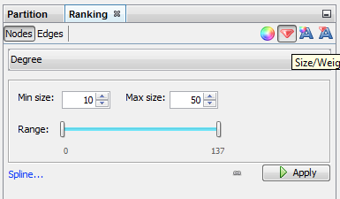 <https://github.com/raphv/gexf-js>

Start visualizing

1. explore & detect communities (compute stats & layout)
2. visualize the community structure (partition & ranking)

**Examine Network Structure Step by Step:**

1. import *.gml or *.gdf
2. click *run* to calculate Modularity (in the Statistics panel at the right)
3. refresh Nodes parameters (in the Partition panel at the top left)
4. select Modularity class and click *Apply*

<you should see the network colored by modules by now>

1. select ForceAtlas2 layout and click *Run*

<you should see modules are group together by colors>

1. Click Edit (edit node attribute), then select any nodes

<you should see the node’s detail: attributes>

1. select Label Adjust layout and click *Run*
2. select Noverlap layout and click *Run*

(if you do not find those layouts that I mention, you need to download plugins, by clicking **Tools**>>plugins>>Available plugins, at the top. Select the layout plugins and Install them) https://gephi.org/plugins/#/

1. click on *Preview*, (default output is selected), click *Refresh*

(configure your text, background etc...)

1. click on Export SVG/PDF/PNG as a file

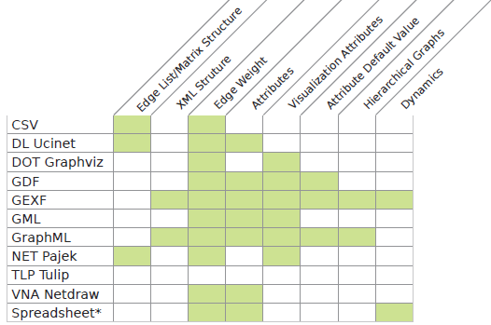

source: https://gephi.org/users/supported-graph-formats/

**After class:**

* Gephi official tutorials <https://gephi.org/users/>
* [Video tutorial](http://www.yurulin.com/class/css2012/wiki/videos.html)s <http://www.yurulin.com/class/css2012/wiki/videos.html>
* More plugin <https://marketplace.gephi.org/plugins/>
* interactive network visualization on the wbe <http://sigmajs.org>
* Gephi datasets <https://github.com/gephi/gephi/wiki/Datasets>
* Time series dynamic network tutorial

<https://seinecle.github.io/gephi-tutorials/generated-html/creating-a-simple-dynamic-network.html>