|  |
| --- |
| Dataset: Grey’s Anatomy Characters’ Relationship (ga_edgelist.csv) |
| library(igraph)  #explore igraph library in Help  ga.data <- read.csv('ga_edgelist.csv', header=TRUE)  g <- graph.data.frame(ga.data, directed=FALSE) |

1. Modularity

|  |
| --- |
| #explore communities, cluster library  #plot a modularized graph & a clustered graph  #what’s the difference?  wc <- walktrap.community(g)  plot(wc, g)  clustered_g <- clusters(g)  plot(clustered)  modularity(wc)  membership(wc)  fc<-fastgreedy.community(g)  modularity(fc)  membership(fc)  plot(fc, g) |

1. Degree Centrality

|  |
| --- |
| centralization.degree(g)  centralization.degree(g)$centralization |

1. Betweenness

|  |
| --- |
| centralization.betweenness (g)  btw <- betweenness(g)  btw.score <- round(btw) + 1  btw.colors <- heat.colors(max(btw.score))  V(g)$color <- btw.colors[ btw.score ]  plot(g ,vertex.label=V(g)$label)  btw.colors <- rev(heat.colors(max(btw.score))) |

1. Eigenvector

|  |
| --- |
| centralization.betweenness (g) |

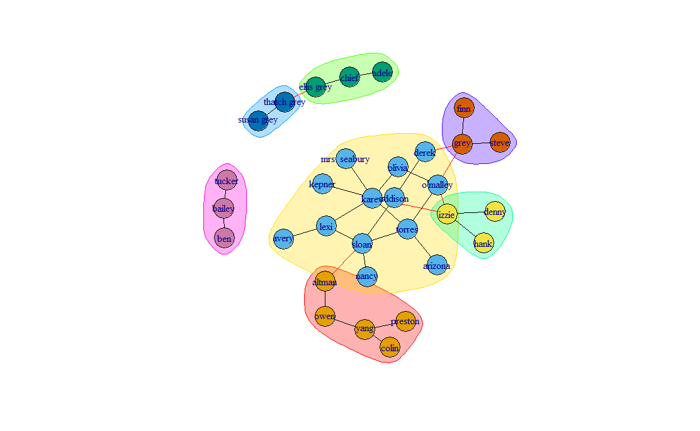

> modularity(wc)

[1] 0.5147059

> membership(wc)

lexi owen sloan torres derek karev o'malley

2 1 2 2 2 2 2

yang grey chief ellis grey susan grey bailey izzie

1 6 3 3 5 7 4

altman arizona colin preston kepner addison nancy

1 2 1 1 2 2 2

olivia mrs. seabury adele thatch grey tucker hank denny

2 2 3 5 7 4 4

finn steve ben avery

6 6 7 2

> fc<-fastgreedy.community(g)

> modularity(fc)

[1] 0.5947232

> membership(fc)

lexi owen sloan torres derek karev o'malley

3 4 3 1 2 1 1

yang grey chief ellis grey susan grey bailey izzie

4 2 5 5 5 6 1

altman arizona colin preston kepner addison nancy

4 1 4 4 1 2 3

olivia mrs. seabury adele thatch grey tucker hank denny

1 1 5 5 6 1 1

finn steve ben avery

2 2 6 3

> plot(fc, g)

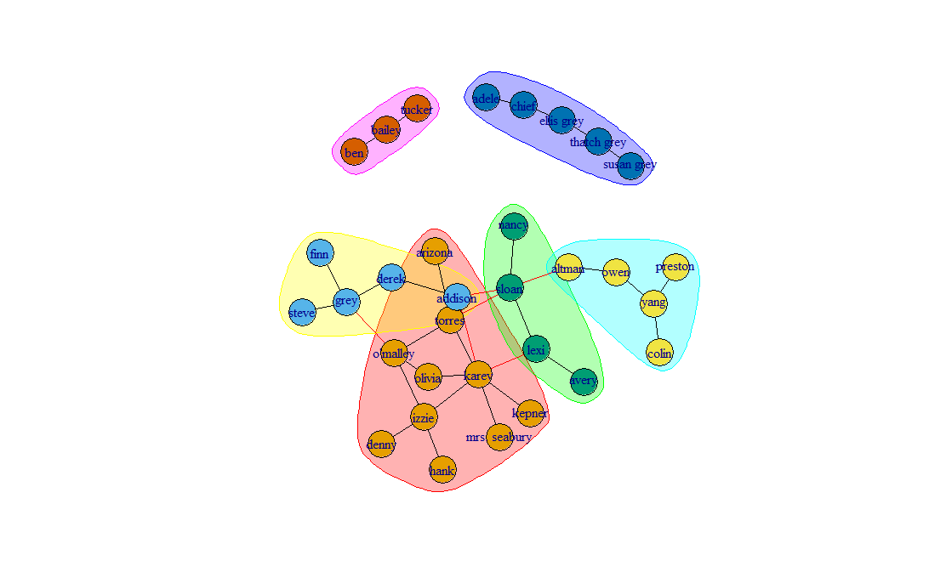

> centralization.degree(g)

$res

[1] 3 2 5 4 2 7 4 3 4 2 2 1 2 4 2 1 1 1 1 3 1 2 1 1 2 1 1 1 1 1 1 1

$centralization

[1] 0.1572581

$theoretical_max

[1] 992

> centralization.degree(g)$centralization

[1] 0.1572581

> centralization.betweenness (g)

$res

[1] 36.00000 60.00000 115.36667 67.15000 17.95000 95.26667 54.41667 43.00000

[9] 46.86667 3.00000 4.00000 0.00000 1.00000 47.95000 76.00000 0.00000

[17] 0.00000 0.00000 0.00000 44.08333 0.00000 4.95000 0.00000 0.00000

[25] 3.00000 0.00000 0.00000 0.00000 0.00000 0.00000 0.00000 0.00000

$centralization

[1] 0.2061556

$theoretical_max

[1] 14415

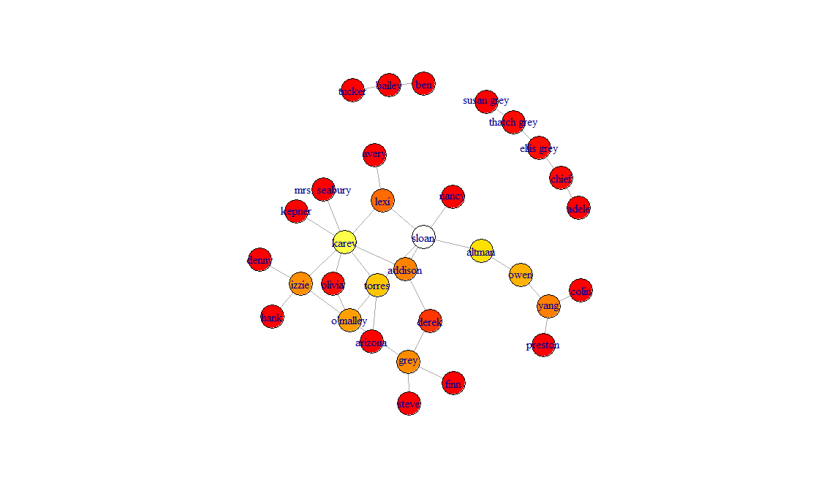

> centralization.betweenness (g)

$res

[1] 36.00000 60.00000 115.36667 67.15000 17.95000 95.26667 54.41667 43.00000

[9] 46.86667 3.00000 4.00000 0.00000 1.00000 47.95000 76.00000 0.00000

[17] 0.00000 0.00000 0.00000 44.08333 0.00000 4.95000 0.00000 0.00000

[25] 3.00000 0.00000 0.00000 0.00000 0.00000 0.00000 0.00000 0.00000

$centralization

[1] 0.2061556

$theoretical_max

[1] 14415