
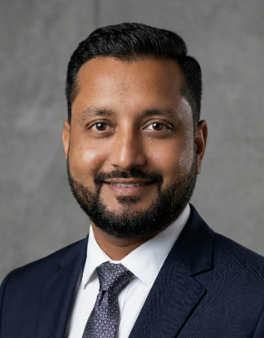
B/H Primary School, At. Khaladi, Ta. Mahudha,
Dist. Kheda, Gujarat, India – 387335
+91 94289 02507 | sagarp451@gmail.com
Portfolio & Projects: sagarpatel-portfolio.netlify.app
www.linkedin.com/in/sagar-patel-dev Scan to View My Portfolio & Projects
SAGAR PATEL
Computer Educator | Web Developer | It Expert






PROFESSIONAL SUMMARY .
Dedicated tech professional and BCA candidate (2025) with experience in building live client solutions and robust database systems. Backed by 13+ years of leadership and technical operations experience, I possess a unique blend of analytical problem-solving, team mentorship, and structured data management skills. Eager to leverage technical expertise as a Web Developer or to mentor the next generation as a Computer Educator.
TECHNICAL SKILLS .
- Web Development: HTML5, CSS3, JavaScript, PHP, API Integration.
- App Development: Android Studio, Java (Android Lifecycle), XML Layouts.
- Programming & Databases: C, C++, Java, MySQL, SQL Queries.
- Tools & OS: VS Code, Git/GitHub, Windows, Linux, Netlify.
- Soft Skills: Team Leadership, Mentorship, Technical Troubleshooting, Data Integrity.
FEATURED PROJECTS .
- Shiv Chula Dosa Hub (Live Client Project).
  - Tech Stack: HTML5, CSS3, JavaScript
  - Developed a responsive Digital QR Menu solution for a real-world client to improve customer service.
  - Implemented categorized menu sections and optimized the UI for mobile-first accessibility.
  - Status: Live & Deployed.
- Blood Bank & Donor Management System.
- Tech Stack: PHP, MySQL, HTML/CSS
- Engineered a secure web platform to track blood inventory and manage donor profiles.
- Streamlined hospital requests with real-time database updates and secure user authentication.
- University Management System.
- Tech Stack: Java, MySQL
- Created a structured database system to handle complex student and faculty records efficiently.
- Integrated advanced search, update, and reporting functionalities for internal academic operations.
- Tic-Tac-Toe Android Game.
- Tech Stack: Java, Android Studio, XML
- Developed a fully functional interactive Android application with custom game logic.
- Focused on responsive design, Activity Lifecycle management, and seamless user interaction.

1


- Frontend Tools & API Apps.
- Tech Stack: JavaScript, External APIs
- Built a Live Currency Converter using exchange rate APIs to demonstrate asynchronous programming.
- Developed functional web utilities to showcase modern DOM manipulation and UI logic.
PROFESSIONAL EXPERIENCE .
- Senior Technical Operator & Supervisor
Drashti X-Ray Clinic, Nadiad | June 2012 – July 2025
  - Leadership & Training: Supervised daily technical operations and mentored junior staff on software protocols and workflow efficiency.
  - Technical Troubleshooting: Managed advanced imaging/computing equipment, resolving hardware and software anomalies to minimize downtime.
  - Data Management: Maintained complex, sensitive patient data records with 100% accuracy and integrity.
EDUCATION .
- Bachelor of Computer Applications (BCA)
Dr. Babasaheb Ambedkar Open University | Completed with 7.94 CGPA July 2025
- Diploma in Radiology Technology
Bharat Sevak Samaj | Completed with 73.11% May 2011
- Bachelor of Commerce (B. Com)
Gujarat University | Completed with 62.14% March 2007
LANGUAGES .
- English
- Hindi
- Gujarati
PERSONAL INFORMATION .
Full Name : Sagarkumar Jitendrabhai Patel
Date of Birth : 12 July 1990
Marital Status : Married
Nationality : Indian
Address : B/H Primary School, At. Khaladi, Ta. Mahudha, Dist. Kheda, Gujarat, India – 387335
DECLARATION .
I hereby declare that all the information provided above is true and correct to the best of my knowledge and belief.

Sagar Patel

2

