Dear IBMer,

Below mentioned are our contact numbers and mail ids for any Queries.

1. Please contact our IBM Priority number – 41255793.

2. Please write to ibmcare@ttkhealthcareservices.com on any unanswered Queries by call centre for more than 2 working days

3. Please write to the TEAM LEADER - Pamela@ttkhealthcareservices.com on any answered Queries by ibmcare for more than 2 working days.

We request you to follow the below mentioned escalation matrix ONLY if your queries are not replied by above mentioned 3 contact points

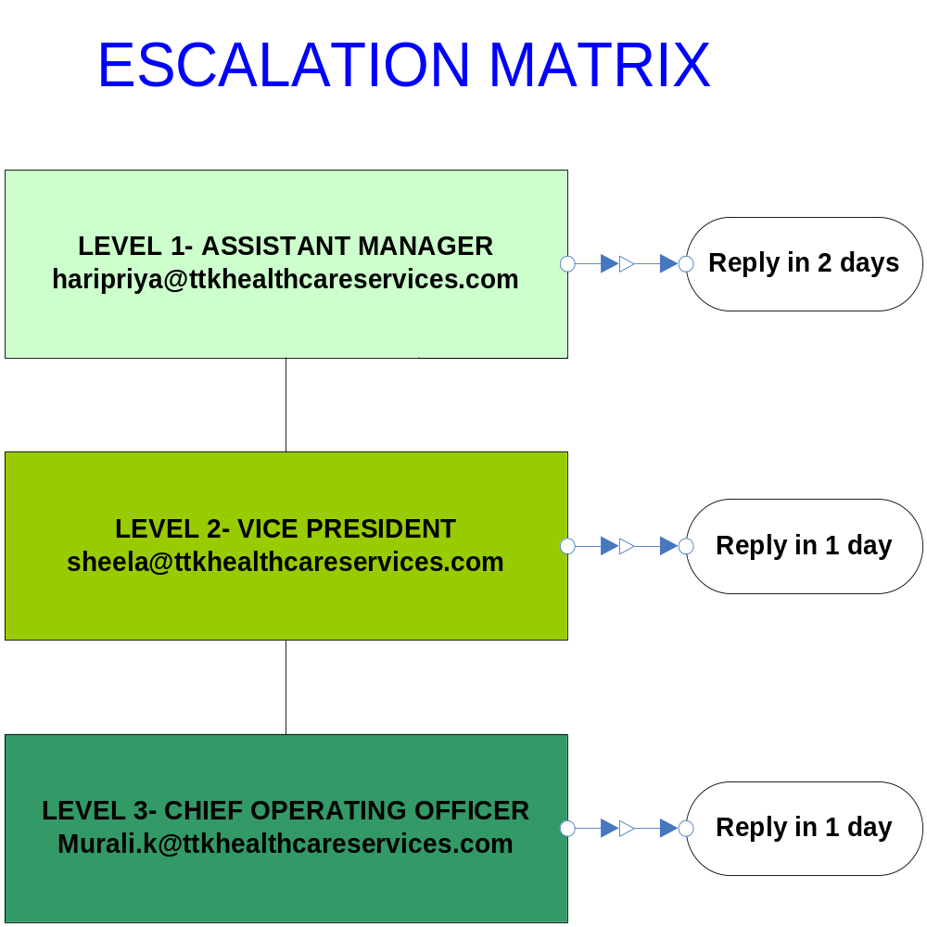
Note

Please write to each escalation level separately according to the timelines.

Do not mark a combined mail to all the escalation points.

