1. How to import database?

Ans: Follow following steps:

1. Go to PhpMyAdmin (e.g., <http://localhost/phpmyadmin/> )
2. On a very first screen click on “SQL” tab. Paste content from file “TestDatabase.txt”
3. Click “Go” button below.

OR

1. Rename file “TestDatabase.txt” to “employee.sql”
2. Go to PhpMyAdmin (e.g., <http://localhost/phpmyadmin/> )
3. On a very first screen click on “Import” tab. Select file that you recently rename. (i.e., File “employee.sql”)
4. Click “Import” button below.
5. Where to put project folder?

Ans:

**Extract “zip file: Plus91” into one of following place depending on which server you used.**

The project folder for PHP can be placed in different locations depending on the web server you are using. Here are the recommended locations for common web servers:

**WampServer:**

The recommended location for the project folder is C:\wamp\www\. You can create a folder inside the www directory and place your PHP project files there.

**XAMPP:**

The recommended location for the project folder is C:\xampp\htdocs\. Similarly, you can create a folder inside the htdocs directory and put your PHP project files in that folder.

These locations are commonly used for local development environments, and they correspond to the default web server configurations for WampServer and XAMPP.

Remember to configure the web server properly to access the PHP project files correctly. Once the project files are placed in the appropriate folder, you can access them through the web browser using the appropriate URL. For example, if your project folder is named "myproject" and you are using WampServer, you can access it through the URL <http://localhost/myproject>.

1. Here are the validations that I have implemented:
2. Blank Value Validation: I have validated all the columns of the XLSX sheet to ensure that no blank values are present. If any of the columns have a blank value, the corresponding row is considered a failed row and will not be inserted into the database.
3. Email Format Validation: I have implemented a validation to check if the email addresses in the sheet have the required characters, such as '@' and '.'. If any email address is missing these characters, the row is considered a failed row.
4. Mobile Number Format Validation: I have implemented a validation to check if the mobile numbers in the sheet comply with the Indian standard, which requires them to be 10 digits long. If any mobile number does not meet this requirement, the row is considered a failed row.

**Note:** I recommend reusing the same XLSX sheet that is present in the folder because I have made some date formatting related settings specifically for this sheet. By using the existing sheet, we can ensure that the data remains consistent and aligned with the formatting requirements.

**Important Note:** I have implemented this project using the PHP library "PhpOffice\PhpSpreadsheet" for handling the XLSX sheet. To install this library, I used Composer through the command line. Please refer to the attached screenshot below for the library installation command.

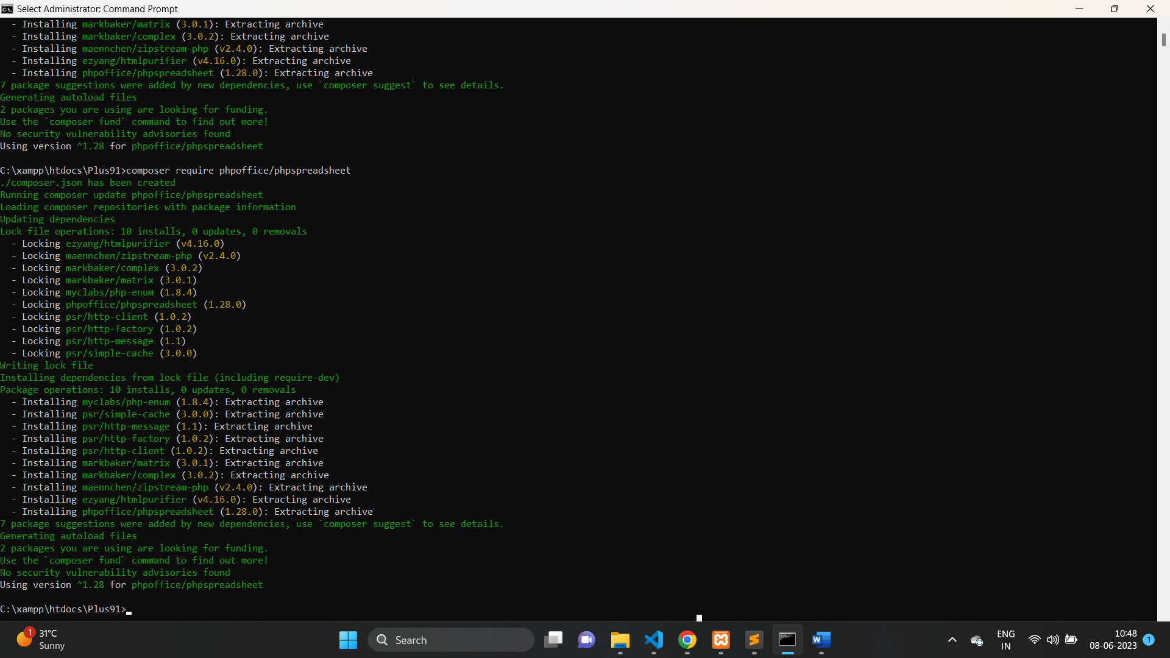

By using the "PhpOffice\PhpSpreadsheet" library, I was able to effectively handle and process the XLSX sheet data in the project.