**Component Structure in CRXDE**

The **Author Component** is created under the following path: **apps/myTraining/components/author**

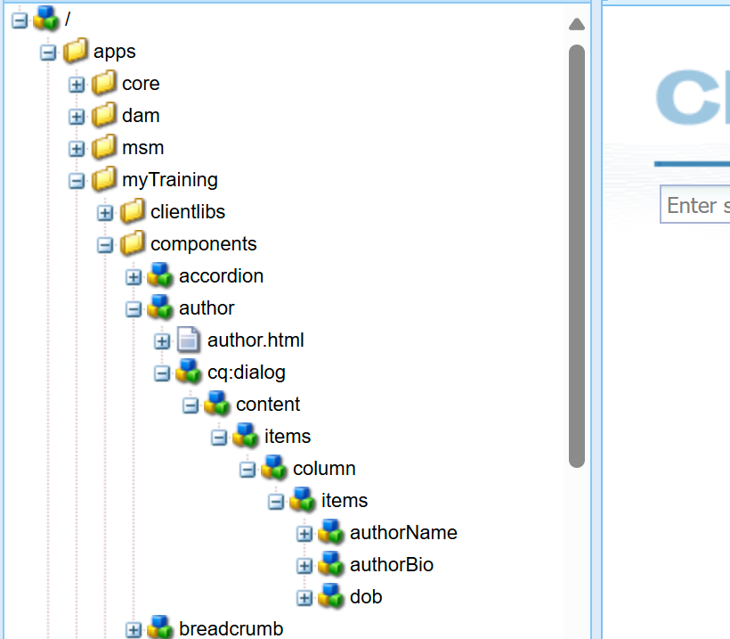

**Dialog Configuration in CRXDE**

The dialog consists of three mandatory fields with properties required:  
 **Author Name** - Single-line text field

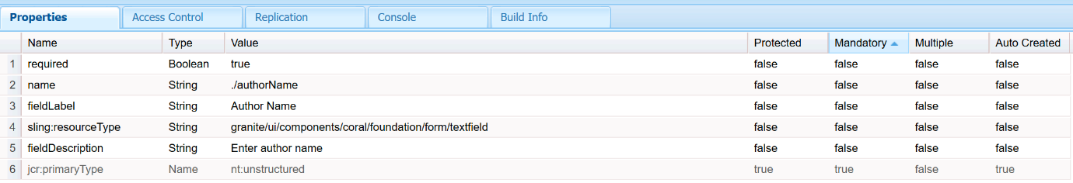  
 **Author Bio** - Multi-line text field

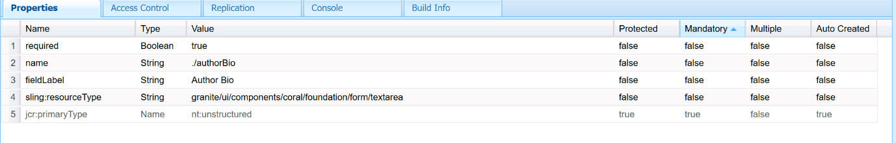  
 **DOB** - Date picker

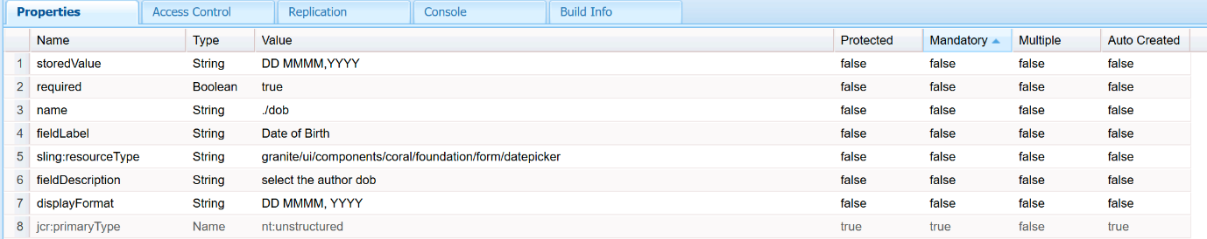

**Create author.html in author component**

Content of author.html is given below

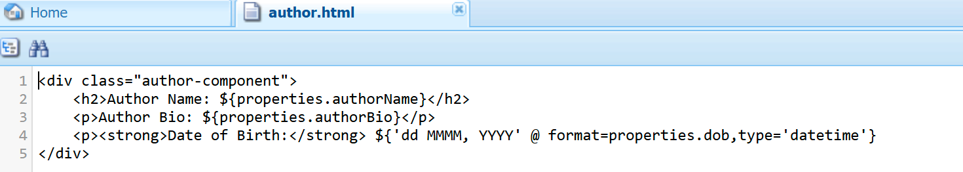

**Create Author Page in aem sites**

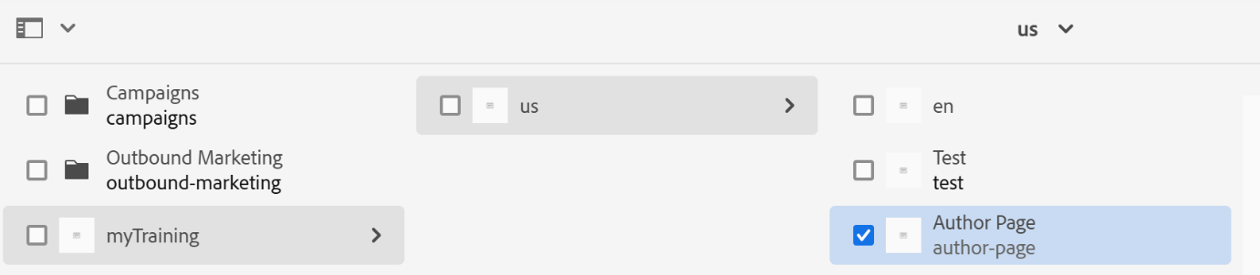

**Add Author component into the author page and fill the required fields**

[**http://localhost:4502/editor.html/content/myTraining/us/author-page.html**](http://localhost:4502/editor.html/content/myTraining/us/author-page.html)

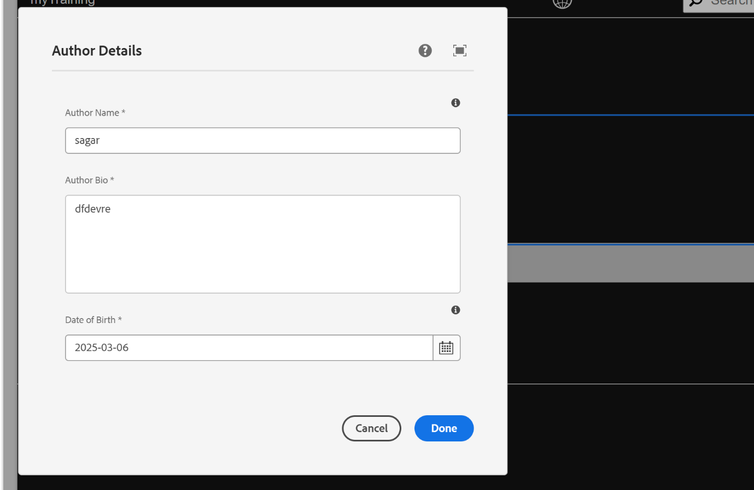

**Click done then the detailes will be displayed**

