 |  |  | Document Ref.:
 |  |  | Version No.:
 |  |  | Date:
 |  |  | Copy No.:
Project Name:
Project Code:
Status: | Draft / Current / Superceded
Document Type: | Controlled / Uncontrolled
<Title>
<Summary>

Prepared By: |  |  |  | Reviewed By:
Name |  | Date |  | Name |  |  | Date
 |  |  |  | Approved By:
 |  |  |  | Name |  |  | Date
Distribution List
Project Representative(s) |  |  |  |  | Guide Representative(s)
- <Name1>  - <Name2>  - <Name3> |  |  |  |  | - <Name4>  - <Name5>  - <Name6>

TABLE OF CONTENTS

Definitions, Acronyms and Abbreviations 2
References 2
Change History 2
1.0 Introduction 2
1.1 Overview 2
1.2 Scope 2
2.0 Design Constraints, Assumptions and Dependencies 2
3.0 Design Description 2
3.1 Master Class Diagram 2
3.2 Module 1 2
3.2.1 Description 2
3.2.2 Use Case Diagram 2
3.2.3 Class Diagram 2
3.2.3.1 Class Description 1 2
3.2.3.2 Sequence Diagram 2
4.0 ER Diagrams 2
5.0 User Interface Diagrams 2
6.0 Report Layouts 2
7.0 External Interfaces 2
8.0 Packaging and Deployment Diagrams 2
9.0 Help 2
10.0 Alternate Design Approach 2
11.0 Reusability Considerations 2
12.0 Traceability Matrix 2
Definitions, Acronyms and Abbreviations
This section provides for definition of all terms, acronyms and abbreviations required for interpreting the High Level Design Document. Well known abbreviations need not be stated
References
This section describes the complete list of documents referred to prepare the High Level Design. This section shall describe the title, version number, dates, authors and publishers of the referenced documents whenever applicable.

If industry standard methodology is used for design, it will be clearly mentioned here. If however, other methodologies are used, the deviation from a standard methodology will be clearly described.

Change History
This section describes the details of changes that have resulted in the current High-Level Design document.
# | Date | Document Version No. | Change Description | Reason for Change

Introduction

Overview
The purpose of the creation of this document is presented in this section. The overview of the whole document is represented here

Scope
This section describes all aspects of high-level design that has been undertaken. It states what has been presented in this document. It states clearly identified design issues that have not been addressed, if they have not been and gives a pointer to the document that they are covered in. It also states design issues that have not been addressed because it is out of scope of our development.

Design Constraints, Assumptions and Dependencies
This section clearly defines the constraints involved in the design with reasons. If these constraints can be overcome by certain assumptions, they will be stated too. Dependencies, if any, in the design will be mentioned clearly

Design Description
This section clearly defines the interfaces that exist between two or more modules/classes.
This could be represented diagrammatically for better understanding of the system.
This section explains briefly about the major modules and classes.

Master Class Diagram
A class diagram of the entire system will be given at a high level and then broken down into sub levels in each of the classes below.

Module 1
…

Description
Detailed description about the module

Use Case Diagram
This section shall depict the use-case diagram or reference to the CRS shall be made if it is defined in CRS. The diagram shall be broken up into multiple levels based on the need.
Example:

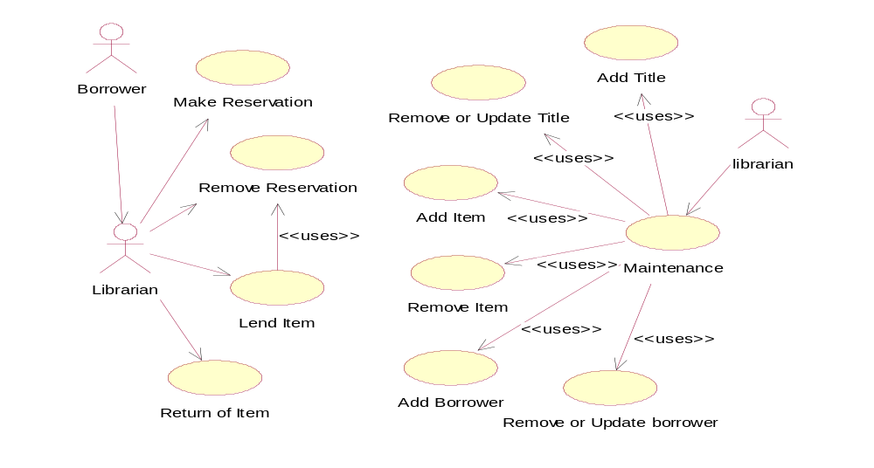
Use Case Item | Description

Class Diagram
Here, a description of each class in this class diagram will be given. A diagram of the entire system will be given at a high level and then broken down into sub levels. Classes maybe repeated across class diagrams, to show the interfaces with other classes. The detailed explanation of each class with its methods will be covered in the low-level design document.
For Example

Item
ID : Integer
find on title()
find on id()
find on reservation()
create()
destroy()
<<Business Object>>
Book Title
lending time : Days = 30
create()
destroy()
<<Business Object>>
magazine title
lending time : days = 10
create()
destroy()
<<Business Object>>
Borrower information
name : String
address : String
find()
create()
destroy()
<<Business Object>>
Loan
date : Date = current date
create()
destroy()
<<Business Object>>
reservation
date : Date = current date
find()
create()
destroy()
<<Business Object>>
Title
name : String
lnumber of reservation
find()
create()
destroy()
<<Business Object>>

Class Description 1
Detailed description about the class.

Sequence Diagram
The Sequence diagram for each module will be presented here.
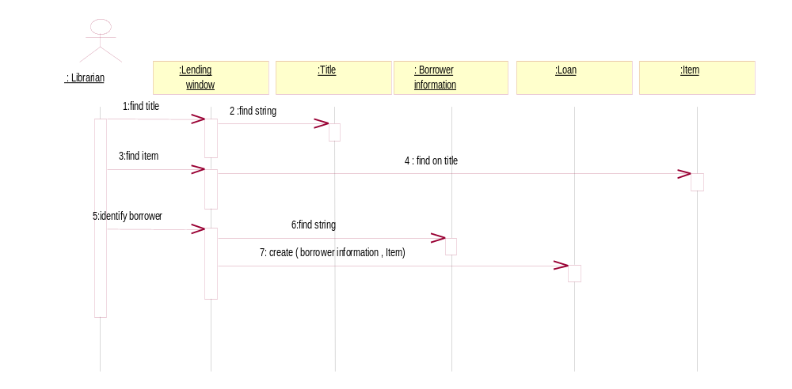For Example:

ER Diagrams
This section will include the ER Diagram. The following table shall be filled for details of the entities and their data elements / attributes.
# | Entity | Name | Definition | Type
ENTITIES
# | Attribute | Name | Definition | Type (size)
DATA ELEMENTS
This section shall describe the data / function used in each module / function.

User Interface Diagrams
A brief description of the screen will be given here. Screens will have references to the appropriate CRS section.

Report Layouts
This section will include a description of the report, which will cover selection criteria, sorting and grouping criteria and the tables used to generate the report. Details like the columns of the table to be used will be mentioned in the low-level design document. The actual report layout will be put into an appendix and a reference to the same will be provided here.

External Interfaces
Gives an overall diagram as to how the system with known interfaces will work. However, the description of the interface may or may not be covered in this document, depending on whether it is within the scope of the offshore development.

Packaging and Deployment Diagrams
The packaging and deployment diagrams for the system shall be presented here.
For Example:

Client Browser

Database

Application Server

Help
This section shall describe the help planned for the system like, online / context sensitive help and other documentation (e.g. User Manual, Technical Manual) planned, to aid in the usage of the system

Alternate Design Approach
This section shall describe the design approaches that were considered. The limitations and the advantages of each approach shall be explained briefly.

Reusability Considerations
This section shall describe the reusability considerations planned for the project. They may comprise of the following:
- Project Components that are and can be generated with available reusable components
- Components that can be built in the project for reuse in the project

Traceability Matrix

CRS Reference Section No.  and Name. | DESIGN / HLD Reference Section No.  and Name.

