

|  |
| --- |
| Name-Sagar Raj  Registration No-12112708  Roll NO-RK21YKB97 |

Home page-

I just made this things:

Home

About Us

Sports Manual

Contact Us

Email Us

Call Us Now



About Us

# I just write about sports.

History

Traditional African sports

Traditional Asian sports

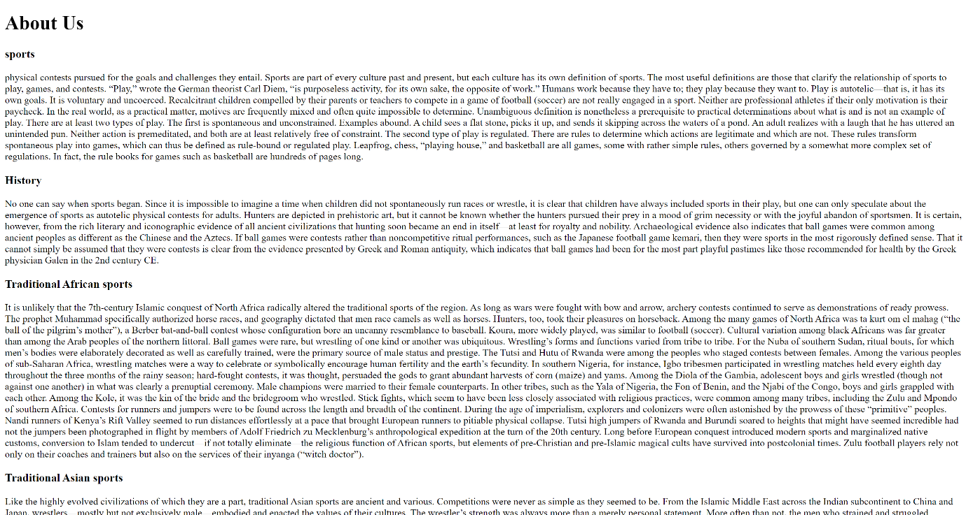

Sports Manual



Contact Us

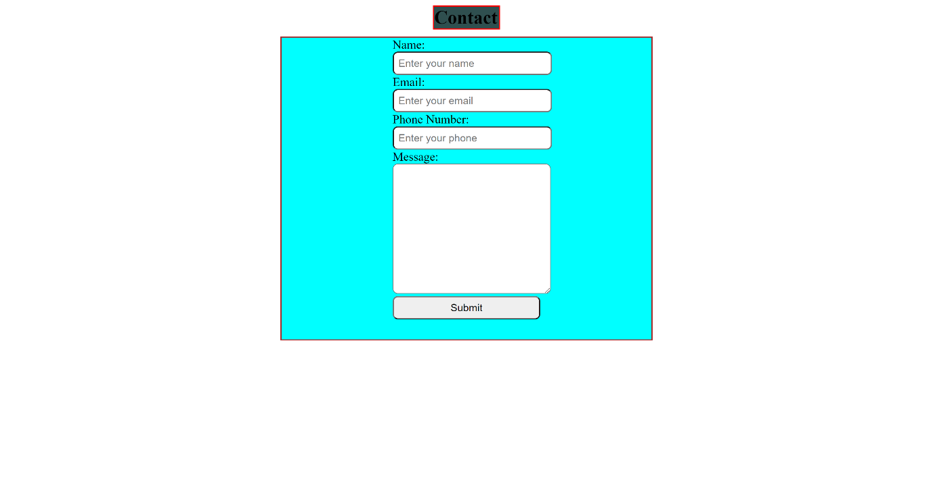

Thanku;