**EXERCISE 1: CONTROL STRUCTURES**

-- STEP 1: Create required tables

BEGIN

EXECUTE IMMEDIATE 'DROP TABLE loans CASCADE CONSTRAINTS';

EXECUTE IMMEDIATE 'DROP TABLE customers CASCADE CONSTRAINTS';

EXCEPTION

WHEN OTHERS THEN NULL;

END;

/

CREATE TABLE customers (

customer_id NUMBER PRIMARY KEY,

name VARCHAR2(100),

age NUMBER,

interest_rate NUMBER,

balance NUMBER,

isvip VARCHAR2(5)

);

CREATE TABLE loans (

loan_id NUMBER PRIMARY KEY,

customer_id NUMBER REFERENCES customers(customer_id),

due_date DATE

);

-- STEP 2: Insert sample data

INSERT INTO customers VALUES (1, 'Alice', 65, 5.5, 12000, 'FALSE');

INSERT INTO customers VALUES (2, 'Bob', 45, 6.2, 8000, 'FALSE');

INSERT INTO customers VALUES (3, 'Charlie', 70, 7.0, 15000, 'FALSE');

INSERT INTO loans VALUES (101, 1, SYSDATE + 10);

INSERT INTO loans VALUES (102, 2, SYSDATE + 40);

INSERT INTO loans VALUES (103, 3, SYSDATE + 5);

COMMIT;

-- SCENARIO 1: Apply 1% discount to interest rate if age > 60

BEGIN

FOR rec IN (SELECT * FROM customers WHERE age > 60) LOOP

UPDATE customers

SET interest_rate = interest_rate - 1

WHERE customer_id = rec.customer_id;

END LOOP;

COMMIT;

END;

/

-- SCENARIO 2: Set VIP flag if balance > 10000

BEGIN

FOR rec IN (SELECT * FROM customers WHERE balance > 10000) LOOP

UPDATE customers

SET isvip = 'TRUE'

WHERE customer_id = rec.customer_id;

END LOOP;

COMMIT;

END;

/

-- SCENARIO 3: Print reminders for loans due in next 30 days

SET SERVEROUTPUT ON;

BEGIN

FOR rec IN (

SELECT c.name, l.due_date

FROM customers c

JOIN loans l ON c.customer_id = l.customer_id

WHERE l.due_date <= SYSDATE + 30

) LOOP

DBMS_OUTPUT.PUT_LINE('Reminder: ' || rec.name || ', your loan is due on ' || TO_CHAR(rec.due_date, 'DD-Mon-YYYY'));

END LOOP;

END;

/

OUTPUT

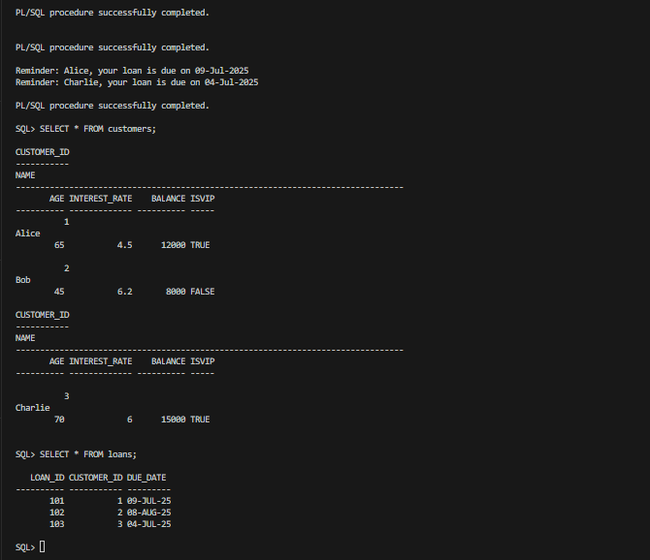

**EXERCISE 2:STORED PROCEDURES**

-- STEP 1: Drop if exists

BEGIN

EXECUTE IMMEDIATE 'DROP TABLE accounts CASCADE CONSTRAINTS';

EXECUTE IMMEDIATE 'DROP TABLE employees CASCADE CONSTRAINTS';

EXCEPTION

WHEN OTHERS THEN NULL;

END;

/

-- STEP 2: Create tables

CREATE TABLE accounts (

account_id NUMBER PRIMARY KEY,

customer_name VARCHAR2(100),

balance NUMBER,

account_type VARCHAR2(20)

);

CREATE TABLE employees (

emp_id NUMBER PRIMARY KEY,

name VARCHAR2(100),

department VARCHAR2(50),

salary NUMBER

);

-- STEP 3: Insert data

INSERT INTO accounts VALUES (1, 'Alice', 10000, 'savings');

INSERT INTO accounts VALUES (2, 'Bob', 5000, 'savings');

INSERT INTO accounts VALUES (3, 'Charlie', 7000, 'checking');

INSERT INTO employees VALUES (101, 'John', 'HR', 40000);

INSERT INTO employees VALUES (102, 'Jane', 'IT', 45000);

INSERT INTO employees VALUES (103, 'Doe', 'IT', 42000);

COMMIT;

-- SCENARIO 1: ProcessMonthlyInterest

CREATE OR REPLACE PROCEDURE ProcessMonthlyInterest IS

BEGIN

FOR rec IN (SELECT account_id, customer_name, balance FROM accounts WHERE account_type = 'savings') LOOP

DBMS_OUTPUT.PUT_LINE('Before Interest - Account ' || rec.account_id || ' (' || rec.customer_name || '): ' || rec.balance);

END LOOP;

UPDATE accounts

SET balance = balance + (balance * 0.01)

WHERE account_type = 'savings';

DBMS_OUTPUT.PUT_LINE('Monthly interest of 1% applied to all savings accounts.');

FOR rec IN (SELECT account_id, customer_name, balance FROM accounts WHERE account_type = 'savings') LOOP

DBMS_OUTPUT.PUT_LINE('After Interest - Account ' || rec.account_id || ' (' || rec.customer_name || '): ' || rec.balance);

END LOOP;

COMMIT;

END;

/

-- SCENARIO 2: UpdateEmployeeBonus

CREATE OR REPLACE PROCEDURE UpdateEmployeeBonus(

dept IN VARCHAR2,

bonus_percent IN NUMBER

) IS

BEGIN

FOR rec IN (SELECT emp_id, name, salary FROM employees WHERE department = dept) LOOP

DBMS_OUTPUT.PUT_LINE('Before Bonus - ' || rec.name || ': ' || rec.salary);

END LOOP;

UPDATE employees

SET salary = salary + (salary * bonus_percent / 100)

WHERE department = dept;

DBMS_OUTPUT.PUT_LINE('Bonus of ' || bonus_percent || '% applied to ' || dept || ' department.');

FOR rec IN (SELECT emp_id, name, salary FROM employees WHERE department = dept) LOOP

DBMS_OUTPUT.PUT_LINE('After Bonus - ' || rec.name || ': ' || rec.salary);

END LOOP;

COMMIT;

END;

/

-- SCENARIO 3: TransferFunds

CREATE OR REPLACE PROCEDURE TransferFunds(

from_account_id IN NUMBER,

to_account_id IN NUMBER,

amount IN NUMBER

) IS

from_balance NUMBER;

to_balance NUMBER;

BEGIN

SELECT balance INTO from_balance FROM accounts WHERE account_id = from_account_id;

SELECT balance INTO to_balance FROM accounts WHERE account_id = to_account_id;

DBMS_OUTPUT.PUT_LINE('Before Transfer - From Account ' || from_account_id || ': ' || from_balance);

DBMS_OUTPUT.PUT_LINE('Before Transfer - To Account ' || to_account_id || ': ' || to_balance);

IF from_balance < amount THEN

RAISE_APPLICATION_ERROR(-20001, 'Insufficient funds.');

END IF;

UPDATE accounts SET balance = balance - amount WHERE account_id = from_account_id;

UPDATE accounts SET balance = balance + amount WHERE account_id = to_account_id;

SELECT balance INTO from_balance FROM accounts WHERE account_id = from_account_id;

SELECT balance INTO to_balance FROM accounts WHERE account_id = to_account_id;

DBMS_OUTPUT.PUT_LINE(amount || ' transferred from Account ' || from_account_id || ' to Account ' || to_account_id);

DBMS_OUTPUT.PUT_LINE('After Transfer - From Account ' || from_account_id || ': ' || from_balance);

DBMS_OUTPUT.PUT_LINE('After Transfer - To Account ' || to_account_id || ': ' || to_balance);

COMMIT;

END;

/

-- ENABLE OUTPUT

SET SERVEROUTPUT ON;

-- SCENARIO 1 EXECUTION

BEGIN

ProcessMonthlyInterest;

END;

/

-- SCENARIO 2 EXECUTION

BEGIN

UpdateEmployeeBonus('IT', 10);

END;

/

-- SCENARIO 3 EXECUTION

BEGIN

TransferFunds(1, 3, 2000);

END;

/

**OUTPUT:**

