**Exercise 1: E-commerce Platform Search Function**

import java.util.Arrays;

import java.util.Comparator;

public class SearchDemo {

public static void main(String[] args) {

Product[] products = {

new Product(1, "Laptop", "Electronics"),

new Product(2, "Shirt", "Clothing"),

new Product(3, "Shoes", "Footwear"),

new Product(4, "Phone", "Electronics"),

new Product(5, "Watch", "Accessories")

};

// Linear Search

Product result1 = linearSearch(products, "Phone");

System.out.println("Linear Search Result: " + result1);

// Sorting for Binary Search

Arrays.sort(products, Comparator.comparing(p -> p.productName));

// Binary Search

Product result2 = binarySearch(products, "Phone");

System.out.println("Binary Search Result: " + result2);

}

public static Product linearSearch(Product[] products, String name) {

for (Product p : products) {

if (p.productName.equalsIgnoreCase(name)) {

return p;

}

}

return null;

}

public static Product binarySearch(Product[] products, String name) {

int low = 0, high = products.length - 1;

while (low <= high) {

int mid = (low + high) / 2;

int cmp = products[mid].productName.compareToIgnoreCase(name);

if (cmp == 0) return products[mid];

else if (cmp < 0) low = mid + 1;

else high = mid - 1;

}

return null;

}

static class Product {

int productId;

String productName;

String category;

public Product(int productId, String productName, String category) {

this.productId = productId;

this.productName = productName;

this.category = category;

}

@Override

public String toString() {

return "Product ID: " + productId + ", Name: " + productName + ", Category: " + category;

}

}

}

**Output**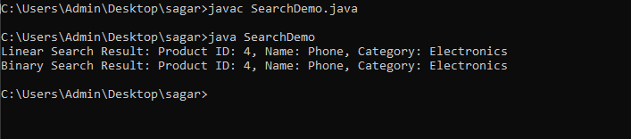

**Exercise 2: Financial Forecasting**public class Forecast {

public static double futureValueRecursive(double presentValue, double rate, int years) {

if (years == 0) {

return presentValue;

}

return (1 + rate) * futureValueRecursive(presentValue, rate, years - 1);

}

public static double futureValueIterative(double presentValue, double rate, int years) {

double result = presentValue;

for (int i = 0; i < years; i++) {

result *= (1 + rate);

}

return result;

}

public static void main(String[] args) {

double presentValue = 10000.0;

double annualGrowthRate = 0.03;

int years = 3;

double futureValueRec = futureValueRecursive(presentValue, annualGrowthRate, years);

System.out.printf("Future Value (Recursive) after %d years: %.2f\n", years, futureValueRec);

double futureValueItr = futureValueIterative(presentValue, annualGrowthRate, years);

System.out.printf("Future Value (Iterative) after %d years: %.2f\n", years, futureValueItr);

}

}**Output**

