################################ Q1 Start ########################################

Q1_1:

import pandas as pd

import numpy as np

import matplotlib.pyplot as plt

from sklearn.impute import SimpleImputer

from category_encoders import BinaryEncoder

df_titanic=pd.read_csv(r"C:\Users\Administrator.DAI-PC2\Desktop\jupiter_demo\MACHINE LEARNING\06 Machine Learning_Sanjay Sane\Repository\Titanic-Dataset.csv")

# eligible columns for Binary Encoding

eligible_cols = ['Sex', 'Survived']

# Create a Binary Encoder

encoder = BinaryEncoder(cols=eligible_cols)

# Fit and transform the eligible columns

titanic_encoded = encoder.fit_transform(df_titanic)

# Print rows of the encoded dataset

titanic_encoded.head()

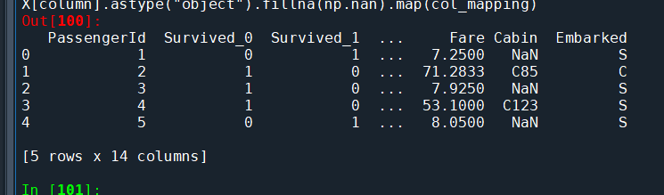

Q1_2:

import pandas as pd

import numpy as np

import matplotlib.pyplot as plt

from sklearn.impute import SimpleImputer

# titanic_data

df_titanic=pd.read_csv(r"C:\Users\Administrator.DAI-PC2\Desktop\jupiter_demo\MACHINE LEARNING\06 Machine Learning_Sanjay Sane\Repository\Titanic-Dataset.csv")

df_titanic['Sex_Encoded'] = df_titanic['Sex'].map({'male': 0, 'female': 1})

print(df_titanic.isna().sum())

# calculate Median

print("after remove all null values ")

median_age = df_titanic['Age'].median()

df_titanic['Age'] = df_titanic['Age'].fillna(median_age)

print(df_titanic.isna().sum())

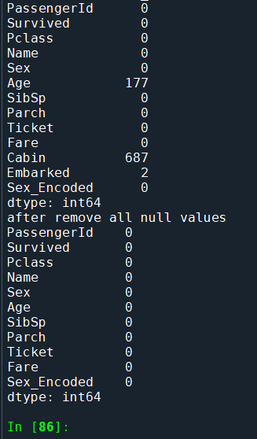

########################## Q1 end here ###############################

############################## Q2 Start ###########################################

Q2.

import pandas as pd

from sklearn.model_selection import train_test_split, GridSearchCV

from sklearn.ensemble import RandomForestClassifier

from sklearn.metrics import accuracy_score, classification_report, confusion_matrix

from sklearn.impute import SimpleImputer

from sklearn.pipeline import Pipeline

# Load the Titanic dataset

df_titanic = pd.read_csv(r"C:\Users\Administrator.DAI-PC2\Desktop\jupiter_demo\MACHINE LEARNING\06 Machine Learning_Sanjay Sane\Repository\Titanic-Dataset.csv")

df_titanic.head()

# Data Preparation

selected_features = ['Pclass', 'Age', 'SibSp', 'Parch', 'Fare', 'Sex', 'Embarked', 'Survived']

df_titanic = df_titanic[selected_features]

df_titanic = pd.get_dummies(df_titanic, columns=['Sex', 'Embarked'], drop_first=True)

imputer = SimpleImputer(strategy='median')

df_titanic['Age'] = imputer.fit_transform(df_titanic[['Age']])

# Split data into features and target variable

X = df_titanic.drop('Survived', axis=1)

y = df_titanic['Survived']

# Split data into training and testing sets

X_train, X_test, y_train, y_test = train_test_split(X, y, test_size=0.2, random_state=42)

# Train Random Forest Classifier with default parameters

rf_model_default = RandomForestClassifier(random_state=42)

rf_model_default.fit(X_train, y_train)

y_pred_default = rf_model_default.predict(X_test)

accuracy_default = accuracy_score(y_test, y_pred_default)

print("Accuracy (Default Parameters):", accuracy_default)

# Confusion Matrix

conf_matrix_default = confusion_matrix(y_test, y_pred_default)

print("\nConfusion Matrix (Default Parameters):")

print(conf_matrix_default)

# Tune Parameters using GridSearchCV

param_grid = {

'n_estimators': [100, 200, 300],

'max_depth': [None, 10, 20],

'min_samples_split': [2, 5, 10],

'min_samples_leaf': [1, 2, 4]

}

rf_model_tuned = RandomForestClassifier(random_state=42)

grid_search = GridSearchCV(estimator=rf_model_tuned, param_grid=param_grid, cv=5, scoring='accuracy')

grid_search.fit(X_train, y_train)

best_params = grid_search.best_params_

# predictions with the tuned model

rf_model_tuned = RandomForestClassifier(random_state=42, **best_params)

rf_model_tuned.fit(X_train, y_train)

y_pred_tuned = rf_model_tuned.predict(X_test)

# Model - Tuned Parameters

accuracy_tuned = accuracy_score(y_test, y_pred_tuned)

print("\nAccuracy (Tuned Parameters):", accuracy_tuned)

# Confusion Matrix

conf_matrix_tuned = confusion_matrix(y_test, y_pred_tuned)

print("\nConfusion Matrix (Tuned Parameters):")

print(conf_matrix_tuned)

# Save results to a single file

results_df = pd.DataFrame({

'Metric': ['Accuracy (Default)', 'Accuracy (Tuned)'],

'Value': [accuracy_default, accuracy_tuned]

})

results_df.to_csv('titanic_results.csv', index=False)

print("\nResults saved to titanic_results.csv")

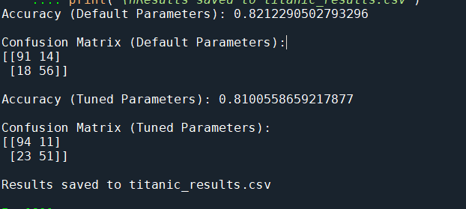

############################ Q2 end here #######################################

################################ Q3 Start ########################################

Q3.

import seaborn as sns

from sklearn.preprocessing import StandardScaler

from sklearn.cluster import KMeans

from sklearn.metrics import silhouette_score

from sklearn.datasets import load_iris

import numpy as np

import pandas as pd

# Load the Iris dataset

df = load_iris()

iris = df.data

# Scale the features

scaler = StandardScaler()

df_scaled = scaler.fit_transform(iris)

# Define the range of clusters to evaluate

Ks = [2, 3, 4, 5]

scores = []

# Iterate over different numbers of clusters

for k in Ks:

# Fit KMeans clustering model

clust = KMeans(n_clusters=k, random_state=24, init='random')

clust.fit(df_scaled)

# Compute silhouette score

score = silhouette_score(df_scaled, clust.labels_)

scores.append(score)

# Find the index of the maximum silhouette score

i_max = np.argmax(scores)

# Print the best number of clusters and its corresponding silhouette score

print("Best number of clusters:", Ks[i_max])

print("Best silhouette score:", scores[i_max])

# Fit KMeans clustering model with the best number of clusters

clust = KMeans(n_clusters=Ks[i_max], random_state=24)

clust.fit(df_scaled)

# Create a DataFrame with cluster labels

clust_data = pd.DataFrame(iris, columns=df.feature_names)

clust_data['Cluster'] = clust.labels_

# Print the mean values of features for each cluster

print(clust_data.groupby('Cluster').mean())

# Access centroids

centroids = clust.cluster_centers_

# Create a DataFrame with cluster labels and centroids

centroids_df = pd.DataFrame(centroids, columns=df.feature_names)

centroids_df['Cluster'] = range(1, Ks[i_max]+1)

# Print centroids

print("Centroids:")

print(centroids_df)

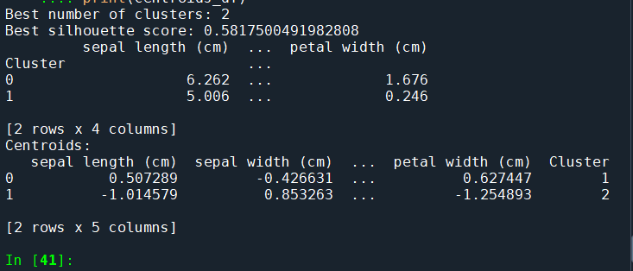

################################ Q3 End ########################################