Amazon EKS Notes (DevOps - 2 Years Experience)
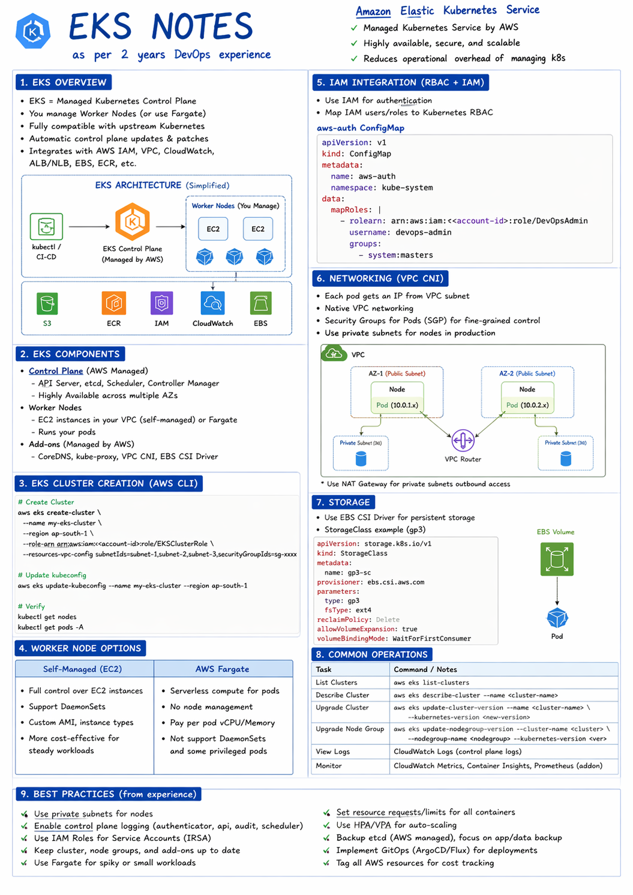

1. What is EKS?
Amazon EKS is a managed Kubernetes service where AWS manages the control plane and users manage worker nodes.

2. Architecture
Control Plane (AWS managed): API Server, etcd, Scheduler.
Worker Nodes: EC2 or Fargate running pods.
Add-ons: CoreDNS, kube-proxy, VPC CNI.

3. Worker Node Types
EC2: Full control, supports DaemonSets.
Fargate: Serverless, no node management.

4. Cluster Creation
aws eks update-kubeconfig --name demo-cluster

5. IAM + RBAC
IAM handles authentication, RBAC handles authorization using aws-auth ConfigMap.

6. Networking
Uses VPC CNI. Pods get IP from VPC subnet. Private subnets recommended.

7. Storage
EBS (gp3), EFS, FSx supported via CSI drivers.

8. Load Balancing
ALB for HTTP/HTTPS, NLB for TCP/UDP using AWS Load Balancer Controller.

9. Scaling
HPA for pods, Cluster Autoscaler for nodes.

10. Monitoring
CloudWatch, Prometheus, Grafana.

11. CI/CD
Code → Docker → ECR → Deploy to EKS.

12. Security
Use IRSA, private subnets, enable logs.

13. Common Issues
Pod failures, 502 errors, node join issues.

14. Best Practices
Use managed node groups, autoscaling, tagging, updates.

