The experiment is designed to capture if there is any significant variation of body weight of an individual due to diabetes. Three treatments are determined depending on the diabetic history of the individual. The individuals are again grouped into four different blocks depending on their ethnicities. Hence this experiment becomes a randomized block design.

The below data is obtained from United Network for Organ Sharing (UNOS)

**DATA**

|  |  |  |  |
| --- | --- | --- | --- |
|  | No diabetes | Diabetes from  0-10 Years | Diabetes from  >10 Years |
| White | 80.25 | 94.57 | 88.21 |
| Black | 82.25 | 92.41 | 88.46 |
| Asian | 67.16 | 71.86 | 70.36 |
| Hispanic | 77.66 | 84.23 | 80.18 |

All weights are in kilograms.

The data is then checked if it satisfies all the assumptions of ANOVA

**Assumptions of ANOVA**

1. Independence of cases
2. Normality
3. Homogeneity of variances

**Independence of Cases**

To make sure that all the cases considered are independent of each other, independence test is carried out

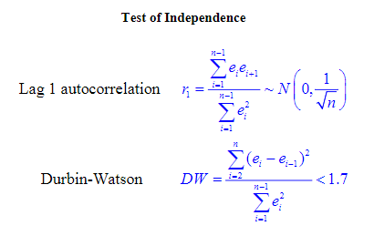

**Normality**

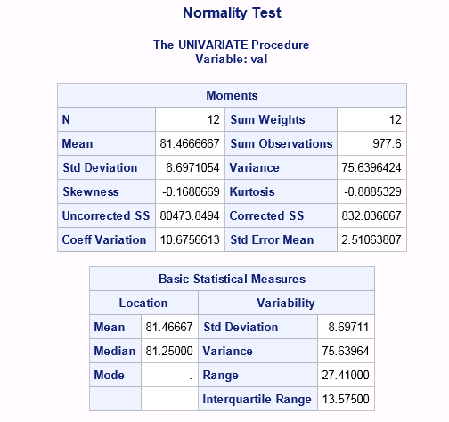

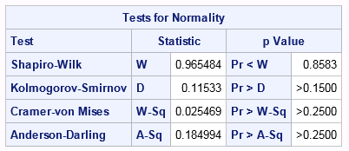

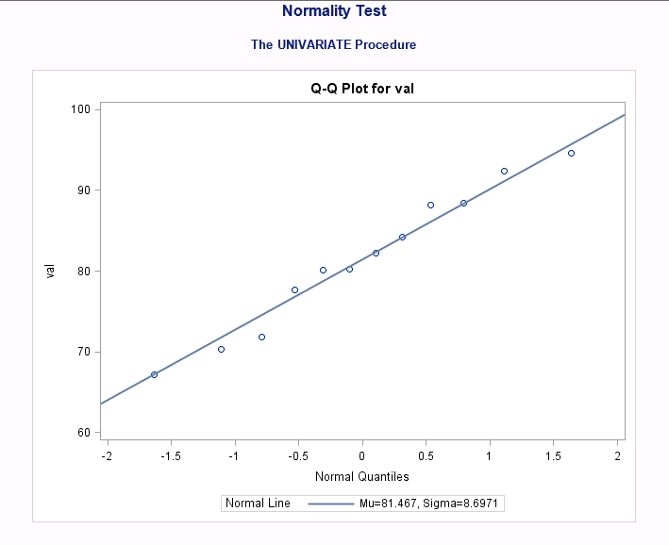

**Homogeneity of variance**

Bartlett test is used to determine if the cases have equal variances. Since the ranges are all below D4Rbar values. We can assume that the data satisfies homogeneity of variance.

**ANOVA**

Analysis of variance is carried out using the block design mentioned above.

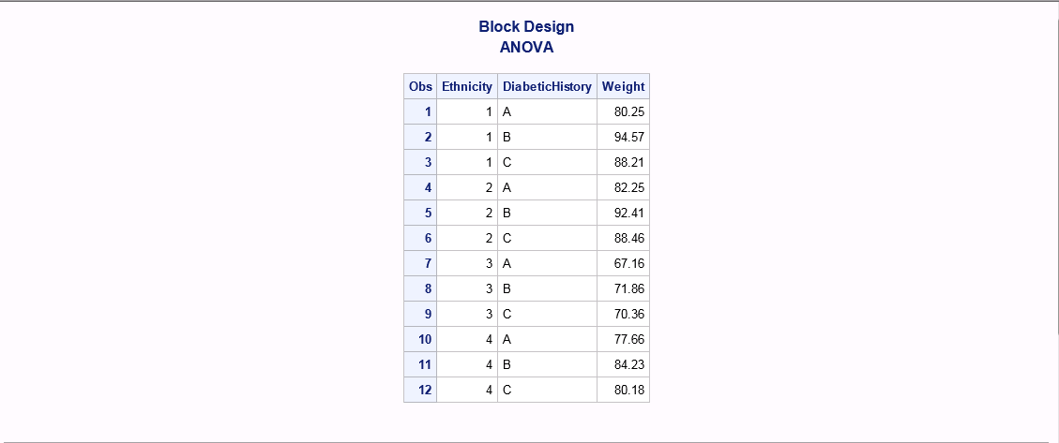

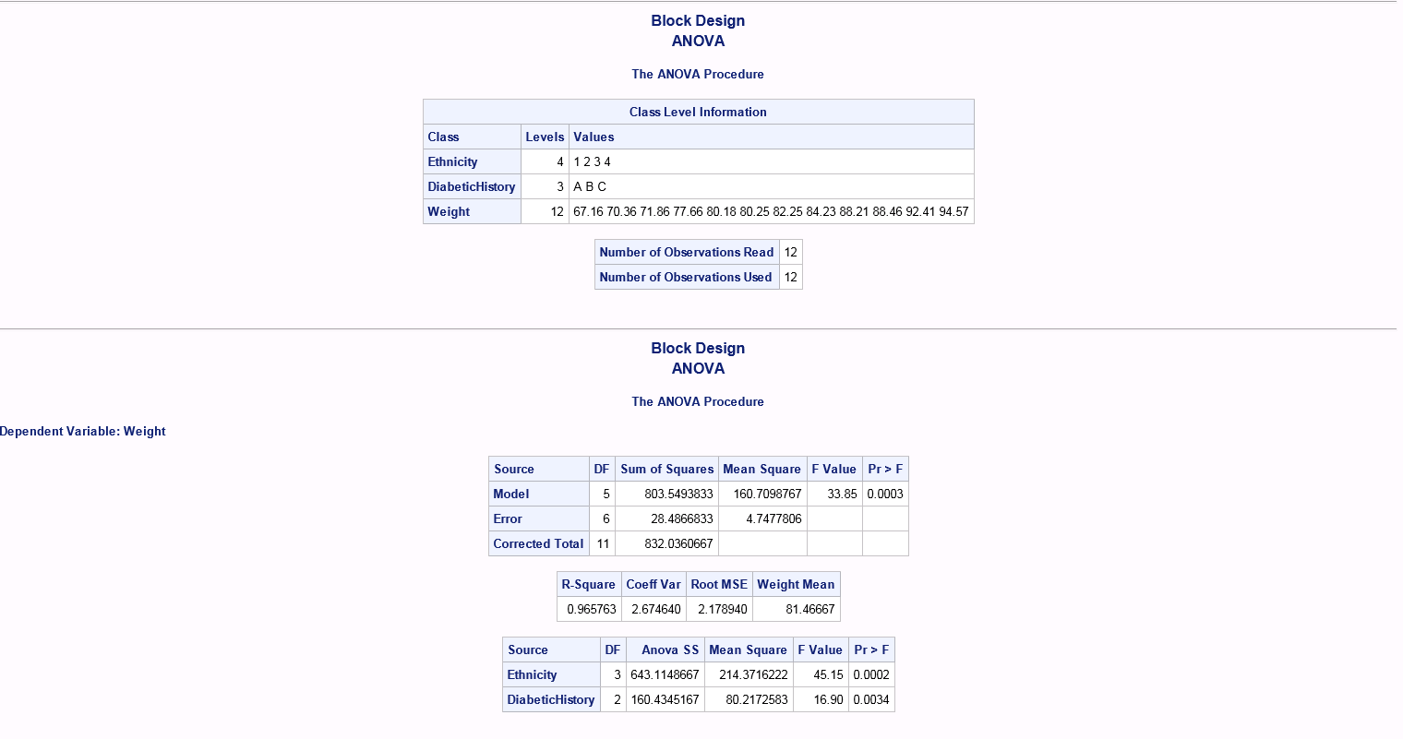

From the p (0.000164) value above. It is clear that there is significant evidence against the null hypothesis (at 95% confidence interval) and hence reject it. In other words the means of the above columns are not similar or they do not come from the same population.

**SNK Test**

From ANOVA we know that there is significant variations in the means of the three groups with different diabetic history. But ANOVA doesn’t really specify as to which means are significant. Hence SNK test is used to determine the significance between combinations of two means. This is done by comparing difference in mean to a yardstick.

|  |  |  |
| --- | --- | --- |
| Difference | A 76.83 | C 81.8 |
| B 85.77 | 8.94 | 3.97 |
| C 81.8 | -7601.2 |  |

|  |  |  |
| --- | --- | --- |
| Yardstick | A 76.83 | C 81.8 |
| B 85.77 | 10.06079 | 8.219429 |
| C 81.8 | 8.219429 |  |

Since the difference is less than the yardstick, there is no significance differences between any two means.