.
Regional Transport Office
(RTO)

Start Date: 20/02/2025.

End Date :

Design Documentation

Department: BASE 24
Concerto Software & Systems

DOCUMENT PREFACE: -

This document is a detailed BASE24 Technical Design Specification of RTO Management System. It will cover the design of various Modules to be developed to achieve the objectives.

DOCUMENT CONTROL: -

Version | Author | Date | Remarks
1.0 | Bhagwat Nirmal  Anjali Bade | 20/02/2025 | Initial Version

Project Description: -
The RTO management system project is prepared for RTO office to issue license like 2 Wheeler , 4 wheeler , LMV Learning license and permanent license, renewal form, etc.
These are the main activities of RTO office. Following are the considerations
- If user does not have permanent license for a specific type then user must apply for learner license first.
- User should have to issue a permanent license before learning license gets expired.
- User can renew License if it is getting expired within specified period.
- User can make payment for specific license applied.
- User can view the status of license applied and the detail of license issued.
- Employee can view the users who has applied for license and can update the status.

Entities: -

User: User who apply or renew for the driving license.

Employee: Employee who works in Regional Transport Office.

User Roles :-

- USER: -
Existing user must able to get login to the system otherwise generate login detail for new user by registering to the system.
After successful login user must able to perform following operation:
- Apply for learner license.
- Apply for permanent license.
- Apply for renew license.
- Make payment.
- View status of applied license.
- View license detail

- EMPLOYEE (RTO): -
Employee must able to get login to the system using login details provided by the RTO.
After successful login employee must able to perform following operation:
- View the users applied for learner license.
- View the users applied for permanent license.
- View the users applied for renew license.
- Update the status of users over their performance.

Flowchart Diagram: -

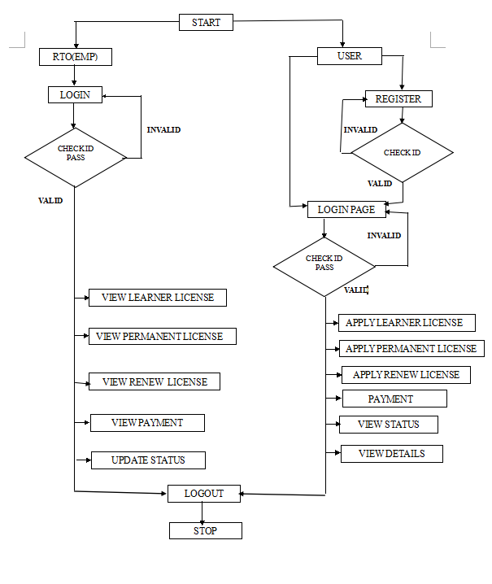

- Employee must able to get login to the system using login details provided by the RTO.

- After successful login employee must able to View the status of users applied for license.

- And also, Update the status of users over their performance.

- After Completing all process employee can logout the system.

- Existing user must able to get login to the system otherwise generate login detail for new user by registering to the system.

- After successful login user must able to apply for the learning license, permanent license, renew license.

- If User already have permanent license and it goes expired then user can apply for renew the license.

- User can able to view the status of applied license.

- After Completing all process user can logout the system.

Database: -

Field name | Length |  | Datatype | Example
RTO Login
User ID | 06 |  | Numeric | 123456
Password | 10 |  | Alphanumeric | Pass123
USER REGISTRAION AND LOGIN
Mobile No | 10 |  | Numeric | 1234567890
Name | 30 |  | Alphanumeric | Anjali M Bade
Password | 10 |  | Alphanumeric | Pass123
APPLIED LICENSE DETAILS
Tok No |  | 06 | Numeric | 555555
Mobile No |  | 10 | Numeric | 1234567890
Name |  | 30 | Alphanumeric | Anjali M Bade
Aadhar |  | 12 | Numeric | 112233445566
DOB |  | 10 | Alphanumeric | 10/06/2001
Gender |  | 01 | Alphanumeric | F
Address |  | 30 | Alphanumeric | XYZ
Issue Date |  | 10 | Alphanumeric | 20/02/2025
Expiry Date |  | 10 | Alphanumeric | 12/03/2030
Status |  | 02 | Alphanumeric | LP
Lic No |  | 10 | Numeric | 4567891230

Design Components: -
Display Screens
- Home Screen: -
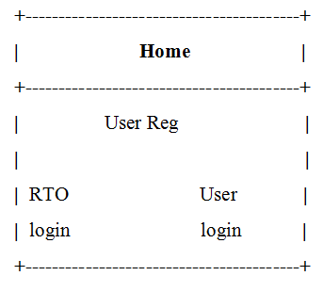
- RTO(Emp) Login: -
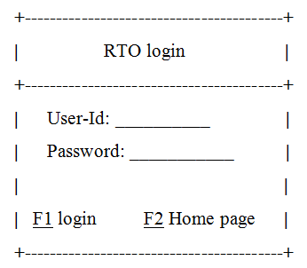

- User Register:-
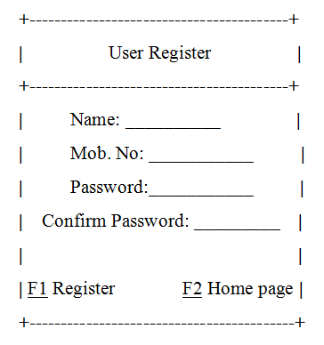
- User Login: -
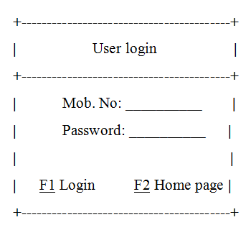

- RTO Process Window: -
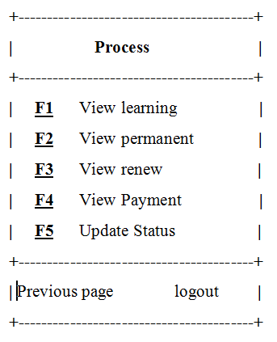
- User Process Window: -
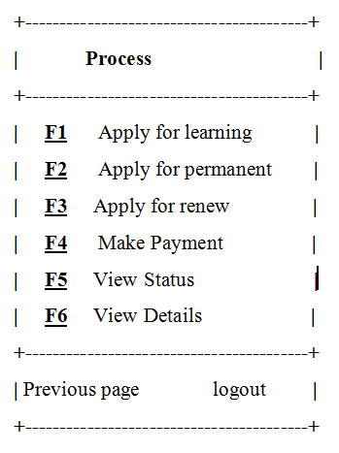

- Update Status: -
