Online Restaurant System

Start Date:

End Date :

Department: BASE 24 of Concerto Software & Systems

Software Project Documentation

Table of Contents

1DOCUMENT PREFACE

2 INTRODUCTION
2.1 Purpose
2.2 Scope of project
2.3 Project Overview

3 PROJECT ORGANIZATIONS
3.1 Flowchart Diagram
3.2 Project Deliverables
3.3 Databases

4 USER INTERFACE DESIGN
4.1 Description of the User Interface

5 PROGRAM SPECIFICATION
5.1 Server Requester flow
5.2 Screen Images

1 DOCUMENT PREFACE

This document is a detailed BASE24 Technical Design Specification of Online Restaurant System. It will cover the design of various Modules to be developed to achieve the objectives.

DOCUMENT CONTROL
Version | Author | Date | Remarks
1.0

2 INTRODUCTION

The Online Restaurant System is designed to streamline the process of food ordering, delivery, and management for both customers and the restaurant administration. The system integrates various functionalities to enhance the customer experience, optimize order management, and ensure efficient operations.The Online Restaurant System is designed to streamline the process of food ordering, delivery, and management for both customers and the restaurant administration. The system integrates various functionalities to enhance the customer experience, optimize order management, and ensure efficient operations.

2.1 Purpose

2.2 Scope of Project

The Online Restaurant System aims to create a seamless, efficient, and user-friendly platform that connects customers and restaurant admins to streamline the food ordering and management process. The system is designed to provide a simple way for customers to view the menu, place orders, and manage their order history while allowing restaurant admins to efficiently manage food items, prices, and customer orders.
• Enhance Customer Experience:
Provide a seamless experience for customers to order, cancel, and track their food orders, along with an easy-to-use interface to browse the menu.
· Increase Restaurant Efficiency:
Allow restaurant admins to easily manage the food list, prices, and customer orders in real-time, reducing manual work and ensuring the menu is up-to-date.
·

Provide Flexibility:
Enable customers to cancel orders , enhancing convenience and customer satisfaction.

2.3 Project Overview

Entities:
Admin
Customer (User)
Admin Functionalities:
Login:
Admin must authenticate and log into the system.
Food Menu Management:
Add, Update, Delete, and View Food List:
Admin can add new dishes to the menu, modify prices, remove dishes, and view all listed food items along with their prices.
Customer Functionalities:
User Registration & Login:
Registration: Customers create an account.

Login: Returning customers authenticate to view the menu and place orders.
Food Menu Browsing:

Search Food List:
Customers can search the menu list.
Order Management:
Place an Order: Customers can order food items they like.
Cancel an Order: Ability to cancel an order before it's processed or delivered.
View My Orders:
Customers can view their order history .

3 PROJECT ORGANIZATION

3.1 Flochart Diagram:

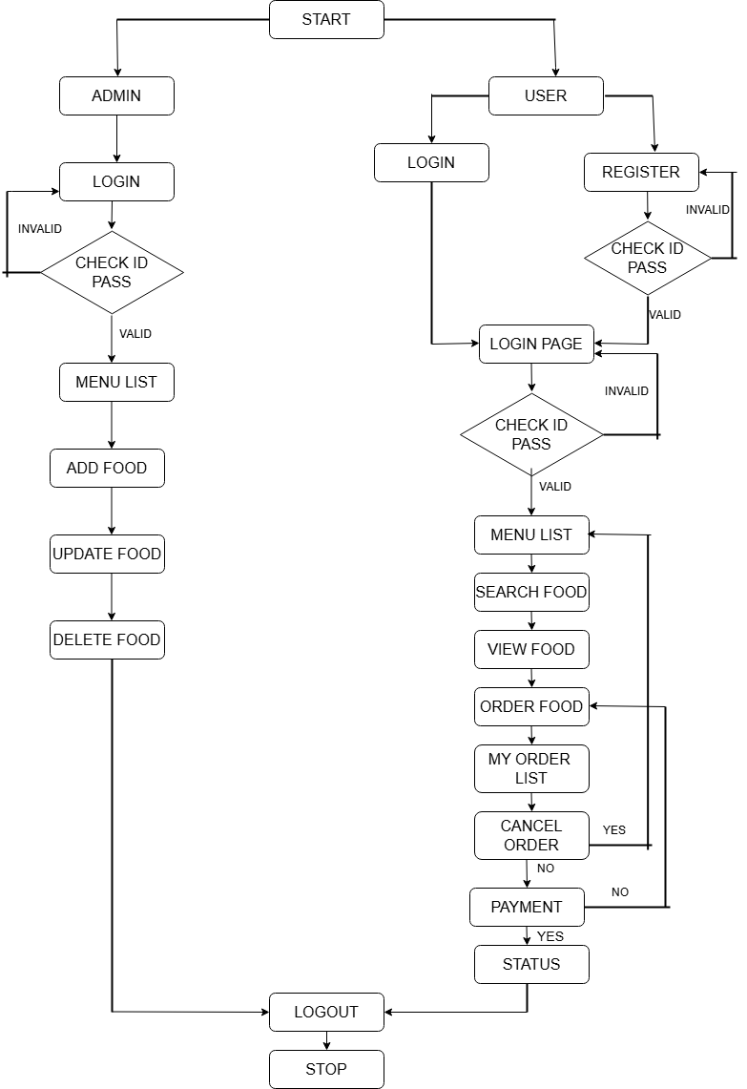

3.2 Project Deliverables

The following deliverables are planned:

- LMS Design Specification
- Source Code for Requester
- Object file for Requester
- Source Code for Server
- Object file for Server
- DDL for Admin, Customer, Food, Order .

3.3 Databases

Fieldname | Length |  | Datatype | Example
AdminDatabase
Admin_Id | 04 |  | Numeric | 1234
Admin_password | 10 |  | Alphanumeric | Ors@957
Customer Database
Customer_ Id | 04 |  | Numeric | 1544
Name | 20 |  | Alphanumeric | Raj
Mobile | 10 |  | Numeric | 7898693508
Address | 20 |  | Alphanumeric | Thane
Password | 10 |  | Alphanumeric | p@445GHH
Food Database
FoodId |  | 04 | Numeric | 4545
Foodname |  | 10 | Alphanumeric | pizza
Price |  | 06 | Numeric | 150
Category |  | 20 | Alphanumeric | Cold/starter/main course
Order Database
OrderID | 04 |  | Numeric | 1001
customer ID | 04 |  | Numeric | 4655
CustomerName | 20 |  | Alphanumeric | Mayuresh
Mobile | 10 |  | Numeric | 9865324756
Address | 20 |  | Alphanumeric | RK road vashi
TotalPrice | 06 |  | Numeric | 600

5.2 SCREEN IMAGES:
BASE SCREEN:
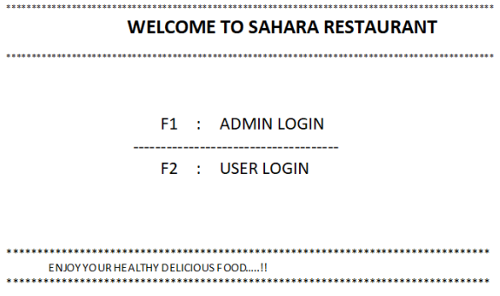
ADMIN LOGIN PAGE:
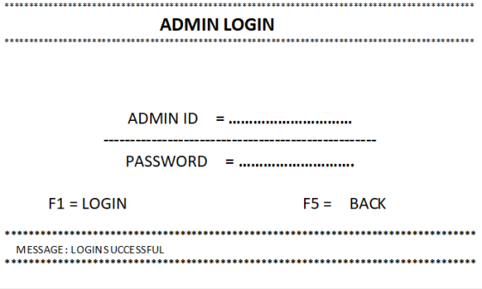

USER LOGIN PAGE:
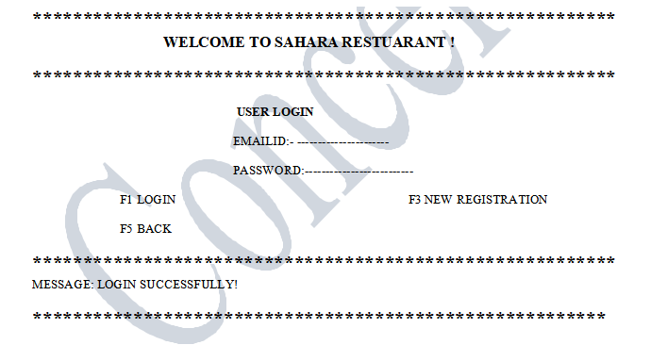
USER REGISTRATION PAGE:
**********************************************************WELCOME TO SAHARA RESTUARANT !
**********************************************************
USERREGISTRATION
NAME :- ------------------------
EMAILID:- ----------------------
PASSWORD: -------------------
MOBILE:- ------------------------
ADDRESS: -----------------------

F5 :SUBMIT F2 :LOGIN
F5:BACK
**********************************************************MESSAGE: REGISTER SUCCESSFULLY!
*********************************************************

USER HOME PAGE
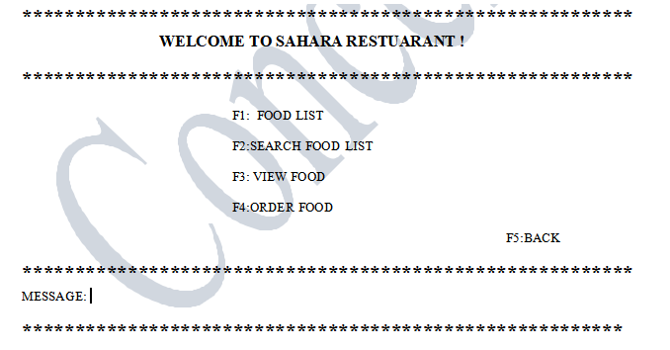

FOOD LIST PAGE
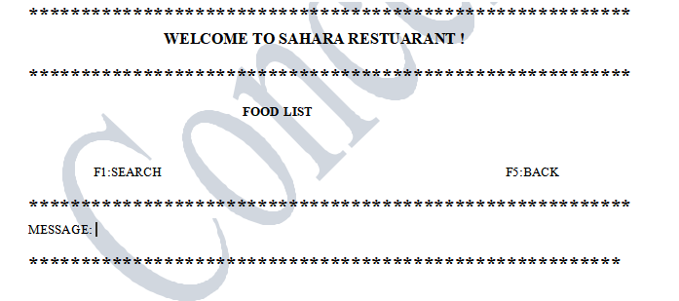

ORDER FOOD:
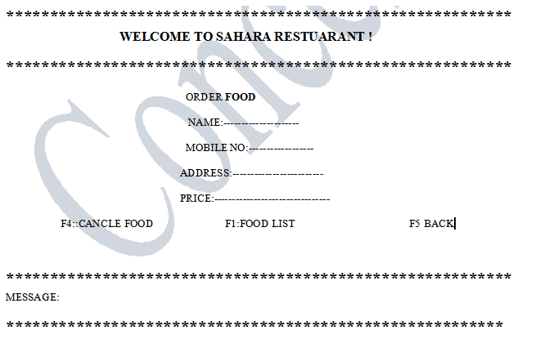

MYORDER LIST
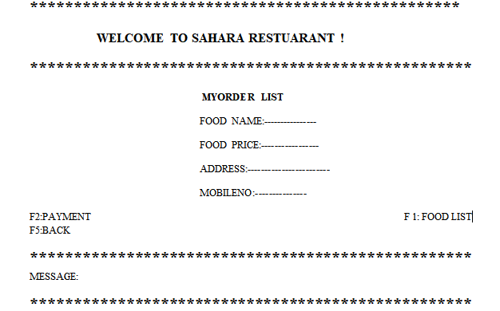

PAYMENT PAGE

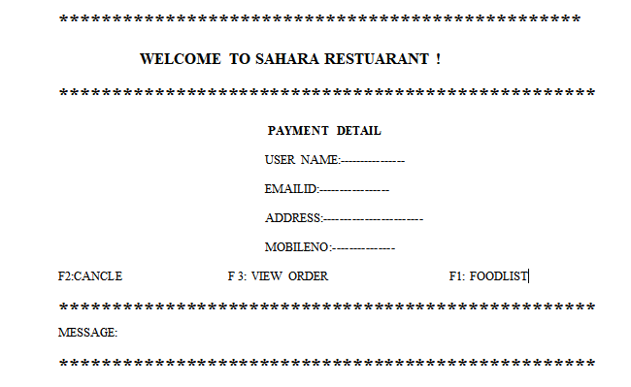

ADMIN HOME PAGE
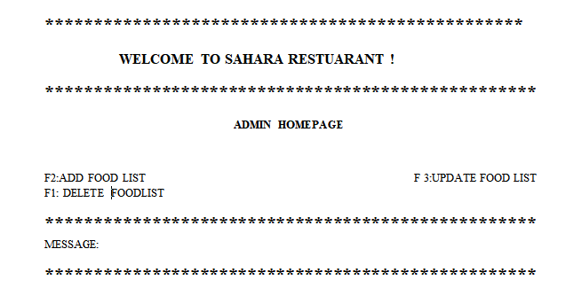

ADD FOOD LIST
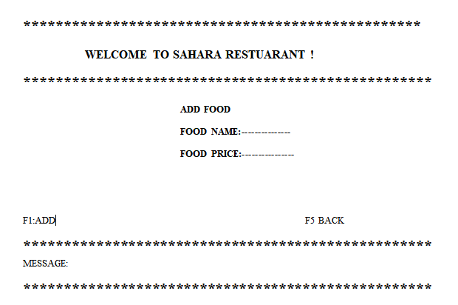

UPDATE FOODLIST:
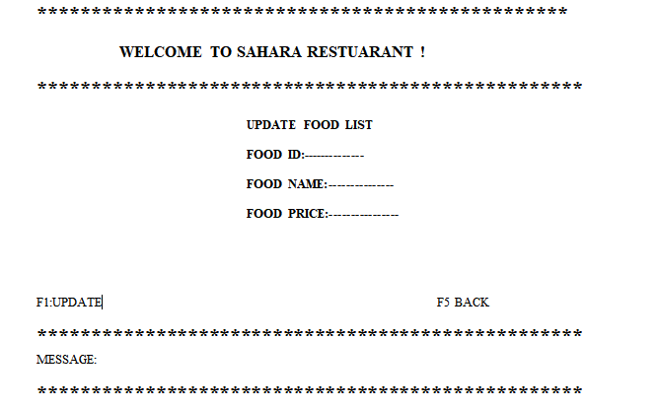

DELETE FOOD:
