**Overview :**

C-ExamPlus is web-based applications provides facility to conduct exams online. It allows numbers of user to give exam at same time and displays results immediately once the exam get over. It saves time and also no need to wait for results as it's automatically generated by server.

The Administrator will manage both teachers & students. Teachers will upload the questions, manage examination and results. Students can login and give their respective exams and view their score & analysis.

**USE CASE DIAGRAM**

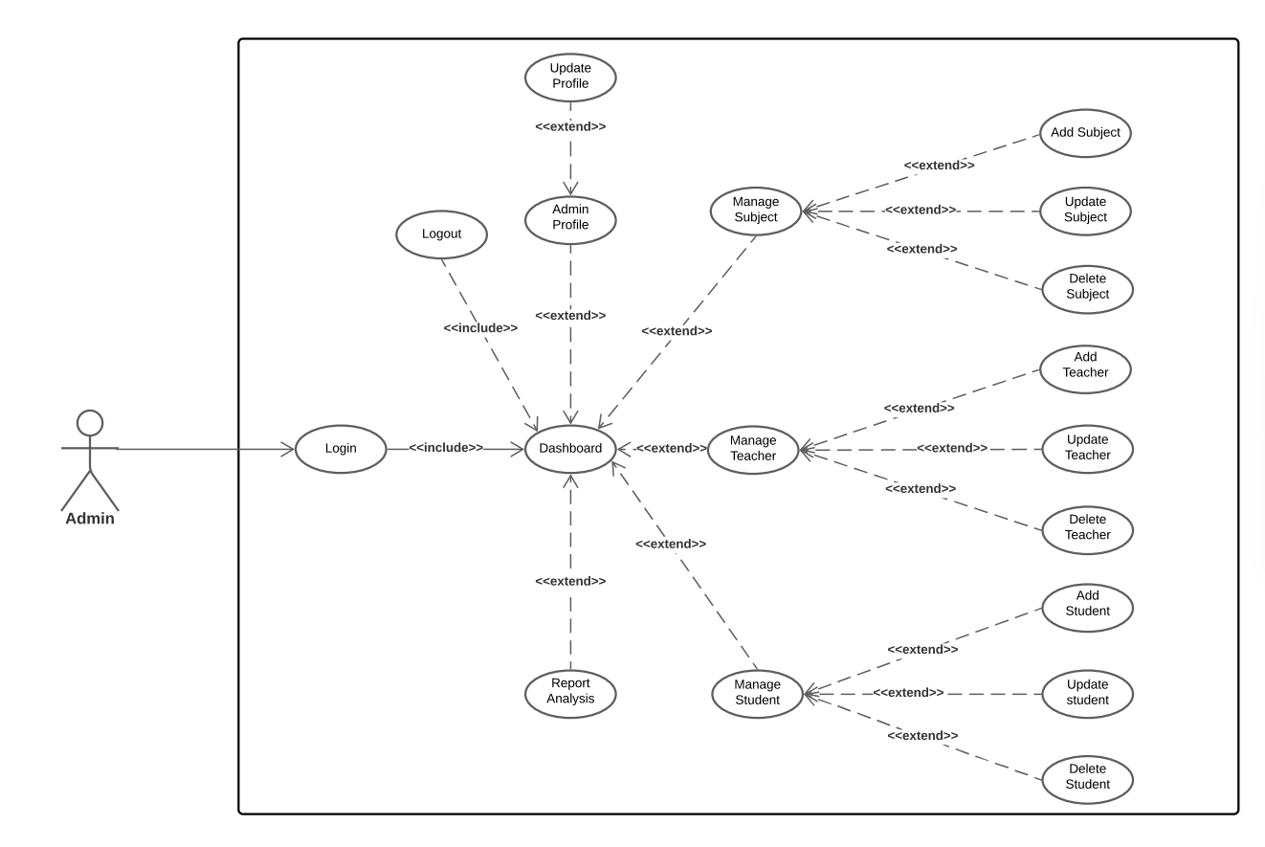

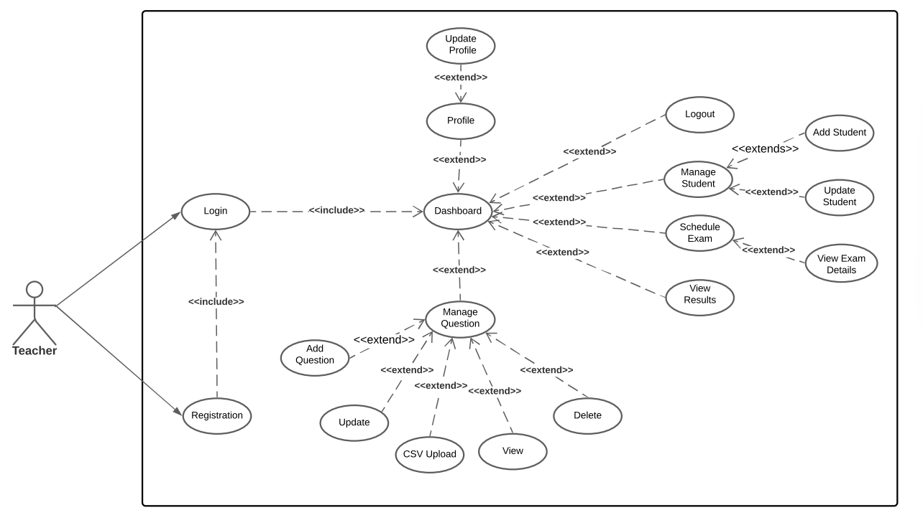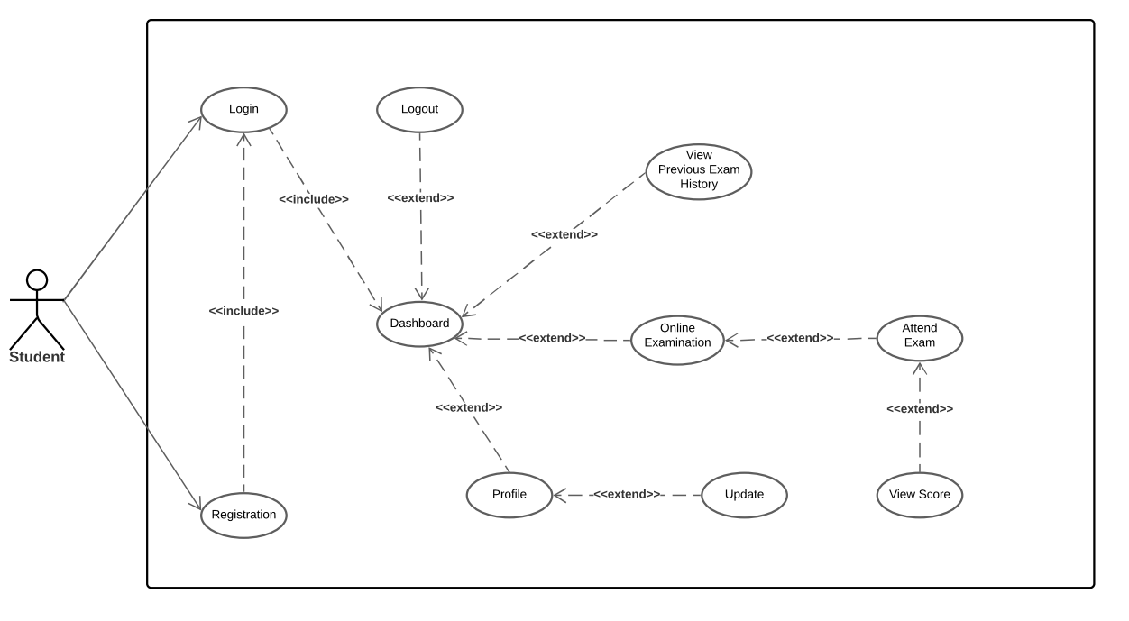

**SCOPE**

1. Login Authentication(admin/student/teacher):
2. Logout
3. Register student
4. Register teacher
5. Assign Exam
6. Auto submit exam
7. Set exam (Add questions/Add questions in batch using CSV files)
8. Student wise performance (graphs and result)
9. Result analysis (visual format)
10. previous test history

**Functionality:**

**C-ExamPlus is an online examination portal, whose main objective is to provide platform where students can register/login and can give online exam easily with instant result.**

**There are 3 main modules:**

1. **Admin Module:**

Admin module contains admin login/register page. After, login admin has dashboard containing options such like add/update Students, Teachers and Subjects. Admin Module has its own profile information with update option and logout option.

1. **Student Module:**

Student module contains student login/register page. After, login Student has dashboard containing options such like attend exam and view score, profile information with update, view previous test result history, feedback, logout.

1. **Teacher Module:**

Teacher module contains login/register page. After, login Teacher has dashboard containing options such like add/update Students, add/update questions to test, view questions, profile information of teacher with update option and logout.

**DATABASE SCHEMA**

**DB Name**: - EXAMDB

**Tables**: -

1. ADMIN (USERID, PASSWORD)
2. STUDENT (STUDENT_ID, FIRST_NAME, LAST_NAME, MOBILE, DOB, USERNAME, PASSWORD, EMAIL_ID)
3. TEACHER (TEACHER_ID, FIRST_NAME, LAST_NAME, MOBILE, DOB, USERNAME, PASSWORD, EMAIL_ID)
4. EXAM (EXAM_ID, SUBJECT ID, DATE)
5. SUBJECT (SUBJECT ID, SUBJECT NAME)
6. QUESTIONS (QUESTION ID, SUBJECT ID, QUESTION, OPTION1, OPTION2, OPTION3, OPTION4, ANSWER)
7. RESULT (RESULT_ID, STUDENT_ID, MARKS, EXAM_ID)

**Git Repository Link :** <https://github.com/kadampritam17/C-ExamPlus.git>