SQL (Structured Query Language)
- What is Data?
The standard definition of data tells us that data can be facts, statistics, audio, video, or images.
- Types of Data?
- Structured Data → Think of a well-organized library where books are sorted by categories, with each book placed in a specific section. Everything is arranged systematically, just like structured data in databases.
- Semi-Structured Data → Imagine a grocery store with labeled sections but with some random products placed in incorrect aisles. The structure exists, but it's not perfectly followed just like semi-structured data, which has some organization but lacks strict formatting.
- Unstructured Data → Picture a messy drawer full of random things-pens, receipts, keys, a charger, and some old notes. There's no order, just like unstructured data, where files and information are scattered without any predefined organization.
- What is Database?
It’s a Collection of well-Organized data is called as the Database.
- What are the different forms of data storage in databases? Provide real-world examples. Answer: The three main types are:
- Tabular (Relational Database - RDBMS): Used in university student records.
- Document-based (NoSQL - MongoDB): Used in e-commerce product catalogs.
- Graph-based (Graph Database - Neo4j): Used in social media relationship mapping.
- Why would you choose a document-based database over a relational database?
Answer:
A document-based database like MongoDB is preferred when data is unstructured or varies significantly between records, such as e-commerce product details or user-generated content.
- What is the advantage of using a graph database?
Answer: Graph databases are excellent for analyzing relationships between data points, making them ideal for social networks, recommendation engines, and fraud detection systems.
- How does data retrieval differ in relational, document, and graph databases?
- Answer: Relational Databases: Use SQL queries to filter rows and columns.
- Document Databases: Use JSON-like queries to search within flexible document structures.
- Graph Databases: Traverse relationships between nodes using graph traversal algorithms.
- Give an example of a real-world problem that can be best solved using a graph database.
Answer: A fraud detection system in banking that identifies suspicious transactions based on relationships between users, merchants, and transaction histories.

- What is SQL, and why is it important?
Answer: SQL (Structured Query Language) is used to communicate with relational databases. It allows users to store, retrieve, update, and manipulate structured data efficiently.
- How is SQL similar to a real-life scenario?
Answer: SQL works like a restaurant order system, where queries act as orders placed to a database, and the database returns the requested information just like a kitchen prepares ares dishes based on orders.
- What are the basic operations of SQL?
Answer:
The four fundamental operations in SQL are CRUD:
- Create (INSERT): Adding new records to the database.
- Read (SELECT): Retrieving data from the database.
- Update (UPDATE): Modifying existing data.
- Delete (DELETE): Removing records from the database.
- What is the difference between SQL and NoSQL?
Answer: SQL databases use structured tables and predefined schemas, making them ideal for relational data. NoSQL databases store data in flexible formats like documents, key-value pairs, or graphs, making them suitable for unstructured or semi-structured data.
- Why do we need SQL when we can store data in spreadsheets?
Answer: Unlike spreadsheets, SQL databases can handle large amounts of data efficiently, allow multiple users to access data simultaneously, and provide powerful querying capabilities to analyze and manipulate data effectively.

- Creating the database?
Create database university;

- Create a Table using university database?
CREATE TABLE Students
(
student_id INT,
student_name VARCHAR(30),
student_DOB DATE,
student_age INT
);
- What is a database, and why is it important?
Answer: A database is an organized collection of data that allows efficient storage, retrieval, and management of information. It ensures data integrity, security, and easy access.
- How is a database structured?
Answer: A database is made up of tables, which consist of rows and columns. Tables store related data, where each column defines a data type, and each row represents an individual record.
- What is the purpose of the CREATE DATABASE command in MySQL?
Answer: The CREATE DATABASE command is used to create a new database in MySQL, allowing users to store and manage data in an organized way.
- How are tables created in a database, and why are they important?
Answer: Tables are created using the CREATE TABLE command. They organize data into structured formats, ensuring easy data retrieval and management.
- What are the key components of a table in MySQL?
Answer:
Tables consist of:
- Columns: Define the type of data (e.g., student ID, name, age).
- Rows: Represent individual records.
- Data types: Specify the kind of data stored (e.g., INT, VARCHAR, DATE).
- How does structuring a database improve efficiency?
Answer: A well-structured database prevents data redundancy, improves search efficiency, and ensures data consistency, making retrieval and management faster and more effective.
- Inserting the data into table?
INSERT INTO table_name VALUES (value1, value2, value3, ...);
INSERT INTO students VALUES (101, 'Akash', '1998-08-31', 24);
INSERT INTO students VALUES (102, 'Prabha', '1997-03-12', 25);
INSERT INTO students VALUES (103, 'Shera', '1998-12-12', 24);
- Basic SQL Data Retrieval
Select student_name form student;
Select student_id,student_name from student;
Select student_name from student where student_id = 101;
Select * from student;
Select * from student where student_name = ‘sagar’;
- What is the purpose of the SELECT statement in SQL?
Answer: The SELECT statement is used to retrieve specific data from one or more tables in a database.
- How does the WHERE clause work in SQL?
Answer: The WHERE clause filters records based on specified conditions, allowing users to fetch only relevant data.
- What is the difference between SELECT * and SELECT column name?
Answer: SELECT * retrieves all columns from a table, whereas SELECT column_name retrieves only specific columns.
- How can you retrieve records where a certain column has a specific value?
Answer: By using a WHERE clause. Example: SELECT * FROM students WHERE age = 24;
- What is the importance of filtering data in SQL?
Answer: Filtering allows users to fetch relevant data efficiently, reducing query load and improving database performance.
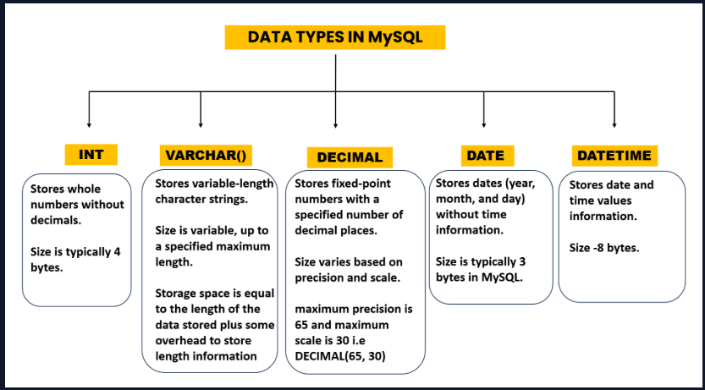
- Common Data type in SQL.
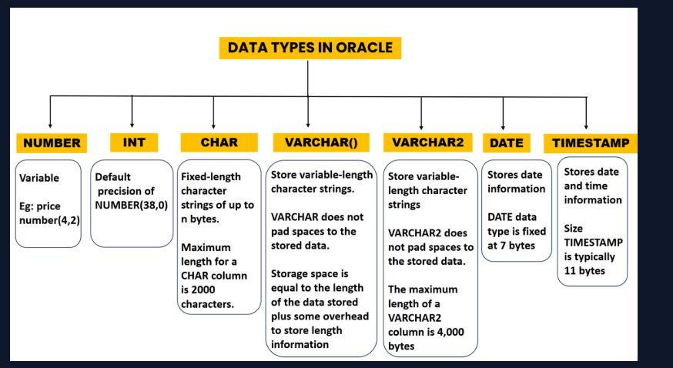
- Common Data Type in Oracle
- Difference Between varchar() and varchar2?
The primary difference between VARCHAR and VARCHAR2 in Oracle lies in how space is managed. VARCHAR2 is more space-efficient because it only uses as much storage as the string requires, without padding unused spaces, unlike VARCHAR or CHAR.
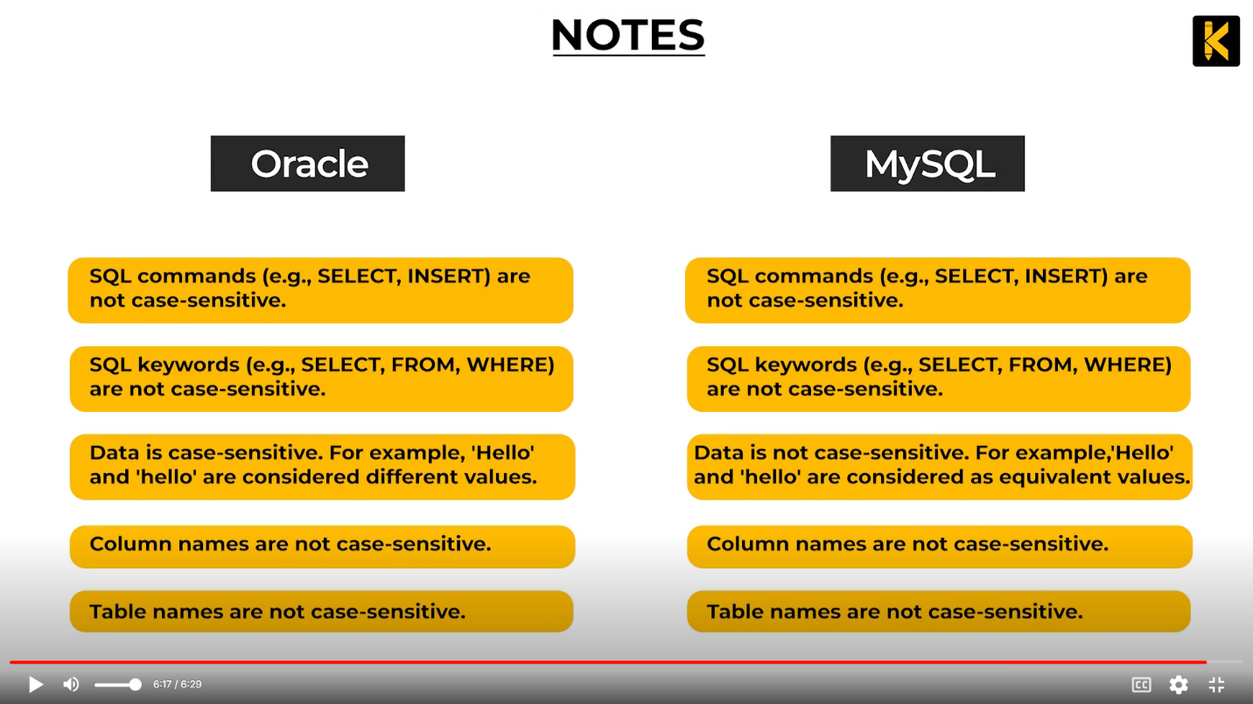
- Explore Case Sensitivity in MySQL and Oracle?

