**A Project Report**

**on**

**Match Master**

Submitted in partial fulfilment of the requirements of

Project-V(BIT306C0)

of

Bachelor of Information Technology

**Submitted To**



Purbanchal University

Biratnagar, Nepal

**Submitted By**

Dhiraj Sapkota (350611)

Sagar Upadhyaya (360287)

Subash Acharya (350629)

**KANTIPUR CITY COLLEGE**

Putalisadak, Kathmandu

17 March 2024

**A Project Report**

**on**

**Match Master**

Submitted in partial fulfilment of the requirements of

Project-V(BIT306C0)

of

Bachelor of Information Technology

**Submitted To**

Purbanchal University

Biratnagar, Nepal

**Submitted By**

Dhiraj Sapkota (350611)

Sagar Upadhyaya (360287)

Subash Acharya (350629)

**Project Supervisor**

Mr. Rubim Shrestha (Project Director)

**KANTIPUR CITY COLLEGE**

Putalisadak, Kathmandu

17 March 2024

**Table of Content**

**List of figures** i

List of tables ii

**Topic Approval Sheet** iii

**Certificate From the Supervisor** iv

**Acknowledgement** v

**Abstract** vi

**Chapter 1: Introduction** 1

1.1 Overview 1

1.2 Problem Statement 1

1.3 Objectives 2

1.4 Features 3

1.5 Significance 5

1.6 Scope and Limitation 6

1.6.1 Scope 6

1.6.2 Limitation: 6

**1.7 Organization of the Document** 6

**Chapter 2: Literature Review** 8

System 1: Book Gara 8

**Chapter 3: Methodology** 9

3.1 Software Development Life Cycle 9

3.2 Technologies and Tools 11

3.2.1 Specified Programming Language 11

3.2.2 Specified Database 11

3.2.3 Specified Software 11

3.3 Assignments of Rolls and Responsibilities 11

**Chapter 4: System Analysis** 12

4.1 Requirement Analysis 12

4.1.1 Requirement Gathering 12

4.1.2 Functional Requirement 13

4.1.3 Non-Functional Requirement 14

4.2 Feasibility study 15

4.2.1 Technical Feasibility 15

4.2.2 Economic Feasibility 15

4.2.3 Operational Feasibility 16

4.2.4 Schedule Feasibility 16

4.2.4.1 Gantt chart 17

**Chapter 5: System Design** 18

5.1 System Architecture 18

5.2 Data Flow diagram 19

5.2.1 Context Level (level 0) DFD: 19

5.2.2 Level 1 DFD: 20

5.2.3 Use Case Diagram: 20

5.3 Database Design 22

5.3.1 ER Diagram 22

5.3.2 Data Dictionary 23

**Chapter 6: System Development and Implementation** 27

6.1 Programming Platform 27

6.2 Operating Environment 27

6.3 Functional Implementation 28

**Chapter 7: Testing and Debugging** 29

7.1 Tools used in testing. 29

7.2 Test Cases 30

**Chapter 8: Conclusion** 33

**Chapter 9: Future Enhancement** 34

**REFERENCES** 35

**APPENDIX** 36

# 

# **List of figures**

|  |  |  |
| --- | --- | --- |
| **Figure No.** | **Name** | **Page No.** |
| 3.1 | Waterfall Model | 9 |
| 4.2.4.1 | Gantt Chart | 17 |
| 5.1 | System Architecture | 18 |
| 5.2.1 | Level 0 DFD | 19 |
| 5.2.2 | Level 1 DFD | 20 |
| 5.2.3 | Use Case Diagram | 21 |
| 5.3.1 | E-R Diagram | 22 |

## **List of tables**

|  |  |  |
| --- | --- | --- |
| **Table No.** | **Name** | **Page No.** |
| 3.3 | Assignment of Rolls and Responsibilities | 11 |
| 4.1.2 | Functional Requirements | 13 |
| 4.1.3 | Non-Functional Requirements | 14 |
| 5.3.2 | Data Dictionary | 23 |
| 7.1 | Tools used in Testing | 29 |
| 7.2.1 | Test Case Admin | 30 |
| 7.2.2 | Test Case Customer | 31 |
| 7.2.3 | Test Case Worker | 32 |

# **Topic Approval Sheet**

It is here by informed that the topic selected by Dhiraj Sapkota, Sagar Upadhyaya and Subash Acharya of BIT V semester project has been found suitable and as per the credit assigned by Purbanchal University (PU), Biratnagar, Nepal. The Project Committee has approved the following topic and supervisor for the mentioned students. This project has been completed for the prescribed period and the project embodied the result of their investigation conducted while they worked as full-time students of this institution.

Topic Approved: Ghar Sewa

Mr. Saroj Pandey Mr. Rubim Shrestha

HOD, Department of IT Project Supervisor

Kantipur City College

# **Certificate From the Supervisor**

This is to certify that the project entitled Ghar Sewa submitted by Dhiraj Sapkota, Sagar Upadhyaya and Subash Acharya to the Department of Information Technology, School of Science and Technology at Kantipur City College, Putalisadak, Kathmandu towards the requirement for BIT: Project-V is an original work carried out by them under my supervision and guidance.

_______________________________

Mr. Rubim Shrestha

Department of Information Technology

Kantipur City College

(Project Supervisor)

# **Acknowledgement**

We are very grateful to submit this project report. This report wouldn’t have been possible without the immense contribution of a few people. Firstly, we would like to express our deepest gratitude to Purbanchal University for providing us with this opportunity to present this project and its report.

We would like to express our gratitude and deep respect to our respected project supervisor Saroj Pandey who helped us solve any problems that arose during the preparation of this project.

Lastly, we want to thank Kantipur City College for providing us with this opportunity by approving our project. We are thankful to our dear friends for constant support and encouragement, and we would like to thank our seniors as well who helped us out while we were stuck at a problem during the development of our project. We hope that this project will fulfill the course requirement.

With regards

Dhiraj Sapkota

Sagar Upadhyaya

Subash Acharya

# **Abstract**

The Ghar Sewa platform emerges as a crucial link between job seekers and employment opportunities, addressing significant challenges in the realm of home-related services. It tackles the issues of inefficient service provider discovery, lack of transparent pricing, and quality assurance by offering a centralized and efficient platform.

The project focuses on streamlining job searches, emphasizing fair hiring practices, fostering skill development, and expanding its regional reach. With features like detailed user profiles, job listings, search filters, messaging, document upload, and application tracking, Ghar Sewa enhances the overall user experience for both job seekers and providers.

The platform's three major modules Admin, Customer, and Service Provider ensure efficient management and engagement. The inclusion of user reviews, privacy settings, and payment integration further enhances the platform's value. In conclusion, Ghar Sewa represents a comprehensive solution to the evolving challenges in the job market and home services, providing a user-friendly interface for seamless connections and empowering individuals on both ends of the employment spectrum.

# **Chapter 1: Introduction**

Ghar Sewa is a platform that serves as a bridge between job seekers and employment opportunities, facilitating seamless connections between individuals seeking meaningful work and organizations in need of skilled professionals or staffing needs. This innovative platform empowers users to effortlessly discover employment options based on their preferred skills, desired location, and specific work profiles. Ghar Sewa is dedicated to streamlining the job search process, ensuring that both job seekers and providers can efficiently meet their respective needs in the ever-evolving world of employment.

## **Overview**

Ghar Sewa is a dynamic platform revolutionizing the way job seekers and service providers connect in the home services industry. It tackles the challenges of inefficient service provider discovery, opaque pricing, and quality assurance head-on, providing a centralized solution for both job seekers and employers. Through detailed user profiles, comprehensive job listings, advanced search filters, and seamless communication tools, Ghar Sewa streamlines the job search process. With a focus on fair hiring practices, skill development, and regional expansion, Ghar Sewa aims to empower individuals on both ends of the employment spectrum. Its user-friendly interface and robust features make it a valuable resource for anyone seeking or offering home-related services.

## **1.2 Problem Statement**

1. **Inefficient Service Provider Discovery and Verification:**

Homeowners face significant challenges in discovering reliable and qualified service providers for their home-related needs. The lack of a streamlined process for verifying the credibility and qualifications of service providers leads to frustration, trust issues, and potential risks when hiring them.

1. **Lack of Transparent Pricing and Quality Assurance:**

Homeowners struggle to obtain transparent information about pricing for various home services, leading to uncertainty and potential overcharging. Additionally, the variation in service quality among providers makes it challenging for homeowners to make informed decisions, often resulting in dissatisfaction with the services they receive.

1. **Navigating Geographic Location**

Efficiently navigating geographic locations in home services ensures timely and targeted service delivery, leveraging location-based technology for optimal resource allocation and personalized user experiences. This approach enhances overall operational efficiency and responsiveness in addressing homeowners' needs.

These problem statements highlight some of the key challenges that a "Ghar Sewa" project can aim to solve by providing a centralized and efficient platform for home-related services.

## **1.3 Objectives**

1. **Matching Skills and Jobs:** To match job seekers with positions that align with their skills, qualifications, and preferences.
2. **Promoting Fair Hiring Practices:** To encourage fair and transparent hiring processes among job providers.
3. **Skill Development:** To provide resources and support for job seekers to enhance their skills and employability.
4. **Regional Expansion:** To expand the platform's reach to serve job seekers and providers in various regions.
5. **Navigating geolocation:** To provide efficient navigating geographic locations in home services ensures timely and targeted service delivery, leveraging location-based technology for optimal resource allocation and personalized user experiences.

## **1.4 Features**

1. **User Profiles:** Job seekers and providers can create detailed profiles with information about their skills, qualifications, job preferences, and hiring requirements.
2. **Job Listings:** Job providers can post job openings with detailed descriptions, requirements, and application instructions.
3. **Search and Filters:** Users can search for jobs or candidates based on criteria such as location, industry, experience level, and salary range.
4. **Messaging:** A built-in messaging system allows seamless communication between job seekers and providers to discuss job details, interview arrangements, and more.
5. **Document Upload:** Job seekers can upload their document for easy application to multiple job listings.
6. **Application Tracking:** Job seekers can track the status of their job applications, and employers can manage, and review received applications.
7. **Notification Alerts:** Users receive notifications for job matches, messages, application updates, and other relevant activities.
8. **User Reviews and Ratings:** Job providers and seekers can leave reviews and ratings for each other based on their interactions and experiences.
9. **Privacy Settings:** Users can control the visibility of their profiles and personal information, ensuring data privacy and security.
10. **Payment Integration:** If applicable, the platform can include payment processing for job postings or premium features.

These features collectively enhance the functionality and user experience of the Ghar Sewa Job Project, making it a valuable resource for both job seekers and providers in the job market.

Ghar Sewa consists of three major modules:

1. Admin
2. Customer
3. Service Provider
4. **Admin:**

* Managing employee.
* Managing customer
* Managing job profile
* Approval

1. **Customer**:

* Registration
* Managing profile
* Search service.
* Request a service.

1. **Service Provider:**

* Registration
* Manage profile.
* Post job profile.
* Manage job profile.

## **1.5 Significance**

1. Bridging the Gap: Ghar Sewa serves as a vital bridge between job seekers and employment opportunities in the home services sector, addressing the challenges of connecting individuals with meaningful work.
2. Streamlining Processes: By offering a centralized platform, Ghar Sewa streamlines the job search process, making it easier for both job seekers and employers to find suitable matches based on skills, preferences, and location.
3. Transparency and Trust: The platform promotes transparency in pricing and quality assurance, fostering trust between service providers and clients. This transparency reduces uncertainty and potential risks associated with hiring home service professionals.
4. Empowering Job Seekers: Ghar Sewa empowers job seekers by providing resources for skill development and enhancing employability. It enables individuals to take control of their career paths and find opportunities that align with their skills and aspirations.
5. Regional Expansion: Through its regional expansion efforts, Ghar Sewa extends its reach to serve job seekers and employers in various geographical areas, catering to diverse needs and enhancing access to employment opportunities.
6. Enhanced User Experience: With user-friendly features such as detailed profiles, advanced search options, messaging systems, and application tracking, Ghar Sewa offers an enhanced user experience for both job seekers and employers, improving engagement and satisfaction.
7. Economic Impact: By facilitating employment opportunities and supporting the growth of the home services industry, Ghar Sewa contributes to economic development and prosperity in communities served by the platform.

Overall, Ghar Sewa plays a significant role in transforming the job market landscape, promoting fair practices, empowering individuals, and fostering growth in the home services sector.

## **1.6 Scope and Limitation**

### 1.6.1 Scope

The scope of Ghar Sewa is wide-ranging and dynamic. Initially focused on home services, it has the potential to expand into various industries and regions. Integrating emerging technologies and partnering with educational institutions and industry stakeholders offers opportunities for growth and innovation. Ghar Sewa aims to become a comprehensive platform that connects job seekers and employers, facilitating meaningful employment opportunities and career advancement.

### 1.6.2 Limitation:

1. Trust Establishment: Building trust between service providers and clients, especially in the home services industry, poses a major challenge.
2. Lack of Direct Interaction: The platform may lack the personal touch and direct interaction found in traditional service hiring methods, making it harder to establish trust between users.
3. Reliance on Online Reviews: Users may be hesitant to trust online reviews and ratings, as they can be manipulated or biased.
4. Concerns about Service Quality: Clients may worry about the quality of service provided by unfamiliar service providers found through the platform.
5. Privacy and Security Concerns: Users may have concerns about the privacy and security of their personal information when using the platform.

# **1.7 Organization of the Document**

This document is structured to guide the reader through the comprehensive exploration of Ghar Sewa. It is divided into the following chapters and sections:

1. **Introduction**: Provides an overview of the research, including the problem statement, objectives, features, significance, scope, and limitations. The organization of the document is also outlined in this section.
2. **Literature Review**: Presents a review of existing literature and research relevant to the topic.
3. **Methodology**: Describes the methodology adopted for the research, including the software development life cycle, technologies, tools, and assignments of roles and responsibilities.
4. **System Analysis**: Analyzes the system requirements, including requirement gathering, functional and non-functional requirements, and feasibility study encompassing technical, economic, operational, and schedule aspects, with a detailed Gantt chart.
5. **System Design**: Explores the design aspects of the system, including system architecture, data flow diagrams (context level and level 1 DFDs), use case diagram, ER diagram, and data dictionary.
6. **System Development and Implementation**: Discusses the programming platform, operating environment, and the process of functional implementation.
7. **Testing and Debugging**: Covers the tools used in testing, along with test cases developed and the debugging process undertaken.
8. **Conclusion**: Summarizes the key findings and conclusions derived from the research.
9. **Future Enhancement**: Proposes potential areas for future development or enhancement of the system.

**References**: Lists all the sources cited in the document.

**Appendix**: Includes additional supporting materials such as code snippets, data samples, or supplementary diagrams.

# **Chapter 2: Literature Review**

The rise of online job portals like LinkedIn, indeed, and Glassdoor underscores the digital transformation of recruitment processes, facilitating efficient connections between job seekers and employers. However, a persistent challenge is the mismatch between job seekers' skills and employers' needs. The COVID-19 pandemic has accelerated the shift to remote work, highlighting the need for job portals catering to remote opportunities. In regions like Nepal, there's a growing demand for tailored platforms like Ghar Sewa to address local needs, including cultural nuances and specific industry requirements, thereby bridging the gap between job seekers and employers more effectively.

## **System 1: Book Gara**

**Merits:**

1. Good User Interface
2. Simple and straightforward
3. Fixed workers

**De-merits:**

1. Lack of Geolocation
2. Lack of Price Transparency
3. Lack of real time chatting
4. Lack of review and rating

# **Chapter 3: Methodology**

## **3.1 Software Development Life Cycle**

We have used waterfall model to work on this project Ghar Sewa is the shortest period or one semester project, it is a small project and requirement are predefined as well as we don’t need to move back so we have chosen it as the best model for our project.

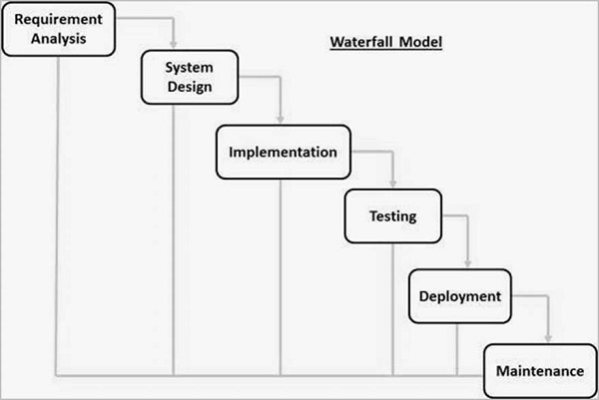

Fig 3.1: Waterfall Model

1. **Requirements Gathering and Analysis:**

In this initial phase, we all development team gathered and documented all the project requirements. Detailed analysis of the requirements is performed to ensure a clear understanding of the “Ghar Sewa” scope and objectives.

1. **System Design:**

Once the requirements are well-defined, the system design phase begins. In this phase, we designed an overall blueprint of system design. Make an entity-relationship diagram to describe relationships between entity and discussed about attributes of each entity, and design Dataflow Diagram (DFD) to understand flow of data.

1. **Implementation (Coding):**

In this phase, we started coding based on the design specifications. The code is written and reviewed to ensure it aligns with the design and meets the specified requirements.

1. **Testing:**

After coding, we are entering the testing phase. We conducted various tests, including unit testing, integration testing, system testing, and user acceptance testing, to identify and rectify defects. Each test is successfully run, after rectifying and debugging errors.

1. **Maintenance:**

The maintenance phase is the last stage of the waterfall model, where we monitor, update, and fix it after it is released to the users. In this phase we can work as an activity such as bug fixing, performance improvement, security enhancement, and feature addition.

## **3.2 Technologies and Tools**

Ghar Sewa is a web-based system. In this project we are using various tools and technologies.

### 3.2.1 Specified Programming Language

Programming language: Java Script, html 5, CSS 3, PHP 3.01

### 3.2.2 Specified Database

Database: MySQL 8.3

### 3.2.3 Specified Software

Software: Vs-code, Figma

## **3.3 Assignments of Rolls and Responsibilities**

The member assigned with these responsibilities:

|  |  |
| --- | --- |
| **Team Members** | **Task Performed** |
| Dhiraj Sapkota | Requirement Gathering, Coding & Documentation |
| Sagar Upadhyaya | System Analysis & Design, Coding & Documentation |
| Subash Acharya | System Analysis & Design, Coding & Debugging |

Table 3.3: Assignments of Rolls and Responsibilities

# **Chapter 4: System Analysis**

## **4.1 Requirement Analysis**

Requirement analysis is a critical phase that follows requirement gathering, where the collected requirements are analyzed and organized to define the scope of the project accurately. During this process, stakeholders' needs and expectations are examined in detail, and functional and non-functional requirements are identified and documented. Prioritization techniques are utilized to determine the importance of each requirement, ensuring that the most critical needs are addressed first. Traceability is established to maintain clarity and accountability throughout the project, enabling stakeholders to understand the origin and rationale behind each requirement. Validation and verification processes are employed to confirm the accuracy and completeness of requirements, while change management procedures facilitate the handling of any modifications that may arise. Overall, requirement analysis serves as a crucial step in shaping the development process, guiding the creation of a solution that meets stakeholder expectations effectively.

### 4.1.1 Requirement Gathering

Requirement gathering is the initial phase of software development where the focus is on understanding the needs and expectations of stakeholders. This process involves various techniques such as interviews, surveys, workshops, and observations to systematically collect and document user requirements, business objectives, and functional specifications. Through effective communication and collaboration, project team members work closely with stakeholders to ensure that all requirements are accurately captured and understood. Prioritization techniques may be employed to distinguish between essential and non-essential requirements, aiding in resource allocation and project planning. Ultimately, the comprehensive gathering of requirements forms the foundation for designing and developing a solution that aligns closely with stakeholder needs and objectives.

### 4.1.2 Functional Requirement

|  |  |
| --- | --- |
| Requirement Name | Description |
| Authentication and authorization | * Allow users to register and create accounts with valid email addresses and passwords. * Implement email verification for account activation. |
| User Profiles | * Allow users to create detailed profiles including personal information, skills, work experience, and certifications. * Allow users to upload relevant documents such as resumes, certificates, and licenses. |
| Job listing and search | * Provide a searchable database of job listings based on categories, location, and keywords. * Allow users to filter search results based on preferences such as job type, location, and salary range. |
| Messaging | * Implement a messaging system to facilitate communication between job seekers and service providers. * Ensure privacy and security of messages exchanged between users. |
| Application tracking | * Enable users to track their job applications and service requests. * Provide status updates (e.g., pending, accepted, rejected) for better transparency. |
| Reviews and Ratings | * Allow users to rate and review service providers based on their experience. * Implement a rating system to help users make informed decisions. |
| Privacy setting | * Offer privacy settings to allow users to control the visibility of their profiles and contact information. |

Table 4.1.2: Functional Requirement

### 4.1.3 Non-Functional Requirement

|  |  |
| --- | --- |
| **Requirement Name** | **Description** |
| Performance | * Responsive and capable of handling concurrent user interactions. * Implement caching mechanisms to improve loading times. |
| Security | * Ensure secure data transmission and storage using encryption protocols. * Implement measures to prevent unauthorized access and protect user privacy. |
| Scalability | * Accommodate future growth in user base and features. * Scalable infrastructure and technologies to support increased traffic. |
| Usability | * Intuitive user interface with clear navigation and user-friendly features. * Usability testing to identify and address any usability issues. |
| System Architecture | * Consists overview of the system architecture, including components such as frontend, backend, and database. * Describe the technologies and frameworks used for development |
| System Interface | * Describe interfaces for user interaction. * Provide guidelines for integrating third-party services such as payment gateways. |
| Data Management | * Defines the database schema and data models for storing user information, job listings, and reviews. * Specify data backup and recovery procedures to ensure data integrity. |
| Testing and quality assurance | * Outline the testing strategy, including unit testing, integration testing, and user acceptance testing. * Define criteria for evaluating the quality and performance of the platform. |

Table 4.1.3: Non-Functional Requirement

## **4.2 Feasibility study**

### 4.2.1 Technical Feasibility

Ghar Sewa's technical feasibility is solid, leveraging established technologies like PHP and JavaScript for robust back end and front-end development, respectively. The platform's architecture ensures scalability through cloud infrastructure and microservices, while stringent security measures safeguard user data. Its modular design allows for seamless integration with third-party services, and performance optimization techniques ensure optimal functionality even under high loads.

### 4.2.2 Economic Feasibility

The Ghar Sewa platform's economic feasibility, as a team project without upfront costs, relies on making money by taking a small cut from job providers' earnings. To see if this will work, we need to figure out how much money could come in from this cut and balance it against the costs of running the platform, like keeping the website up and running, helping users with technical issues, advertising, and paying staff. We also need to make sure there's enough demand for our platform among people who need home services and those offering them. Plus, we have to make sure our platform can handle more users and transactions as it grows without costing us a lot more money. By looking at all these factors, we can decide if the platform can make enough money to be successful in the long run.

### 4.2.3 Operational Feasibility

Operational feasibility for Ghar Sewa involves ensuring the platform is easy to use, effectively matches users, provides secure communication, scales smoothly, and is managed efficiently. Features like user-friendly interfaces, efficient job matching, reliable messaging, and robust admin tools are vital. Additionally, mechanisms for user feedback and compliance with regulations ensure trust and legality. By addressing these operational aspects, Ghar Sewa can function effectively, meeting user needs and fostering its success in connecting job seekers with service providers.

### 4.2.4 Schedule Feasibility

Ghar Sewa's schedule feasibility is well-managed, with a detailed development timeline and sufficient resources allocated for each phase. An iterative development approach, like Agile methodology, allows for flexibility and adaptability to meet project deadlines and milestones. Contingency plans are in place to address any unexpected challenges, ensuring project timelines remain on track throughout implementation.

### 4.2.4.1 Gantt chart

Table 4.2.4.1: Gantt chart

Fig 4.2.4.1: Gantt chart

# **Chapter 5: System Design**

## **5.1 System Architecture**

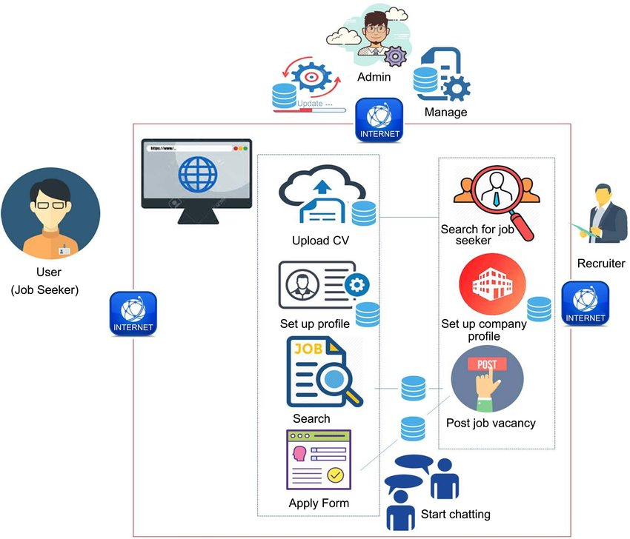

Fig 5.1: System Architecture

## **5.2 Data Flow diagram**

A data-flow diagram is a way of representing a flow of data through a process or a system. The DFD also provides information about the outputs and inputs of each entity and the process itself.

### 5.2.1 Context Level (level 0) DFD:

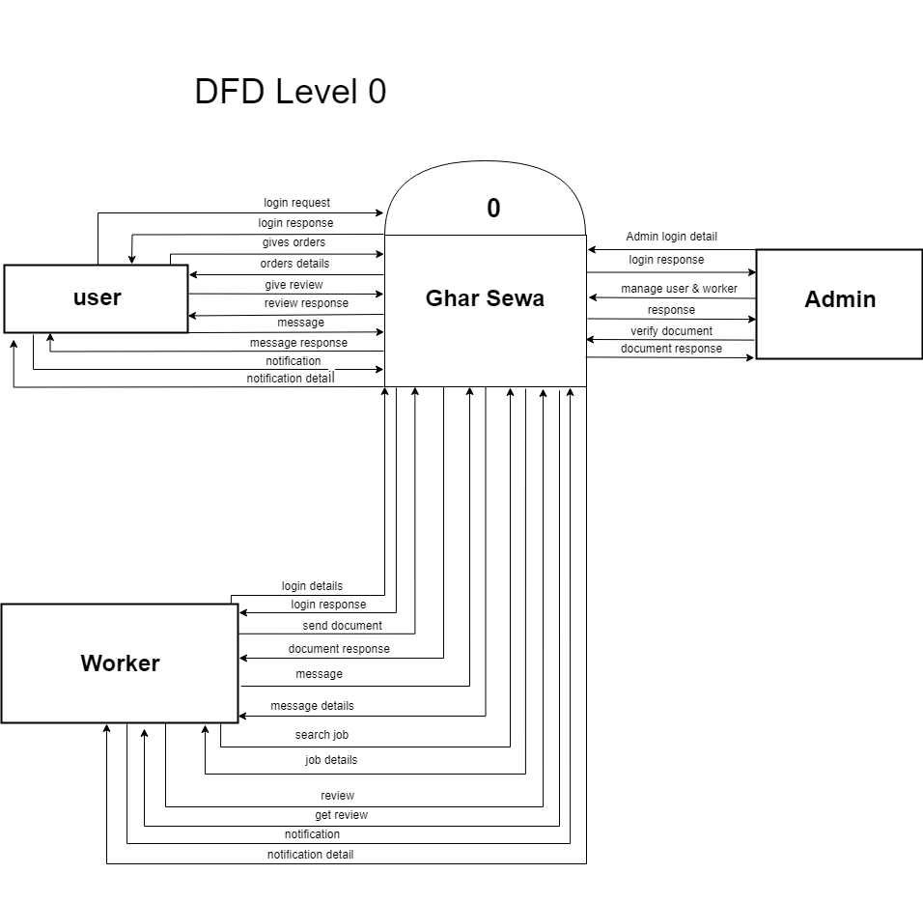

Fig 5.2.1: Level 0 DFD

### 5.2.2 Level 1 DFD:

### 

Fig 5.2.2: Level 1 DFD

### 5.2.3 Use Case Diagram:

Fig 5.2.3: Use Case Diagram

## **5.3 Database Design**

### 5.3.1 ER Diagram

Fig 5.3.1: E-R Diagram

### 5.3.2 Data Dictionary

|  |  |
| --- | --- |
| **Table Name** | **Description** |
| documents | Stores various documents uploaded by users. |
| message | Contains messages exchanged between users. |
| notification | Records notifications sent to users. |
| orders | Stores information about orders placed by users. |
| reviews | Stores reviews submitted by users for workers. |
| user | Contains user information including login credentials. |
| worker | Stores details about workers offering services. |
| working_days | Records the availability of workers on different days. |

Table 5.3.2: Data Dictionary

For each table, there is a summary of the columns:

1. **documents**:
   * doc_id: Unique identifier for each document.
   * type: Type of document uploaded (e.g., Certificate, Resume).
   * url: URL or file path of the document.
   * user_id: ID of the user who uploaded the document.
2. **message**:
   * mid: Unique identifier for each message.
   * time: Timestamp of the message.
   * message: Content of the message.
   * sender: ID of the sender user.
   * receiver: ID of the receiver user.
   * isRead: Flag indicating if the message has been read (0 for unread, 1 for read).
3. **notification**:
   * nid: Unique identifier for each notification.
   * message: Content of the notification.
   * user_id: ID of the user receiving the notification.
   * link: URL or link associated with the notification.
   * time: Timestamp of the notification.
   * title: Title of the notification.
   * read: Flag indicating if the notification has been read (0 for unread, 1 for read).
4. **orders**:
   * order_id: Unique identifier for each order.
   * user_id: ID of the user placing the order.
   * worker_id: ID of the worker assigned to the order.
   * status: Status of the order (Pending, Active, Completed).
   * from: Start date of the order.
   * to: End date of the order.
   * description: Description or details of the order.
5. **reviews**:
   * review_id: Unique identifier for each review.
   * user_id: ID of the user submitting the review.
   * worker_id: ID of the worker being reviewed.
   * rating: Rating given by the user for the worker.
   * comment: Textual comment or feedback provided by the user.
6. **user**:
   * user_id: Unique identifier for each user.
   * first_name: First name of the user.
   * last_name: Last name of the user.
   * username: Username used for login.
   * password: Encrypted password for login.
   * email: Email address of the user.
   * phone: Phone number of the user.
   * address: Address of the user.
   * profilePic: URL or file path of the user's profile picture.
   * map_lon: Longitude coordinate of the user's location.
   * map_lat: Latitude coordinate of the user's location.
   * isAdmin: Flag indicating if the user is an admin (0 for regular user, 1 for admin).
   * isWorker: Flag indicating if the user is a worker (0 for regular user, 1 for worker).
7. **worker**:
   * worker_id: Unique identifier for each worker.
   * user_id: ID of the user associated with the worker.
   * service_type: Type of service offered by the worker.
   * description: Description or details about the worker's services.
   * status: Availability status of the worker (Available, Busy, Unavailable).
   * completed_jobs: Number of completed jobs by the worker.
   * work_time_start: Starting time of the worker's work hours.
   * work_time_end: Ending time of the worker's work hours.
   * identity_verify: Flag indicating if the worker's identity has been verified.
   * document_verify: Flag indicating if the worker's documents have been verified.
   * background_check: Flag indicating if a background check has been performed on the worker.
   * approved: Flag indicating if the worker's profile has been approved (0 for pending, 1 for approved).
   * cover_image: URL or file path of the worker's cover image.
   * qualifications: Details about the worker's qualifications.
   * hourly_rate: Hourly rate charged by the worker for services.
8. **working_days**:
   * wd_id: Unique identifier for each working day entry.
   * sunday to saturday: Flags indicating availability on each day of the week (1 for available, 0 for unavailable).
   * worker_id: ID of the worker associated with the working day schedule.

This data dictionary provides a comprehensive overview of the tables and their corresponding columns in the database.

# **Chapter 6: System Development and Implementation**

## **6.1 Programming Platform**

Ghar Sewa's programming platform is crafted using core languages to ensure efficiency, reliability, and customization capabilities. Employing languages like PHP for back-end development and JavaScript with HTML/CSS for front-end interfaces, our platform offers a robust foundation for delivering seamless user experiences. By leveraging php's versatility and scalability, we ensure that our platform can handle complex business logic and high user traffic with ease. Additionally, JavaScript enables dynamic and interactive user interfaces, enhancing engagement and usability. Our platform architecture follows a modular design, allowing for easy integration of new features and third-party services. We prioritize performance optimization, utilizing caching mechanisms, asynchronous processing, and database indexing techniques to ensure fast response times and scalability. Security is paramount, with stringent measures in place to protect user data, including encryption protocols, secure authentication mechanisms, and regular security audits. Through continuous testing and monitoring, we maintain the stability and reliability of the platform, ensuring a seamless experience for both job seekers and service providers.

.

## **6.2 Operating Environment**

Software Specifications

Computer software specification we have used for development:

* Operating System: Windows 10 Operating System
* Vs-code
* MySQL 8.3 database Server

Hardware Specifications

Computer hardware specification we have used for development:

* Processor: Intel Core i5
* RAM: 8GB
* SSD: 512GB

## **6.3 Functional Implementation**

During the functional implementation of Ghar Sewa, we utilized HTML, CSS, JavaScript, PHP, and MySQL to build the platform's features. HTML and CSS were employed for structuring and styling the user interface to ensure its visually appealing and easy to navigate. JavaScript enhanced user interactions and dynamic content, while PHP handled server-side processing and logic, ensuring smooth functionality. MySQL served as the database management system, storing essential data such as user profiles, job listings, and service provider information. By organizing our code into separate files for each language and technology, we maintained a modular and scalable architecture. Rigorous testing was conducted throughout the implementation process to verify functionality and address any issues promptly. Through the integration of these technologies, we successfully developed Ghar Sewa, providing a user-friendly platform for connecting job seekers with home-related service opportunities.

# **Chapter 7: Testing and Debugging**

Testing and debugging are essential stages in the development process of Ghar Sewa to ensure its reliability and functionality. Testing involves systematically examining each component of the platform to verify that it performs according to its specifications. This process includes unit testing, where individual modules are tested in isolation to ensure they function correctly, and integration testing, where different modules are combined and tested together to ensure they work seamlessly as a whole. Additionally, user acceptance testing is conducted to evaluate the platform from the end-users' perspective, ensuring it meets their needs and expectations. Throughout the testing phase, any defects or issues identified are logged and addressed through debugging. Debugging involves identifying and fixing errors in the code, whether they are logical errors, syntax errors, or other issues preventing the platform from functioning as intended. By conducting thorough testing and debugging, we ensure that Ghar Sewa operates reliably and delivers a seamless user experience for both job seekers and service providers.

|  |  |  |
| --- | --- | --- |
| **S. N** | **Tools** | **Specification** |
| 1 | Laptop | Hardware |
| 2 | Vs-code | IDE |
| 3 | MySQL | Database server |

## **7.1 Tools used in testing.**

Table 7.1 Tools used in testing.

## **Test Cases**

|  |  |  |  |  |
| --- | --- | --- | --- | --- |
| **Test Case Description** | **Test Case Data** | **Expected Result** | **Actual Result** | **Status** |
| Register new admin | Admin details (name, email, password) | Admin registered | Admin registered | Success |
| Manage pending service provider accounts | List of pending service provider accounts | Pending accounts displayed | Pending accounts displayed | Success |
| Process service provider account | Service provider account details (name, email) | Account processed (Accepted/Rejected) | Account processed (Accepted/Rejected) | Success |
| View active service provider accounts | List of active service provider accounts | Active accounts displayed | Active accounts displayed | Success |

Table 7.2.1: Test case admin

|  |  |  |  |  |
| --- | --- | --- | --- | --- |
| **Test Case Description** | **Test Case Data** | **Expected Result** | **Actual Result** | **Status** |
| Register new customer | Customer details (name, email, password) | Registered | Registered | Success |
| Search for service providers | Search criteria (location, services required) | Results displayed | Results displayed | Success |
| View service provider profiles | Provider details (name, services offered, ratings) | Viewed | Viewed | Success |
| Request service | Service details (type, location, preferred date/time) | Service requested | Service requested | Success |
| Rate service provider | Service feedback (rating, comments) | Rating submitted | Rating submitted | Success |
| Send message to service provider | Message content, recipient (service provider) | Message sent | Message not sent | Failed |
| Set location on map | Location coordinates | Location set on map | Location set on map | Success |

Table 7.2.2: Test case user (customer)

|  |  |  |  |  |
| --- | --- | --- | --- | --- |
| **Test Case Description** | **Test Case Data** | **Expected Result** | **Actual Result** | **Status** |
| Register new service provider | Provider details (name, email, password, services offered) | Registered | Registered | Success |
| Update service availability | Availability schedule (days, hours) | Schedule updated | Schedule updated | Success |
| Receive job notifications | Job alerts (new listings, matching criteria) | Notifications received | All notification received | Failed |
| Send message to user | Message content, recipient (user) | Message sent | Message sent | Success |
| Set location on map | Location coordinates | Location set on map | Location set on map | Success |

Table 7.2.3: Test case service provider

# **Chapter 8: Conclusion**

Ghar Sewa is your go-to platform, acting as a matchmaker between job seekers and home service providers. It's designed to be straightforward, offering easy-to-navigate profiles and messaging features to connect people efficiently. With built-in safeguards like reviews and secure payment options, Ghar Sewa ensures that interactions are fair and safe for all involved.

In essence, Ghar Sewa simplifies life's tasks by providing a reliable hub for job opportunities and home services. It's like having a trustworthy friend who knows just the right person for the job, making everything from finding work to getting chores done a breeze. With Ghar Sewa, convenience and peace of mind go hand in hand, creating a community-driven platform where everyone can thrive.

# **Chapter 9: Future Enhancement**

1. **Machine Learning Integration**: Implement machine learning algorithms to personalize user experiences, such as recommending jobs or service providers based on past interactions and preferences.
2. **Advanced Matching Algorithms**: Develop advanced matching algorithms to improve the accuracy of jobseeker and service-provider matches, considering factors such as skills, experience, and user preferences.
3. **Mobile Application Development**: Develop native mobile applications for iOS and Android devices to provide users with a seamless and optimized experience on their smartphones and tablets.
4. **Expanded Service Categories**: Expand the range of service categories offered on the platform to include additional home-related services such as pet care, gardening, or tutoring, catering to a broader audience.
5. **Integration with Smart Home Devices**: Integrate with smart home devices and platforms to offer innovative services such as home automation, security monitoring, or energy management through certified service providers.
6. **Multilingual Support**: Implement multilingual support to accommodate users from diverse linguistic backgrounds, enhancing accessibility and user inclusivity.
7. **Blockchain for Transparency**: Utilize blockchain technology to ensure transparency and integrity in user reviews, payment transactions, and service provider credentials, fostering trust and reliability on the platform.
8. **Continuous Improvement Feedback Loop**: Establish a feedback loop mechanism to gather user feedback continuously and iterate on the platform's features and functionalities, ensuring ongoing improvements and relevance to user needs.

# **REFERENCES**

* Merorojgari. (n.d.). *Jobs in Nepal - Job Vacancies in Nepal*. Retrieved October 15, 2023, from <https://www.merorojgari.com/?fbclid=IwAR3uGvwjl1fyXu-eB-lv3M5EKifQEMkZNQSS1gsJTuDtIVKUGyuN8eHNcR8>
* JobsNepal. (n.d.). *Find Job / Jobs in Nepal - Job, Online Vacancy, Recruitment*. Retrieved October 15, 2023, from <https://www.jobsnepal.com/?fbclid=IwAR2vZyCQmuHTl_EJwLBy6KAFuTN2LS_WepHVPa966WT6cd7Iy7wgeof-lx0>
* Merojob.com. (n.d.). *Jobs in Nepal | Job Vacancies in Nepal | merojob.com.* Retrieved Oct 15, 2023, from <https://merojob.com/?fbclid=IwAR3y52GOKPGWgEvB0OKXriY2c0DJAcR2TNukbz5uywpwpcMnzaAjJzlQiY0>

# **A person and child in a bathroom Description automatically generatedAPPENDIX**

