ITMD – 411 Intermediate Software Development

Spring 2013 – MP2
This project is to implement the high level and core concepts of OOP using Java, namely
- Data structures in java.
- Abstract Classes.
- Serialization.
- Comparators.
- I/O operations in java.
The project is basically to inculcate the usage of reading input files, usage of complex Data structures in Java.
The usage of different functions that calculate the required data by comparing various objects within the list with the help of Comparators function which reside in the Java Util Pacakage.

System Requirement
- OS – Windows 7
- IDE – NetBeans 7.2.1
- JDK – 1.7.0
- JRE Version 6

Architecture

Domain classes
- Base abstract class - Record
- Concrete subclass - DaylightRecord
- Serializing - PersistantObject
Util classes
- Comparators – to implement from Comparator and is used to compare different objects for data analytics.
- Utility – has functions utilities to get the input from the CSV file and other functions to calculate Equinoxes and Solstices.
- Main() function - this calls the functions to do the following tasks :
- Read the CSV and Serialize
- Functions to calculate Equinoxes and Solstices

Expected Result
- Data successfully read from CSV
- Creation of ArrayList of type DaylightRecord.
- Serialize the Array
- Sleep for 10 seconds
- Deserialize the Array
- Display of Autumnal Equinox, Summer Solistice, Vernal Equinox, Winter Solistice

Steps To Follow

- Unzip the provided file into C-Drive. i.e the file path should be C:/MP2
- Go to the MP2 folder and double click on mp2out.bat file.
- Now navigate to the ”output” folder which is inside the base folder MP2 and find the output.txt for the programs output.

TestCases
- Double click mp2out.bat in the main folder, go to the output folder to view the output. 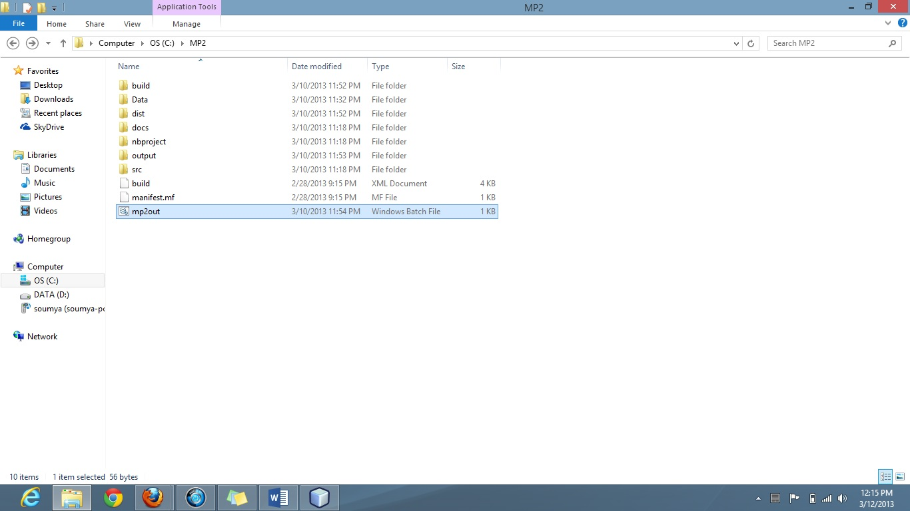

- Go to the “output” folder to view the output in output.txt and daylight-records.txt 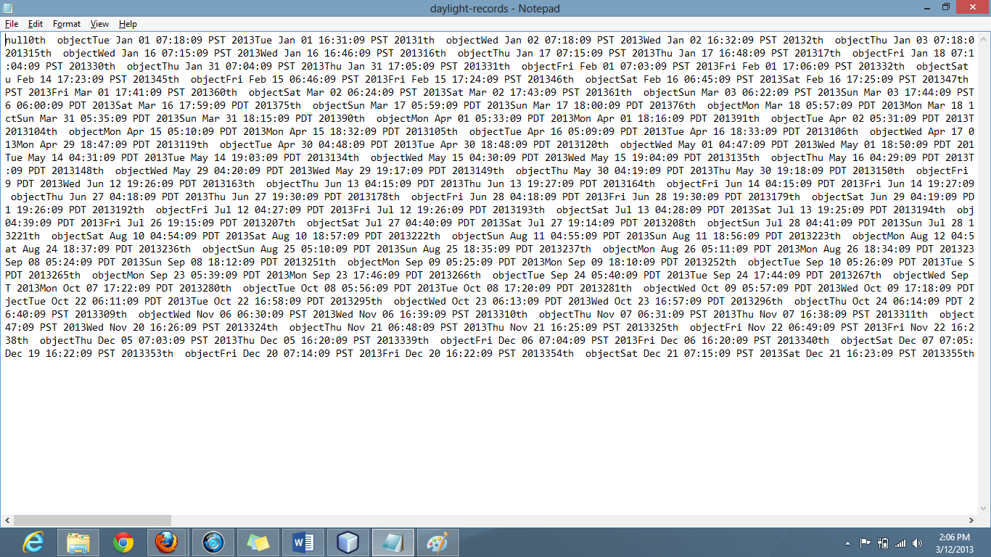

- The project can also be exported into Net Beans and can be run from there to see the output

Conclusion
Thus the implementation of the projects successfully meets the requirements.

