CAPSTONE PROJECT PROPOSAL
Supply Chain Analytics Platform: Relational Database Design and a Power BI Business Intelligence Dashboard for Supply Chain Decision-Making
Prepared by Sagarkc — Master of Business Informatics (Business Analytics), Yoobee College, Auckland — September 2026

1. Introduction
Supply chain operations generate data across several disconnected areas — supplier records, product catalogues, warehouse inventory, purchase orders, and sales transactions — that are rarely brought together in a way decision-makers can query directly. This proposal sets out a capstone project to design a relational database that consolidates these areas into one coherent model, and to build a Power BI dashboard on top of it that answers the recurring questions supply chain stakeholders ask about cost, inventory risk, supplier reliability, and sales performance.

2. Problem Statement
Small and mid-size supply chain operations frequently track products, suppliers, warehouses, purchase orders, and sales in spreadsheets or transactional systems that were never designed for analysis. Without a consolidated data model, decision-makers cannot easily answer basic questions such as which suppliers are reliably on time, which products are at risk of stocking out, or which categories drive the most profit. This project proposes to address that gap for a representative supply chain dataset.

3. Purpose and Objectives
The purpose of this capstone is to design, build, and validate an end-to-end supply chain business intelligence solution — from relational schema to a decision-ready dashboard — in order to demonstrate applied data modelling, SQL-based data validation, and DAX-based analytics. Proposed objectives:
- Design a normalised relational schema covering suppliers, products, warehouses, inventory, purchase orders, and sales, with enforced referential integrity (foreign keys).
- Document the schema with a clear entity-relationship diagram.
- Build a Power BI data model (star-schema relationships plus a Date dimension) on top of that database.
- Deliver a four-page dashboard that answers a defined set of more than fifty stakeholder business questions across financial, inventory, procurement, and sales performance.
- Establish a data-quality validation process — referential integrity checks, null handling, and logical date checks — so that every dashboard KPI can be traced back to a validated SQL query.
- Produce recommendations for the simulated business based on the completed analysis.

4. Scope
In scope: design of a six-table relational database (suppliers, products, warehouses, inventory, purchase_orders, sales); a Power BI data model built from that database; four proposed dashboard pages; a documented business-question framework; and a data-quality validation plan.
Out of scope: real-time or streaming data integration, production deployment, and integration with external systems such as an ERP or WMS. These are noted as possible future work in Section 10.

5. Proposed Database Design
The project will use a single relational database, provisionally named SCM_Inventory_Database, made up of three dimension tables (suppliers, products, warehouses) and three fact tables (inventory, purchase_orders, sales). Each fact table will carry foreign keys back to the dimension tables it describes, giving the model a standard star-schema shape suited to Power BI's relationship view.
Table | Type | Purpose | Primary Key
suppliers | Dimension | Vendor master data: contact info, region, payment terms, promised lead time, self-reported reliability score. | supplier_id
products | Dimension | Product catalogue: category, brand, unit cost/price, gross margin, reorder point, safety stock. Linked to its default supplier. | product_id
warehouses | Dimension | Distribution centre master data: location, region, storage capacity. | warehouse_id
inventory | Fact (snapshot) | Current on-hand, available, and reserved quantity for every product/warehouse combination. | inventory_id
purchase_orders | Fact (transaction) | Every procurement transaction: supplier, product, warehouse, quantities, costs, order/expected/actual delivery dates, status. | purchase_order_id
sales | Fact (transaction) | Every sales transaction: product, warehouse, date, quantity, unit price. | sale_id

5.1 Proposed Entity-Relationship Diagram
Figure 1 sets out the intended primary keys, foreign keys, and cardinalities for the six tables. Each fact table (green) will connect to its parent dimension tables (blue) through a one-to-many relationship, to be enforced with foreign-key constraints in SQL Server.
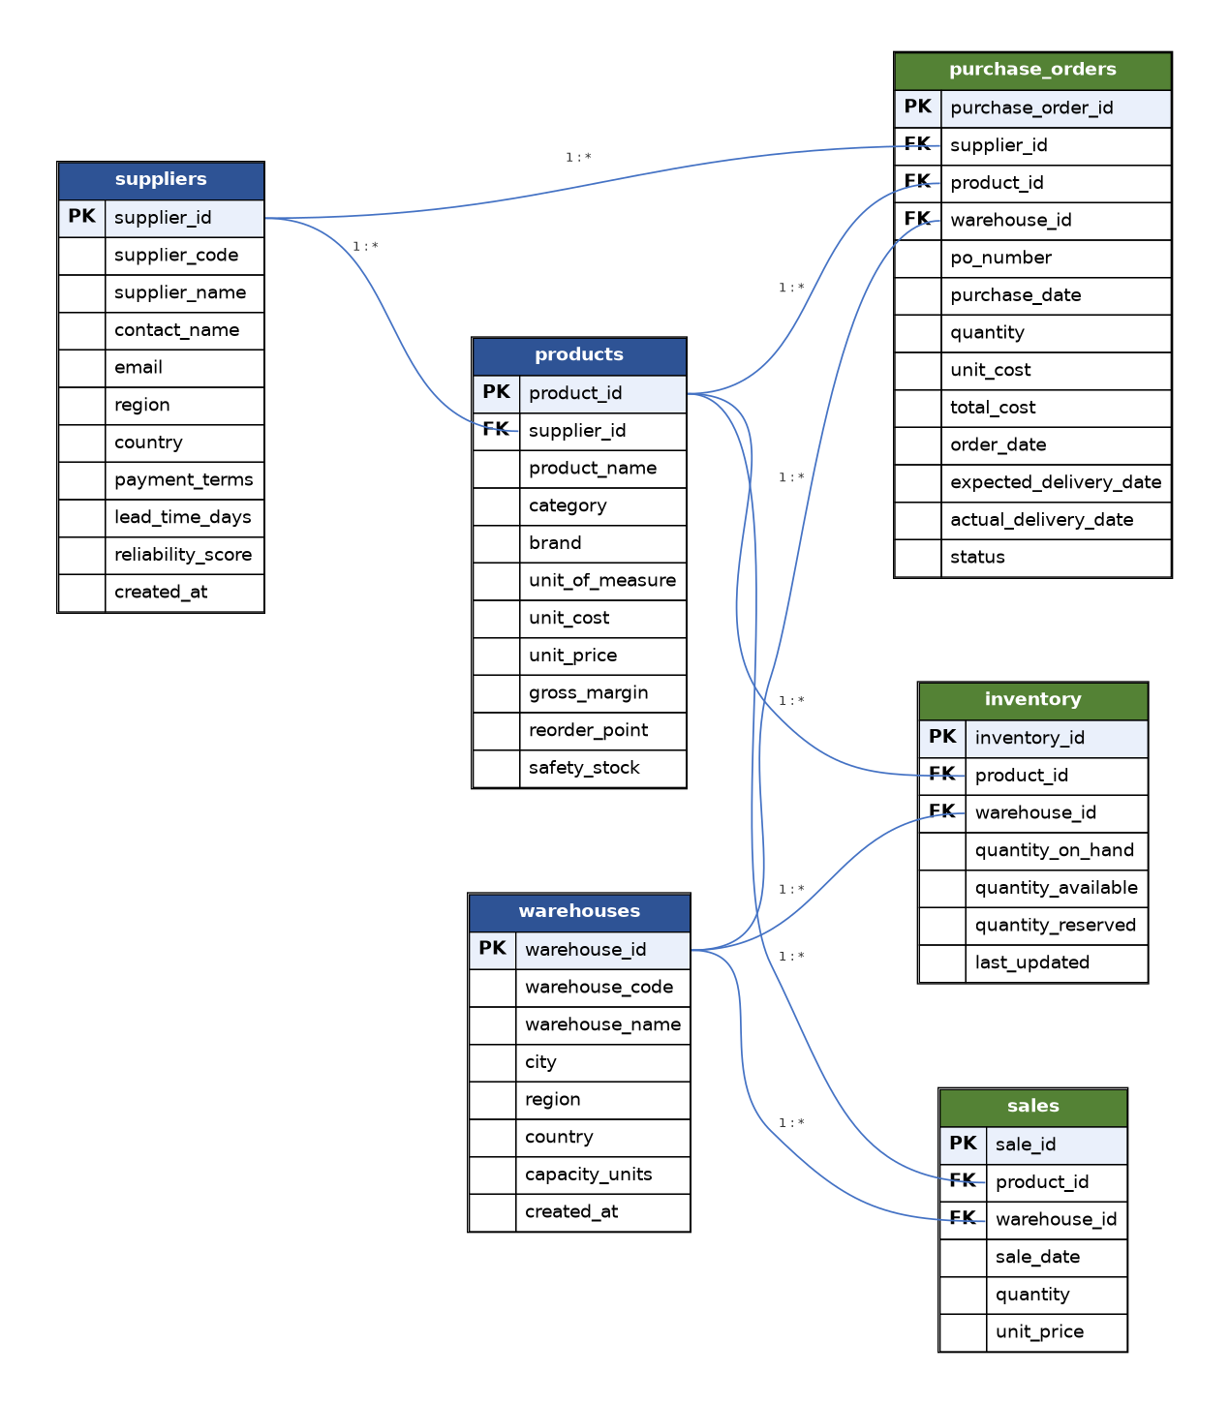
Figure 1. Proposed entity-relationship diagram for the supply chain database.

6. Proposed Methodology and Tools
The project will follow a standard BI development lifecycle: schema design and validation in SQL Server Management Studio, data modelling and DAX measure development in Power BI Desktop, and iterative dashboard construction, with each measure checked against an equivalent SQL query before it is accepted onto a dashboard page.
- Database: Microsoft SQL Server, designed and queried through SSMS.
- Modelling and visualisation: Power BI Desktop — relationships, a dedicated Date table, and DAX measures for revenue, margin, inventory health, and supplier performance.
- Data preparation: Power Query for shaping and validating imports, and T-SQL scripts to check referential integrity, identify missing or inconsistent values, and resolve them before they reach the dashboard.
- Validation approach: every DAX measure will be checked against a direct SQL aggregate query before being accepted as final.

7. Proposed Power BI Dashboard Structure
The dashboard is planned as four pages, each aimed at a different stakeholder decision:

7.1 Page 1 — Executive Overview
Audience: senior leadership. Will answer the financial-performance questions in Section 8.1 — total revenue, gross profit, margin %, monthly trend, and category/product contribution.

7.2 Page 2 — Inventory Health
Audience: inventory planners and warehouse managers. Will surface stock status (Critical / Reorder Required / Healthy), stock availability and reservation rates, and on-hand value by category and warehouse.

7.3 Page 3 — Procurement & Supplier Performance
Audience: buyers and procurement managers. Will track purchase order volume and status, procurement spend by supplier, on-time delivery %, and average lead time and reliability by supplier.

7.4 Page 4 — Sales & Product Performance
Audience: category managers. Will rank products and brands by revenue and gross profit, show sales-quantity share by category, apply ABC revenue classification, and flag high-inventory/low-sales products as dead-stock candidates.

8. Business Question Framework (50+ Questions)
The dashboard's design will be driven by a structured list of questions that supply chain stakeholders repeatedly ask. Each question below is intended to be answerable directly from a dashboard visual or an underlying DAX measure, and each will be verified against a T-SQL query during development. The questions are grouped by stakeholder area and mapped to the relevant planned dashboard page.

8.1 Executive & Financial Performance — Page 1
Primary stakeholder: CEO / CFO / general management.
1. What is total revenue, total cost, gross profit, and gross margin % for a selected period?
2. How does monthly revenue trend compare to the same month in the prior year?
3. Which product categories contribute the most to total revenue and to total gross profit?
4. Which product categories have the highest and lowest gross margin %?
5. What is the revenue and margin contribution of the top 10 products by name?
6. How does revenue vary by warehouse region?
7. What percentage of total revenue comes from the top 20% of products (ABC analysis)?
8. Is revenue growth driven mainly by sales volume or by price?
9. Which month or quarter generates the highest gross profit, and is there seasonality?
10. How much would gross profit change if margin on the lowest-performing category improved by 5 percentage points?

8.2 Inventory Health & Stock Management — Page 2
Primary stakeholder: inventory planners, warehouse managers.
11. What is the total quantity on hand, available, and reserved across all warehouses?
12. What is total inventory value, and how is it distributed by category?
13. How many SKU/warehouse combinations are Critical, Reorder Required, or Healthy at a given time?
14. What is the current stock availability % and stock reservation %?
15. Which warehouses hold the largest share of on-hand inventory?
16. Which specific products are below their reorder point?
17. Which products are overstocked relative to their recent sales velocity (slow movers)?
18. What is the inventory turnover ratio by category?
19. What is the average days-of-supply for fast-moving versus slow-moving categories?
20. Which warehouse is closest to its storage capacity (quantity on hand vs. capacity_units)?
21. How many distinct products does each warehouse carry, and is stock concentrated or spread out?
22. What dollar value of inventory is tied up in Reorder-Required or Critical stock?

8.3 Supplier & Procurement Performance — Page 3
Primary stakeholder: procurement / buying team.
23. What is the total number of purchase orders, and how many are Delivered versus Overdue?
24. What is total procurement spend, and how does it trend month over month?
25. What is the average purchase cost per unit across all purchase orders?
26. What is the overall on-time delivery percentage across all suppliers?
27. Which suppliers have the best and worst on-time delivery percentages?
28. How does each supplier's self-reported reliability_score compare with their actual on-time delivery rate?
29. What is the average lead time promised versus the average lead time actually delivered, per supplier?
30. Which suppliers have the most overdue purchase orders?
31. What is the total value of open (Approved) purchase orders versus Overdue purchase orders?
32. How concentrated is procurement spend — do the top three suppliers account for more than half of total spend?
33. What is the average requisition-to-order approval time?
34. What is the average end-to-end procurement cycle time, from requisition to actual delivery?
35. Which product categories are sourced from the fewest suppliers, indicating supply-risk concentration?
36. Based on cost, reliability, and delivery performance combined, which suppliers are candidates for renegotiation or replacement?

8.4 Sales & Product Performance — Page 4
Primary stakeholder: category / product managers.
37. Which are the top 10 and bottom 10 products by revenue?
38. Which are the top 10 products by gross profit, and do they differ from the top-revenue list?
39. What is the sales quantity share by category?
40. Which categories show clear seasonal sales patterns month over month?
41. How does average selling price trend over time, by category?
42. Which warehouse or region sells the most of each top-selling category?
43. Is there a relationship between a product's unit price and its sales volume?
44. Which products show both high inventory and low sales — candidates for dead-stock write-down?
45. What is the ABC classification (A/B/C) of products by cumulative revenue contribution?
46. How does brand performance compare within the same category?
47. What is the average order value per sales transaction?
48. Which products should be prioritised for reorder, based on combined sales velocity and current stock status?

8.5 Cross-Functional Strategy & Data Quality
Primary stakeholder: data/BI team and general management — questions that validate the dashboard itself or connect insights across pages.
49. Does each product's stored gross_margin actually equal (unit_price − unit_cost) ÷ unit_price?
50. Are there orphaned foreign keys — inventory, sales, or purchase-order rows referencing a product, warehouse, or supplier that does not exist?
51. Are there duplicate or negative stock quantities anywhere in the inventory table?
52. Are there purchase orders with an actual_delivery_date earlier than their order_date (impossible sequencing)?
53. What is the overall data-completeness rate (NULL rate) across the six tables' key columns?
54. If lead time and reliability improved by 10% for the two worst-performing suppliers, what would be the projected effect on overall on-time delivery %?
55. Which single operational change — supplier renegotiation, reorder-point adjustment, or warehouse rebalancing — would likely have the largest combined financial and service-level impact?
56. Taken together, what would the four dashboard pages suggest leadership prioritise next quarter?

9. Proposed Timeline
The table below sets out an eight-week plan from project approval to final submission.
Phase | Weeks | Planned activities | Deliverable
1. Requirements & Design | 1–2 | Confirm stakeholder questions with supervisor, finalise schema, produce ER diagram, define KPI glossary. | ER diagram, KPI dictionary
2. Data Preparation | 2–3 | Load SQL Server tables, check referential integrity, resolve any missing/incomplete fields, log data-quality issues found. | Validated database, DQ log
3. Data Modelling | 3–4 | Build the Power BI data model: relationships, a Date table, and DAX measures for each dashboard page. | Power BI data model
4. Dashboard Development | 4–6 | Build the four dashboard pages: Executive Overview, Inventory Health, Procurement & Supplier Performance, Sales & Product Performance. | Four-page dashboard
5. Validation & Testing | 6–7 | Cross-check every KPI against an equivalent SQL query; work through the full business-question list; incorporate supervisor feedback. | Validation log, Q&A appendix
6. Documentation & Presentation | 7–8 | Write the final report and user guide; prepare the presentation and live demo. | Final report + demo

10. Expected Outcomes and Future Work
On completion, the project is expected to deliver: a referentially-intact SQL Server database with a documented schema and ER diagram; a four-page Power BI dashboard answering the 56 defined business questions; a data-quality validation log; and a final report with recommendations (for example, which suppliers to renegotiate with, which products are at stockout risk, and which categories to prioritise for margin improvement).
Possible extensions beyond this capstone's scope include automated data refresh from a live ERP or WMS source, a demand-forecasting model layered on top of the sales fact table, and a what-if simulation page for reorder-point and safety-stock optimisation.

11. Conclusion
This project applies core business analytics skills — relational database design, data validation, and business intelligence dashboard development — to a realistic, multi-entity supply chain scenario. I am seeking approval to proceed with this project as my capstone, and welcome any feedback on scope or approach before formal work begins.

