#Q1) You are given with a list of integer elements. Make a new list which will store square of elements of previous list.

l=[]

list=[1,2,3,4,5]

for i in list:

j=i*i

l.append(j)

print(l)

#Q2) From a list containing ints, floats, strings make three list to store them seperately.

int_list=[]

string_list=[]

float_list=[]

list=[123,'abc',12.22,23.24,12,'xyz']

for i in list:

if type(i)==int:

int_list.append(i)

elif type(i)==str:

string_list.append(i)

else:

float_list.append(i)

print("int: ",int_list)

print("string : ",string_list)

print("float : ",float_list)

#Q3)Print the pattern

1

1 2

1 2 3

1 2 3 4

1 2 3 4 5

n=int(input("enter n: "))

for i in range(1,n+1):

for j in range(1,i+1):

print(j,end="")

print()'''

#Q4)

import numpy as np

a1=np.array([[[10,20,30],[40,50,60],[70,80,90]]])

a2=np.array([[[1,2,3],[4,5,6],[7,8,9]]])

sum=np.array([[[0,0,0],[0,0,0],[0,0,0]]])

sum=a1+a2

print(sum)

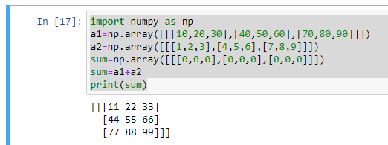

#Q5)write a program to check whether a given number is a narcissistic number or not.

n=int(input("enter a number: "))

d=n

sum=0

if(n>=100 and n<=999):

while (n!=0):

r=n%10

sum+=(r*r*r)

n//=10

elif (n>=1000 and n<=9999):

while (n!=0):

r=n%10

sum+=(r*r*r*r)

n//=10

if sum==d:

print("narcissistic no")

else:

print("Not")