 UHF RFID Read & Write Solution
  - For a Solar Module Tracking

Project Overview & Solution Architecture
Project Overview The objective is to design and implement a secure UHF RFID software-hardware integration for solar module tracking. The system focuses on reading the immutable Tag Identifier (TID) for hardware authentication and writing variable, unique data exclusively to the User Memory bank.
Proposed Solution Architecture The complete solution integrates a UHF RFID Reader with your backend application (e.g., Java/Android). It bypasses the easily cloneable EPC bank. Instead, it pairs the unalterable TID with a dynamically generated unique ID stored in the User Memory, creating a two-factor verification at the hardware level.

Network Topology & System Architecture
The Solar Application features a flexible, scalable infrastructure designed to adapt to varying manufacturing environments, from isolated production lines to fully connected enterprise networks. The system operates through three primary layers:
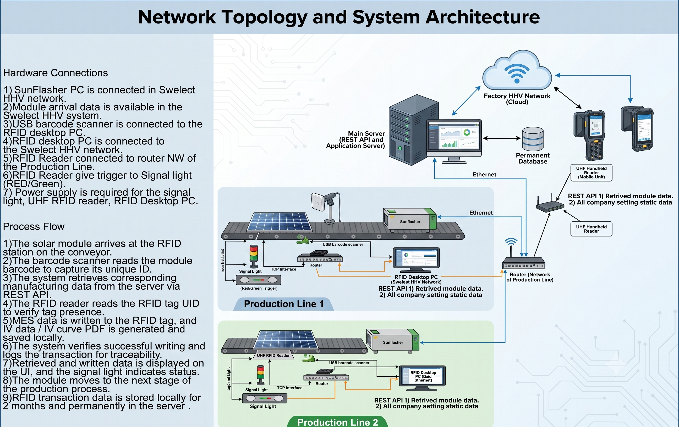
1. Deployment Architectures Depending on facility requirements, the software operates in one of two configurations:
- Standalone Architecture: The application host runs entirely independently. This model is ideal for single production stations or environments with restricted network access. All processing, RFID writing, and file generation (e.g., IV curve PDFs) are executed and stored directly on the local machine.
- Client–Server Architecture: A distributed setup where local Production Line Edge Servers (Clients) manage real-time hardware interactions and synchronize transaction logs with a Main Central Server. This model ensures centralized traceability across multiple solar manufacturing lines.
2. Hardware Integration & Protocols The system supports multiple communication protocols to interface seamlessly with industrial peripherals:
- TCP/IP (Ethernet/Wi-Fi): The primary protocol used for high-speed communication with fixed UHF RFID Readers, Line Edge Servers, and the main enterprise network.
- USB: Utilized for rapid, plug-and-play connectivity with standard peripheral devices, such as handheld barcode scanners and desktop input interfaces.
- Serial (COM / RS-232): Supported for legacy equipment integration, specific industrial triggers, and stack light relay controllers.
3. Data Layer & Accessibility To ensure uninterrupted production and rapid data retrieval, the application can route data through three distinct pathways:
- Local Machine: High-speed, local data retention (e.g., CSV or local MDB files) used for immediate transaction processing and short-term cache storage.
- Network Share: Shared database access across the local factory Intranet, allowing multiple stations to pull synchronized company settings and static production data.
- Remote API (REST): Secure, programmatic access to remote databases (such as an MES or central Sun Simulator database). The application uses RESTful APIs to instantly fetch specific solar module metrics upon a barcode scan and to push successful RFID write confirmations back to the central server.

System Configuration & Setup
1. Connection Mode Selection When the user clicks on Settings at the bottom of the connectivity view, they can select their preferred connection mode:
- USB — Direct USB cable connection to the RFID reader
- Serial Port (COMx) — RS-232 / RS-485 serial communication
- TCP (IP : Port) — Ethernet-based communication over the network

2. Data Source Configuration After establishing a successful connection, the user configures the data retrieval settings:
Setting | Description
File Access Path | Select Local Computer or Network Shared Location
Supported Formats | CSV, Excel, MDB (Microsoft Access)
Online Retrieval | Fetch data directly from a central database via integrated API

3. Master Data Management
- Master Menu: Provides a Module Details configuration section to add and manage essential data (Project, Customer, Module Type, Module/Cell Manufacturer, Country of Origin, Test Lab Information).
- Company Settings: Designed for one-time static configuration, ensuring consistent data across the application.

Data Mapping & Retrieval Workflow

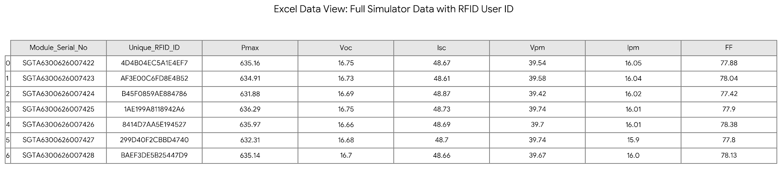
Fig: Excel / MDB (MS Access) Data View (Showing the Generated RFID Unique ID)
(Context: Excel / MDB Data View - Generated RFID Unique ID)
- The Origin Data (MDB Database): Raw electrical performance data (Pmax, Voc, Isc) is generated directly by the Sun Simulator testing machine and automatically logged into a local MS Access (MDB) database.
- The Mapping Process (Excel View): The backend application retrieves this raw data using the Module_Serial_No. The software then dynamically generates a secure, unique 16-character hexadecimal code (Unique_RFID_ID) specifically for that individual solar panel.
- The Hardware Link: To optimize speed and security, only the Unique_RFID_ID (e.g., EF4F4F1EE1F245A0) is encoded into the 688-bit User Memory of the physical RFID tag. The complete electrical dataset remains secure on the server rather than being heavily written to the tag.
- Data Retrieval: When a worker scans the tag in the field, the reader captures the Unique_RFID_ID. The system immediately queries the central database and displays the full Excel/MDB test history and production metrics for that exact solar module.

RFID Technology & Memory Banks
1. UHF RFID Memory Banks Overview
- Bank 0 (Reserved): Stores kill and access passwords for tag security.
- Bank 1 (EPC): Electronic Product Code, typically used for general identification, but can be rewritten or cloned.
- Bank 2 (TID - Tag Identifier): The factory-programmed, globally unique, read-only serial number. This ensures the physical tag cannot be cloned.
- Bank 3 (User Memory): Read/Write memory used to store custom, variable data. This is where our unique variable number will be saved.
2. RFID Tag Data Sheet
- Physical Specifications: Glass Liner/PET (Transparent/White), 98x12mm (Customizable), Linear Polarization. Working Temp: -20°C to +60°C.
- RFID Capabilities: EPC Global C1 Gen2 / ISO18000-6C, Frequency 840-960 MHz. (Chip: M4QT/AH3/G2iM/H9).
- Memory: 128-bit EPC Memory, 688-bit User Memory (Provides ample space for writing the unique variable data required for this solution).
- Read Range: Up to 10m (Fixed Reader) / Up to 6m (Handheld Reader).
- Lifecycle: >10 years expected life, 100,000 rewrite capability, Adhesive installation.

Step-by-Step Read & Write Workflows
1. Workflow: Reading the TID
- Step 1: The application issues a read command to the UHF reader.
- Step 2: The command explicitly targets Memory Bank 2 (TID).
- Step 3: The reader retrieves the TID (typically 64 or 96 bits) starting from pointer 0x00.
- Step 4: The TID is validated against the application database to confirm the physical authenticity of the tag.
2. Workflow: Writing to User Memory
- Step 1: The backend generates a unique variable data point (e.g., an encrypted unique asset number or database primary key).
- Step 2: The application authenticates the tag using the Access Password (if configured in Bank 0).
- Step 3: A write command is executed, targeting Memory Bank 3 (User Memory).
- Step 4: The unique variable data is saved to the tag. The physical tag now contains an unclonable hardware ID (TID) and a unique software-linked ID (User Memory).

Integration & Implementation Details
When writing the implementation logic (e.g., in Java using reader SDKs):
- Target Bank: Ensure commands specify 0x02 for TID read and 0x03 for User Memory write.
- Pointers & Length: Define the starting word pointer and calculate the exact hex word length of the variable data to avoid memory overflow.
- Error Handling: Implement retry logic for write operations, as UHF writes require more power and a stronger RF field than reads.

RFID Reader Relay Integration with Stack Light and Buzzer
This schematic details the physical integration between the UHF RFID Reader's relay outputs and a multi-signal stack light system to provide immediate visual and auditory feedback on the production line:
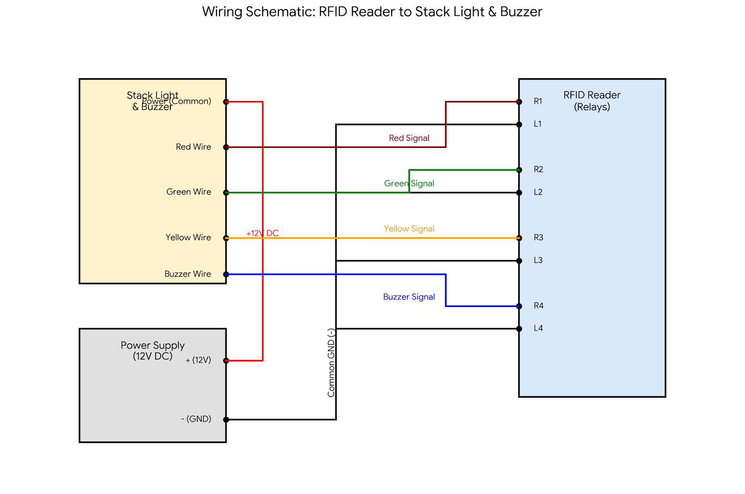
- Power Delivery: A central 12V DC power supply drives the system. The positive (+12V) terminal connects directly to the common power terminal of the stack light via a red wire. The negative (Ground) terminal establishes a common ground to the reader's L1, L2, L3, and L4 relay terminals via a black bus wire.
- Relay Triggers: The reader's four R-terminals dictate the signal states:
  - R1 (Dark Red Wire): Triggers the Red Signal (e.g., Invalid Tag / Write Failure).
  - R2 (Green Wire): Triggers the Green Signal (e.g., Valid Tag / Write Success).
  - R3 (Yellow Wire): Triggers the Yellow Signal (e.g., System Ready / Processing).
  - R4 (Blue Wire): Triggers the Buzzer (auditory alert for specific events).

Final Output & Reporting
When a processed module is scanned by end-users or QA teams, the application renders a comprehensive digital report.
FIGURE: SOLAR PANEL I-V CURVE GRAPH AND DATA REPORT NEXT PAGE

The generated UI/PDF report includes:
- Complete PV Module & Cell Information
- Manufacturer and Customer specific tracking details
- IEC Certification metrics
- Graphical representation of the I-V Curve based on Simulator data

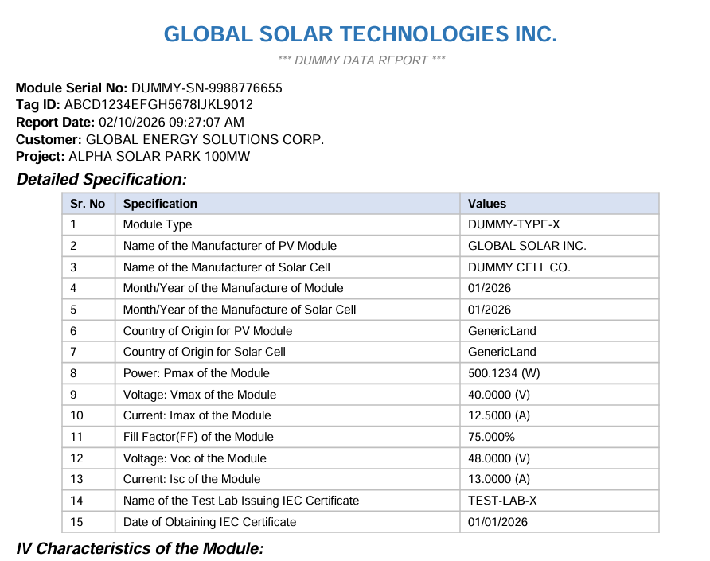
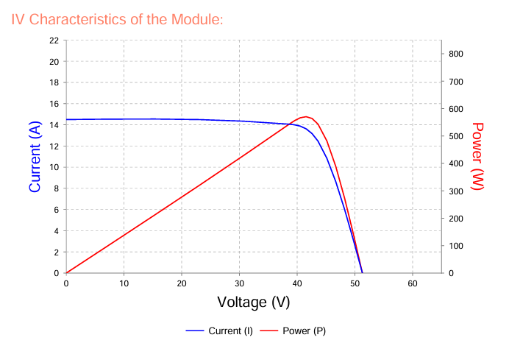
Conclusion
The dual-memory UHF RFID strategy permanently bridges the physical and digital lifecycles of solar modules. By binding the factory-locked, immutable Tag Identifier (TID) to dynamically updated production data within the tag's User Memory, the system creates an unforgeable hardware-software link. This approach transitions module tracking from a vulnerable, manual logging process into an automated, highly secure traceability framework spanning from the manufacturing floor to long-term field deployment.

Return on Investment (ROI) and Strategic Value
- Risk Mitigation & Warranty Protection: Relying on the immutable TID definitively eliminates hardware cloning and counterfeit modules entering the supply chain. This protects brand reputation and prevents financial losses from illegitimate warranty claims.
- Production Line Acceleration: Automating data retrieval and integrating instant visual operator feedback (via stack lights) removes manual scanning bottlenecks, drastically reduces human error, and increases overall manufacturing throughput.
- Comprehensive Lifecycle Traceability: Guarantees 100% real-time tracking of every solar module. Instant field access to centralized production data streamlines quality assurance checks, simplifies compliance audits, and accelerates on-site maintenance.
- Long-Term Asset Utility: Utilizing the rewritable User Memory allows module data and operational states to be updated dynamically over time. This flexibility ensures the tracking system remains relevant and useful throughout the multi-decade lifespan of the solar asset without requiring physical tag replacements.

