1. npx create-next-app --example with-tailwindcss Netflix
2. npm run build
3. npm run dev
4. **ES7+ React/Redux/React-Native snippets**
5. **Tailwind CSS IntelliSense**
6. npm install **@heroicons/react@v1** (HeroIcons)
7. npm install react-icons
8. Setup Api (<https://www.themoviedb.org>) username : Sagarrana17 Paswword : Sagarrana1127 Email Id : [sagarrana1717@gmail.com](mailto:sagarrana1717@gmail.com)
9. npm i --save-dev tailwindcss-textshadow (text shadow tailwind)
10. 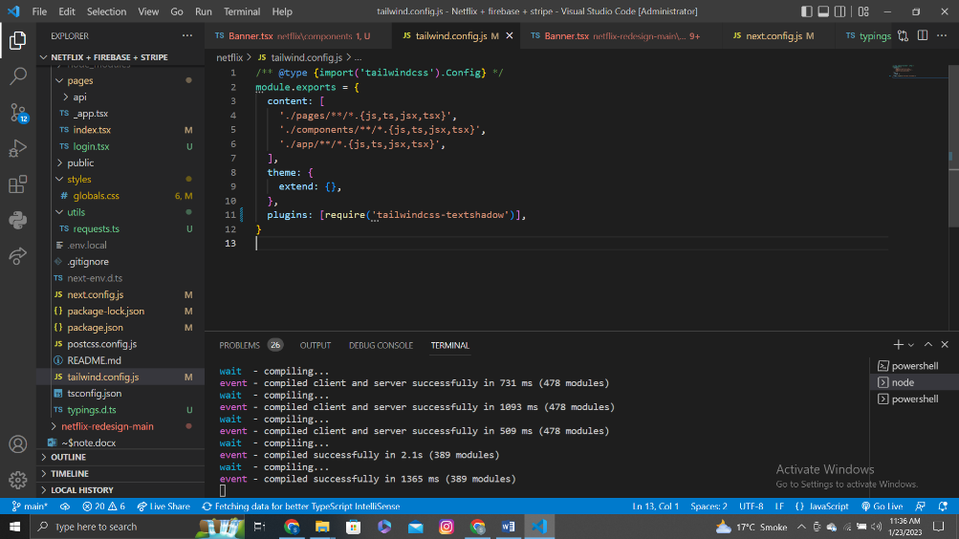
11. npm install tailwind-scrollbar-hide

// tailwind.config.js

module.exports = {

theme: {

// ...

},

plugins: [

require('tailwind-scrollbar-hide')

// ...

]

}

<div class="w-4 scrollbar-hide">...</div>

1. npm install react-hook-form
2. <https://recoiljs.org/>
3. npm install recoil
4. mui.com
5. npm install @mui/material @emotion/react @emotion/styled
6. npm install react-player
7. fire base [sagarrana17@gmail.com](mailto:sagarrana17@gmail.com)
8. password Sagarrana1127@ or Sagarrana1127

Error

1. Server not start

ready - started server on 0.0.0.0:3002, url: http://localhost:3002

[Error: UNKNOWN: unknown error, readlink 'C:\...\seo-site\.next\server\pages\_document.js'] {

errno: -4094,

code: 'UNKNOWN',

syscall: 'readlink',

path: 'C:\\...\\seo-site\\.next\\server\\pages\\_document.js'

}

Slove :

deleting the .next file and running npm run dev fixed the issue. I am not sure why this worked but I think it has something to do with next.js trying to use parts of a previous build when you make updates that are causing errors. deleting folder forces next to rebuild everything again.

Delete File .next and npm run build and start project npm run dev