**KATHFORD INTERNATIONAL COLLEGE OF**

**ENGINEERING AND MANAGEMENT**

Balkumari, Lalitpur

A

Major Project Proposal

On

**“FAKE PRODUCT IDENTIFICATION USING QR CODE BASED BLOCKCHAIN SYSTEM”**

[Subject Code: EX654]

**Project Members**

Bharat Karki (003/BEX/2074)

Niranjan Tamang (007/BEX/2074)

Sagar Shrestha (011/BEX/2074)

**DEPARTMENT OF COMPUTER AND ELECTRONICS &**

**COMMUNICATION ENGINEERING**

**LALITPUR, NEPAL**

**JUNE 2021**

Abstract

fd

**Keywords:** Blockchain, Ethereum, Smart contracts

Table of Contents

Abstract i

Table of Contents ii

List of Figures iv

List of Tables v

List of Abbreviations vi

1 Introduction 1

1.1 Background 1

1.2 Problem Statement 1

1.3 Objectives 2

1.3.1 Main Objective 2

1.3.2 Specific Objectives 2

2 Literature Review 3

3 Feasibility Study 5

3.1 Technical Feasibility 5

3.2 Financial Feasibility 5

3.3 Schedule Feasibility 5

3.4 Operational Feasibility 6

4 Project Methodology 7

4.1 Block Diagram 7

4.2 Flow Chart 8

5 Implementation Plan 9

5.1 Schedule 9

5.2 Hardware and Software Requirements 10

5.2.1 Hardware Requirements 10

5.2.2 Software Requirements 10

6 Expected Outcomes 11

7 Cost Estimation 12

References 13

List of Figures

Figure 4.1 Block Diagram 7

Figure 4.2 Flow Chart 8

List of Tables

Table 5.1 Gantt Chart 9

Table 7.1 Cost Estimation Table 12

List of Abbreviations

Dapps Decentralized Application

# Introduction

## Background

In context of Nepal, lots of fake product of renowned company is found in market. Because of this it causes a lots of renowned company a huge loss and also break trust about the product for a customer. Individual customer also get in loss because they get the fake product not the genuine one. Also, retailer who is selling a genuine product may have to compete with the retailer who is selling a Counterfeiting product. As a result, retailer who is selling a genuine product may goes his/her business to a loss. In order to resolve this problems, one popular technology that can be used is Blockchian. One of the renowned Blockchain application is Bitcoin cryptocurrency. Blockchain is simply a chain of blocks connected together with hash value. If any of data gets changed in one block, whole of the block following that blocks gets wrong. Any application built using Blockchain technology ensures that contents in data are tamper-proof.

The main goal of our project is to make a decentralized Blockchain system to keep the record of information of manufactured product such as ownership of the product, model number, Date of Manufacture and so on. At the customer side, we tends to use the QR code scanner to get the information about product using and check whether or not the product is genuine or not which indeed help the customer to buy the given product or not.

## Problem Statement

career.

## Objectives

### Main Objective

* To design and develop a decentralized Blockchain system for fake product identification using QR code.

### Specific Objectives

1. To make a smart contracts using solidity programming language
2. Design and develop Dapps
3. To make a Blockchain with each block containing necessary data.
4. To generate QR code for a product

# Literature Review

Rachit Adhvaryu [1] described about the OCR. According to him OCR is the process of classification of optical pattern contained in a digital image corresponding to alphanumeric characters. OCR Technology allows us to convert scanned documents, pdf files and images from digital camera to editable and readable form. It is also described as the different technique used for speech recognition, optical mark reading, online character recognition and offline character recognition etc.

M. Jordan [2] described in this book about the concept on recognition system and machine learning helpful for the different type of modeling system. Richard O. Duda [3] described how to implement the modeling system on different type of design cycle to help for design algorithm.

Computer vision is the science and technology of machines that machine is capable to extract the information from the information such as numbers, text and many more to solve some task. Alphanumeric recognition system can recognize almost all the letters and numbers correctly and their respective locations as they appear in the image. In general, alphanumeric recognition is classified into two types as off-line and online handwriting recognition methods. In the off-line recognition takes the raster image from the scanner (scanned images), digital camera. The image is binarized based on for instance, color pattern (color or gray scale) so that the image pixel is either 1 or 0. But, in case of on-line character recognition, the current information is presented to the system and recognition is carried out at the same time. Basically, it accepts the string of (x, y) coordinate pairs from an electronic pen touching a pressure sensitive digital tablet. Adaptive Template matching and Feature Extraction using curvelet transform can be used to recognize the alphanumeric character [4].

Text characters are often in different scale in the documents to give an importance and also the character could also appear in different orientation other than the usual horizontal and vertical direction. Partha [5]used the convex Hull based approach for multi-oriented character recognition from the graphical documents. A Support Vector Machine (SVM) classifier has been used for recognition purpose.

Alphanumeric recognition results vary a bit from different types of classifiers. Classifier like Projection distance (PD), Subspace method (SM), Linear discriminant function (LDF), Support vector machines (SVM), Modified quadratic discriminant function (MQDF), Mirror image learning (MIL), Euclidean distance (ED), Nearest neighbor, k-Nearest neighbor (k-NN), Modified Projection distance (MPD), Compound projection distance (CPD), and Compound modified quadratic discriminant function (CMQDF) are there [6]. For recognition purpose, four sets of features are there(two are from binary and two are from gray-scale image). Most of the case we use the binary dataset, but our data set is grey scale, to get the feature on the binary images we convert the gray-scale image into binary using Otsu method.

Sometimes photo we click may be blurring artifacts, varying illuminations, changing background due to which some of recognition system may not work properly, so this above problem can be efficiently solve by using stroke width transform [7]. At first, pre-processing of the image is done to remove blurring artifacts. Then the significant edges in the image are detected and new image is formed by grouping the connecting rays.

# Feasibility Study

## Technical Feasibility

All the technical resources required for the project including hardware parts and software are easily available in the market. Also, most of the equipment that is required for the project is there within the reach of college’s Electronics Lab. And there must not be a problem for us to get those things that are required for the project. Evaluating the technical feasibility is the most intricate part of the feasibility study. Here, as we will be making an OCR using python and mat lab. For making an OCR application, the image preprocessing (Noise Reduction, Skew correction, Gray scaling, Thresholding) will be done by using OpenCV. The segmentation part (Page Segmentation, box segmentation and Character Segmentation) will also be done by OpenCV and the Character classification will be done by using Neural Networks and Machine Learning techniques We just need Rasp Bain OS. Since our project does not require many resources and technical requirements it can be operated easily.

## Financial Feasibility

The project we are going to work on is economically feasible and is within the range of affordable expenditure as most of the equipment and electronic devices are already available. Once the system setup is done and it starts functioning as it is supposed to, then all the expenses that are made during the project would look worth it. A simple financial analysis which gives the actual comparison of costs and benefits are much more meaningful in every project. This gives the top management economic justification for the new system. Since we do have to use few hardware components in our project so, the total cost for our project is very low which makes it financially feasible and easy to complete within deadline.

## Schedule Feasibility

The project is currently in the analysis and requirement gathering phase. So, in 9 months, the project is expected to be completed within the proposed schedule.

## Operational Feasibility

Our final project will need the computer and raspberry pi controller with internet connection to utilize it. The result will be in PDF form that contains the mark sheets of students.

# Project Methodology

## Block Diagram

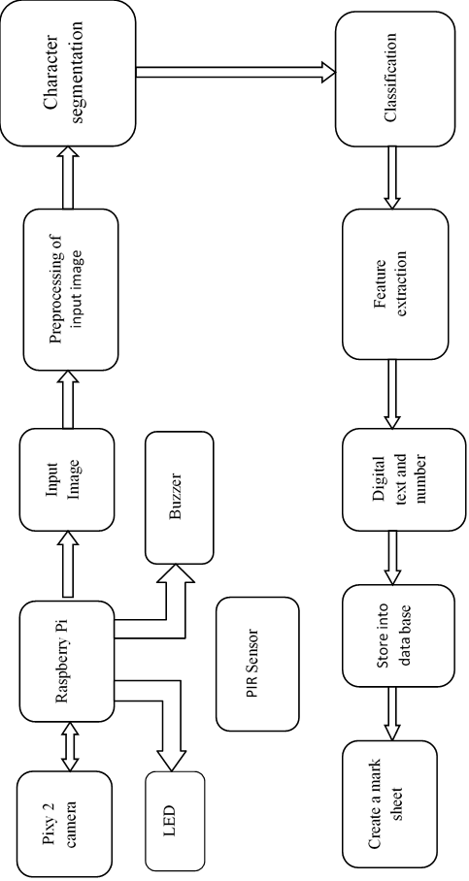

**Figure 4.1 Block Diagram**

## Flow Chart

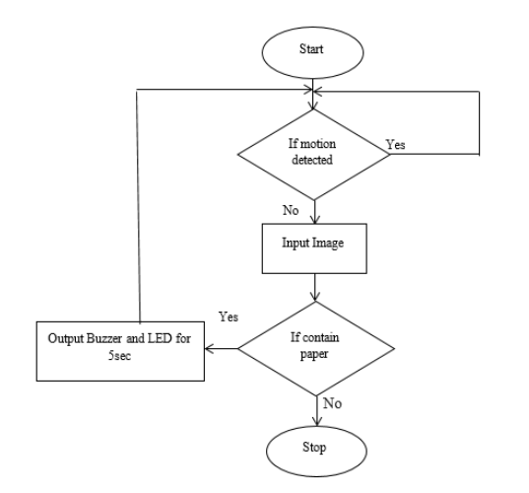

**Figure 4.2 Flow Chart**

# Implementation Plan

## Schedule

**Table 5.1 Gantt Chart**

|  |  |  |  |  |  |
| --- | --- | --- | --- | --- | --- |
| **S.N.** | **ACTIVITY** | **JAN-MAR** | **MAY-JUN** | **JUL-AUG** | **SEPT-OCT** |
| 1 | Feasibility Study |  |  |  |  |
| 2 | System specification |  |  |  |  |
| 3 | Requirement Analysis |  |  |  |  |
| 4 | Design  Hardware Interface with Microcontroller |  |  |  |  |
| Entire Hardware Assembling |  |  |  |  |
| 5 | Designing and Building Prototype |  |  |  |  |
| 6 | Documentation |  |  |  |  |
| 7 | Testing |  |  |  |  |
| 8 | Implementation |  |  |  |  |

## Hardware and Software Requirements

### Hardware Requirements

* + A computer with internet connection
  + Mobile Device with Camera with internet connection

### 5.2.2 Software Requirement

* + Ethereum
  + solidity
  + Node.js
  + HTML
  + CSS
  + Ganache
  + GIT
  + Javascript
  + Android Studio

# Expected Outcomes

The following outcomes have been presumed for this project:

* + Get the information from QR code attach to product using QR code scanner
  + By providing the information of product to Dapps, Customers can verify that the product is genuine or not.

References

|  |  |
| --- | --- |
| [1] | R. Adhvaryu, R. Parikh and K. Vora, "Design and Implementation of OCR to identify English Characters and Numbers," *International Journal of Scientific Research in Science, Engineering and Technology,* vol. 4, no. 2, pp. 57-62, 2018. |
| [2] | M. Jordan, J. Kleinberg and B. Scholkopf, PATTERN RECOGNITION AND MACHINE LEARNING, New York, 2006. |
| [3] | R. O.Duda, P. E.Hart and D. G.Stork, "Pattern Classification". |
| [4] | K. S.Machhale and P. Zode, "Implementation of Number Recognition using Adaptive Template Matching and Feature Extraction Method," 2012. |
| [5] | U. P. J. L. F. K. P. P. Roy, "Convex Hull based Approach for Multi-Oriented Character Recognition from Graphical Documents," IEEE, 2008. |
| [6] | T. W. and F. K. U. Pal, "Comparative Study of Devnagari Handwritten Character Recognition using Different Feature and Classifiers," 2009. |
| [7] | J. C. A. P. J. K.V, "Automatic Number Plate Recognition system," 2013. |