**K8S / Video-1**

----------------------------------------------------------------------------------------------

**Rename the Linux terminal**

*To Rename the Linux terminal IP to change as required name.

# sudo hostname Master

# vi /etc/hostname 🡪 Mention the required name

-----------------------------------------------------------------------------------------------

**Kubernetes commands**

# kubectl get nodes

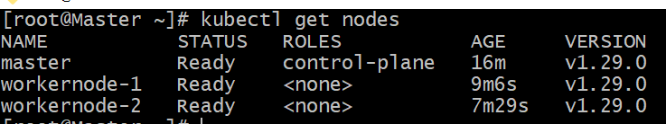

# kubectl get pods -A (-A represents hidden one)

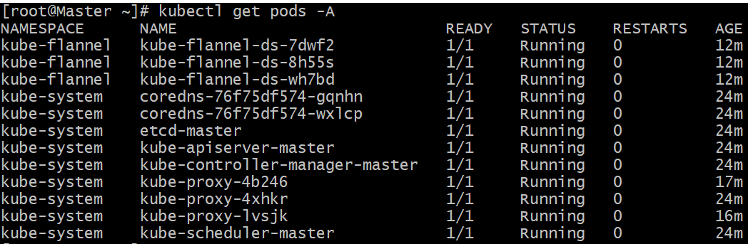

We can see some pods are executed and running in the background. These pods are maintaining the cluster. Without this pods may not setup the cluster.

# kubectl get pods -A -o wide

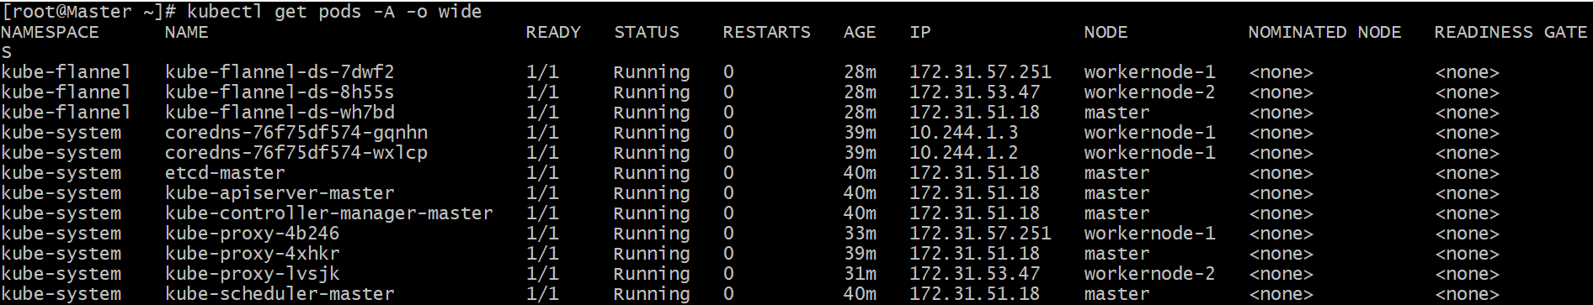

It will shown the IP address of all pods

Which pod is installed in which node.

# kubectl run firstpod --image=nginx



To create the pod for Nginx use this command

# kubectl get pods

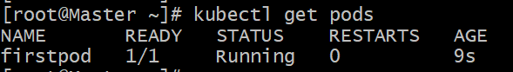

To check the created specific pod

# kubectl get pods -o wide

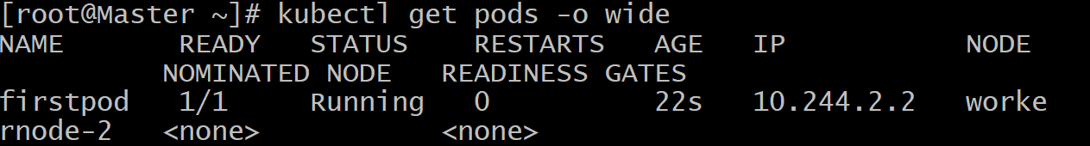  
  
To check in the which inside node -> pod is created & IP also

# kubectl describe pod firstpod  
  
Detail information of the pod created.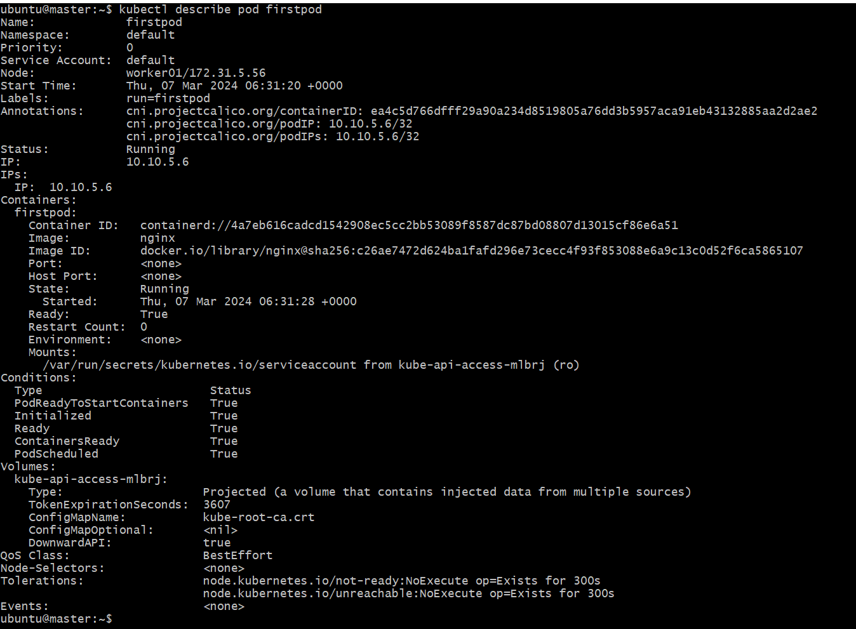  
  
# kubectl explain pods  
Detailed description of pods  
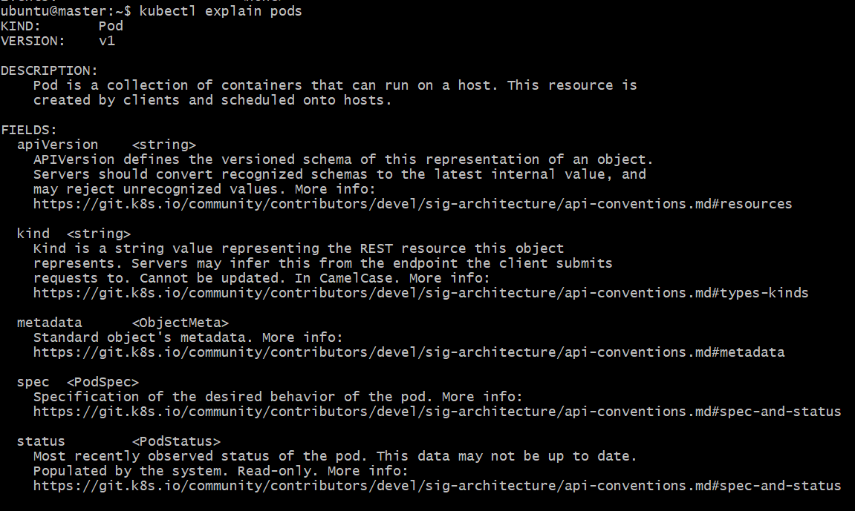

# kubectl explain rs  
Detailed description of   
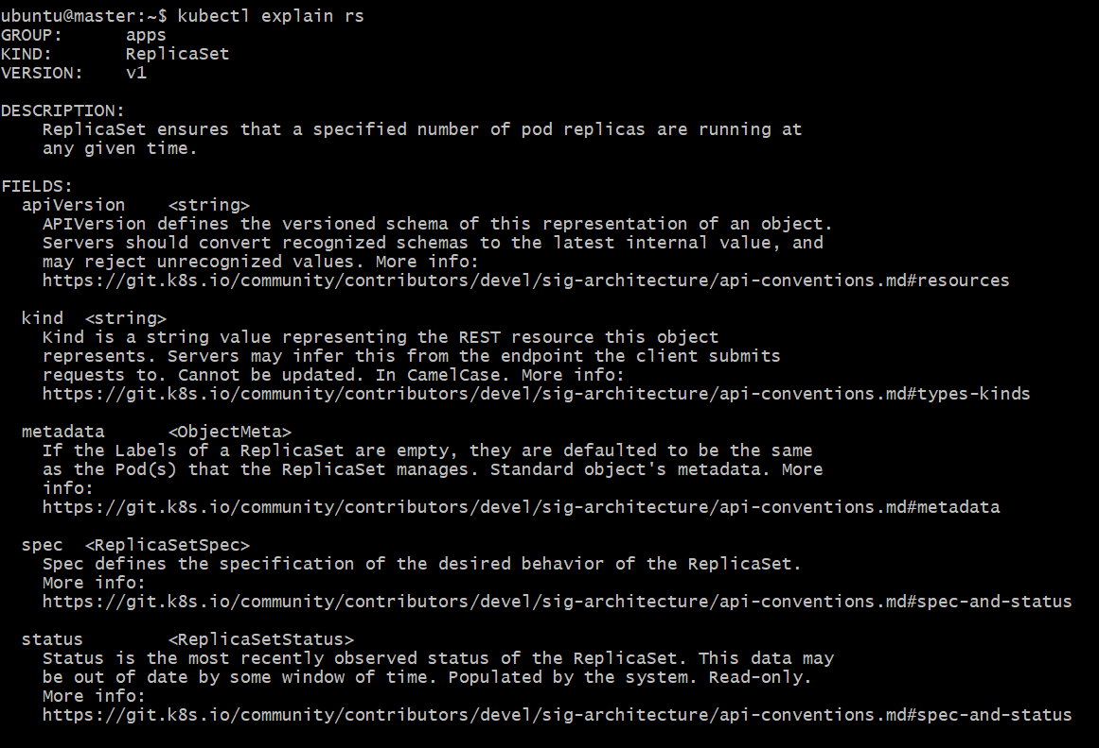  
  
# kubectl get pods -w  
Continuously watch the status of POD  
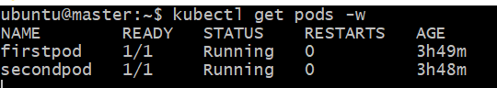  
  
# kubectl delete pod firstpod  
To delete the pod  
  
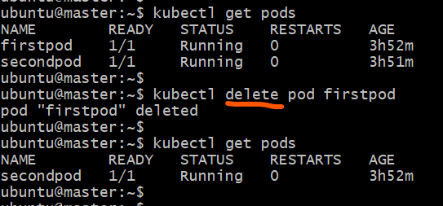

# kubectl get events  
To view the events happened our cluster  
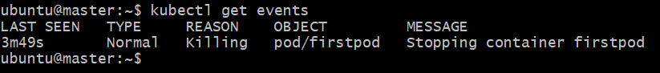  
  
# kubectl delete resourcetype resourcename  
resourcetype = pod   
resourcename = pod name  
To delete the replicaset & namespace we can use this command  
  
# kubectl run nginx --dry-run=client --image=nginx  
To check how the command will execute  


# kubectl describe pod secondpod  
kubectl describe pod <pod_name> --> to check the label attached  
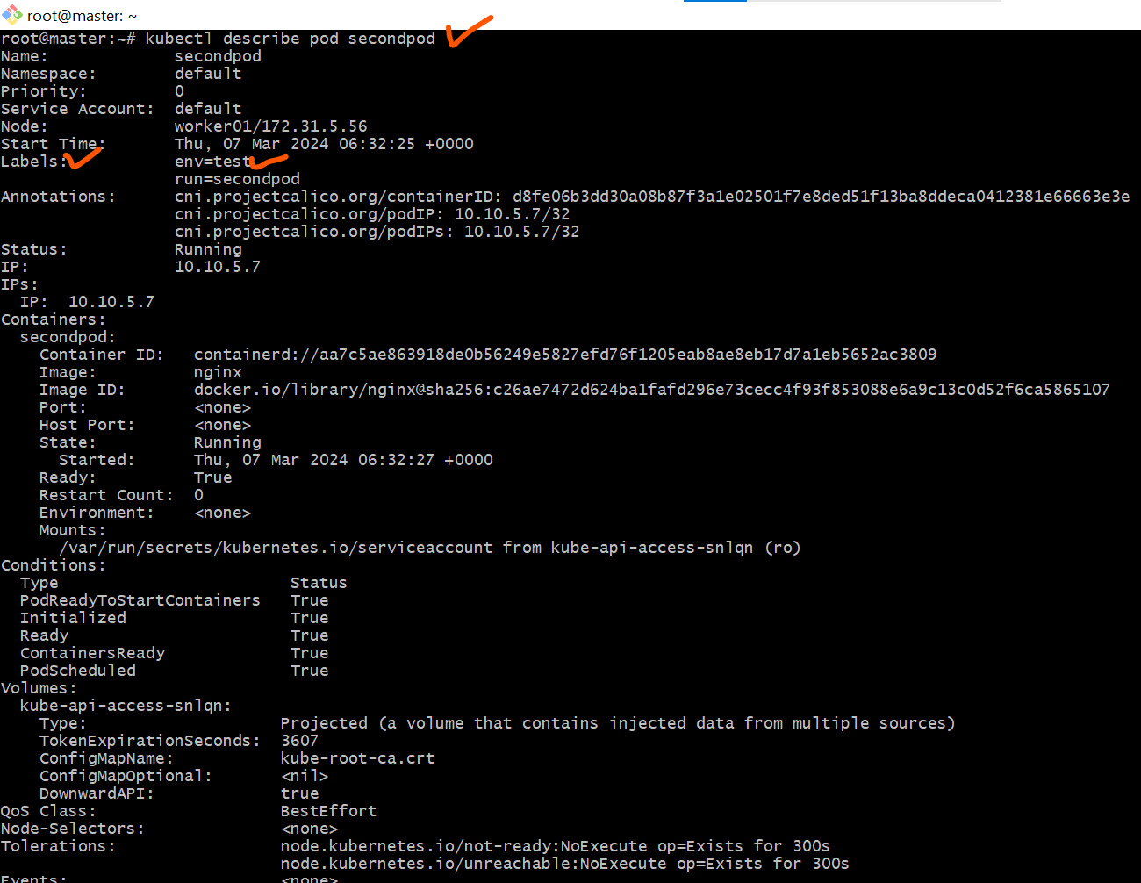  
  
# kubectl label pod firstpod env=test --> To attach label env=test  
  
# kubectl label --overwrite pod firstpod env=prod -->  
 To update the label env  
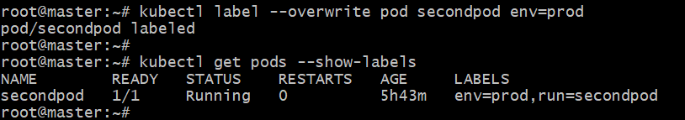  
# kubectl label pod firtpod env- --> To delete the label env

# Kubectl label pods -all status=xyz --> To update the label to all pods

# kubectl get pods --show-labels --> to check labels  


-----------------------------------------------------------------------------------------------

**ERRORS**

1. When we turn off the of Kubernetes Ec2 instances

like -> Master Node. Then our kubelet services will be go down.

1. When we check the pods list 🡪 it will be not shown the pods list.

# kubectl get nodes / Will not show the data of Nodes

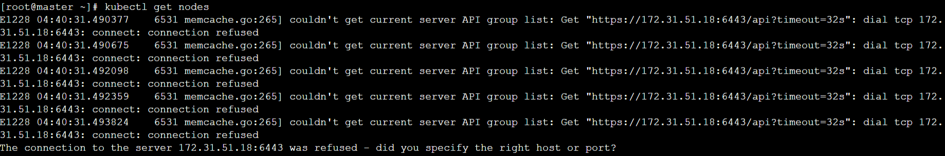

# kubectl get pods / Will not show the data of pods

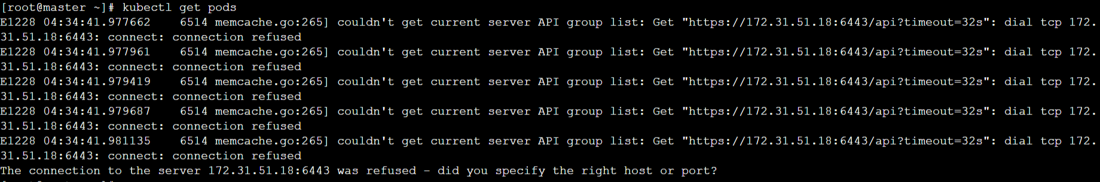

# systemctl status kubelet  
Check the status -> Kubelet / it will be inactive

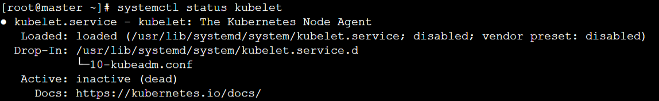

Start the kubelet service by applying this command ->

# systemctl start kubelet



# systemctl status kubelet  
Kubelet service will be activated

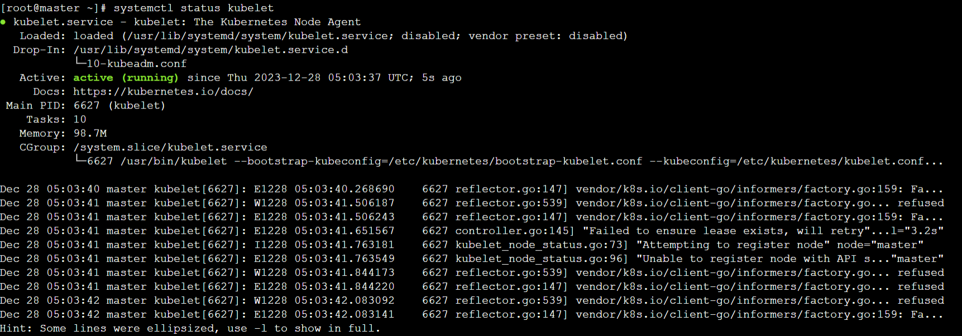

Then it will be shown the pods list

# kubectl get pods

