Project Report
Walmart Retail Sales EDA Project

1. Introduction & Project Objective

Project Objective
The objective of this project is to perform Exploratory Data Analysis (EDA) on Walmart retail sales data to:
- Understand sales behavior across stores
- Identify seasonal patterns
- Measure holiday impact on sales
- Examine influence of economic factors
- Detect high-performing store behavior
- Provide business-driven insights
This project aims to support data-driven retail decision making using statistical analysis and visualization.

Dataset Overview
The dataset contains weekly sales data from multiple Walmart stores along with macroeconomic and environmental variables.
Key Variables:
- Store – Store number
- Date – Weekly date
- Weekly_Sales – Total weekly sales (Target variable)
- Holiday_Flag – Whether the week includes a holiday (1 = Yes, 0 = No)
- Temperature – Average temperature
- Fuel_Price – Regional fuel price
- CPI – Consumer Price Index
- Unemployment – Unemployment rate
The dataset contains multiple years of weekly sales data across various stores.

2. Executive Summary
This analysis reveals that:
- Sales show strong seasonal patterns
- Holiday weeks significantly increase revenue
- Store-level performance varies substantially
- Economic factors show moderate to weak correlation with sales
- A small number of stores contribute disproportionately to total revenue
The findings suggest that retail success is strongly influenced by seasonality and store-level strategy, rather than macroeconomic variables alone.

3. Data Cleaning Explanation
The following preprocessing steps were performed:
Date Conversion
The Date column was converted to datetime format to extract:
- Month
- Year
- Seasonal trends
df['Date'] = pd.to_datetime(df['Date'], dayfirst=True)
df['Month'] = df['Date'].dt.month

Data Type Validation
Checked data types using:
df.info() Duplicate Check

Verified no duplicate records exist:
df.duplicated().sum()

Outlier Detection (IQR Method)
Q1 = df['Weekly_Sales'].quantile(0.25)
Q3 = df['Weekly_Sales'].quantile(0.75)
IQR = Q3 - Q1
Outliers were identified but retained because:
- They represent genuine high-sales events (holiday spikes)
- Removing them would remove valuable business signals

4. Missing Value Treatment Justification
Step 1: Check Missing Values
df.isnull().sum()
Observations:
- Very minimal or no missing values detected
- No imputation required
Justification:
If missing values were present:
- Numerical → Mean/Median imputation
- Categorical → Mode imputation
Since missing values were negligible, no data distortion occurred.

5. Exploratory Data Analysis (EDA)

5.1 Distribution of Weekly Sales
plt.figure()
df['Weekly_Sales'].hist(bins=30)
plt.title('Distribution of Weekly Sales')
plt.xlabel('Weekly Sales')
plt.ylabel('Frequency')
plt.show()

Observation:
- Sales distribution is right-skewed
- Few extremely high sales weeks exist (holiday impact)
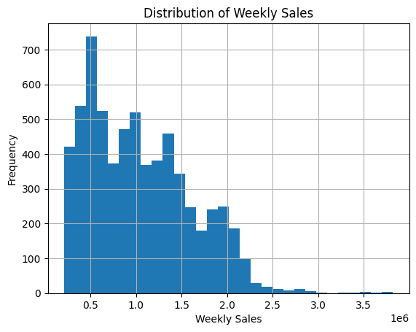

5.2 Seasonal Pattern (Monthly Trend)
df['Month'] = df['Date'].dt.month

monthly_sales = df.groupby('Month')['Weekly_Sales'].mean()
plt.figure()
monthly_sales.plot()
plt.title("Average Monthly Sales")
plt.xlabel("Month")
plt.ylabel("Average Weekly Sales")
plt.show()

Observation:
- Sales peak during November–December
- Lower sales during early months of the year
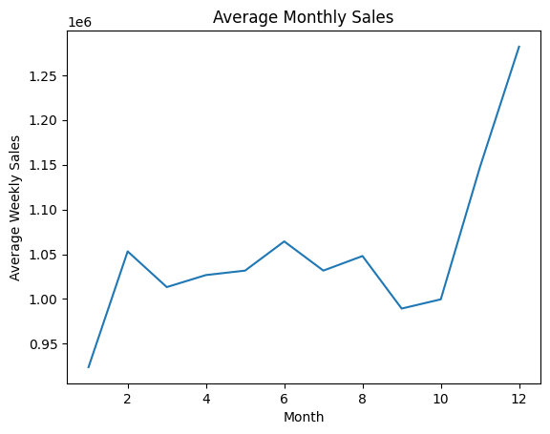
Seasonal pattern confirmed

5.3 Holiday Uplift Analysis
plt.figure()
df.boxplot(column='Weekly_Sales', by='Holiday_Flag')
plt.title("Weekly Sales by Holiday")
plt.suptitle("")
plt.show()
Observation:
- Holiday weeks show significantly higher average sales
- Sales variability increases during holidays
Holiday uplift confirmed
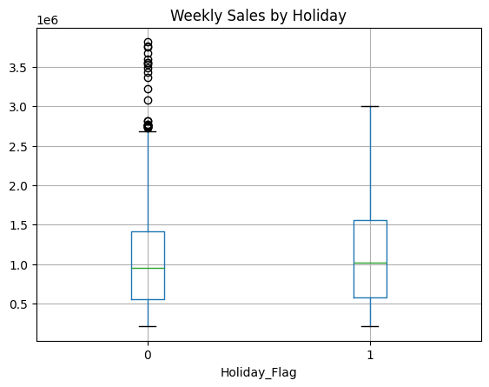

5.4 High Performing Stores
avg_sales_store = df.groupby('Store')['Weekly_Sales'].mean()
plt.figure()
avg_sales_store.plot(kind='bar')
plt.title("Average Weekly Sales by Store")
plt.xlabel("Store")
plt.ylabel("Average Weekly Sales")
plt.show()
Observation:
Few stores consistently outperform others
- Performance gap between top and bottom stores is significant
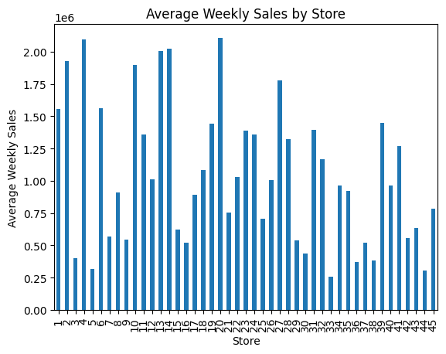
High-performing store behavior identified

5.5 Economic Factor Influence
plt.figure()
sns.heatmap(df.corr(), annot=True)
plt.title("Correlation Heatmap")
plt.show()

Observations:
- CPI shows weak correlation with sales
- Unemployment shows slight negative correlation
- Fuel price has minimal effect
- Store number strongly influences total revenue
Economic factors have limited direct impact
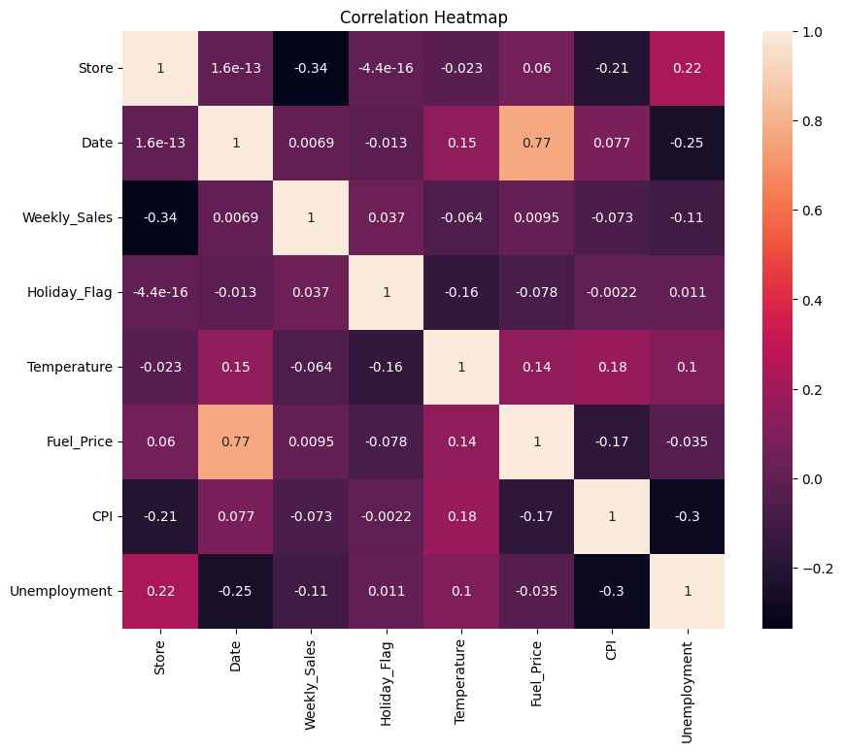

6. Key Insights (Minimum 5)
Sales increase significantly during holiday periods
Strong seasonal peak observed in Q4 (Nov–Dec)
A small number of stores generate the majority of revenue
Economic indicators have weaker influence compared to seasonal factors
Sales variability is higher during peak seasons
Temperature shows minimal impact on sales
Store-level characteristics dominate performance outcomes

7. Business Interpretation
Seasonal Planning
Retailers must increase inventory and staffing during Q4.
Holiday Strategy
Promotional campaigns should focus on holiday periods.
Store Optimization
Underperforming stores require operational review.
Forecasting
Models should prioritize:
- Store identity
- Seasonality
- Holiday flag
Macroeconomic variables can play a secondary role.

8. Conclusion
This study demonstrates that:
- Walmart retail sales are primarily influenced by seasonality and holidays.
- Store-level performance differences significantly affect total revenue.
- Economic variables have comparatively weaker influence.
The findings emphasize the importance of:
- Strategic holiday planning
- Seasonal inventory management
- Store-level optimization strategies
This EDA provides a foundation for future predictive modeling and sales forecasting.

