INDEX
Practical No. | Aim
1 | To perform fundamental data handling and processing operations using Python, including:  1. Parsing and extracting data from text, CSV, HTML, XML and JSON files  2. Performing read and write operations on binary files  3. Searching, splitting and replacing strings using regular expressions  4. Creating and managing a relational database using SQL CRUD operations
2 | To perform the ETL process in Power BI by extracting, transforming, and loading data to prepare it for analysis.
3 | To implement and demonstrate single and multiple document insertion and retrieval operations in MongoDB.
4 | To perform noise elimination, feature selection, and exploratory data analysis (EDA) using Python libraries.
5 | To extract user data from a REST API and a flat CSV file, transform and merge the data using Python.
6 | To design and configure a scheduled Apache Airflow DAG for orchestrating an ETL workflow through sequential tasks for pipeline initialization, data extraction, and successful pipeline completion.
7 | To design and implement an ETL pipeline using Python for extracting data from CSV files, cleaning and transforming the data, validating the records, and loading the processed data into a database.
8 | To implement PySpark DataFrame operations for reading and analyzing CSV data, including schema inspection, filtering, grouping, aggregation, duplicate removal, joining datasets, and calculating average sales by product category.
9 | To design and implement an end-to-end data pipeline that extracts e-commerce data from CSV files, cleans and transforms the data using Python/Pandas, loads it into a SQL database, generates a report, and handles both historical and newly arriving data.
Mini Project | To design and implement a retail data warehouse ETL pipeline in Python that ingests store, product and transaction data from CSV and JSON files, applies data-quality rules, shapes the data into a star schema, loads it incrementally into SQL Server, and generates a revenue report.

Practical No. – 1
Aim:
To perform fundamental data handling and processing operations using Python, including:
- Parsing and extracting data from text, CSV, HTML, XML and JSON files
- Performing read and write operations on binary files
- Searching, splitting and replacing strings using regular expressions
- Creating and managing a relational database using SQL CRUD operations

1. Parsing and extracting data from text, CSV, HTML, XML, and JSON files
Code:
import csv
import json
import xml.etree.ElementTree as ET
from bs4 import BeautifulSoup
import pandas as pd
import io

def parse_and_check_csv(csv_data):
print("--- Parsing CSV ---")
try:
df = pd.read_csv(io.StringIO(csv_data))
print("Data loaded successfully:")
display(df)

missing_summary = df.isnull().sum()
print("\nMissing values count per column:")
print(missing_summary)

duplicates = df.duplicated().sum()
print(f"\nDuplicate rows found: {duplicates}")

return df
except Exception as e:
print(f"Error parsing CSV: {e}")
return None

def parse_and_check_json(json_data):
print("\n--- Parsing JSON ---")
try:
data = json.loads(json_data)
print("Valid JSON syntax parsed successfully.")

if not data:
print("Warning: The JSON document is empty.")
else:
print(f"Root element type: {type(data)}")
if isinstance(data, list):
for i, item in enumerate(data):
null_keys = [k for k, v in item.items() if v is None or v == ""]
if null_keys:
print(f"Warning: Record {i} has empty values in fields: {null_keys}")
return data
except json.JSONDecodeError as e:
print(f"JSON Decode Error (Invalid Syntax): {e}")
return None

def parse_and_check_html(html_data):
print("\n--- Parsing HTML ---")
try:
soup = BeautifulSoup(html_data, 'html.parser')
print("HTML parsed with BeautifulSoup.")

tables = soup.find_all('table')
print(f"Total tables found: {len(tables)}")
for i, table in enumerate(tables):
rows = table.find_all('tr')
print(f" Table {i+1} has {len(rows)} rows.")
if len(rows) == 0:
print(f" Anomaly: Table {i+1} is empty.")
return soup
except Exception as e:
print(f"Error parsing HTML: {e}")
return None

def parse_and_check_xml(xml_data):
print("\n--- Parsing XML ---")
try:
root = ET.fromstring(xml_data)
print(f"XML root element tag: '{root.tag}' parsed successfully.")

empty_elements = []
for elem in root.iter():
if elem.text is None or elem.text.strip() == "":
if len(elem) == 0:
empty_elements.append(elem.tag)

if empty_elements:
print(f"Warning: Found empty leaf elements: {empty_elements}")
else:
print("No empty elements found in XML structure.")
return root
except ET.ParseError as e:
print(f"XML Parse Error: {e}")
return None

def parse_and_check_text(text_data):
print("\n--- Parsing Plain Text ---")
try:
lines = text_data.strip().split('\n')
print(f"Total lines parsed: {len(lines)}")

empty_lines = [i+1 for i, line in enumerate(lines) if not line.strip()]
if empty_lines:
print(f"Warning: Found empty or blank lines at line number(s): {empty_lines}")
return lines
except Exception as e:
print(f"Error parsing plain text: {e}")
return None

csv_sample = """id,name,age,email
1,Alice,30,alice@example.com
2,Bob,,bob@example.com
3,Charlie,25,
1,Alice,30,alice@example.com"""

json_sample = """[
{"id": 1, "name": "Product A", "price": 12.99},
{"id": 2, "name": "Product B", "price": null},
{"id": 3, "name": "", "price": 15.00}
]"""

html_sample = """<html>
<body>
<h1>Product Summary</h1>
<table>
<tr><th>Item</th><th>Stock</th></tr>
<tr><td>Item A</td><td>10</td></tr>
<tr><td>Item B</td><td></td></tr>
</table>
<table id='empty_table'>
</table>
</body>
</html>"""

xml_sample = """<store>
<item>
<id>101</id>
<name>Laptop</name>
<price>999</price>
</item>
<item>
<id>102</id>
<name></name>
<price>499</price>
</item>
</store>"""

text_sample = """First line of configuration data.
Second line contains value: 123.

Fourth line after an anomaly of an empty line.
"""

parse_and_check_csv(csv_sample)
parse_and_check_json(json_sample)
parse_and_check_html(html_sample)
parse_and_check_xml(xml_sample)
parse_and_check_text(text_sample)

Output:
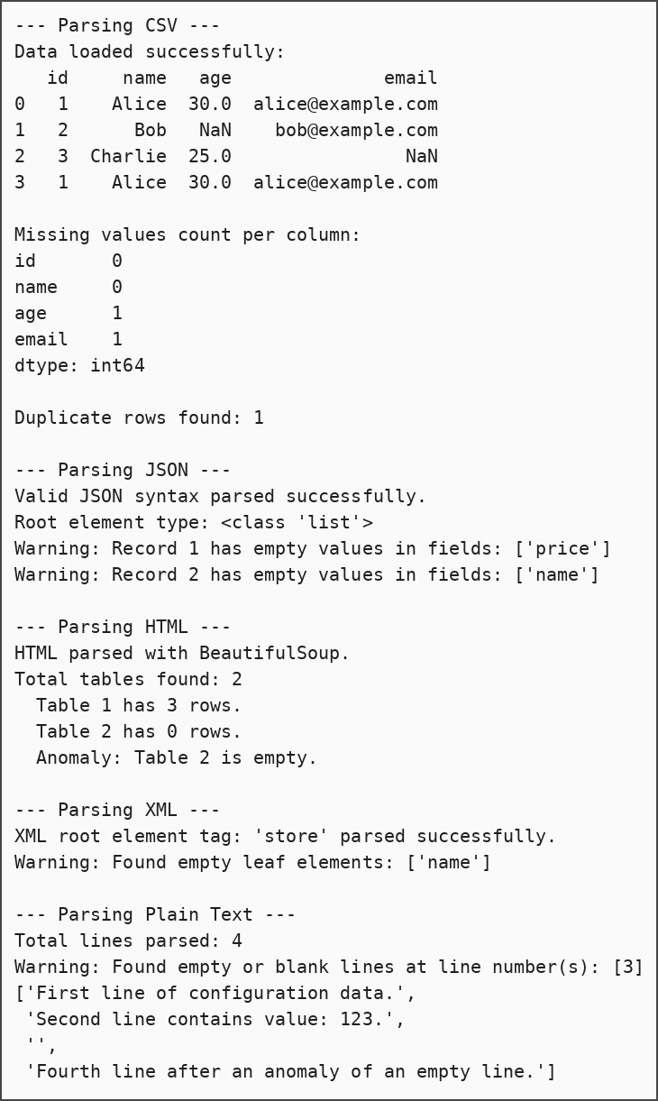

2. Performing read and write operations on binary files
Code:
import os

def write_binary_file(filepath, byte_data):
"""Writes binary data to a file safely, creating directory structures if needed."""
print(f"Writing to binary file: {filepath}")
try:
dir_name = os.path.dirname(filepath)
if dir_name and not os.path.exists(dir_name):
os.makedirs(dir_name)

with open(filepath, 'wb') as binary_file:
binary_file.write(byte_data)
print("Binary data written successfully.")
return True
except IOError as e:
print(f"I/O Error during writing binary file: {e}")
return False
except Exception as e:
print(f"Unexpected error during write: {e}")
return False

def read_binary_file(filepath):
"""Reads binary data from a file safely, returning None if errors occur."""
print(f"\nReading from binary file: {filepath}")
if not os.path.exists(filepath):
print(f"Error: The file '{filepath}' does not exist.")
return None

try:
with open(filepath, 'rb') as binary_file:
data = binary_file.read()
print(f"Successfully read {len(data)} bytes.")
return data
except IOError as e:
print(f"I/O Error during reading binary file: {e}")
return None
except Exception as e:
print(f"Unexpected error during read: {e}")
return None

test_filename = "demo_file.bin"
sample_bytes = bytes([120, 3, 255, 0, 18, 99, 104, 101, 99, 107])

if write_binary_file(test_filename, sample_bytes):
retrieved_bytes = read_binary_file(test_filename)

if retrieved_bytes == sample_bytes:
print("SUCCESS: Retrieved binary content matches original byte data!")
else:
print("FAILURE: Content mismatch.")

if os.path.exists(test_filename):
os.remove(test_filename)

Output:
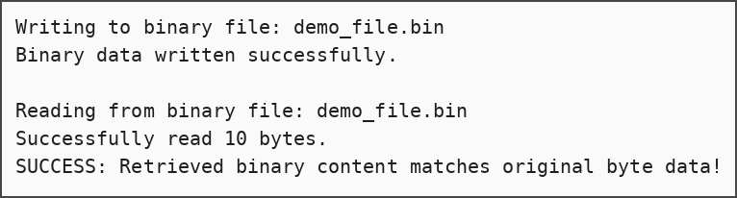

3. Searching, splitting and replacing strings using regular expressions
Code:
import re

def find_patterns(pattern, text):
"""Searches for all occurrences of a pattern in the given text."""
print(f"Searching for pattern '{pattern}'...")
try:
compiled_re = re.compile(pattern)
matches = compiled_re.finditer(text)

results = []
for match in matches:
results.append({
"match": match.group(),
"start_index": match.start(),
"end_index": match.end()
})

if results:
print(f"Found {len(results)} match(es):")
for res in results:
print(f" - '{res['match']}' at position {res['start_index']}:{res['end_index']}")
else:
print("No matches found.")
return results
except re.error as e:
print(f"Invalid Regular Expression: {e}")
return []

def split_by_pattern(pattern, text):
"""Splits a string based on match occurrences of a pattern."""
print(f"\nSplitting text using pattern '{pattern}'...")
try:
segments = re.split(pattern, text)
# Remove empty string elements from results
segments = [seg.strip() for seg in segments if seg.strip()]
print(f"Splits generated: {segments}")
return segments
except re.error as e:
print(f"Invalid Regular Expression: {e}")
return []

def replace_pattern(pattern, replacement, text):
"""Replaces instances of a pattern with a replacement string/callback."""
print(f"\nReplacing pattern '{pattern}' with '{replacement}'...")
try:
modified_text, replacement_count = re.subn(pattern, replacement, text)
print(f"Replacements made: {replacement_count}")
print(f"Result: '{modified_text}'")
return modified_text
except re.error as e:
print(f"Invalid Regular Expression: {e}")
return text

target_text = "Contact us at info@example.com or support@business-hub.co.uk before tomorrow!"

find_patterns(r'\b[A-Za-z0-9._%+-]+@[A-Za-z0-9.-]+\.[A-Z|a-z]{2,}\b', target_text)

split_by_pattern(r'[\s,!.@]+', target_text)

replace_pattern(r'\b[A-Za-z0-9._%+-]+@[A-Za-z0-9.-]+\.[A-Z|a-z]{2,}\b', '[REDACTED_EMAIL]', target_text)

Output:
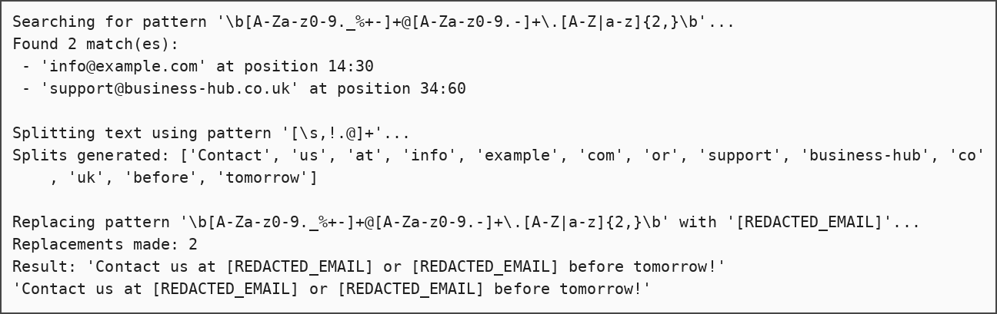

4. Creating and managing a relational database using SQL CRUD operations
SQL Script (SQL Server):
CREATE DATABASE BookstoreApp;
GO
USE BookstoreApp;
GO

CREATE TABLE Books (
book_id INT PRIMARY KEY,
title VARCHAR(100) NOT NULL,
author VARCHAR(50) NOT NULL,
price DECIMAL(5, 2),
stock_quantity INT
);

INSERT INTO Books (book_id, title, author, price, stock_quantity)
VALUES
(1, 'Deep Learning', 'Ian Goodfellow', 45.99, 10),
(2, 'Python Crash Course', 'Eric Matthes', 25.50, 20),
(3, 'SQL QuickStart', 'Walter Shields', 19.99, 15),
(4, 'The Pragmatic Programmer', 'Andy Hunt', 35.00, 5);

SELECT * FROM Books;
UPDATE Books
SET stock_quantity = 14
WHERE book_id = 3;
DELETE FROM Books
WHERE book_id = 4;

Output (result of SELECT * FROM Books):
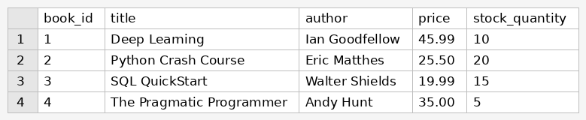

Practical No. – 2
Aim:
To perform the ETL process in Power BI by extracting, transforming, and loading data to prepare it for analysis.

Step 1 — SQL Server: create the SalesDW star schema
SQL Script:
CREATE DATABASE SalesDW;
GO
USE SalesDW;
GO

CREATE TABLE DimProduct (
ProductKey INT IDENTITY(1,1) PRIMARY KEY,
ProductID INT NOT NULL,
ProductName NVARCHAR(100) NOT NULL,
QuantityPerUnit NVARCHAR(50)
);

CREATE TABLE DimDate (
DateKey INT PRIMARY KEY,
FullDate DATE,
OrderYear INT,
OrderMonth INT
);

CREATE TABLE FactSales (
SalesKey INT IDENTITY(1,1) PRIMARY KEY,
ProductKey INT FOREIGN KEY REFERENCES DimProduct(ProductKey),
DateKey INT FOREIGN KEY REFERENCES DimDate(DateKey),
Quantity INT,
UnitPrice DECIMAL(18,2),
LineTotal DECIMAL(18,2)
);

INSERT INTO DimProduct (ProductID, ProductName, QuantityPerUnit)
VALUES
(1, 'Chai', '10 boxes x 20 bags'),
(2, 'Chang', '24 - 12 oz bottles');

INSERT INTO DimDate (DateKey, FullDate, OrderYear, OrderMonth)
VALUES
(20231001, '2023-10-01', 2023, 10),
(20231002, '2023-10-02', 2023, 10);

INSERT INTO FactSales (ProductKey, DateKey, Quantity, UnitPrice, LineTotal)
VALUES
(1, 20231001, 15, 18.00, 270.00),
(2, 20231002, 20, 19.00, 380.00);

Output:

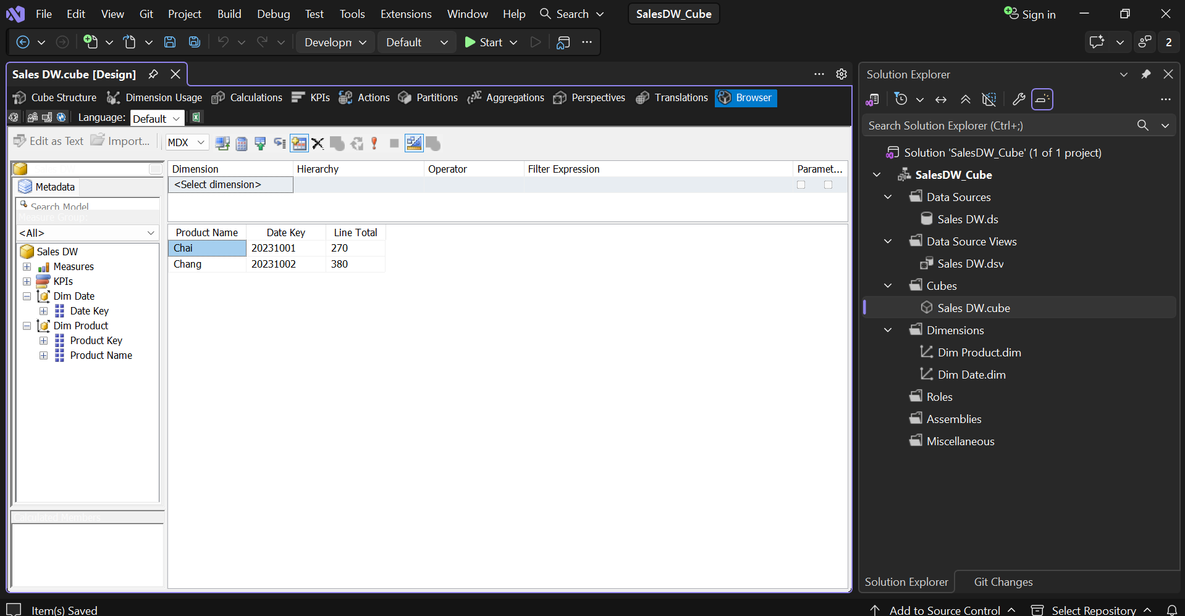
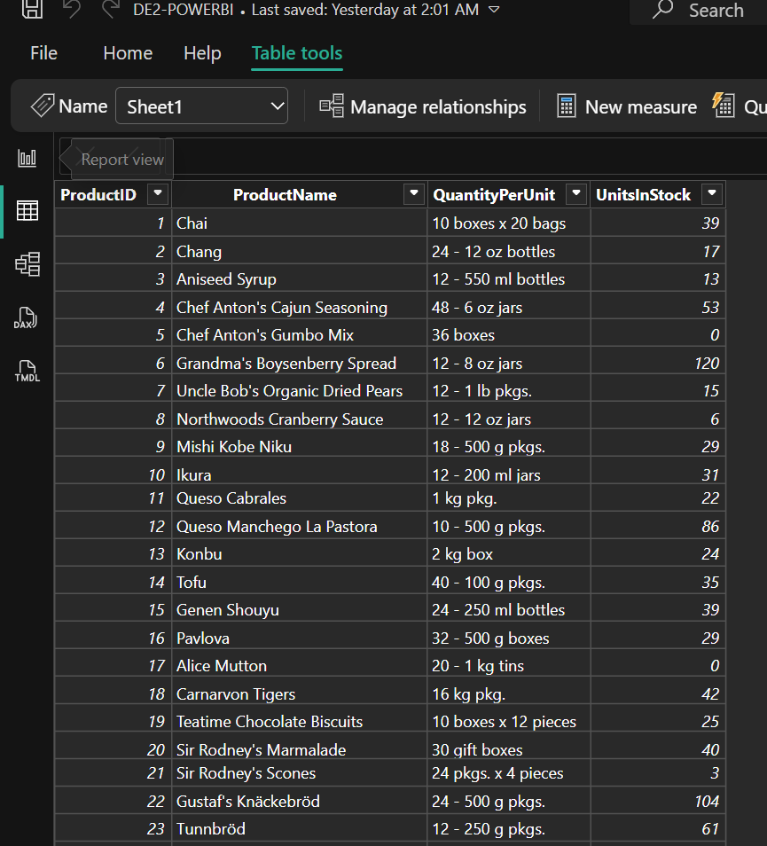
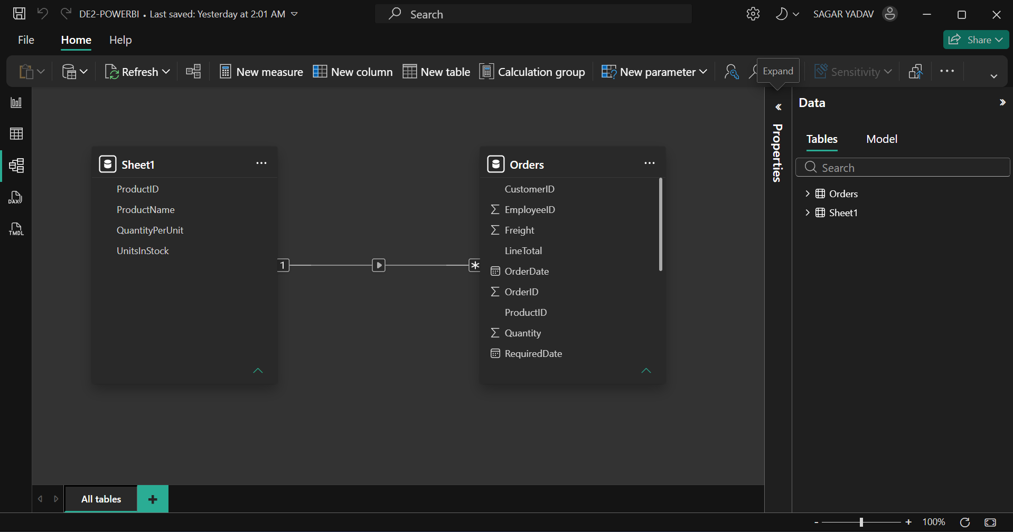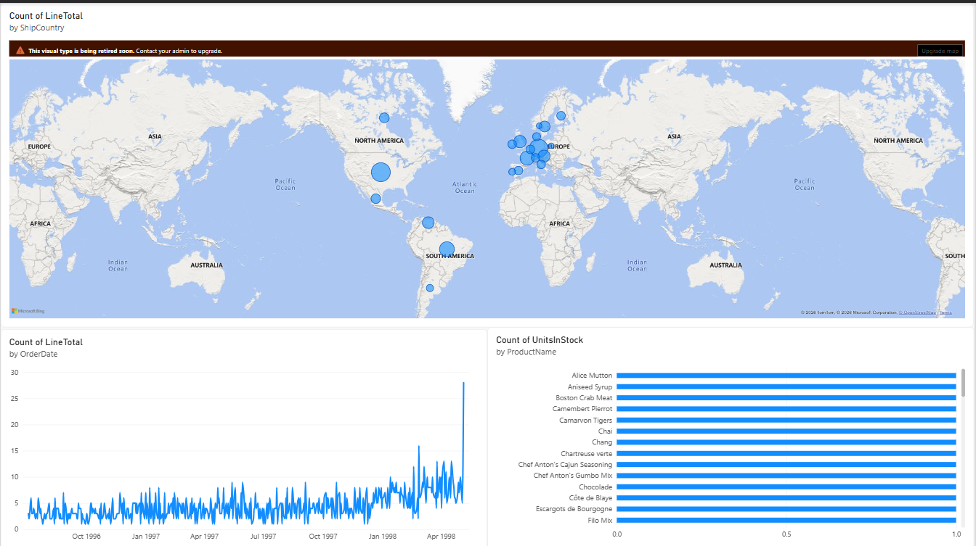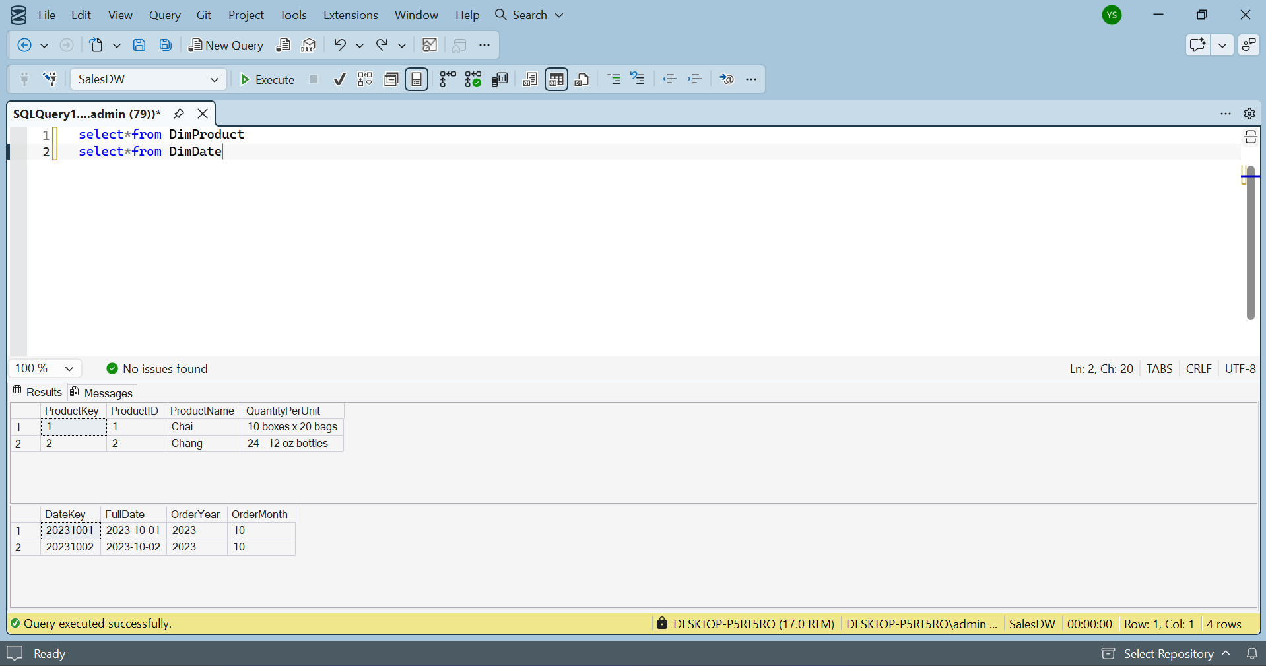
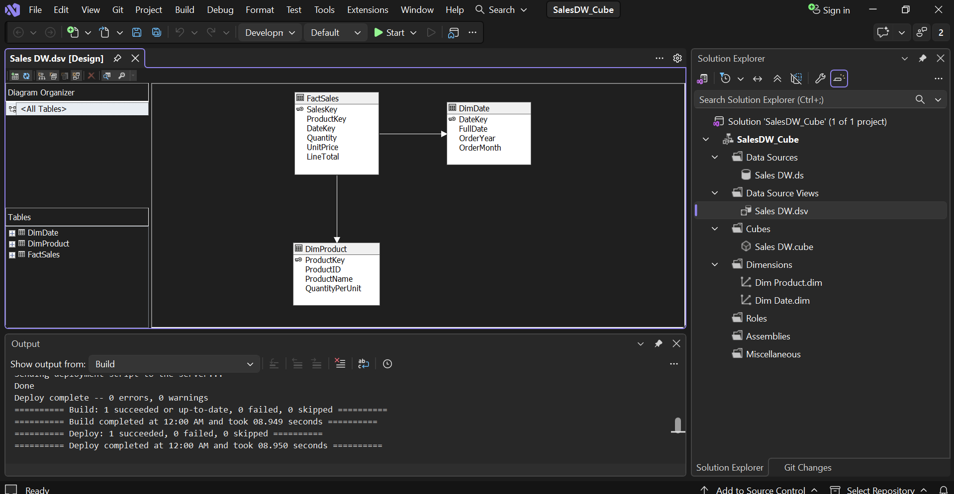

Practical No. – 3
Aim:
To implement and demonstrate single and multiple document insertion and retrieval operations in MongoDB.

Step 1: Insert Single Document
Query:
db.items.insertOne({ name: "laptop", price: 999 });

Step 2: View Inserted Document
Query:
db.items.find();

Step 3: Insert Multiple Documents
Query:
db.products.insertMany([
{ name: "phone", price: 500, stock: 10 },
{ name: "tablet", price: 300, stock: 5 },
{ name: "watch", price: 150, stock: 0 }
]);

Step 4: View Products in Formatted JSON
Query:
db.products.find().pretty();

Output:
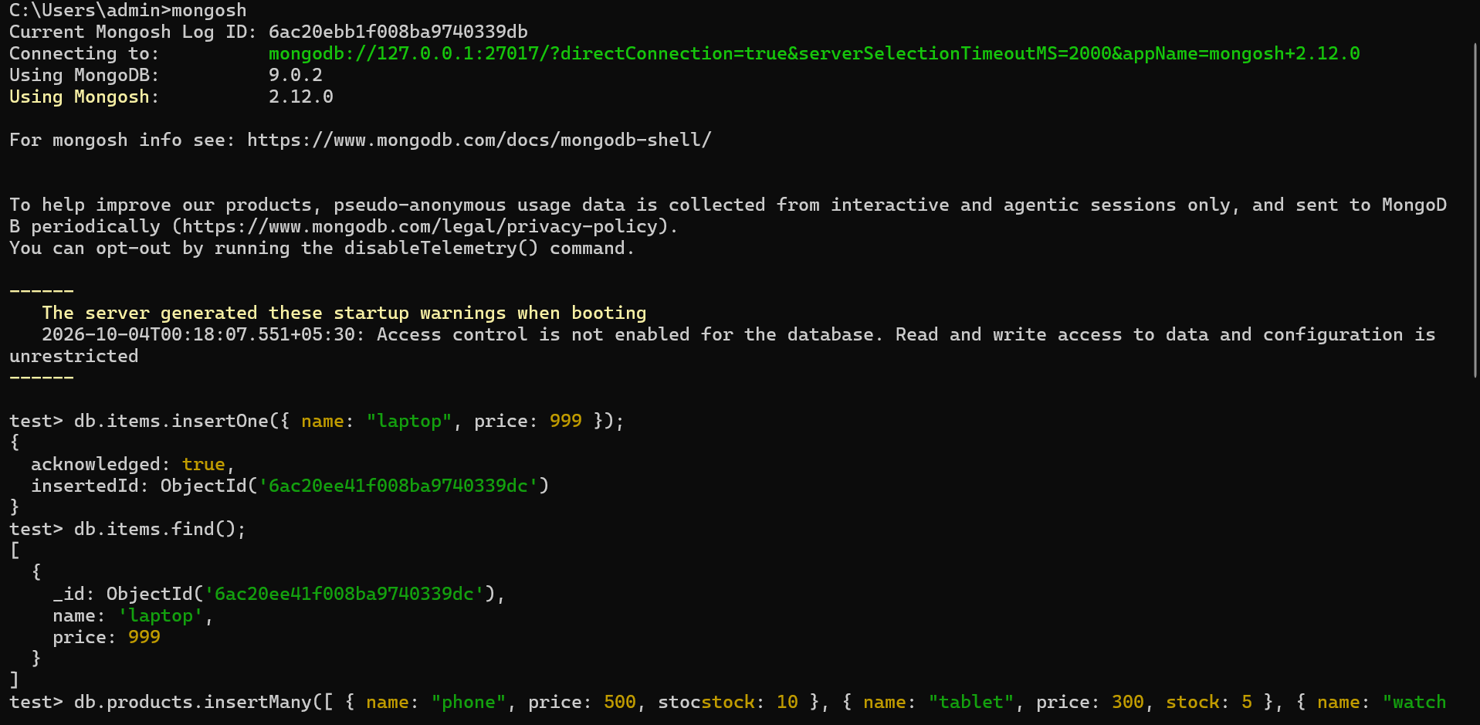
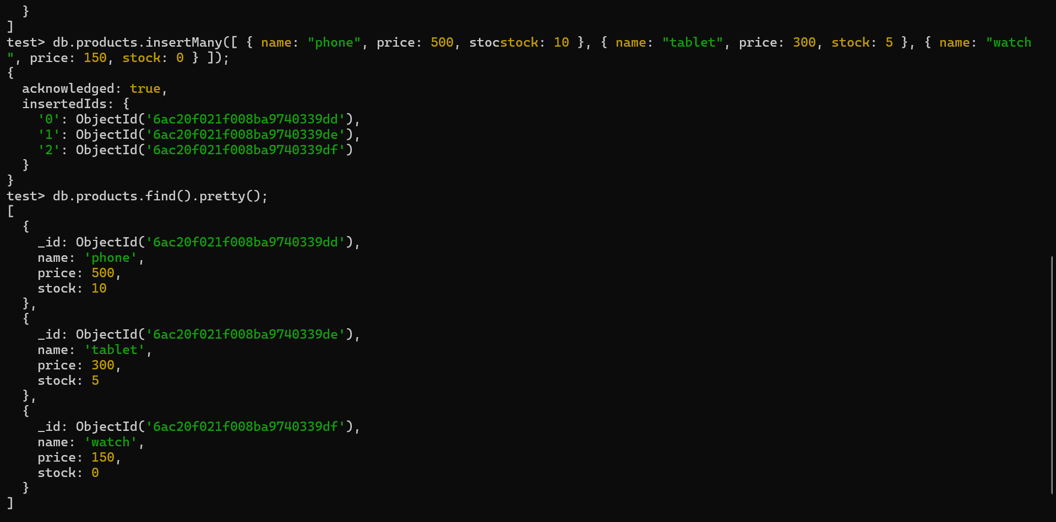

Practical No. – 4
Aim:
To perform noise elimination, feature selection, and exploratory data analysis (EDA) using Python libraries.

Part 1 — Data cleaning: missing values, duplicates and normalization
Code:
import pandas as pd

data = {
'Name': ['Amit', 'Riya', 'Amit', 'Neha', None],
'Age': [22, 24, 22, None, 26],
'Marks': [85, 90, 85, 78, None]
}

df = pd.DataFrame(data)

print("Original Data:")
print(df)

print("\nHandling Missing Values...")

df['Age'] = df['Age'].fillna(df['Age'].mean())

df['Marks'] = df['Marks'].fillna(df['Marks'].mean())

df['Name'] = df['Name'].fillna('Unknown')

print(df)

print("\nRemoving Duplicates...")

df = df.drop_duplicates()

print(df)

print("\nNormalizing Age and Marks...")

df['Age_Normalized'] = (df['Age'] - df['Age'].min()) / (df['Age'].max() - df['Age'].min())

df['Marks_Normalized'] = (df['Marks'] - df['Marks'].min()) / (df['Marks'].max() - df['Marks'].min())

print(df)

print("\nFinal Processed Data:")
print(df)

Output:
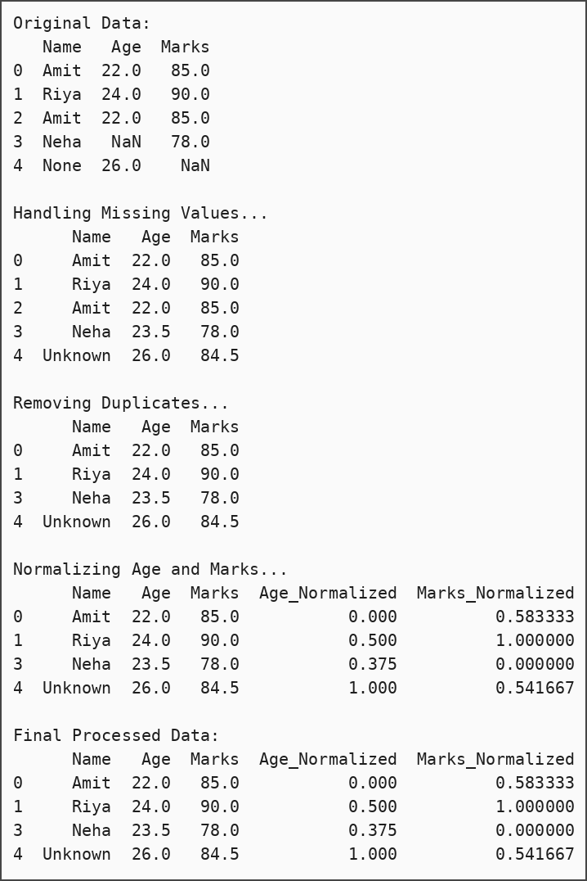

Part 2 — Noise elimination, feature selection and EDA
Code:
import pandas as pd
import numpy as np
import matplotlib.pyplot as plt
from sklearn.feature_selection import VarianceThreshold

data = {
'Age': [20, 21, 22, 23, 24, 100],
'Marks': [75, 80, 85, 90, 95, 20],
'Attendance': [85, 88, 90, 92, 94, 50],
'Constant': [1, 1, 1, 1, 1, 1]
}

df = pd.DataFrame(data)

print("Original Dataset:")
print(df)

Q1 = df['Age'].quantile(0.25)
Q3 = df['Age'].quantile(0.75)
IQR = Q3 - Q1

lower = Q1 - 1.5 * IQR
upper = Q3 + 1.5 * IQR

df_clean = df[(df['Age'] >= lower) & (df['Age'] <= upper)]

print("\nDataset after Noise Elimination:")
print(df_clean)

selector = VarianceThreshold(threshold=0.0)
selected = selector.fit_transform(df_clean)

selected_columns = df_clean.columns[selector.get_support()]

print("\nSelected Features:")
print(selected_columns)

print("\nDataset Information:")
print(df_clean.info())

print("\nStatistical Summary:")
print(df_clean.describe())

print("\nCorrelation Matrix:")
print(df_clean.corr())

df_clean.hist(figsize=(8,6))
plt.suptitle("Histogram of Features")
plt.show()

df_clean.boxplot(figsize=(8,5))
plt.title("Boxplot of Dataset")
plt.show()

Output:
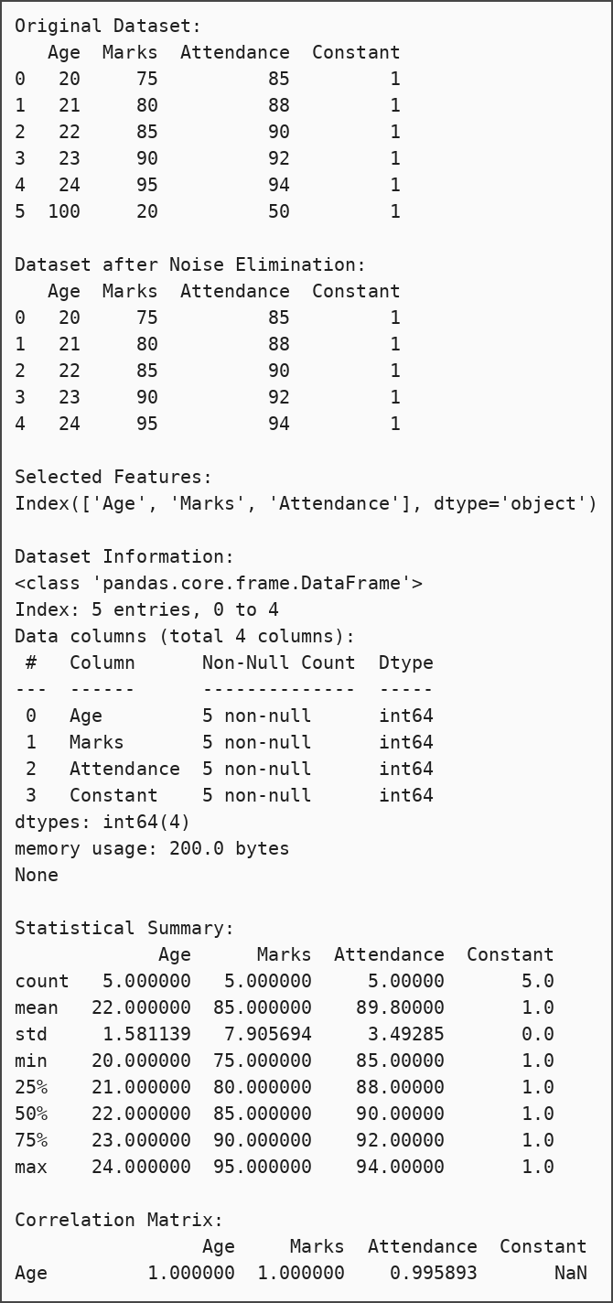
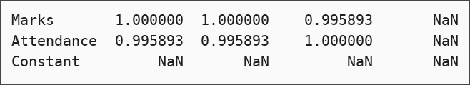
Histogram:
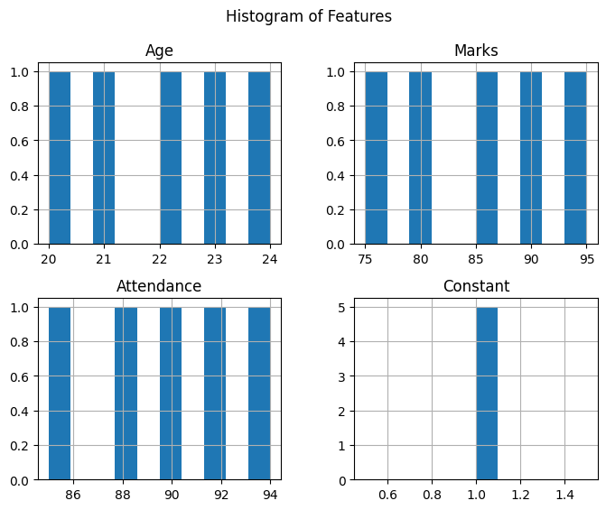
Boxplot:
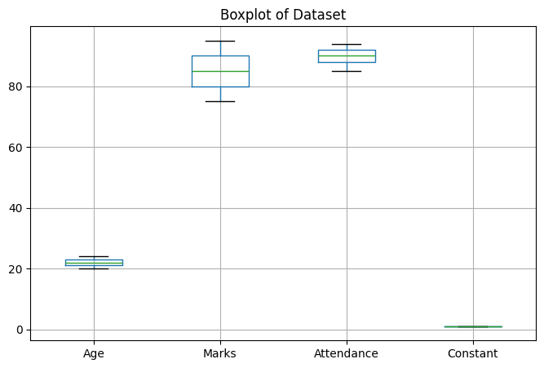

Practical No. – 5
Aim:
To extract user data from a REST API and a flat CSV file, transform and merge the data using Python.
Code:
import pandas as pd
import requests

def extract_api_data(url):
try:
response = requests.get(url, timeout=10)
response.raise_for_status()
data = response.json()
return pd.json_normalize(data)
except requests.exceptions.RequestException as e:
print(f"API Error: {e}")
return pd.DataFrame()

def extract_csv_data(file_path):
try:
return pd.read_csv(file_path)
except FileNotFoundError as e:
print(f"File Error: {e}")
return pd.DataFrame()

api_url = "https://jsonplaceholder.typicode.com/users"
api_df = extract_api_data(api_url)
if not api_df.empty:
api_df = api_df[["id", "name", "email", "company.name"]]
api_df.rename(columns={"company.name": "company"}, inplace=True)

csv_file = "locations.csv"
pd.DataFrame(
{
"id": list(range(1, 11)),
"city": [
"New York",
"London",
"Paris",
"Tokyo",
"Berlin",
"Delhi",
"Sydney",
"Moscow",
"Cairo",
"Beijing",
],
}
).to_csv(csv_file, index=False)

csv_df = extract_csv_data(csv_file)

if not api_df.empty and not csv_df.empty:
merged_df = pd.merge(api_df, csv_df, on="id", how="inner")
print("\n--- Merged ETL Pipeline Data View ---")
display(merged_df.head())
merged_df.to_csv("cleaned_warehouse_profiles.csv", index=False)
print("\nData successfully saved to 'cleaned_warehouse_profiles.csv'")

Output:
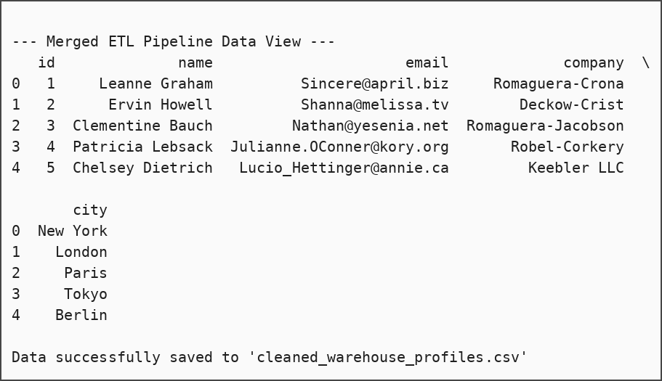

Practical No. – 6
Aim:
To design and configure a scheduled Apache Airflow DAG for orchestrating an ETL workflow through sequential tasks for pipeline initialization, data extraction, and successful pipeline completion.
Code:
from datetime import datetime, timedelta
from airflow import DAG
from airflow.providers.standard.operators.bash import BashOperator
from airflow.providers.standard.operators.empty import EmptyOperator

default_args = {
"owner": "data_engineering_lab",
"depends_on_past": False,
"start_date": datetime(2026, 1, 1),
"email_on_failure": False,
"email_on_retry": False,
"retries": 1,
"retry_delay": timedelta(minutes=5),
}

with DAG(
"university_etl_orchestration",
default_args=default_args,
description="Lab assignment for API and Flat File ETL orchestration",
schedule=timedelta(days=1),
catchup=False,
) as dag:

start_pipeline = EmptyOperator(task_id="start_pipeline")

execute_extraction = BashOperator(
task_id="run_extraction_script",
bash_command="python3 /absolute/path/to/data_extraction.py",
)

pipeline_complete = BashOperator(
task_id="log_pipeline_success",
bash_command='echo "ETL Execution completed successfully at $(date)"',
)

start_pipeline >> execute_extraction >> pipeline_complete

Task execution test:
# We test the tasks sequentially inside the notebook context
# to bypass metadata database serialization constraints in Airflow 3
print("Executing 'start_pipeline'...")
start_pipeline.execute(context={})

print("\nExecuting 'run_extraction_script'...")
try:
execute_extraction.execute(context={})
except Exception as e:
print(f"Task execution failed as expected (since file doesn't exist): {e}")

print("\nExecuting 'log_pipeline_success'...")
pipeline_complete.execute(context={})

Output:
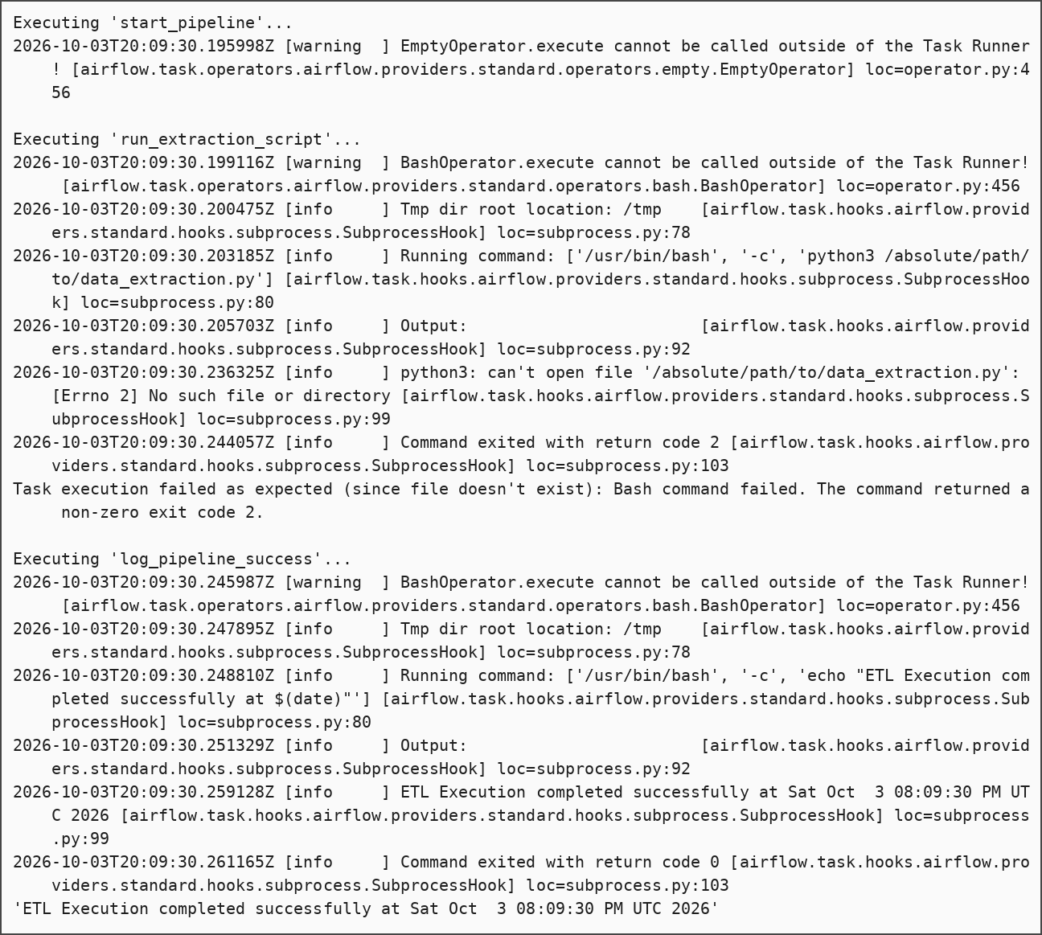

Practical No. – 7
Aim:
To design and implement an ETL pipeline using Python for extracting data from CSV files, cleaning and transforming the data, validating the records, and loading the processed data into a database.
Input files (raw_data):
sales_jan.csv
transaction_id,category,price,quantity,transaction_date
101,electronics,250.50,2,2023-01-15
102,clothing,-15.00,1,2023-01-16
103,furniture,120.00,4,2023-01-17

sales_feb.csv
transaction_id,category,price,quantity,transaction_date
104,electronics,899.99,1,2023-02-10
,groceries,5.50,10,2023-02-11
105,books,45.00,3,2023-02-12

sales_mar.json
[
{"transaction_id": 106, "category": "sports", "price": 55.00, "quantity": 2, "transaction_date": "2023-03-05"},
{"transaction_id": 107, "category": "clothing", "price": 40.00, "quantity": 1, "transaction_date": "2023-03-08"}
]

Code:
import pandas as pd
import glob
from sqlalchemy import create_engine
from sqlalchemy.engine import URL

def run_etl():
print("--- Starting ETL Pipeline ---")

print("[1/4] Extracting data from CSV and JSON sources...")

csv_files = glob.glob("raw_data/*.csv")
df_csv = pd.concat((pd.read_csv(f) for f in csv_files), ignore_index=True)

df_json = pd.read_json("raw_data/sales_mar.json")

df_staging = pd.concat([df_csv, df_json], ignore_index=True)
print(f"Extracted {len(df_staging)} total records.")

print("[2/4] Validating and removing invalid records...")

df_valid = df_staging.dropna(subset=['transaction_id'])

df_valid = df_valid[df_valid['price'] > 0]

dropped_count = len(df_staging) - len(df_valid)
print(f"Removed {dropped_count} invalid records.")

print("[3/4] Transforming fields...")

df_valid['category'] = df_valid['category'].str.upper()

df_valid['transaction_date'] = pd.to_datetime(df_valid['transaction_date'])

df_valid['total_value'] = df_valid['price'] * df_valid['quantity']

df_valid['transaction_id'] = df_valid['transaction_id'].astype(int)

print("[4/4] Executing incremental load to MS SQL Server...")

server_name = r'DESKTOP-P5RT5RO'
database_name = 'DataEngineeringLab'
table_name = 'Fact_Sales'

connection_url = URL.create(
"mssql+pyodbc",
host=server_name,
database=database_name,
query={
"driver": "ODBC Driver 17 for SQL Server",
"Trusted_Connection": "yes"
}
)

engine = create_engine(connection_url, fast_executemany=True)

try:
query = f'SELECT transaction_id FROM {table_name}'
existing_ids = pd.read_sql(query, engine)['transaction_id'].tolist()

df_new = df_valid[~df_valid['transaction_id'].isin(existing_ids)]
except Exception:
df_new = df_valid

if not df_new.empty:
df_new.to_sql(table_name, engine, if_exists='append', index=False)
print(f"SUCCESS: {len(df_new)} new records loaded into '{table_name}'.")
else:
print("SUCCESS: 0 new records to load. Database is up to date.")

print("--- ETL Pipeline Complete ---")

if __name__ == "__main__":
run_etl()

Output:
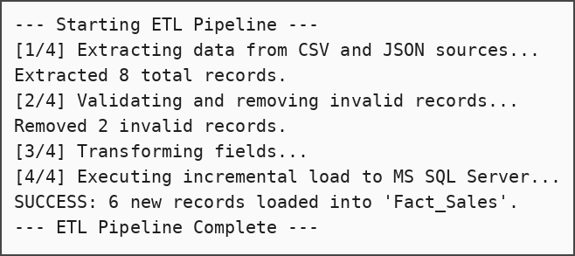
SQL Script (SQL Server):
CREATE DATABASE DataEngineeringLab;
GO
USE DataEngineeringLab;
GO

SELECT * FROM DataEngineeringLab.dbo.Fact_Sales;

Output (result of SELECT * FROM DataEngineeringLab.dbo.Fact_Sales):
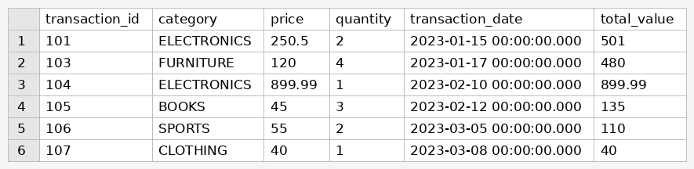

Practical No. – 8
Aim:
To implement PySpark DataFrame operations for reading and analyzing CSV data, including schema inspection, filtering, grouping, aggregation, duplicate removal, joining datasets, and calculating average sales by product category.

1. Create the Spark session
Code:
!pip install pyspark

from pyspark.sql import SparkSession
from pyspark.sql.functions import col, avg

# Initialize Spark Session
spark = SparkSession.builder \
.appName("PySpark Operations Demo") \
.getOrCreate()

print("Spark Session Created Successfully!")

Output:
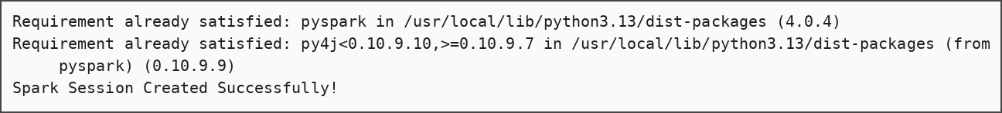

2. Create the sample CSV files
Code:
import pandas as pd

sales_raw = {
'transaction_id': [1, 2, 3, 4, 5, 5, 6, 7],
'product_id': [101, 102, 101, 103, 102, 102, 104, 101],
'amount': [150.0, 300.0, 150.0, 450.0, 300.0, 300.0, 100.0, 200.0],
'region': ['North', 'South', 'North', 'East', 'South', 'South', 'West', 'East']
}
pd.DataFrame(sales_raw).to_csv('sales_data.csv', index=False)

products_raw = {
'product_id': [101, 102, 103, 104],
'product_name': ['Laptop', 'Smartphone', 'Tablet', 'Headphones'],
'category': ['Electronics', 'Electronics', 'Electronics', 'Accessories']
}
pd.DataFrame(products_raw).to_csv('products_data.csv', index=False)

print("Mock CSV files 'sales_data.csv' and 'products_data.csv' successfully created!")

Output:

3. Read the CSV and inspect the schema
Code:
sales_df = spark.read.csv('sales_data.csv', header=True, inferSchema=True)

sales_df.printSchema()

sales_df.show()

Output:
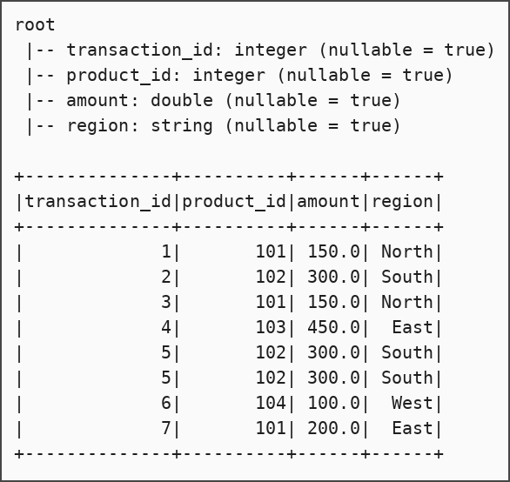

4. Remove duplicate records
Code:
deduplicated_sales_df = sales_df.dropDuplicates()

print("Original Count:", sales_df.count())
print("Deduplicated Count:", deduplicated_sales_df.count())
deduplicated_sales_df.show()

Output:
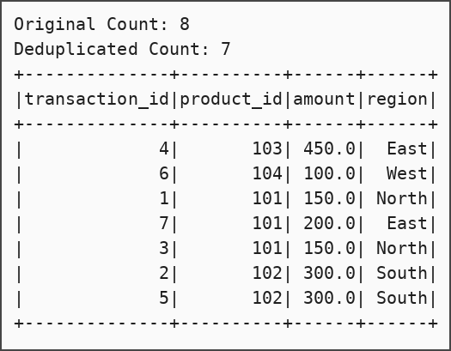

5. Filter, group and aggregate
Code:
filtered_agg_df = deduplicated_sales_df \
.filter(col("amount") > 100) \
.groupBy("region") \
.sum("amount") \
.withColumnRenamed("sum(amount)", "total_sales")

filtered_agg_df.show()

Output:
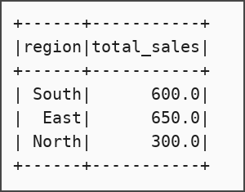

6. Join with the products dataset
Code:
products_df = spark.read.csv('products_data.csv', header=True, inferSchema=True)

joined_df = deduplicated_sales_df.join(products_df, on="product_id", how="inner")

joined_df.show()

Output:
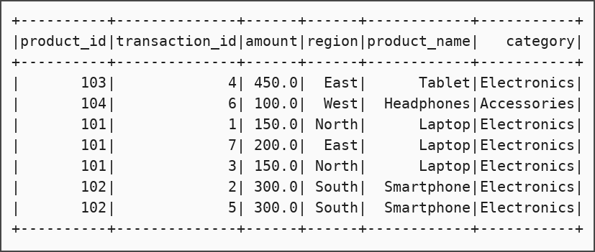

7. Average sales by product category
Code:
avg_sales_by_category = joined_df \
.groupBy("category") \
.agg(avg("amount").alias("average_sales"))

avg_sales_by_category.show()

Output:
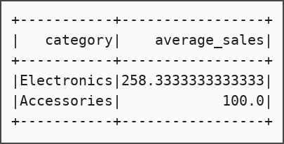

Practical No. – 9
Aim:
To design and implement an end-to-end data pipeline that extracts e-commerce data from CSV files, cleans and transforms the data using Python/Pandas, loads it into a SQL database, generates a report, and handles both historical and newly arriving data.
Input files (ecommerce_data):
customers.csv
customer_id,name,email,signup_date
1,alice smith,alice@email.com,2023-01-10
2,bob jones,,2023-01-15
3,charlie brown,charlie@email.com,2023-02-01

products.csv
product_id,product_name,category,price
101,Laptop,Electronics,1200.00
102,Wireless Mouse,Electronics,25.50
103,Desk Chair,Furniture,-50.00

orders.csv
order_id,customer_id,product_id,quantity,order_date
1001,1,101,1,2023-10-01
1002,2,102,2,2023-10-02
1003,3,101,1,2023-10-05
1004,1,102,1,2023-10-06

Code:
import pandas as pd
import os
from sqlalchemy import create_engine
from sqlalchemy.engine import URL

def setup_dummy_data():
os.makedirs('ecommerce_data', exist_ok=True)

if os.path.exists('ecommerce_data/orders.csv'):
print(" -> Data files already exist. Skipping dummy generation so your new data is safe.")
return

with open('ecommerce_data/customers.csv', 'w') as f:
f.write("customer_id,name,email,signup_date\n")
f.write("1,alice smith,alice@email.com,2023-01-10\n")
f.write("2,bob jones,,2023-01-15\n")
f.write("3,charlie brown,charlie@email.com,2023-02-01\n")

with open('ecommerce_data/products.csv', 'w') as f:
f.write("product_id,product_name,category,price\n")
f.write("101,Laptop,Electronics,1200.00\n")
f.write("102,Wireless Mouse,Electronics,25.50\n")
f.write("103,Desk Chair,Furniture,-50.00\n")

with open('ecommerce_data/orders.csv', 'w') as f:
f.write("order_id,customer_id,product_id,quantity,order_date\n")
f.write("1001,1,101,1,2023-10-01\n")
f.write("1002,2,102,2,2023-10-02\n")
f.write("1003,3,101,1,2023-10-05\n")
f.write("1004,1,102,1,2023-10-06\n")

def load_incrementally(df, table_name, primary_key, engine):
try:
query = f"SELECT {primary_key} FROM {table_name}"
existing_keys = pd.read_sql(query, engine)[primary_key].tolist()

df_new = df[~df[primary_key].isin(existing_keys)]
except Exception:
df_new = df

if not df_new.empty:
df_new.to_sql(table_name, engine, if_exists='append', index=False)
print(f" -> SUCCESS: Inserted {len(df_new)} new records into '{table_name}'.")
else:
print(f" -> SUCCESS: '{table_name}' is already up to date. No new records inserted.")

def run_pipeline():
print("--- Starting Practical 9 E-Commerce ETL Pipeline ---\n")

print("[0/5] Checking for data files...")
setup_dummy_data()

print("\n[1/5] EXTRACT: Reading Data from CSVs...")
print("\n[1/5] EXTRACT: Reading Data from CSVs...")
df_cust = pd.read_csv('ecommerce_data/customers.csv')
df_prod = pd.read_csv('ecommerce_data/products.csv')
df_ord = pd.read_csv('ecommerce_data/orders.csv')

print("\n[2/5] TRANSFORM: Cleaning and Formatting Data...")
df_cust['name'] = df_cust['name'].str.title()
df_cust['email'] = df_cust['email'].fillna('Unknown')
df_cust['signup_date'] = pd.to_datetime(df_cust['signup_date'])

df_prod = df_prod[df_prod['price'] > 0]

df_ord['order_date'] = pd.to_datetime(df_ord['order_date'])

print("\n[3/5] LOAD: Connecting to MS SQL Server...")
server_name = r'DESKTOP-P5RT5RO'
database_name = 'ECommerceDB'

connection_url = URL.create(
"mssql+pyodbc",
host=server_name,
database=database_name,
query={"driver": "ODBC Driver 17 for SQL Server", "Trusted_Connection": "yes"}
)
engine = create_engine(connection_url, fast_executemany=True)

print("\n[4/5] LOAD: Executing Incremental Database Inserts...")
load_incrementally(df_cust, 'dim_customers', 'customer_id', engine)
load_incrementally(df_prod, 'dim_products', 'product_id', engine)
load_incrementally(df_ord, 'fact_orders', 'order_id', engine)

print("\n[5/5] REPORT: Generating Automated Analytics Report...")
report_query = """
SELECT
p.product_name,
SUM(o.quantity) as total_units_sold,
SUM(o.quantity * p.price) as total_revenue
FROM fact_orders o
JOIN dim_products p ON o.product_id = p.product_id
GROUP BY p.product_name
ORDER BY total_revenue DESC;
"""

df_report = pd.read_sql(report_query, engine)

print("\n================ BUSINESS REPORT ================")
print(df_report.to_string(index=False))
print("=================================================\n")

df_report.to_csv('ecommerce_data/final_sales_report.csv', index=False)
print("Pipeline Complete! Report saved to 'ecommerce_data/final_sales_report.csv'.")

if __name__ == "__main__":
run_pipeline()

Output:
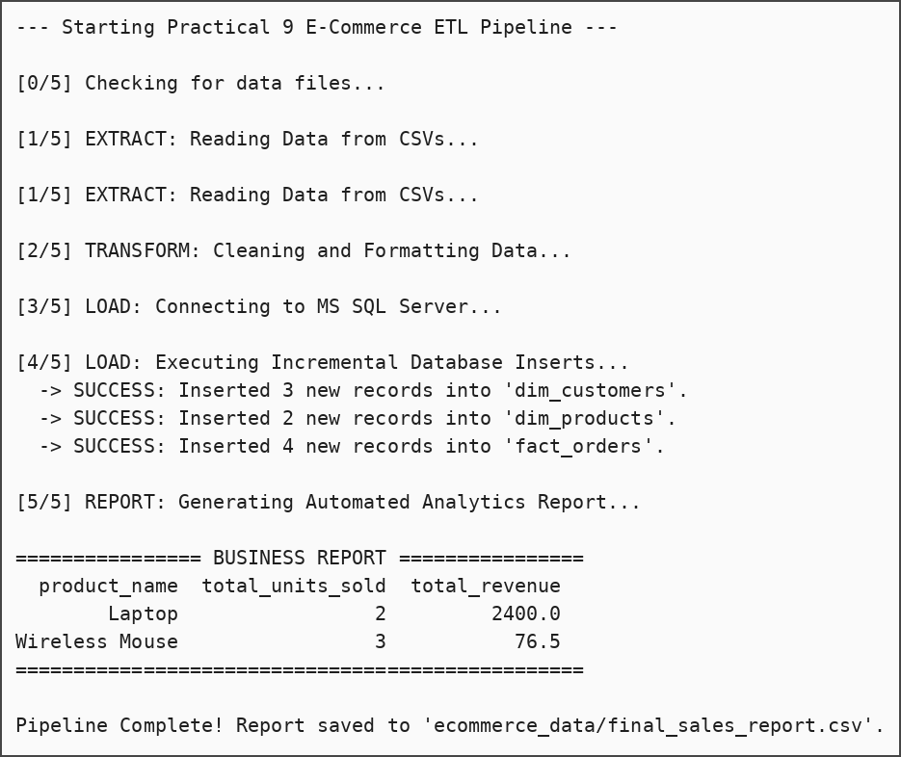
Generated report file (final_sales_report.csv):
product_name,total_units_sold,total_revenue
Laptop,2,2400.0
Wireless Mouse,3,76.5

SQL Script (SQL Server):
CREATE DATABASE ECommerceDB;
GO

SELECT * FROM dim_customers;
SELECT * FROM dim_products;
SELECT * FROM fact_orders;

Output (SELECT * FROM dim_customers):
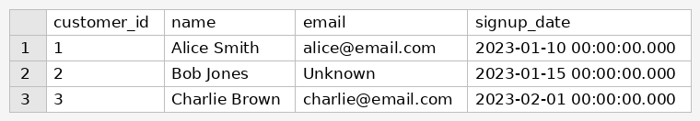
Output (SELECT * FROM dim_products):
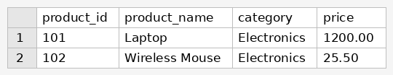
Output (SELECT * FROM fact_orders):
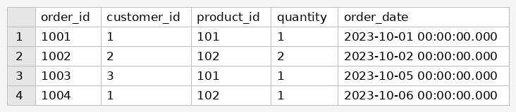

Mini Project – Retail Data Warehouse ETL Pipeline
Aim:
To design and implement a retail data warehouse ETL pipeline in Python that ingests store, product and transaction data from CSV and JSON files, applies data-quality rules, shapes the data into a star schema, loads it incrementally into SQL Server, and generates a revenue report.
Input files (source_data):
stores.csv
store_id,location,region
1,Mumbai,West
2,Pune,West
3,Delhi,North

products.json
[
{"product_id": 101, "name": "Apples", "category": "Groceries", "unit_price": 120},
{"product_id": 102, "name": "Milk", "category": "Dairy", "unit_price": 65},
{"product_id": 103, "name": "Bread", "category": "Bakery", "unit_price": -20}
]

transactions.csv
transaction_id,store_id,product_id,quantity,sale_date
1001,1,101,5,2026-10-01
1002,1,102,2,2026-10-01
1003,2,101,10,2026-10-02
1004,,103,1,2026-10-02

Code:
import pandas as pd
import os
from sqlalchemy import create_engine
from sqlalchemy.engine import URL

def generate_source_data():
os.makedirs('source_data', exist_ok=True)

if os.path.exists('source_data/transactions.csv'):
print(" -> Source files already exist. Skipping generation.")
return

with open('source_data/stores.csv', 'w') as f:
f.write("store_id,location,region\n1,Mumbai,West\n2,Pune,West\n3,Delhi,North\n")

products_json = """[
{"product_id": 101, "name": "Apples", "category": "Groceries", "unit_price": 120},
{"product_id": 102, "name": "Milk", "category": "Dairy", "unit_price": 65},
{"product_id": 103, "name": "Bread", "category": "Bakery", "unit_price": -20}
]"""
with open('source_data/products.json', 'w') as f:
f.write(products_json)

with open('source_data/transactions.csv', 'w') as f:
f.write("transaction_id,store_id,product_id,quantity,sale_date\n")
f.write("1001,1,101,5,2026-10-01\n")
f.write("1002,1,102,2,2026-10-01\n")
f.write("1003,2,101,10,2026-10-02\n")
f.write("1004,,103,1,2026-10-02\n")

def load_to_dw(df, table_name, pk_column, engine):
try:
existing_keys = pd.read_sql(f"SELECT {pk_column} FROM {table_name}", engine)[pk_column].tolist()
df_new = df[~df[pk_column].isin(existing_keys)]
except Exception:
df_new = df

if not df_new.empty:
df_new.to_sql(table_name, engine, if_exists='append', index=False)
print(f" -> SUCCESS: Loaded {len(df_new)} new records into '{table_name}'.")
else:
print(f" -> SUCCESS: '{table_name}' is up to date.")

def execute_pipeline():
print("=== Starting Retail Data Warehouse ETL Pipeline ===\n")

print("[1/5] DATA INGESTION: Sourcing raw data...")
generate_source_data()

df_stores = pd.read_csv('source_data/stores.csv')
df_products = pd.read_json('source_data/products.json')
df_sales = pd.read_csv('source_data/transactions.csv')

print("\n[2/5] DATA CLEANING: Applying quality rules...")
invalid_price_count = len(df_products[df_products['unit_price'] <= 0])
df_products = df_products[df_products['unit_price'] > 0]

missing_fk_count = df_sales['store_id'].isna().sum()
df_sales = df_sales.dropna(subset=['store_id'])
print(f" -> Removed {invalid_price_count} invalid products and {missing_fk_count} orphaned sales records.")

print("\n[3/5] TRANSFORMATION: Shaping data for Star Schema...")
df_sales['sale_date'] = pd.to_datetime(df_sales['sale_date'])

df_sales_enriched = df_sales.merge(df_products[['product_id', 'unit_price']], on='product_id', how='left')
df_sales['total_amount'] = df_sales_enriched['quantity'] * df_sales_enriched['unit_price']

df_sales['store_id'] = df_sales['store_id'].astype(int)

print("\n[4/5] STORAGE: Loading into SQL Server Star Schema...")
server_name = r'DESKTOP-P5RT5RO'
connection_url = URL.create(
"mssql+pyodbc",
host=server_name,
database='RetailDW',
query={"driver": "ODBC Driver 17 for SQL Server", "Trusted_Connection": "yes"}
)
engine = create_engine(connection_url, fast_executemany=True)

load_to_dw(df_stores, 'Dim_Store', 'store_id', engine)
load_to_dw(df_products, 'Dim_Product', 'product_id', engine)
load_to_dw(df_sales, 'Fact_Sales', 'transaction_id', engine)

print("\n[5/5] REPORTING: Generating Analytical Output...")
report_query = """
SELECT
s.location,
p.category,
SUM(f.quantity) as total_units_sold,
SUM(f.total_amount) as total_revenue
FROM Fact_Sales f
JOIN Dim_Store s ON f.store_id = s.store_id
JOIN Dim_Product p ON f.product_id = p.product_id
GROUP BY s.location, p.category
ORDER BY total_revenue DESC;
"""
df_report = pd.read_sql(report_query, engine)
print("\n=== EXECUTIVE REVENUE REPORT ===")
print(df_report.to_string(index=False))
print("================================\n")

df_report.to_csv('source_data/warehouse_revenue_report.csv', index=False)
print("Pipeline Execution Completed Successfully.")

if __name__ == "__main__":
execute_pipeline()

Output:
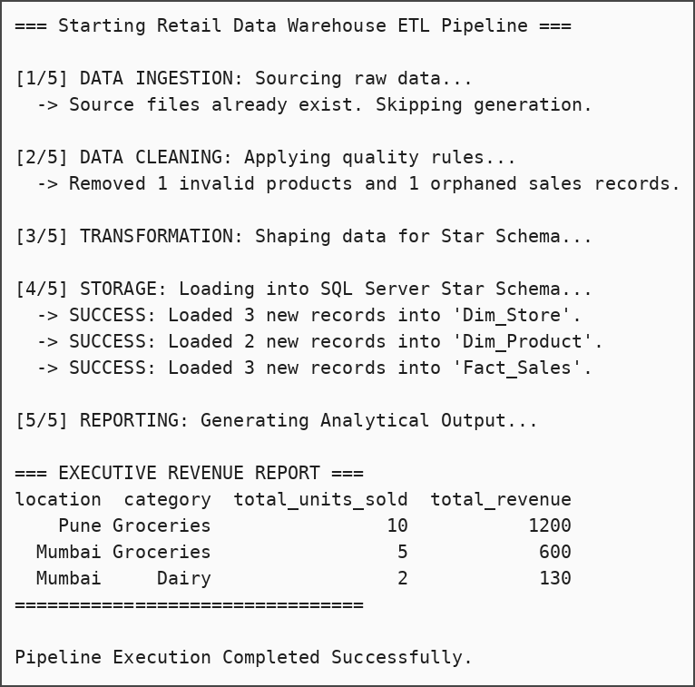
Generated report file (warehouse_revenue_report.csv):
location,category,total_units_sold,total_revenue
Pune,Groceries,10,1200
Mumbai,Groceries,5,600
Mumbai,Dairy,2,130

SQL Script (SQL Server):
CREATE DATABASE RetailDW;
GO

SELECT * FROM Fact_Sales;

Output (SELECT * FROM Fact_Sales):
