**Mini Project Report**

***CSE (SE) IV – Semester***

**2020 – 2021**



**Submitted by:**

Somya Malgudi

Roll. No.:2015106

B-Tech CSE (SE) 4thSem

Session: 2020-2021

**Voice-Based Email Service for Visually Challenged People**

**Problem Statement:**

As the title suggests, the application will be a web-based application for visually impaired persons using voice control-based interaction, thus enabling everyone to control their mail accounts using their voice only and to be able to read and send emails without any problems.

**Motivation:**

We have seen that the growth of the Internet has dramatically revolutionized many fields. The Internet has made the life of people so easy that people today have access to any information they want sitting at their home. One of the major fields that the Internet has revolutionized is communication.When we are talking about communication over the Internet, the first thing that comes in our mind is E-mails. E-mails are considered to be a very reliable way of communication over the Internet that is used all over the world.

But there is a special criterion for humans to access the Internet and the criteria is you must be able to see. Many specially-abled people in our society are not gifted with the ability of proper sight. For these people, looking at the computer screen and the keyboard is not a viable option.

The only way by which a visually impaired person can send an E-mail is, they have to dictate the entire content of the mail to a third person who is not visually challenged, and then the third person will compose the mail and send it on the behalf of the visually impaired person.

But this is not a correct way to deal with this problem. It is very less likely that every time a visually challenged person can find someone for help.So, for the betterment of society and giving equal status to such specially-abled people,I have come up with this project idea which provides the user with the ability to send mails using only the mouse and voice commands and thus eliminating the use of the keyboard or the screen.

**Methodology: -**

I have divided the project into several parts. The first part was the voice-controlled interface of the service and the second part was the sending& receiving of emails.

For the sake of this project,I have used python 3 for the development process and have utilized python’s rich library for the aid of this project. I have used the following libraries:

import speech_recognition as sr

import easyimap as e

import pyttsx3

import smtplib

* By using the speechrecognitionpackage,I have converted the audio spoken from the microphone to text that can be used for our e-mail.
* The pyttsx3 module is themodule that provides text-to-speech functionality to the program.
* The smtplib and the easyimap packagesare used as an interface between our code and Gmail.

Using these we can send emails from within the code and can also fetch the emails from the inbox of the user.

By combining the above-mentionedmethodologies, we can prepare a voice-controlled email service for visually challenged people.

After all, this was done, I created a menu-based interaction between the program and the user which prompts the user to speak what action they want to perform:

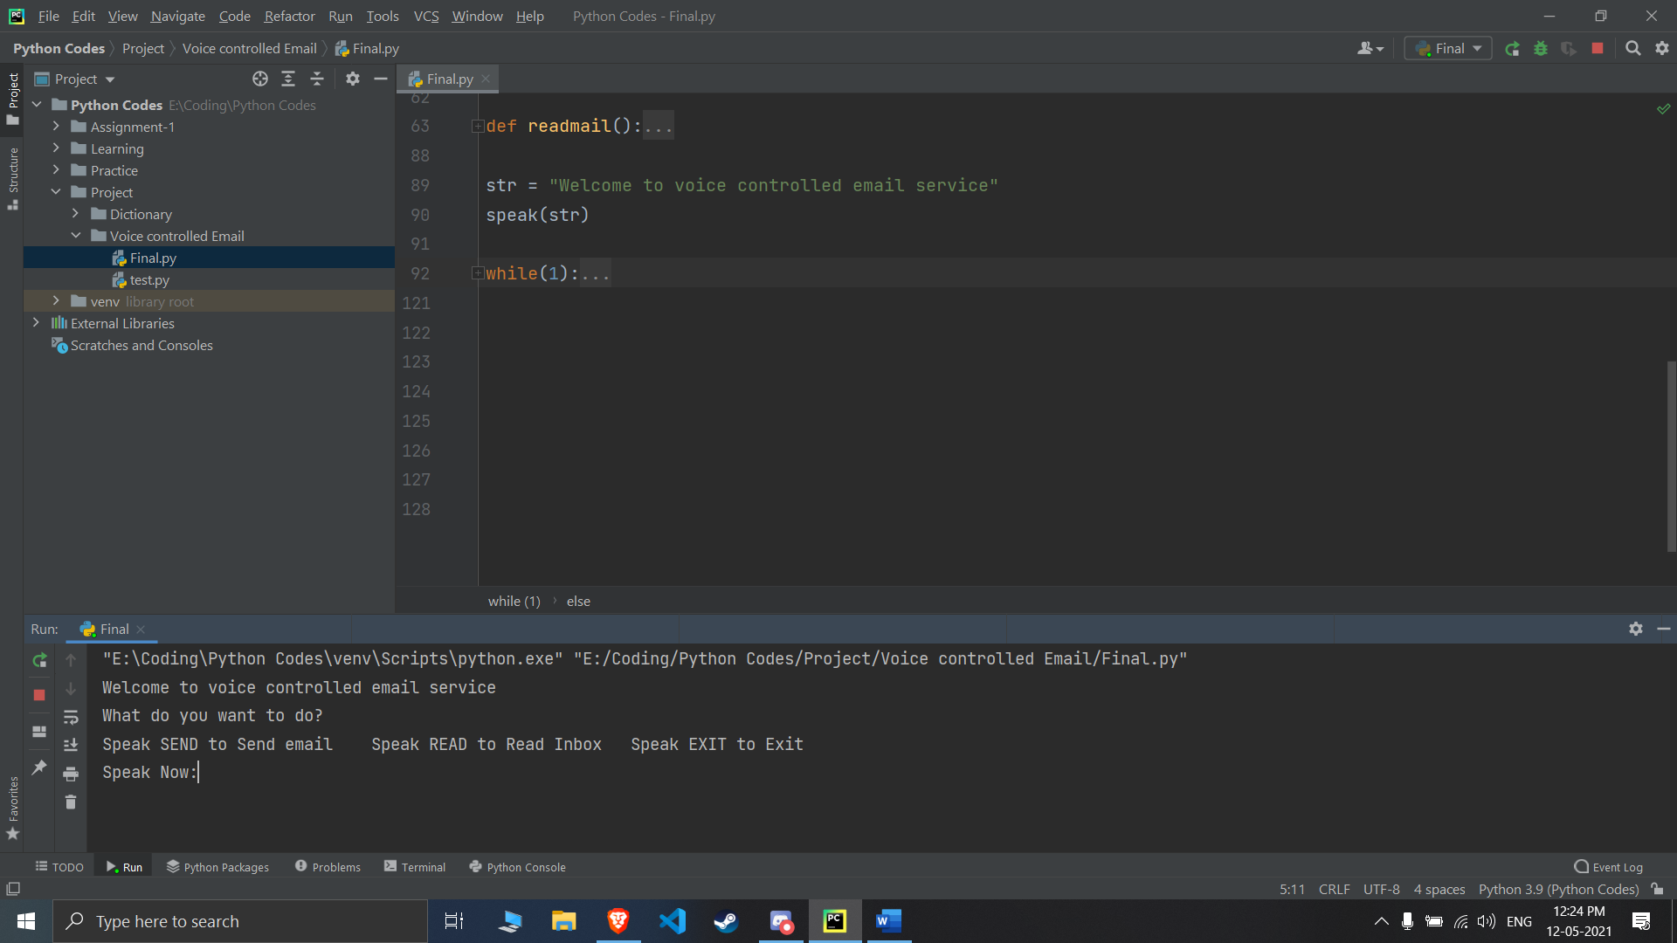

Based on the inputs from the user the program works accordingly to either send or read emails.

NOTE: - All the outputs from the program are being printed on the screen and are being spoken out as well (using text to speech).

To use the speech recognition, I had to make use of another python module called the pyaudio so as to take the audio input from the microphone. After taking the audio input, it is converted to the text by the speech recognition and then that text is used for the further execution of the program.

**REFERENCES**

1. Python 3.0: -

<https://www.python.org/download/releases/3.0/>

1. Speech Recognition: -<https://pypi.org/project/SpeechRecognition/>
2. smtplib: -

<https://docs.python.org/3/library/smtplib.html>

1. easyimap: -

<https://pypi.org/project/easyimap/>

1. pyttsx3: -

<https://pypi.org/project/pyttsx3/>

1. pyaudio: -

<https://pypi.org/project/PyAudio/>

-------------------------X--------------------------