Introduction
There are two types of order in nature: centralized order, which requires uniformity, and decentralized order, which requires diversity. Living systems are decentralized. Every cell acts on local knowledge of its own conditions and signals its neighbors voluntarily, yet the result is coordinated organization across trillions of cells without any master controller [1,2]. Synthetic biology, however, overwhelmingly treats living systems as machines—specifying every promoter, every codon, every ribosome binding site from above, as though the cell were a factory floor awaiting instructions [3,4]. This is the machine metaphor applied to molecules: it reduces the system to parts, and in doing so makes what was once robust brittle. Engineered genetic circuits fail at high rates precisely because this reductionist approach destroys the distributed knowledge embedded in the system it attempts to control [5,6]. The persistent failure of centrally designed biological constructs suggests that the problem is not in the details of circuit design but in the paradigm itself—that living things are not machines, and engineering them as if they were misrepresents how biological order actually works.
In biology there are no central banks and no legal tender laws—there is only voluntary trade. Cells exchange molecular signals, but they react to those signals by choice: a cytokine does not command a T cell to activate any more than a price tag forces a customer to buy [7]. The diversity of life is not random difference—it is ordered diversity based on local knowledge of time and place that no central planner can possess [8]. Network analyses have confirmed this architecture at the molecular level. Gene regulatory networks in Escherichia coli exhibit scale-free degree distributions with no single master regulator, and protein-protein interaction networks in both E. coli and Saccharomyces cerevisiae show distributed hub structures that tolerate removal of substantial fractions of nodes before losing connectivity [1,9]. Feed-forward loops—the most over-represented network motif in transcriptional regulation—function as local signal-processing modules, enabling rapid coordination without routing information through a central node [10,11]. At the cellular level, single-cell RNA sequencing has shown that immune cell types specialize into complementary roles through local cytokine signaling, without any master cell assigning fates [12,13].
The distributed knowledge that coordinates living systems is dictated by prices—the ratios between voluntary exchanges at every node. Austrian economics provides the formal theory for this: Hayek demonstrated that the knowledge required for rational coordination is dispersed among individual agents as tacit, local knowledge that cannot be aggregated by any central authority, and that prices are the distributed signal that transmits this knowledge without concentrating it [8,14]. Mises showed that without prices emerging from voluntary exchange, a central planner has no mechanism to determine rational resource allocation [15]. In the cell, metabolite concentrations, receptor occupancies, and energy ratios function exactly as these distributed price signals—each node making educated guesses and adjusting to local conditions, and in doing so the whole is ordered. If DNA is a language, the cell speaks it and can write in that language. Bioinformatics is the study of this distributed knowledge written into the sequence of DNA [16].
Previous work has characterized individual properties of biological networks—scale-free topology [1], robustness to random failure [9], motif enrichment [10]—and has modeled metabolic systems using constraint-based optimization [17]. However, these analyses treat each property in isolation rather than asking what unifying principle connects network architecture, metabolic coordination, cellular specialization, and cross-species gene compatibility. Systems biology has largely adopted the machine framework, modeling cells as circuits to be optimized rather than economies to be understood [18,19]. This is the same category error that central planning makes in economics: treating distributed knowing as if it could be centrally held, treating knowers as if they were merely data. Synthetic biology design tools—codon optimization algorithms, promoter libraries, genetic circuit CAD platforms—implicitly assume the engineer can specify optimal parameters from outside the system [4,20]. The concept that biological coordination operates through a genuine price system has been noted qualitatively [21] but never tested quantitatively across multiple scales. What is missing is a systematic, multi-scale analysis that tests whether biological systems are structured as decentralized economies—and whether reducing them to centrally planned machines explains why engineered constructs are fragile while natural systems are robust.
Here, we report a computational analysis testing whether biological coordination operates through distributed knowledge across three scales of organization. First, we compare the network topology of five biological networks (gene regulatory, metabolic, and protein-protein interaction networks in E. coli and S. cerevisiae) against five synthetic architectures representing centralized, random, and structured alternatives, measuring degree distribution, betweenness centrality, and robustness under node removal. Second, we model thirteen metabolic pathways as economic agents under distributed versus centralized resource allocation, testing whether local feedback alone—the biological price system—achieves superior robustness despite lacking global information. Third, we analyze cross-species gene transferability across eight organisms from four kingdoms as a trade network, using codon usage distance as a measure of exchange friction. We synthesize these results into a unified framework—the price system of the cell—showing that intracellular metabolite ratios function as costs of capital, intercellular signals function as market prices, and signaling integrators such as mTOR function as molecular entrepreneurs reading distributed price information (Fig. 1). This analysis provides quantitative evidence that living things are not machines—that biological order emerges from distributed knowledge at every node—and that synthetic biology should design with this living architecture rather than against it.

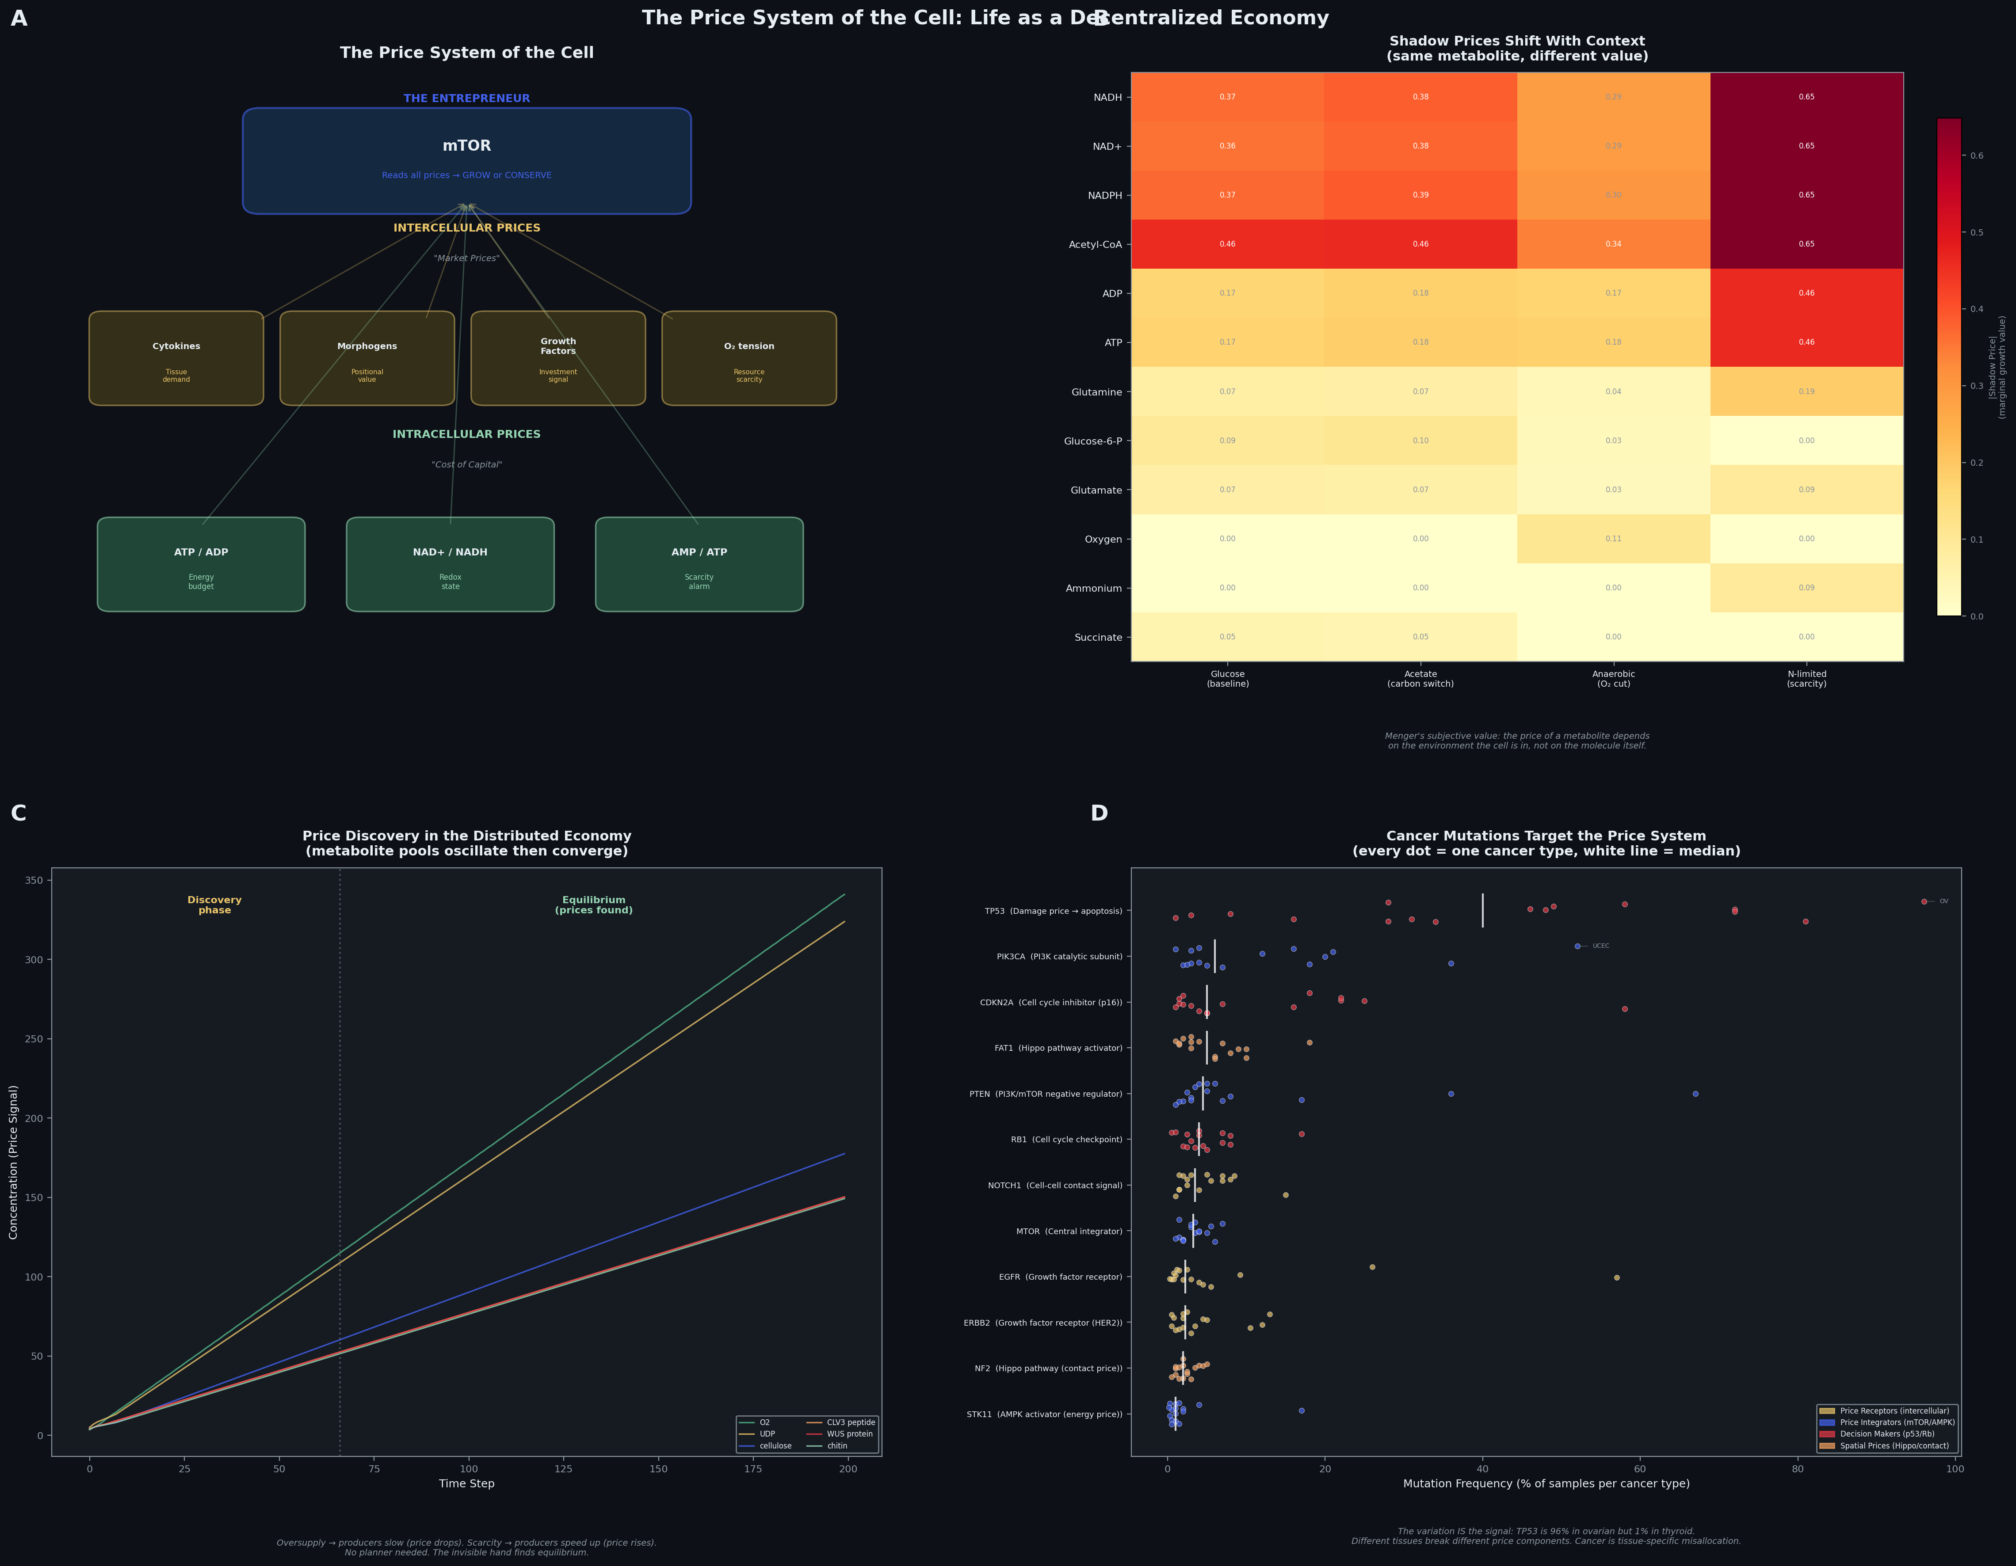
Figure 1. The price system of the cell: life as a decentralized economy. (A) The cell reads prices at three tiers. Intracellular metabolite ratios (ATP/ADP, NAD+/NADH, AMP/ATP) function as the cost of capital—signals of the cell’s own energetic state. Intercellular signals (cytokines, morphogens, growth factors, oxygen tension) function as market prices—tissue-level information about supply and demand. mTOR integrates all price inputs and makes a grow-or-conserve decision without central instruction. (B) Shadow prices from flux balance analysis of the E. coli genome-scale model (iML1515; 2,712 reactions) under four environmental conditions. The same metabolite has different value depending on context—NADH is cheap on glucose but expensive on acetate; oxygen is near-zero aerobically but spikes under anaerobic conditions. This is Menger’s subjective value theory [13] measured in a metabolic model. (C) Metabolite pool concentrations over 200 simulation time steps in the distributed allocation regime. Early oscillations represent the price discovery phase; late convergence represents equilibrium found through local feedback alone, with no central planner. (D) Mutation frequency of key signaling genes across cancer types (COSMIC database). Each dot is one cancer type. The most frequently mutated genes—TP53, PIK3CA, PTEN, mTOR, EGFR—all encode components of the cellular price system. The variation across cancer types (e.g., TP53: 96% in ovarian, 1% in thyroid) demonstrates that different tissues depend on different price components. Cancer is a price system disease: the cell loses its ability to read distributed signals correctly.

References
[1] Barabási, A.-L. & Oltvai, Z.N. Network biology: understanding the cell’s functional organization. Nature Reviews Genetics 5, 101–113 (2004).
[2] Kitano, H. Biological robustness. Nature Reviews Genetics 5, 826–837 (2004).
[3] Kwok, R. Five hard truths for synthetic biology. Nature 463, 288–290 (2010).
[4] Cameron, D.E., Bashor, C.J. & Collins, J.J. A brief history of synthetic biology. Nature Reviews Microbiology 12, 381–390 (2014).
[5] Purnick, P.E.M. & Weiss, R. The second wave of synthetic biology: from modules to systems. Nature Reviews Molecular Cell Biology 10, 410–422 (2009).
[6] Cardinale, S. & Arkin, A.P. Contextualizing context for synthetic biology — identifying causes of failure of synthetic biological systems. Biotechnology Journal 7, 856–866 (2012).
[7] Ramilowski, J.A. et al. A draft network of ligand–receptor-mediated multicellular signalling in human. Nature Communications 6, 7866 (2015).
[8] Hayek, F.A. The use of knowledge in society. American Economic Review 35, 519–530 (1945).
[9] Albert, R., Jeong, H. & Barabási, A.-L. Error and attack tolerance of complex networks. Nature 406, 378–382 (2000).
[10] Shen-Orr, S.S., Milo, R., Mangan, S. & Alon, U. Network motifs in the transcriptional regulation network of Escherichia coli. Nature Genetics 31, 64–68 (2002).
[11] Mangan, S. & Alon, U. Structure and function of the feed-forward loop network motif. Proceedings of the National Academy of Sciences 100, 11980–11985 (2003).
[12] Zheng, G.X.Y. et al. Massively parallel digital transcriptional profiling of single cells. Nature Communications 8, 14049 (2017).
[13] Wolf, F.A., Angerer, P. & Theis, F.J. SCANPY: large-scale single-cell gene expression data analysis. Genome Biology 19, 15 (2018).
[14] Hayek, F.A. The pretence of knowledge. Nobel Memorial Lecture, December 11, 1974. American Economic Review 79, 3–7 (1989).
[15] Mises, L. von. Economic calculation in the socialist commonwealth. In Collectivist Economic Planning (ed. Hayek, F.A.) 87–130 (Routledge, 1920/1935).
[16] Shapiro, J.A. How life changes itself: the Read-Write (RW) genome. Physics of Life Reviews 10, 287–323 (2013).
[17] Orth, J.D., Thiele, I. & Palsson, B.Ø. What is flux balance analysis? Nature Biotechnology 28, 245–248 (2010).
[18] Kitano, H. Systems biology: a brief overview. Science 295, 1662–1664 (2002).
[19] Alon, U. An Introduction to Systems Biology: Design Principles of Biological Circuits. Chapman & Hall/CRC (2007).
[20] Salis, H.M., Mirsky, E.A. & Voigt, C.A. Automated design of synthetic ribosome binding sites to control protein expression. Nature Biotechnology 27, 946–950 (2009).
[21] Krakauer, D.C. & Flack, J.C. Better living through physics. Nature 467, 661 (2010).

