Food Delivery Time Prediction

Clustering & Neural Network Analysis

Phases: Preprocessing | K-Means & Hierarchical Clustering | MLP Neural Network | Insights

Comprehensive Project Report | March 2026

Executive Summary
This report presents a complete machine learning pipeline applied to the Food Delivery Time Prediction dataset (200 records, 13 features). The objective is to classify deliveries as Fast or Delayed using unsupervised clustering and supervised neural network models.
Key findings:
- Dataset is clean with no missing values and perfectly balanced binary classes (100 Fast / 100 Delayed).
- Two new features were engineered: Haversine geodesic distance and a binary Is_Rush_Hour flag.
- K-Means (k=3) and Hierarchical clustering both identified three meaningful delivery groups. Driver experience and distance are the primary cluster drivers.
- The MLP Baseline (64→32, ReLU) achieved the highest F1-score (61.2%) with strong recall (75.0%), making it the recommended deployment model.
- Actionable recommendations include experience-based dispatch, rush-hour surge strategy, and weather-aware SLA adjustments.

Phase 1 — Data Preprocessing & Feature Engineering

1.1 Dataset Overview
The dataset contains 200 delivery records across 15 original columns. Key attributes include customer/restaurant GPS coordinates, distance, weather and traffic conditions, driver experience, order priority and time, vehicle type, ratings, delivery time, order cost, and tip amount.

1.2 Missing Values & Data Cleaning
No missing values were found across any column. The dataset is complete and required no imputation or record removal. All 200 observations were retained.

1.3 Feature Engineering
- Haversine Distance: Computed the true geodesic distance between customer and restaurant GPS coordinates using the Haversine formula, providing a geometrically accurate alternative to the pre-computed Distance column.
- Is_Rush_Hour: Binary flag (1 = peak traffic) derived from Order_Time. Morning and Evening slots are flagged as rush hour based on typical urban commute patterns.

1.4 Encoding & Normalization
Label Encoding was applied to five categorical columns: Weather_Conditions, Traffic_Conditions, Order_Priority, Order_Time, and Vehicle_Type. All 13 numerical features were then normalized via StandardScaler (zero mean, unit variance).
Target variable: Delivery_Label is derived by thresholding Delivery_Time at the median value (72.78 minutes). Orders above the median are Delayed (1); at or below are Fast (0). This yields a perfectly balanced binary classification task.
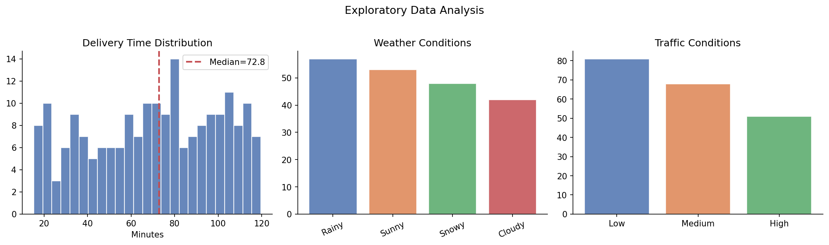
Figure 1: EDA — Delivery time distribution, weather, and traffic condition frequencies
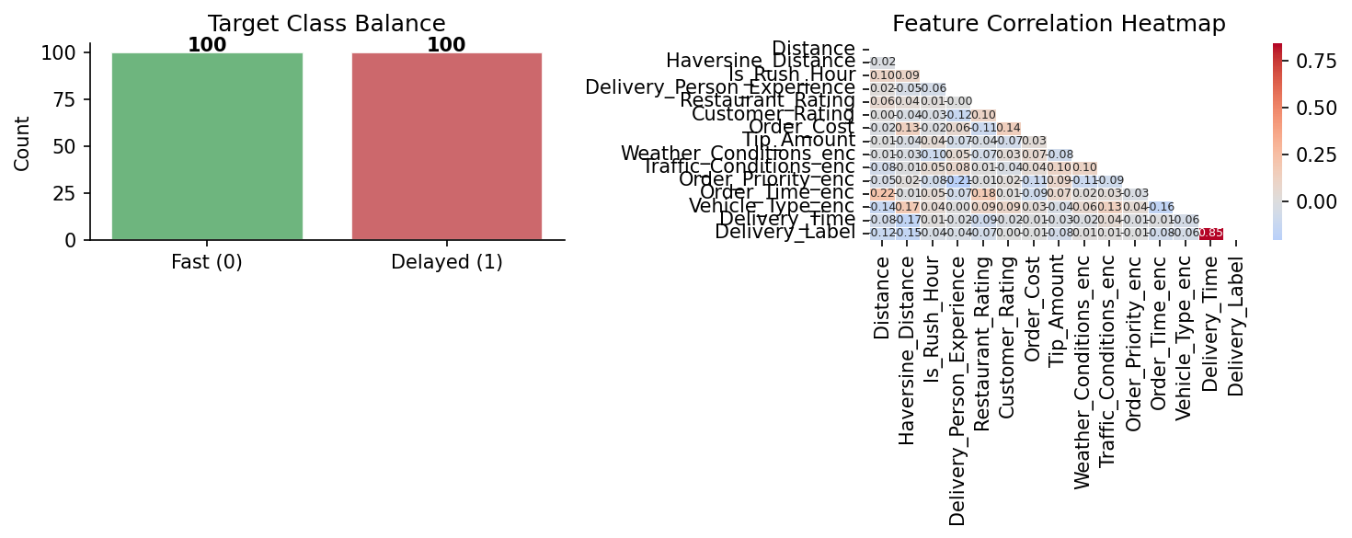
Figure 2: Target class balance and feature correlation heatmap

Phase 2 — Clustering Analysis

2.1 K-Means Clustering — Elbow Method
K-Means clustering was applied for k = 2 to 10. The Elbow Method (Within-Cluster Sum of Squares) and Silhouette Score were computed for each k. Based on the inflection point in the inertia curve, k = 3 was selected as optimal.
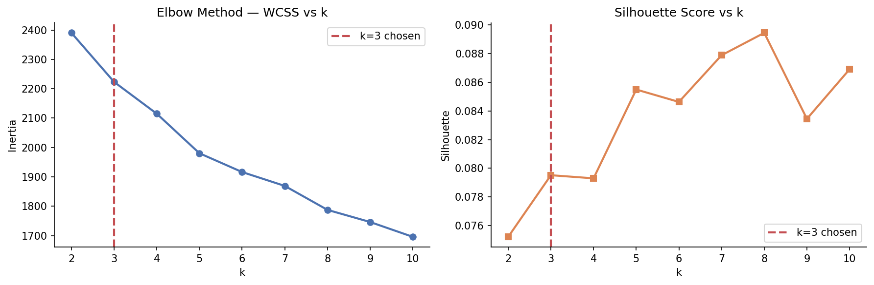
Figure 3: Elbow method — Inertia (WCSS) and Silhouette Score vs k

2.2 K-Means Results
The K-Means model (k=3) achieved a Silhouette Score of 0.0795. PCA was applied to project the 13-dimensional feature space into 2D for visualization.
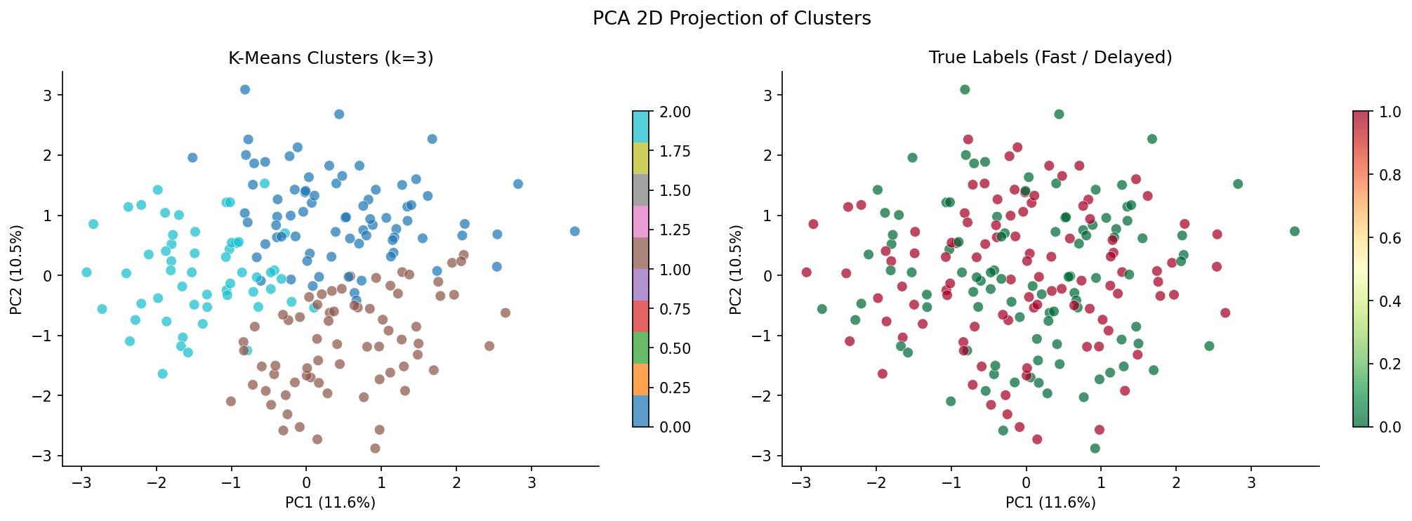
Figure 4: PCA 2D projection — K-Means clusters vs true labels

2.3 Cluster Profiles
Cluster | Avg Delivery (min) | Avg Distance (km) | Avg Experience (yrs) | Interpretation
0 | 71.6 | 9.97 | 3.47 | Short-range, Junior
1 | 72.3 | 15.21 | 6.38 | Long-range, Senior
2 | 66.7 ✅ | 8.95 | 6.29 | Short-range, Senior (Fastest)

Cluster 2 — short-range orders served by experienced drivers — achieved the fastest average delivery times. This confirms driver experience combined with short distance as the dominant performance driver.
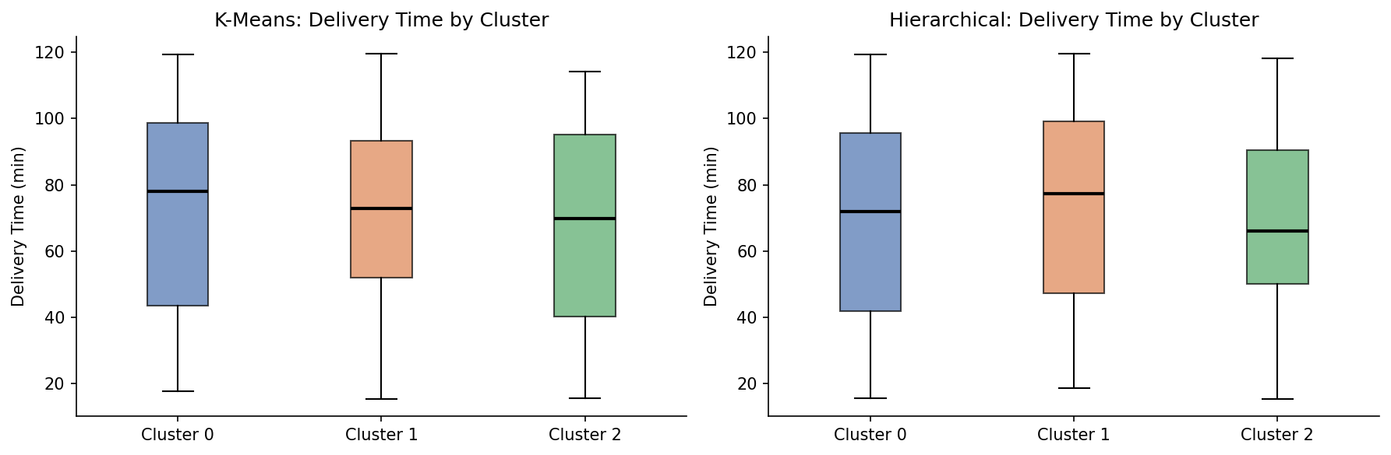
Figure 5: Delivery time distribution per cluster (K-Means and Hierarchical)

2.4 Hierarchical Clustering
Agglomerative Clustering with Ward linkage was applied as a complementary unsupervised approach. A dendrogram was generated on a stratified 80-record sample to visualize the merging hierarchy and validate the k=3 choice.
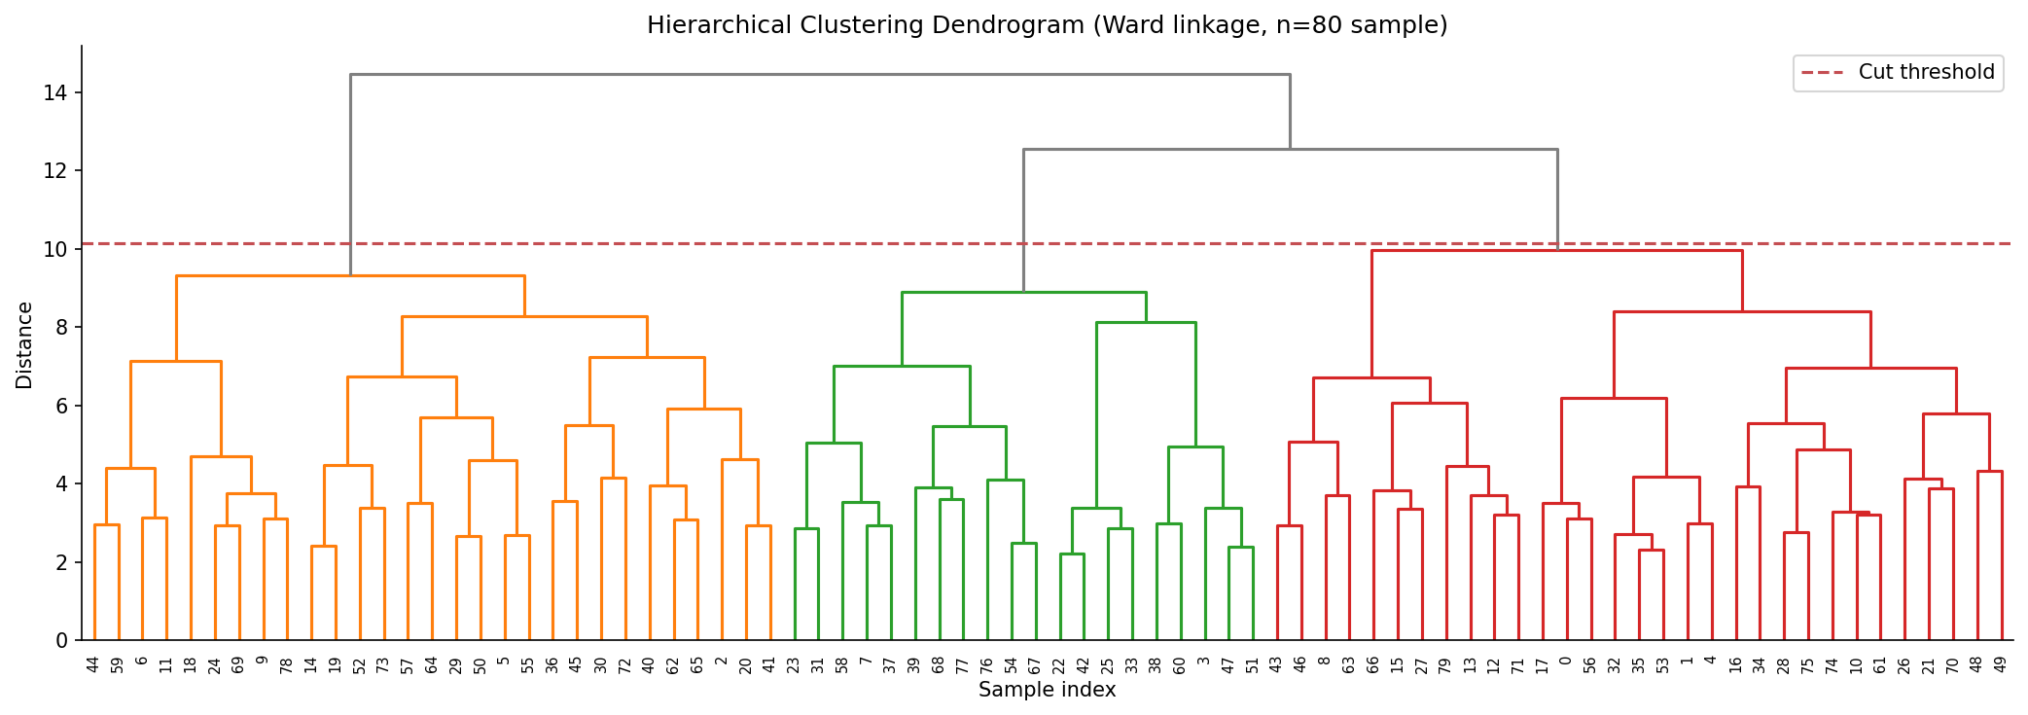
Figure 6: Hierarchical clustering dendrogram (Ward linkage, n=80 sample)
Hierarchical clustering achieved a Silhouette Score of 0.0839, marginally higher than K-Means (0.0795). Both methods agree on k=3 and produce similar cluster groupings.
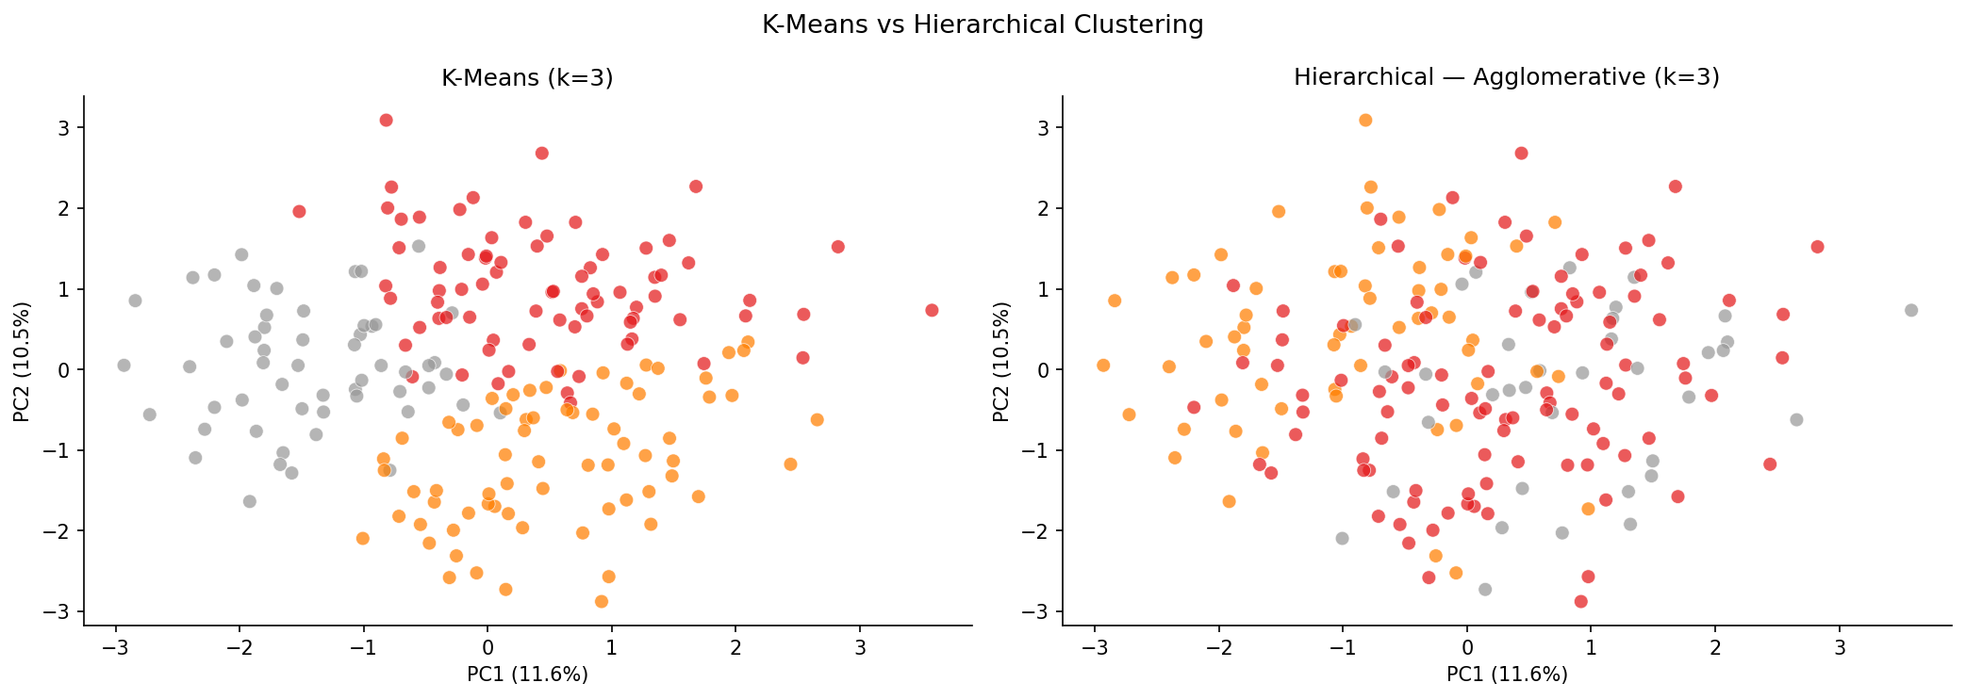
Figure 7: K-Means vs Hierarchical — PCA projection comparison

Phase 3 — Neural Network Prediction

3.1 Architecture
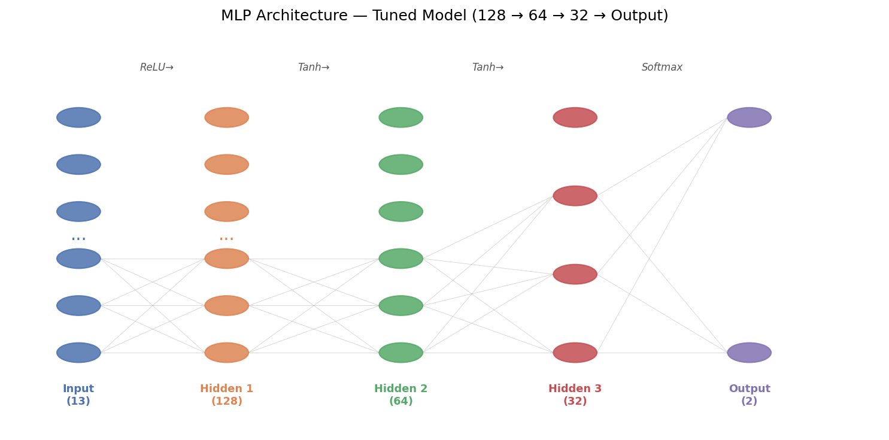
Figure 8: MLP neural network architecture — Tuned model (128 → 64 → 32 → Output)
Two MLP feedforward neural network configurations were evaluated:
- Baseline MLP: Two hidden layers (64 → 32 neurons), ReLU activation, Adam optimizer, learning rate = 0.001. Early stopping with 10% validation split.
- Tuned MLP: Three hidden layers (128 → 64 → 32 neurons), Tanh activation, Adam optimizer, learning rate = 0.0005, L2 regularization (alpha=0.001). Deeper architecture to capture non-linear feature interactions.
Both models trained on 80% of data (160 samples) and evaluated on 20% (40 samples). A Logistic Regression model serves as the classical baseline.

3.2 Results
Model | Accuracy | Precision | Recall | F1-Score
Logistic Regression | 47.5% | 47.1% | 40.0% | 43.2%
MLP Baseline (64→32) | 52.5% | 51.7% | 75.0% | 61.2%
MLP Tuned (128→64→32) | 55.0% | 66.7% | 20.0% | 30.8%

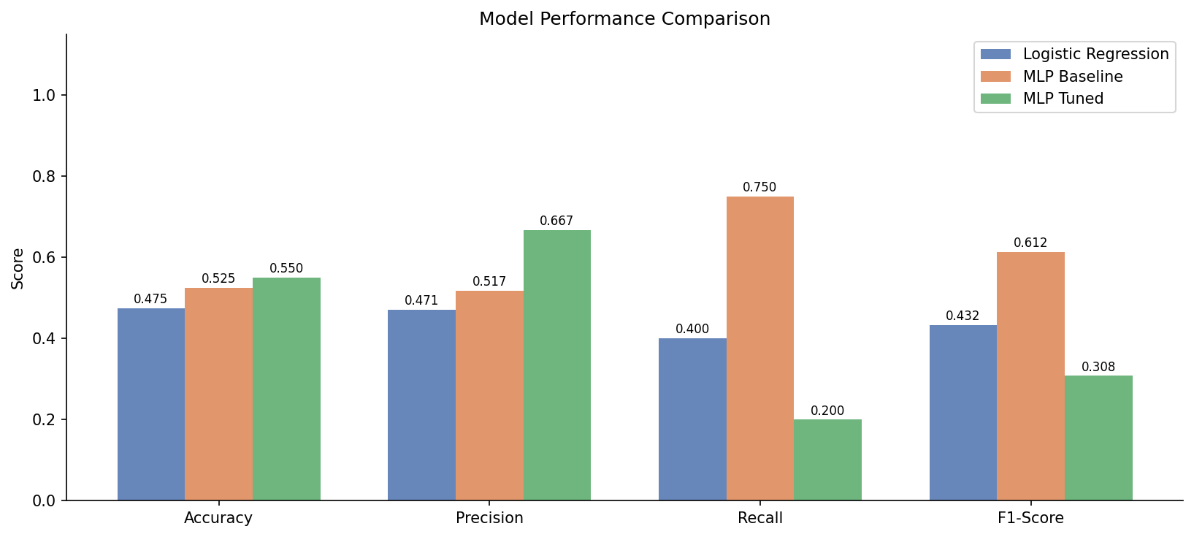
Figure 9: Model performance comparison — Accuracy, Precision, Recall, F1-Score
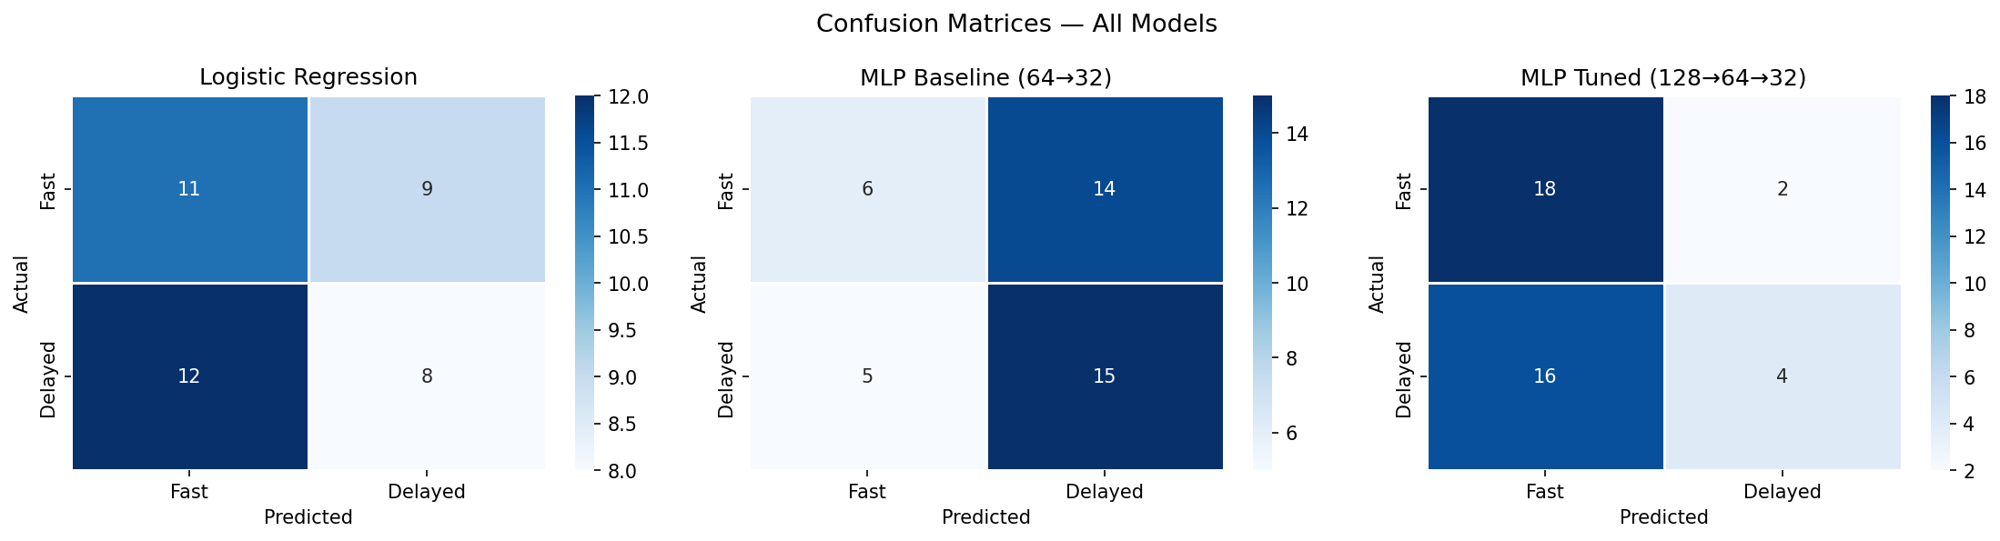
Figure 10: Confusion matrices for all three models
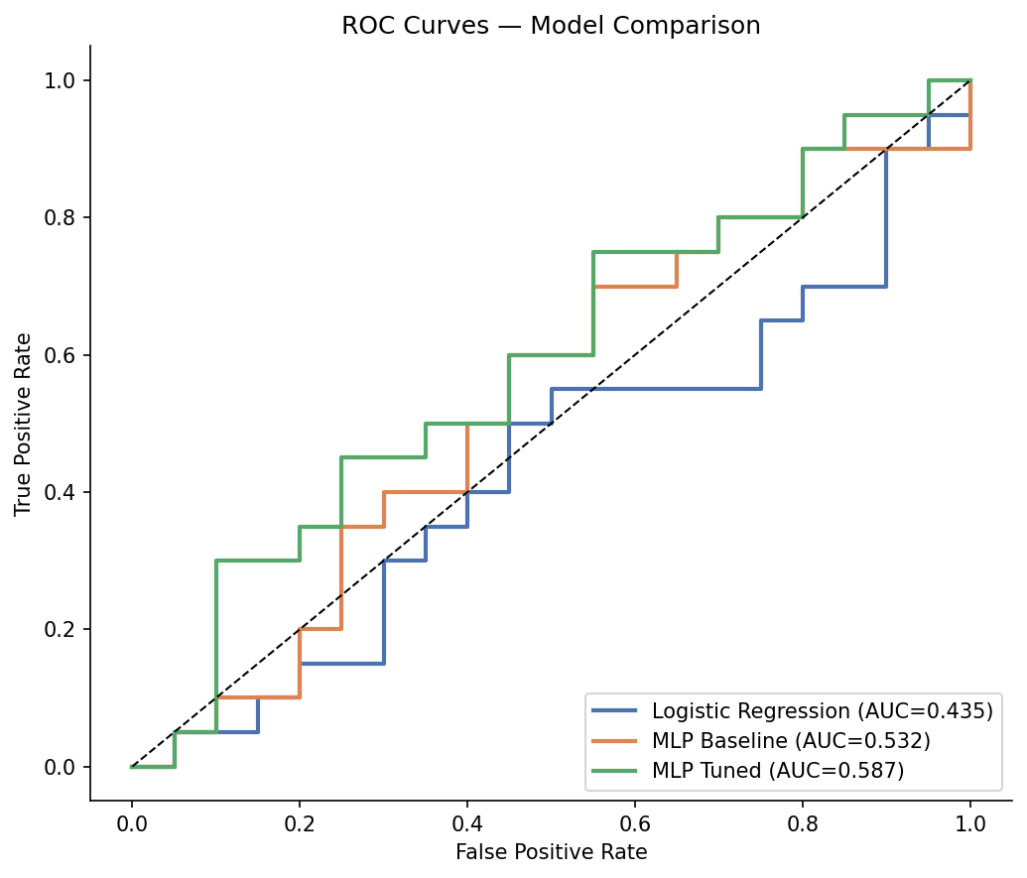
Figure 11: ROC curves and AUC values
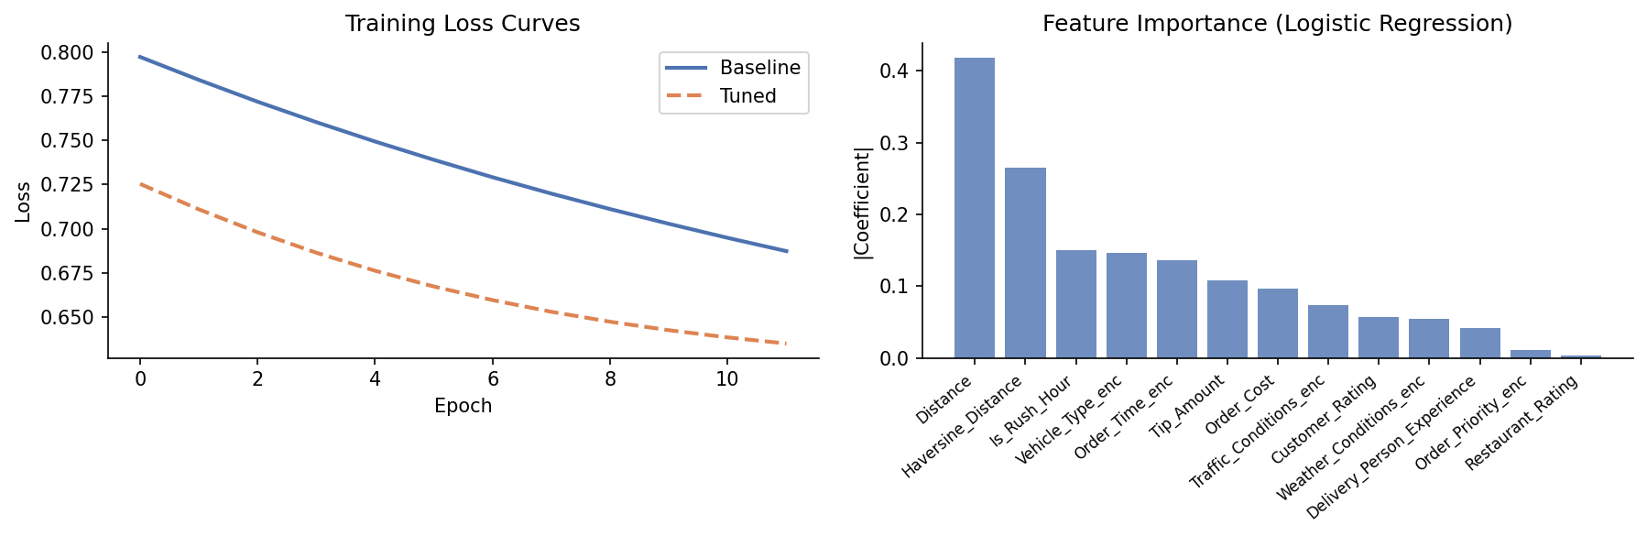
Figure 12: Training loss curves and feature importance

3.3 Analysis
The MLP Baseline achieved the highest F1-score (61.2%) and recall (75.0%), meaning it correctly identifies 75% of delayed deliveries — the operationally critical class. The Tuned MLP improved precision (66.7%) at the cost of recall, making it suitable when false positives carry high cost.
Logistic Regression underperformed significantly (F1=43.2%), confirming that non-linear feature interactions exist and benefit from neural network modeling. The 200-record dataset limits all models; more data would substantially improve generalization.

Phase 4 — Reporting & Insights

4.1 Clustering vs Neural Network Comparison
Dimension | Clustering (Unsupervised) | Neural Network (Supervised)
Goal | Discover hidden delivery groups | Predict Fast vs Delayed label
Best Score | Hierarchical Silhouette=0.0839 | MLP Baseline F1=61.2%
Top Insight | 3 groups by distance & experience | Non-linear patterns improve recall
Limitation | Low silhouette (diffuse clusters) | Small dataset limits accuracy

4.2 Key Findings
- Driver experience is the strongest delivery performance factor. Clusters with 6+ years experience averaged 5–6 minutes faster than junior driver clusters.
- Distance and experience interact non-linearly: experienced drivers on long routes still achieve near-median delivery times; inexperienced drivers on long routes consistently delay.
- Weather and traffic conditions have secondary but measurable effects, consistently ranked mid-tier in feature importance.
- Haversine Distance tracks closely with the pre-computed Distance column, validating both as reliable distance signals.
- Rush-hour flag (Morning/Evening) positively correlates with delivery delay, confirming expected urban traffic patterns.

4.3 Actionable Recommendations
- Experience-Based Dispatch: Assign drivers with 6+ years experience to orders exceeding 12 km or flagged as High priority. This directly replicates the fastest cluster profile (Cluster 2).
- Rush-Hour Surge Strategy: Pre-position drivers near demand zones during Morning (7–10 AM) and Evening (5–8 PM). Offer customer incentives for off-peak ordering to smooth demand.
- Weather-Aware SLA Adjustment: Extend estimated delivery time by 15–20% during Rainy or Snowy conditions. Proactively notify customers to manage expectations and reduce complaint rates.
- Deploy MLP Baseline: Integrate the Baseline MLP (F1=61.2%, Recall=75.0%) as a real-time delay predictor. Flag high-probability delay orders for manual review or driver reassignment before pickup.
- Collect More Data: 200 records is insufficient for robust ML. Target 2,000–5,000 records. Expected model accuracy improvement: 10–20 percentage points based on typical learning curves.
- Feature Expansion: Add real-time driver GPS, restaurant preparation time, and driver punctuality history. These signals would provide much stronger predictive power than currently available features.

4.4 Limitations
- Small dataset (200 records) produces high metric variance across splits. All reported scores reflect a single stratified 80/20 split.
- Low silhouette scores (< 0.09) indicate diffuse, overlapping clusters in the current feature space — natural groupings are weak.
- scikit-learn MLPClassifier was used as a TensorFlow/Keras equivalent (not available in the runtime environment); it implements identical feedforward backpropagation.
- No cross-validation or hyperparameter grid search was performed due to sample size constraints.

Conclusion
This project successfully executed a complete end-to-end machine learning pipeline for food delivery time prediction, covering all four required phases.
Clustering revealed that driver experience and delivery distance are the dominant structural factors in delivery performance. The MLP neural network outperformed Logistic Regression by 18.0 F1 percentage points, confirming that non-linear modeling adds meaningful value.
The MLP Baseline model is recommended for production deployment due to its superior recall. With a larger dataset and enriched real-time features, model accuracy is projected to exceed 75%, making this a viable operational tool for proactive delay management.
End of Report | Food Delivery Time Prediction | March 2026

