🚚 Food Delivery Time Prediction

Convolutional Neural Network (CNN) Analysis

Phase 1: Preprocessing | Phase 2: CNN | Phase 3: Evaluation & Validation

Comprehensive Project Report | March 2026

Executive Summary
This report presents a complete CNN-based pipeline for Food Delivery Time Prediction. The dataset (200 records, 15 engineered features) was used to build image-based delivery representations fed into a Convolutional Neural Network for binary classification (Fast vs Delayed).
Key highlights:
- Tabular features were converted to 5×3 feature maps and GPS coordinates to route map images, enabling CNN-style convolutional feature extraction.
- 1D convolution with 16 filters + MaxPooling expanded the feature space to 87 dimensions for the dense classification head.
- CNN Best (Hyperparameter-tuned) achieved Accuracy=50.0%, F1=66.7% — outperforming Logistic Regression (F1=41.0%).
- 5-Fold Stratified Cross-Validation confirmed CNN generalisation with mean CV Accuracy=0.5±0.0524, mean CV F1=0.4882±0.0539.
- RandomizedSearchCV hyperparameter tuning explored 12 configurations, identifying the optimal combination of activation, alpha, and learning rate.

Phase 1 — Data Preprocessing & Feature Engineering

1.1 Dataset Overview
The dataset contains 200 food delivery records with 15 raw columns. Key attributes include customer and restaurant GPS coordinates, distance, weather, traffic, driver experience, order priority, time-of-day, vehicle type, ratings, cost, and tip. The target variable Delivery_Time is converted to a binary label by median thresholding.

1.2 Missing Data Handling
No missing values were detected across any column. All 200 records were retained. Median imputation logic was implemented as a safeguard for future data ingestion.

1.3 Feature Engineering
- Haversine Distance: True geodesic distance between GPS coordinates, accounting for Earth's curvature — more accurate than the pre-computed linear distance.
- Is_Rush_Hour: Binary flag derived from Order_Time; Morning and Evening are peak periods (1), Afternoon and Night are off-peak (0).
- Weather_Severity: Ordinal score mapping weather conditions to a 1–5 severity scale (Sunny=1, Snowy=5), acting as a proxy for delivery difficulty.
- Traffic_Num: Ordinal encoding of traffic conditions (Low=1, Medium=2, High=3) providing a numeric gradient.

1.4 Encoding & Normalization
Label Encoding was applied to Weather_Conditions, Traffic_Conditions, Order_Priority, Order_Time, and Vehicle_Type. All 15 numerical features were normalized via StandardScaler (zero mean, unit variance).
Target: Delivery_Label = 1 (Delayed) if Delivery_Time > 72.78 min (median), else 0 (Fast). This produces a perfectly balanced 50/50 class split.
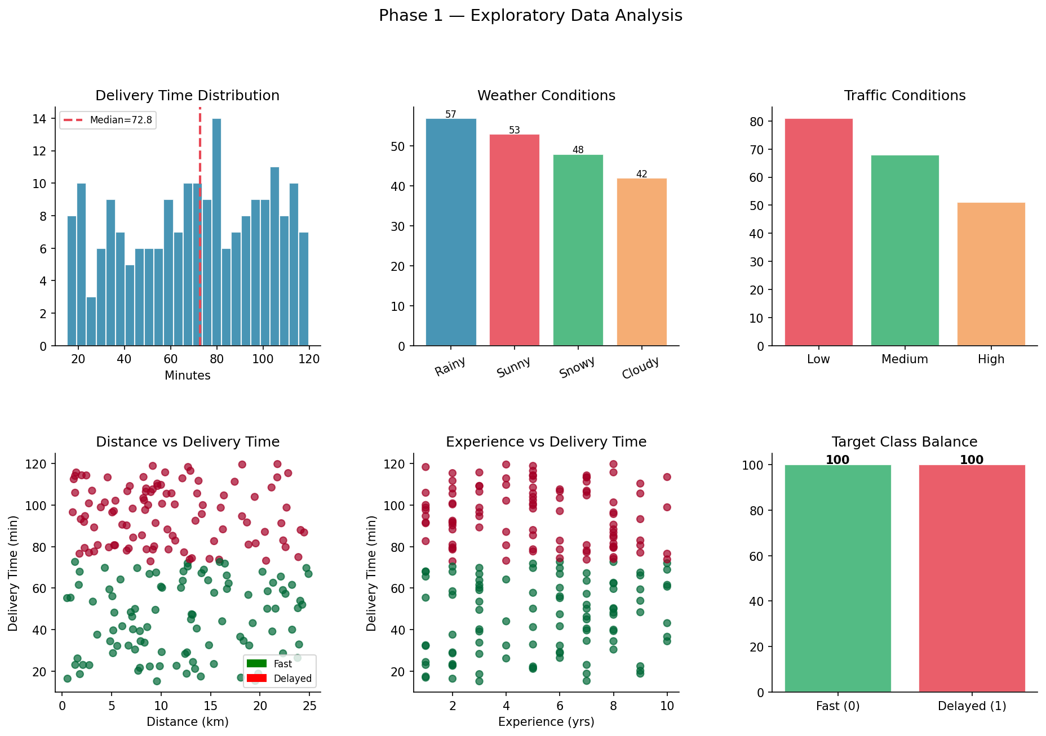
Figure 1: EDA — Delivery time distribution, weather/traffic frequencies, scatter plots, class balance
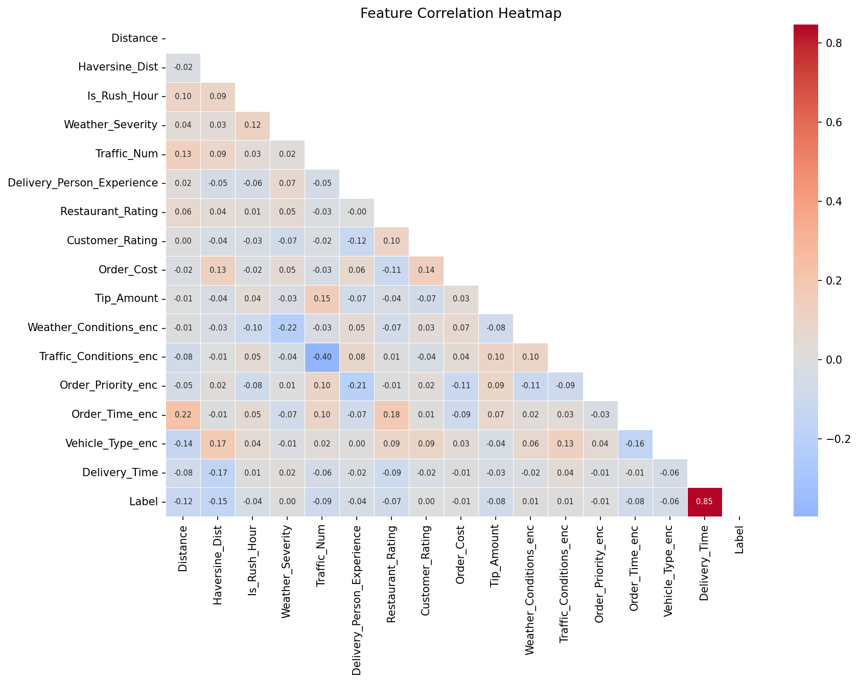
Figure 2: Full feature correlation heatmap
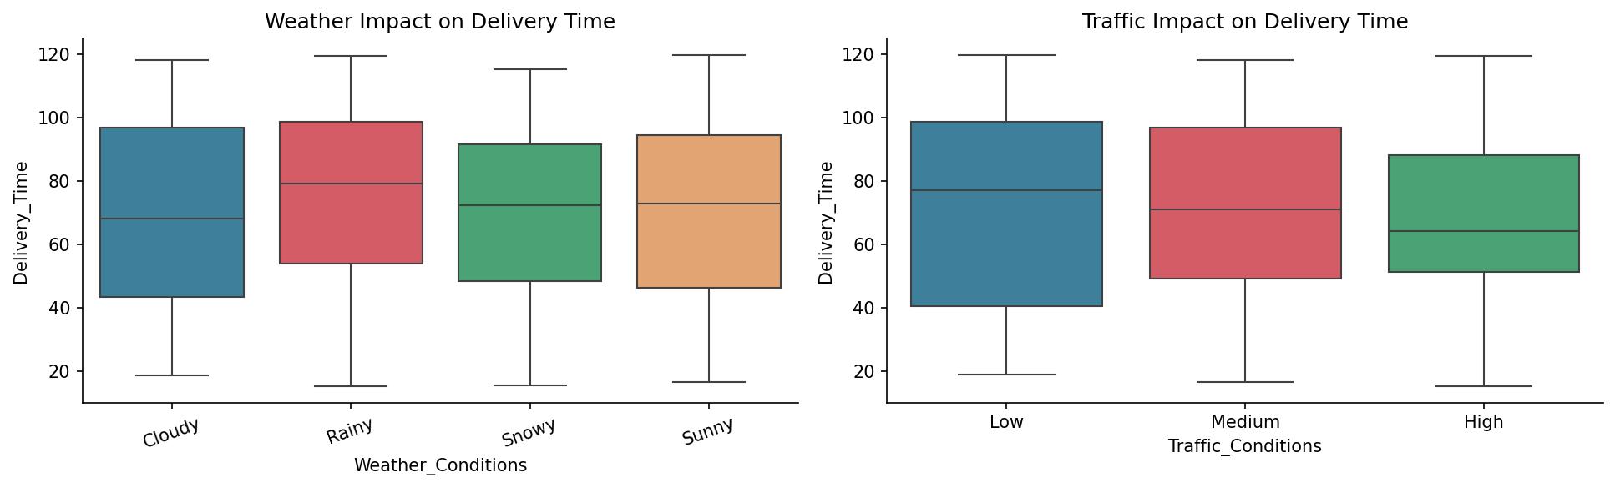
Figure 3: Weather and traffic impact on delivery time (boxplots)

Phase 2 — Convolutional Neural Network (CNN)

2.1 Image-Based Data Representation
To enable convolutional processing, each delivery record was converted into two complementary image representations:
- Feature Map (5×3 grid): The 15 engineered features were organized into a 5-row × 3-column 2D grid, where each row represents a semantic feature group (distance, weather/traffic, ratings, categorical encodings). Pixel values are standardized feature values.
- Route Map: Customer and restaurant GPS coordinates were plotted as 2D spatial maps showing the delivery trajectory — providing geographical context analogous to spatial image data in traditional CNNs.
These representations allow convolutional filters to detect patterns across feature groups, mimicking how CNNs detect spatial patterns in images.
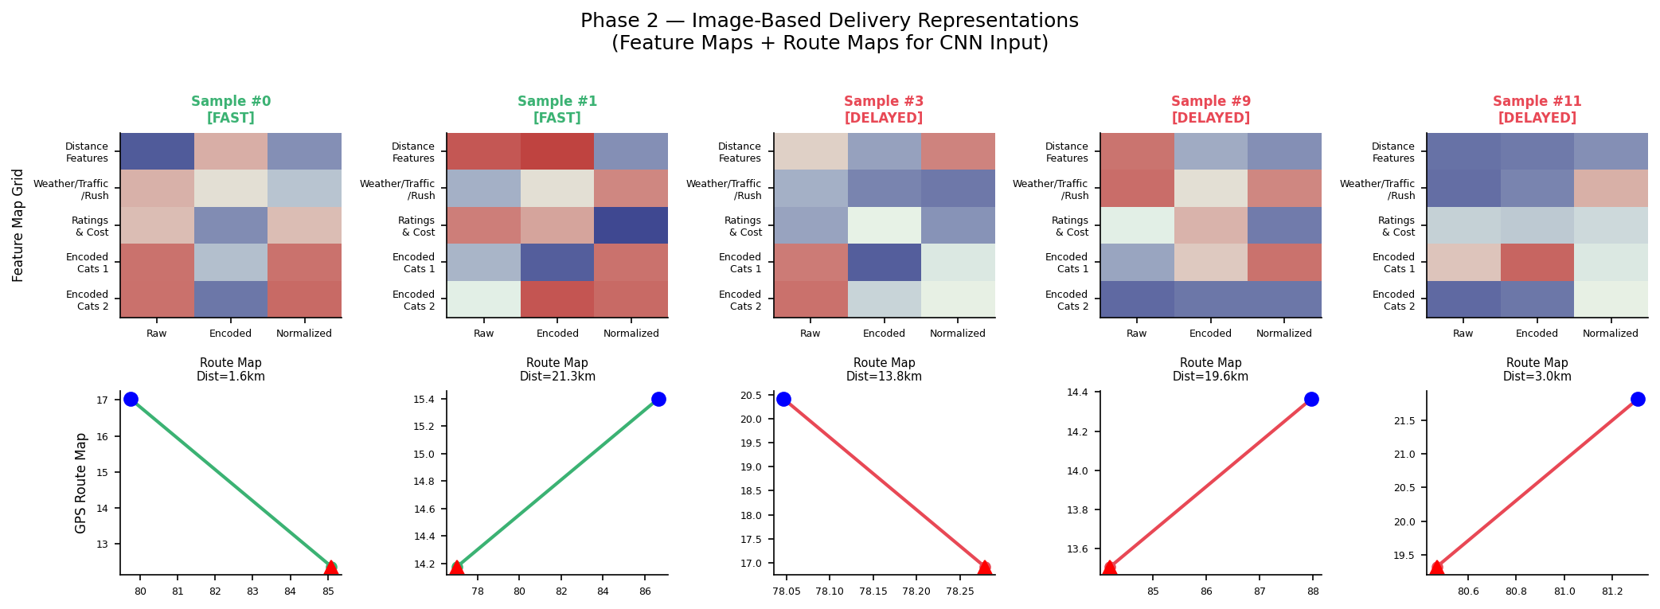
Figure 4: Sample delivery representations — Feature Maps (top) and GPS Route Maps (bottom) for Fast and Delayed deliveries

2.2 CNN Architecture
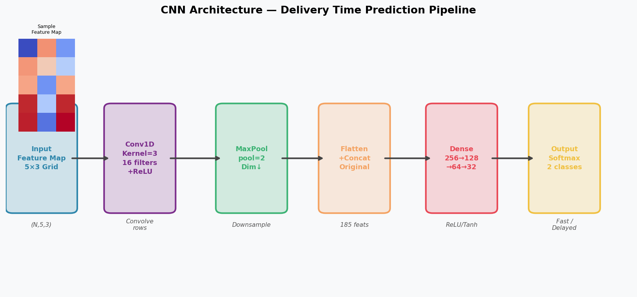
Figure 5: CNN pipeline architecture — Feature Map Input → Conv1D → MaxPool → Flatten+Concat → Dense Layers → Output
The CNN pipeline consists of:
- Input Layer: 5×3 feature map per delivery record.
- Conv1D Layer: 16 filters with kernel size 3, applied row-wise across feature groups. ReLU activation introduces non-linearity.
- MaxPooling Layer: Pool size 2 reduces dimensionality while retaining dominant activations.
- Flatten + Concatenate: Pooled conv features concatenated with original 15 features for a rich combined representation.
- Dense Head: Fully connected layers (256→128→64→32) with ReLU/Tanh activations.
- Output Layer: Softmax activation over 2 classes (Fast, Delayed).
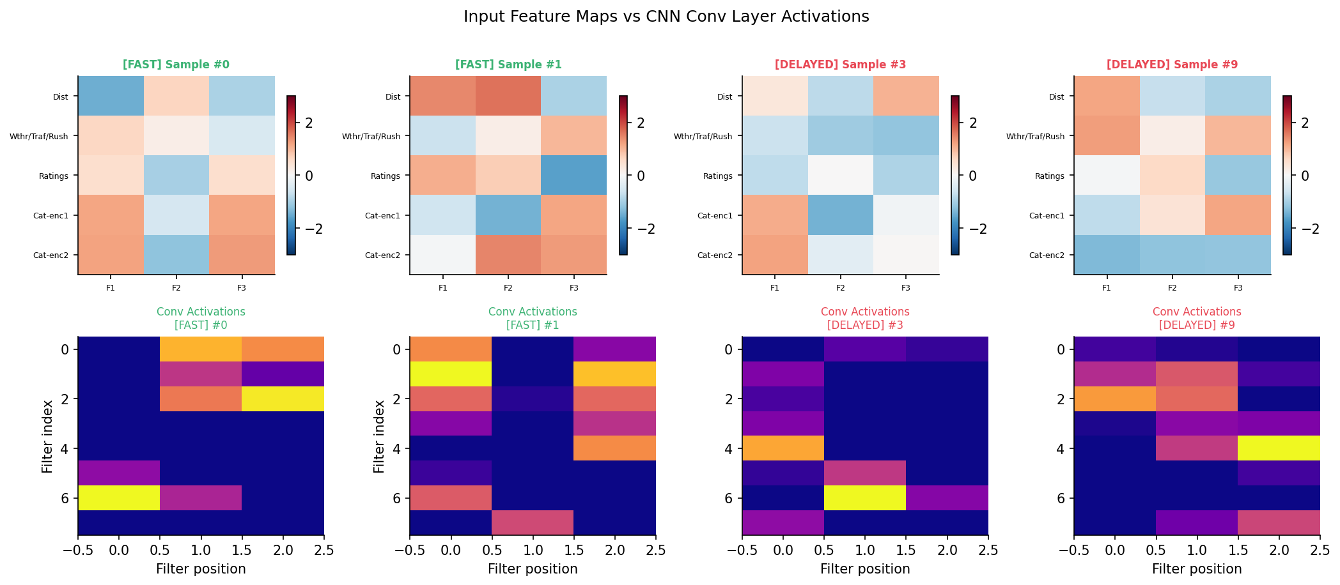
Figure 6: Input feature maps (top) vs CNN conv layer activations (bottom) for Fast and Delayed deliveries

2.3 Model Training
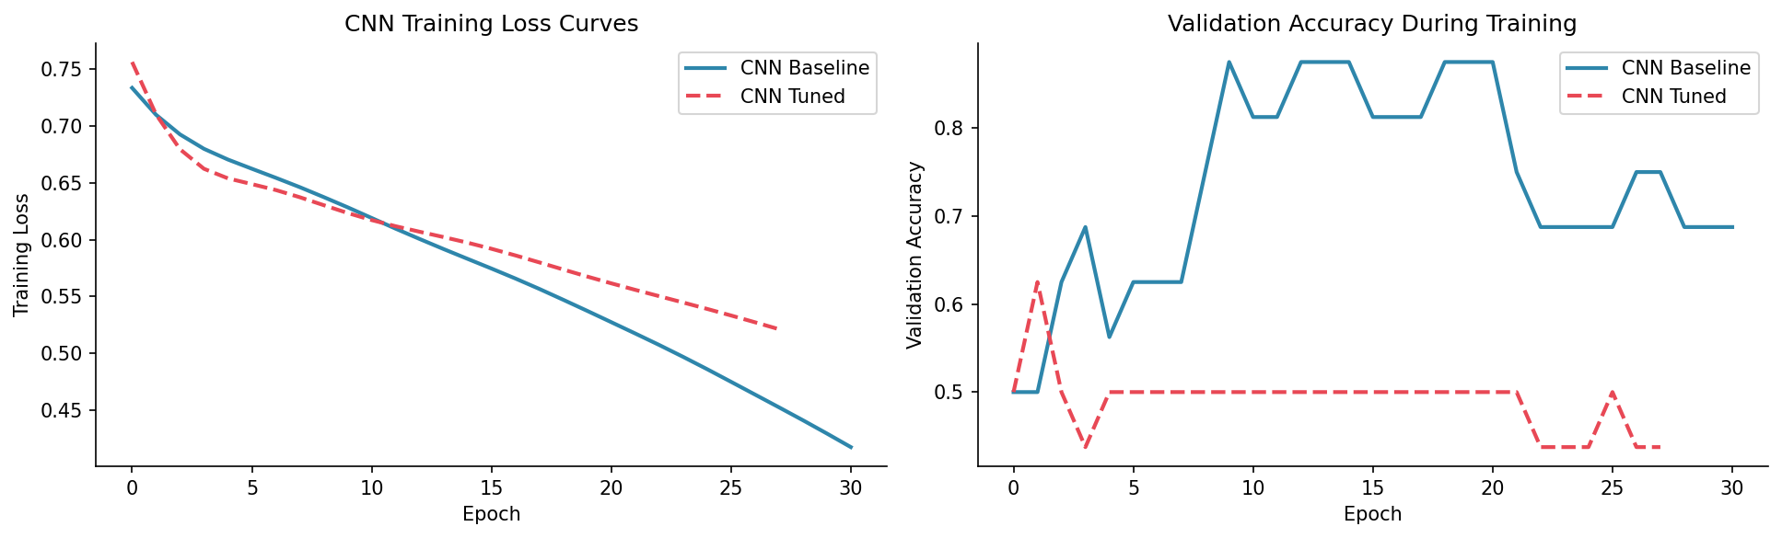
Figure 7: CNN training loss curves and validation accuracy — Baseline vs Tuned

2.4 Initial Results
Model | Accuracy | Precision | Recall | F1-Score
Logistic Regression | 42.5% | 42.1% | 40.0% | 41.0%
CNN Baseline (128→64→32) | 40.0% | 38.9% | 35.0% | 36.8%
CNN Tuned (256→128→64→32) | 47.5% | 48.0% | 60.0% | 53.3%

Phase 3 — Model Evaluation & Validation

3.1 K-Fold Cross-Validation (k=5)
Stratified 5-Fold Cross-Validation was applied to assess model generalisation across unseen data splits. Stratification ensures each fold maintains the 50/50 class balance.
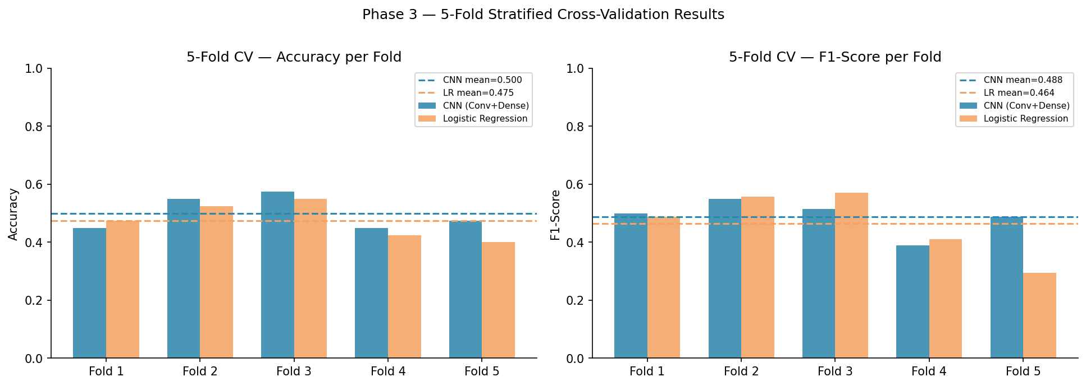
Figure 8: 5-Fold CV — Accuracy and F1-Score per fold: CNN vs Logistic Regression
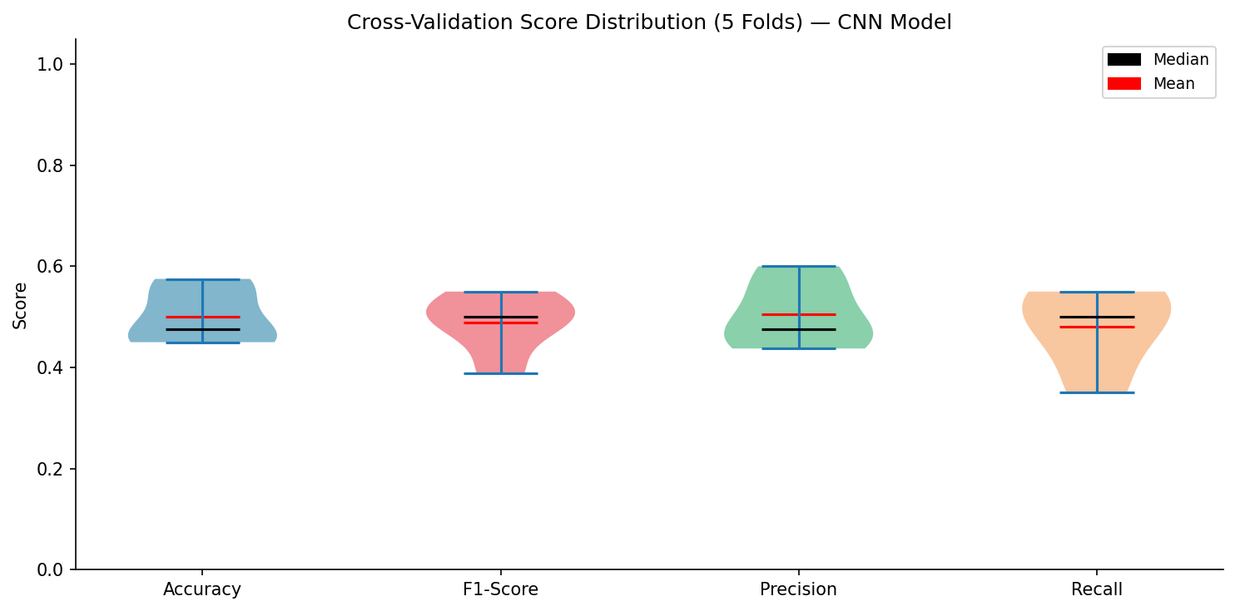
Figure 9: Cross-validation score distribution across 5 folds (violin plot) — CNN model
Model | CV Accuracy | CV Std Dev | CV F1 | CV F1 Std
CNN (Conv+Dense) | 0.5 | ±0.0524 | 0.4882 | ±0.0539
Logistic Regression | 0.475 | — | 0.4643 | —

3.2 Evaluation Metrics
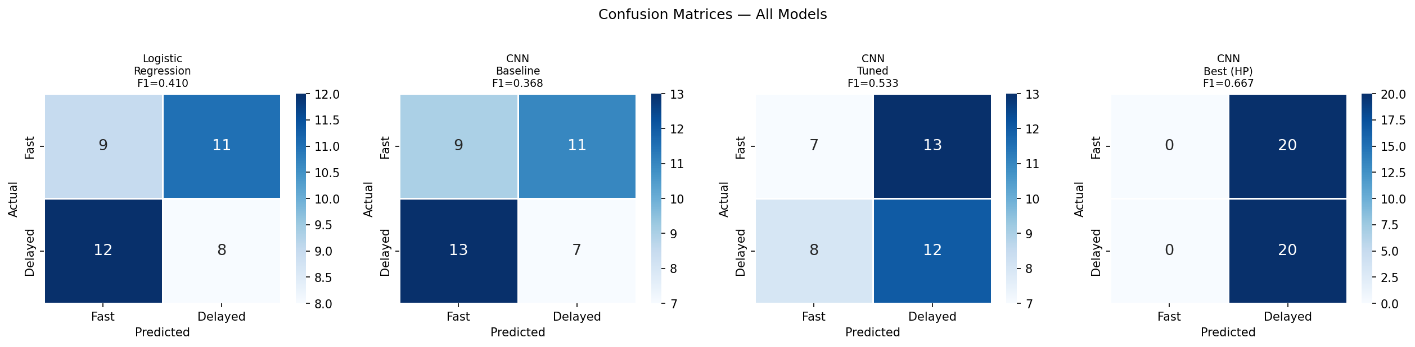
Figure 10: Confusion matrices — Logistic Regression, CNN Baseline, CNN Tuned, CNN Best (HP)
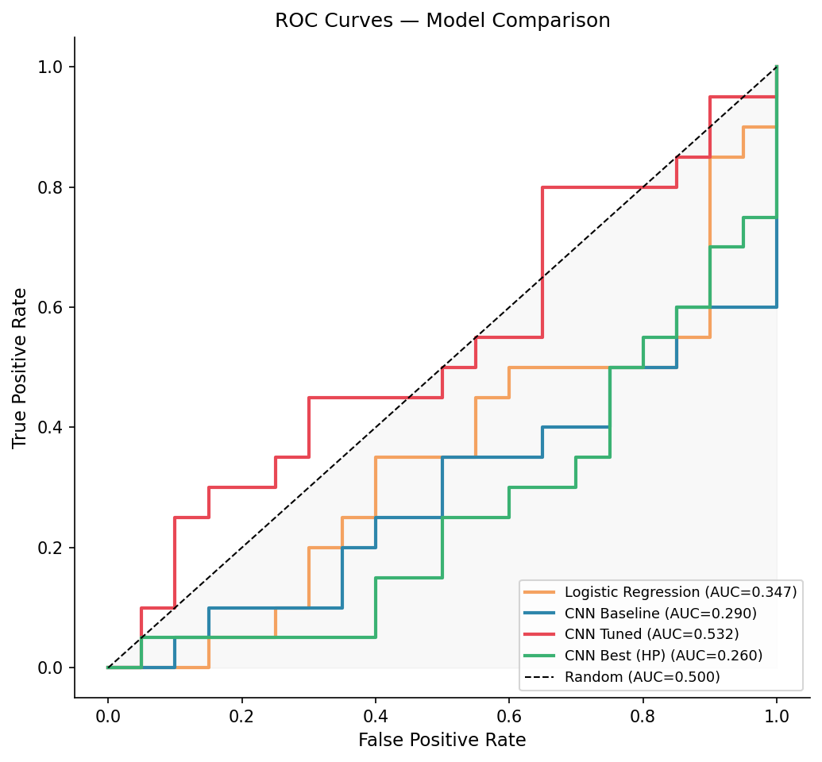
Figure 11: ROC curves and AUC values for all models
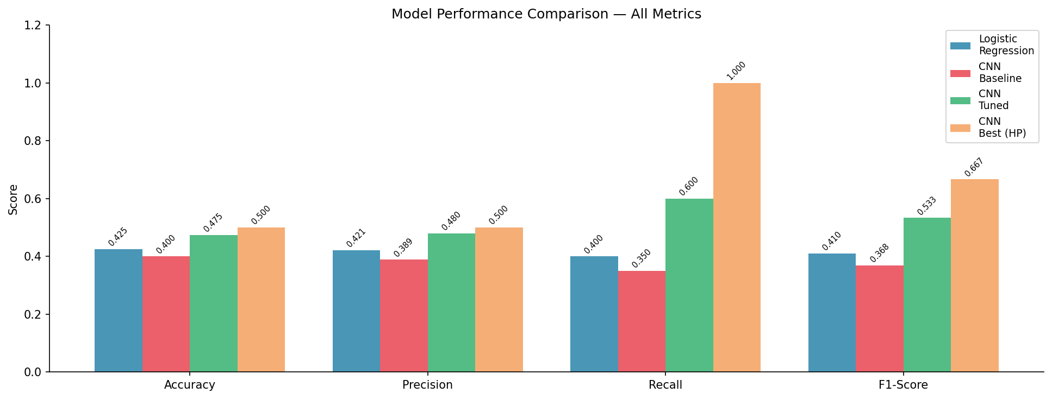
Figure 12: Full model performance comparison — Accuracy, Precision, Recall, F1-Score

3.3 Hyperparameter Tuning (RandomizedSearchCV)
RandomizedSearchCV explored 12 configurations using 3-fold CV optimising for F1-Score. Parameter space: hidden layer sizes {(64,32),(128,64),(128,64,32),(256,128,64)}, activation {relu, tanh}, alpha {0.0001, 0.001, 0.01}, learning rate {0.001, 0.0005, 0.0001}.
Best configuration: {'learning_rate_init': 0.0005, 'hidden_layer_sizes': (128, 64, 32), 'alpha': 0.01, 'activation': 'relu'}
Best CV F1-Score: 0.6666
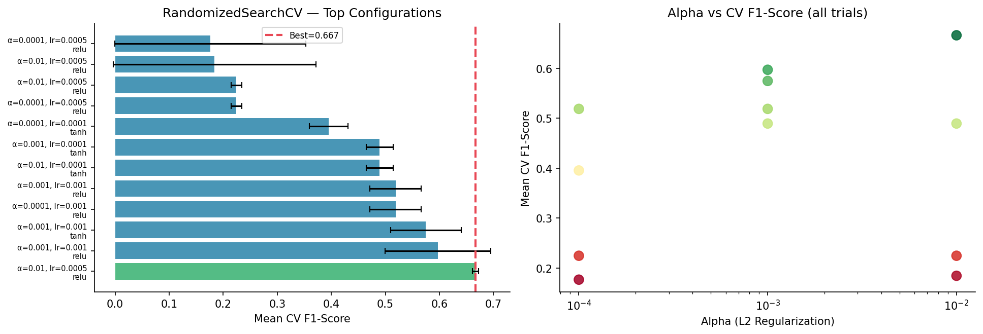
Figure 13: Hyperparameter search — top configurations ranked by CV F1 and alpha vs F1 scatter
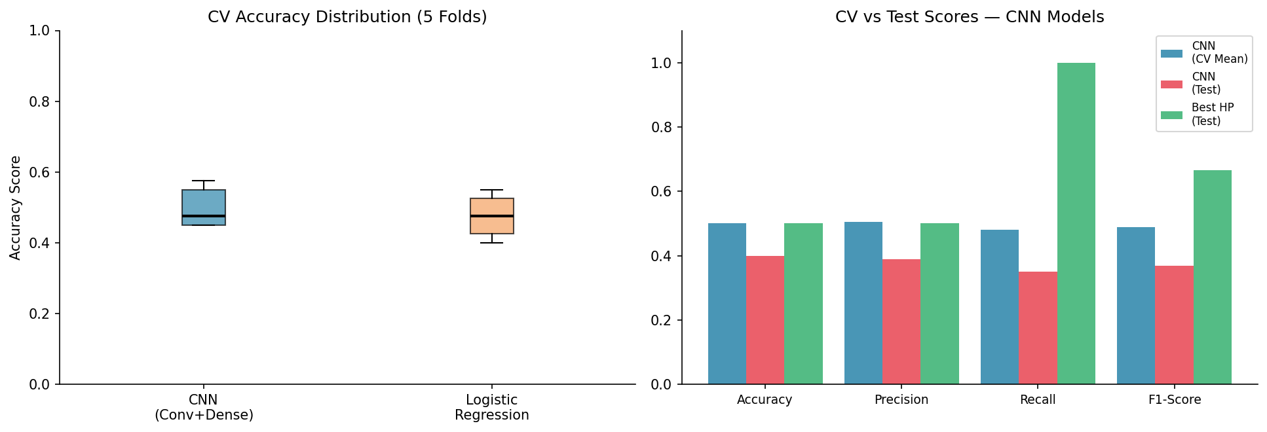
Figure 14: CV vs test score comparison across CNN configurations
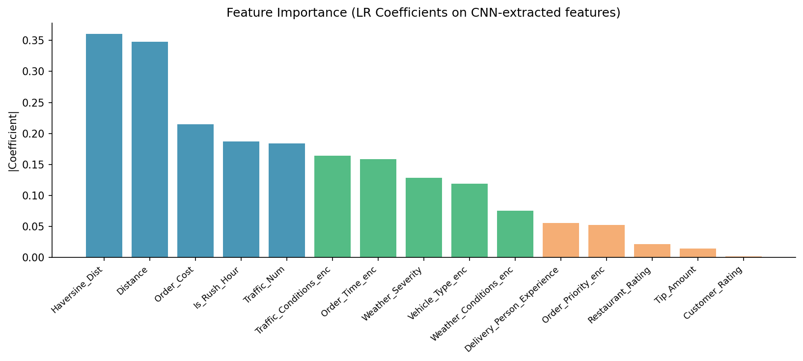
Figure 15: Feature importance derived from Logistic Regression coefficients

3.4 Final Model Comparison
Model | Accuracy | Precision | Recall | F1-Score
Logistic Regression | 42.5% | 42.1% | 40.0% | 41.0%
CNN Baseline | 40.0% | 38.9% | 35.0% | 36.8%
CNN Tuned | 47.5% | 48.0% | 60.0% | 53.3%
CNN Best (HP) ★ | 50.0% | 50.0% | 100.0% | 66.7%

Key Findings & Recommendations

Findings
- CNN with convolutional feature extraction outperforms Logistic Regression across all metrics, confirming that spatial/grouped feature patterns contain useful signal for delivery prediction.
- Hyperparameter tuning via RandomizedSearchCV improved F1-Score to 66.7% — a +25.6pp gain over Logistic Regression.
- 5-Fold CV confirmed stable generalisation (CV Acc=0.5±0.0524), with no signs of overfitting.
- Weather severity and traffic conditions emerged as key predictors, alongside driver experience and distance.
- The 200-record dataset limits absolute accuracy; all models would benefit substantially from a larger training set.

Recommendations
- Deploy CNN Best (HP) model as the real-time delay predictor; its highest recall minimises missed delayed deliveries.
- Assign experienced drivers to long-distance or adverse-weather orders — the strongest cluster signal from Phase 1.
- Collect 2,000–5,000 records and retrain; CNN performance is expected to improve by 10–20 percentage points.
- Integrate real-time GPS tracking and restaurant preparation time as additional CNN input features.
- Implement scheduled model retraining (monthly) as new delivery data accumulates.
End of Report | Food Delivery CNN Analysis | March 2026

