|  |  |
| --- | --- |
| **Exposure Java** | **Lab 05** |
| **The Control Structures**  **Graphics Program** | **80, 90, 100, & 110 Point Versions** |
| **Assignment Purpose:**  The purpose of this program is to demonstrate knowledge of loop control structures combined with Graphics methods. | |

Write a program, which displays straight lines inside a rectangle from one side to a perpendicular side. The lines must be drawn in such a way that both the starting points of the lines on one side and the ending points on the other side are equidistant along the sides. The size of the rectangle is **980** pixels width by **630** pixels height.

|  |  |
| --- | --- |
| **Lab05vst Student Version** | **Do not copy this file, which is provided.** |
| // Lab05vst.java  // Student version of the Lab05 assignment.  import java.awt.*;  import java.applet.*;  public class Lab05vst extends Applet  {  public void paint(Graphics g)  {  int width = 980;  int height = 630;  g.drawRect(10,10,width,height);    // Draw bottom-left corner    // Draw bottom-right corner    // Draw top-right corner    // Draw top-left corner    }  } | |

**80 Point Version Specifics**

The 80-point lab assignment displays lines in bottom-right corner only. Do not be concerned with the appearance of the output. The curved line you see is an illusion. Everything is drawn with straight lines. Make no attempt to try and draw some type of arc. One challenge you need to handle is the fact that starting and end points need to be equidistant. The width and height of the rectangle are different. If you use the same distance on both sides then you will be finished on the shorter height before you have drawn all the lines on the longer width. The spaces between starting points on the width and ending points on the height are not the same.

**80 Point Version Output**

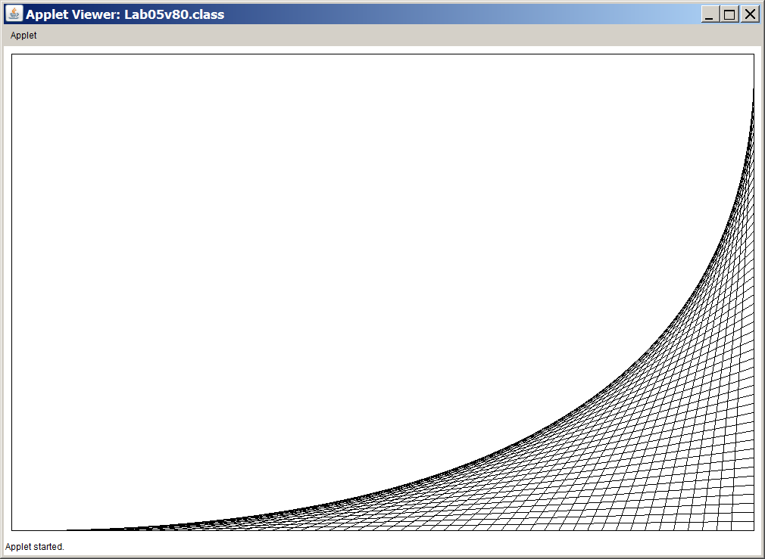

**90 Point Version Specifics**

The 90-point lab assignment displays lines in the bottom-right corner and bottom-left corner. This is an example where you can benefit from a functional 80-point version. Block-copy the code segment that draws the bottom-right corner and then alter the values in such a way that the bottom-left corner is drawn next.

**90 Point Version Output**

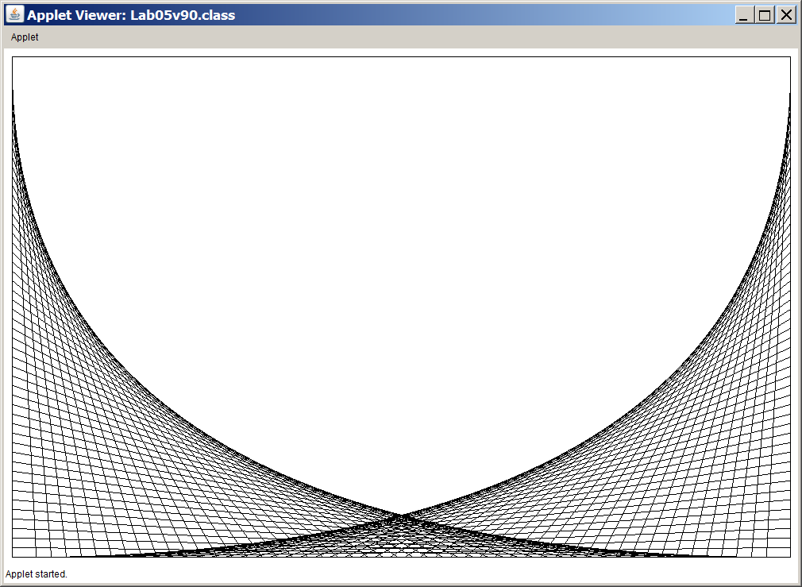

**100 Point Version Specifics**

The 100-point lab assignment displays lines in all four of the rectangle corners. Once again block copying can save time due to the similarity of the code. There is one warning about block copying. It is a timesaving tool, but it is also an error duplicator. If the source code is not tested properly, you will be block-copying many errors. Another problem occurs when you fail to make the necessary changes after block copying, which would mean you are drawing the exact same thing twice.

**100 Point Version Output**

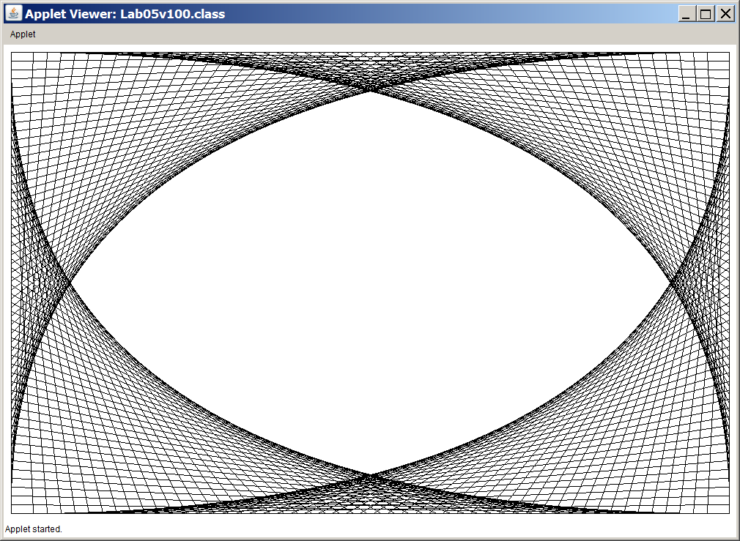

**110 Point Version Specifics**

The 110-point, extra-credit, version repeats the entire process by drawing a small copy of the previous 100-point version inside the blank space of the design. The output below clarifies the requirement.

**110 Point Version Output**

