Sage 300 Web Screens SDK

Resx Generation Utility

August 2016

The MIT License (MIT)

Copyright © 2016 The Sage Group plc or its licensors. All rights reserved.

Permission is hereby granted, free of charge, to any person obtaining a copy of this software and associated documentation files (the “Software”), to deal in the Software without restriction, including without limitation the rights to use, copy, modify, merge, publish, distribute, sublicense, and/or sell copies of the Software, and to permit persons to whom the Software is furnished to do so, subject to the following conditions:

The above copyright notice and this permission notice shall be included in all copies or substantial portions of the Software.

THE SOFTWARE IS PROVIDED “AS IS”, WITHOUT WARRANTY OF ANY KIND, EXPRESS OR IMPLIED, INCLUDING BUT NOT LIMITED TO THE WARRANTIES OF MERCHANTABILITY, FITNESS FOR A PARTICULAR PURPOSE AND NONINFRINGEMENT. IN NO EVENT SHALL THE AUTHORS OR COPYRIGHT HOLDERS BE LIABLE FOR ANY CLAIM, DAMAGES OR OTHER LIABILITY, WHETHER IN AN ACTION OF CONTRACT, TORT OR OTHERWISE, ARISING FROM, OUT OF OR IN CONNECTION WITH THE SOFTWARE OR THE USE OR OTHER DEALINGS IN THE SOFTWARE.

Contents

1. Overview 4

2. Control Descriptions 5

2.1 Toolbar Buttons 5

2.2 Resource Information Grid 5

2.3 Checkboxes 6

3. Resource Information Text File 7

3.1 Text File Format 7

4. Settings Text File 8

4.1 Text File Format 8

5. User Interface Operation 9

6. Headless Operation 10

7. Special Character Sequences 11

1. Overview

The **Resx Generation Utility** is a C# project developed in Visual Studio 2012 and will be used to generate **resx** (web language resource files) files from **rc** (desktop language resource files) files. The following sections will show screen shots and explain the steps being performed in the utility.

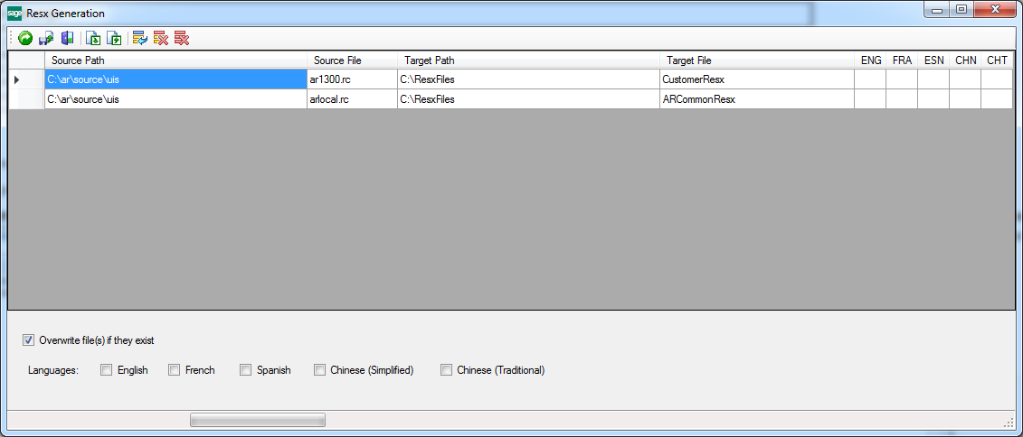

1. Control Descriptions
   1. Toolbar Buttons

* Proceed
  + Select to start the generation process.
* Save
  + Select to save the Resource Information details with statuses per each language.
  + Use this option to save the results of a particular process run.
* Exit
  + Select to exit the utility.
* Import
  + Select to import a text file containing Resource Information
* Export
  + Select to save the Resource Information details without statuses per each language.
  + Use this option to save any modifications made in the Resource Information grid.
* Add Row
  + Select to add a row in the Resource Information grid.
* Delete Row
  + Select to delete the current row in the Resource Information grid.
* Delete Rows
  + Select to delete all rows in the Resource Information grid.
  1. Resource Information Grid

Displays source file, target file and statuses for each language. The grid can be populated manually or populated with a text file via the Import Toolbar Button.

* 1. Checkboxes
* Overwrite
  + Defaults to checked.
  + Will overwrite an existing Resx file if this option is checked.
  + A warning status will be displayed if a file is skipped if this checkbox is unchecked.
* Languages
  + Select the language or languages for the generated resx files

1. Resource Information Text File

The utility can import a text file pointing to one or more **rc** files to be processed.

This implementation will allow for one **rc** file to be processed or many **rc** files to be processed.

**Important:** The source files are located in language specific sub-folders under the specified Source Path and the Target will also observe this folder naming convention. Additionally, the target resx file will have Culture Information added to the name of the Target File.

* 1. Text File Format

The layout of the text file is to supply a **Source Path**, a **Source rc File**, a **Target Path** and a **Target File**. The utility will use this information to locate the source file and generate the target file for the language(s) selected.

* The text file uses a semi-colon as a separator
* A/R Customer Example (ArCustomer.txt)

C:\ar\source\uis**;**ar1300.rc**;**C:\ResxFiles**;**CustomerResx

C:\ar\source\uis**;**arlocal.rc**;**C:\ResxFiles**;**ARCommonResx

If the above example file was imported and then processed for the English and French languages, the following files would be generated:

C:\ResxFiles\ENG\CustomerResx.resx

C:\ResxFiles\ENG\ARCommonResx.resx

C:\ResxFiles\FRA\CustomerResx.fr-CA.resx

C:\ResxFiles\FRA\ARCommonResx.fr-CA.resx

1. Settings Text File

The utility can also be run from the command line without the user interface (headless operation)

* 1. Text File Format

The layout of the text file is to supply a **Boolean** value and the **Languages** to be processed.

* The text file uses a semi-colon as a separator
* Settings Example (settings.txt)

true**;**ENG**;**FRA

In the above example, true refers to the Overwrite Checkbox and the remaining languages are to be processed by the utility.

The following languages are allowed:

* ENG (English)
* FRA (French)
* ESN (Spanish)
* CHN (Chinese Simplified)
* CHT (Chinese Traditional)

1. User Interface Operation

* A valid Resource Information text file can either be specified or the grid may be manually populated.
* An error message will be displayed if the Resource Information grid is empty or none of the Language checkboxes have been checked when the Proceed Toolbar button is selected.
* Any warnings or errors associated with the reading and parsing of source files or the generation of target files will be reflected in the Resource Information status columns.
  + The appropriate icon will be displayed (Warning or Error) and Hover Over text is available over the icon to see the exact reason for failure.
* Upon the successful generation of a resx file, the appropriate language column will display the Success Icon

1. Headless Operation

* The utility maybe run without input in the UI by providing information at the command line.
* The fully qualified Resource Information file must specified for the first parameter.
* The fully qualified Settings file must specified for the second parameter.

call Sage.CA.SBS.ERP.Sage300.ResxGeneration.exe C:\ArCustomer.txt C:\settings.txt

1. Special Character Sequences

The .resx file may contain a few significant character sequences which will need to be dealt with upon accessing a string from a resource.

The "\n", "\r" and "\t" escape sequences are for New Lines, Returns and Tab sequences. If a locally defined string were to contain these sequences, the string would behave with the appropriate behavior (new line, return, tab). However, when a string in a resource file in .NET has these escape sequences, they are escaped upon retrieval and are treated as literals (i.e. "\n" becomes "\\n", etc.).

Therefore, when a string is retrieved from a resource file, it will need to be sent to a routine which will perform a replacement of these "literals", which in turn transforms them back into their special sequence values.