**Detection and Classification of ECG Arrhythmia using LSTM Autoencoder**

Laxman Singh1*, Zeeshan Ahmad2*, Shivank Goel3*, Aditya Raj4* and Sarik Anwar5*

* Department of Computer Science and Engineering, Sharda University, Greater Noida, U. P., India

1Laxman.singh4@sharda.ac.in

22018009161.zeeshan@ug.sharda.ac.in

32018006884.shivank@ug.sharda.ac.in

42018007210.aditya@ug.sharda.ac.in

52018015190.sarik@ug.sharda.ac.in

**Abstract**

Arrhythmia is a coronary heart rhythm circumstance that reasons abnormal heartbeats. The electrocardiographic (ECG) sign can screen abnormalities withinside the conduction machine. An electrocardiogram (ECG) is an vital diagnostic device for detecting coronary heart arrhythmias in medical practise. Due to the very low amplitudes, visually assessing the ECG alerts may be hard and time-consuming. Implementing an automatic method withinside the medical context ought to probably accelerate and decorate the accuracy of arrhythmia diagnosis. In this paper, we advocate an automatic machine for detecting ordinary sinus rhythm, R-on-T Premature Ventricular Contraction (R-on-T PVC), Supra-ventricular Premature or Ectopic Beat (SP or EB), Unclassified Beat (UB) and untimely ventricular contraction (PVC) on ECG alerts the usage of a protracted short-time period memory (LSTM). The primary cause of this look at is to create a deep mastering method for categorizing one-of-a-kind forms of arrhythmia this is simple, dependable, and clean to use. In order to categorize ordinary and pathological beats in an ECG, recurrent neural networks (RNN) have been used. The major intention of this studies changed into to make it feasible to routinely distinguish among everyday and abnormal beats. The beat type overall performance is assessed the usage of the MIT-BIH Arrhythmia database. As inputs to the Long Short Term Memory Network, a big quantity of popular data, consisting of ECG time-collection data, is used. The dataset changed into separated into education and trying out sub-data. The proposed technique done nicely in phrases of type, with a ninety seven percentage accuracy rate. Our proposed method can help clinicians in as it should be detecting not unusualplace arrhythmias.

**Keywords:** Deep Learning, ECG Detection and Classification, Recurrent Neural Networks, Long Short Term Memory

1. **Introduction**

Electrocardiography (ECG) is a essential and effective diagnostic tool for detecting cardiac abnormalities. The electrocardiogram (ECG) signal is a example of the coronary coronary heart`s bioelectrical activities. The electrocardiogram is a useful tool for identifying a person`s health status. It offers complete facts about physiological processes withinside the human body and consequently can be considered a capability tool for health evaluation. Early analysis of coronary coronary heart disorders (abnormalities) at an early age can help to growth existence and beautify exceptional of existence. Changes or anomalies withinside the ECG signal observed thru a human observer had been a traditional technique of detecting cardiac disorders. As a result, it`s miles critical to beautify the accuracy and effectiveness of signal automation and beat class.

Automatic cardiac arrhythmia class will provide intention diagnostic effects and maintain time for cardiologists. These advantages have sparked a flurry of agency interest withinside the categorization and analysis of ECG facts using laptop power.

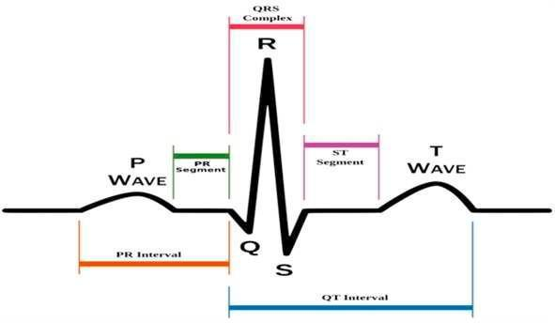

**Figure 1: ECG Signal Curve (Source: ICCIDS)**

The purpose of this studies is to apply an RNN Long Short-time period Memory community to hit upon arrhythmia from ECG alerts effectively. The ECG sign is made from 5 one of a kind styles of heartbeats, which might be categorized into groups: everyday and arrhythmia. Normal (N), R-on-T Premature Ventricular Contraction (R-on-T PVC), Premature Ventricular Contraction (PVC), Supra-ventricular Premature or Ectopic Beat (SP or EB), and Unclassified Beat (UB) are the numerous styles of arrhythmia heartbeats.

Cardiologists, who've spent years studying to discriminate among everyday and arrhythmic beats, have failed severa instances because of human nature, taking into consideration in addition research and invention on this discipline of biotechnology. For detecting arrhythmia, numerous system studying and deep studying fashions had been used, and a number of them have outperformed cardiologists. We will now discover diverse system studying fashions for arrhythmia detection with a purpose to achieve a higher know-how of the fashions and to advantage insights into what must and might be suitable for this discipline of studies.

To get rid of the want for human detection of arrhythmic beats withinside the ECG, we used a system studying gadget to hit upon abnormal beats automatically, which can also additionally then be taken to a heart specialist for verification and extra research. The type accuracy may be appeared to a few level, and this paper can assist docs simplify their paintings and be taken into consideration for destiny development and development.

1. **Related Works**

As a result, this newsletter makes use of recurrent neural networks with exceptional parameters and variety of epochs, in which the accuracy modifications because the neurons withinside the hidden layer and the variety of epochs.

To produce robotized popularity and discovery of ECG, wonderful techniques were available. To enhance execution, Support Vector Machines (SVM), Multilayer Perceptron (MLP), Markov Models, Fuzzy or Neuro-fuzzy Systems, and a number of tactics were suggested. To far, only some analysts have tried to diagnose coronary heart beats the use of SVM and a exceptional classifier. Over the years, diverse strategies for constructing up motorised systems to exactly organise ECG facts were proposed. These strategies encompass wavelet transforms, direct vector quantization, probabilistic neural networks, and fuzzy crossover neural systems. Silipo et al. proposed an ECG characterization differentiation undertaking that used opportunity association techniques: one with an administered getting to know approach and the alternative with unlabeled facts. Sugiura and co-workers created a fuzzy rationale-primarily based totally machine for detecting ECG and ventricular arrhythmias. Acharya et al. hired coronary heart fee changeability (HRV) because the simple flag and ANN and fuzzy proportionality connections to classify 4 ECG arrhythmias. SVM-primarily based totally arrhythmia association, in line with Kohli et al., is hooked up with 3 techniques: one as opposed to one, one in opposition to all, and fuzzy selection capacity. In this paintings, a one-in opposition to-all approach outperforms different strategies in phrases of precision. Jadhav et al. created 3 exceptional ANN fashions for detecting coronary heart arrhythmia. A RNN version is evolved on this paper to categorise arrhythmia in heartbeats.

The majority of modern research on this discipline have targeted on detecting diverse cardiovascular illnesses. ECG alerts, for example, were efficaciously used to categorise arrhythmias, locate myocardial ischemia, and diagnose coronary artery disease. The ee-e book presents a complete evaluation of the modern kingdom of ECG sign processing and interpretation.

The ECG alerts regulate form for a number of non-cardiac conditions, together with pulmonary embolism, important anxious machine (CNS) ailments, myasthenia gravis, muscle tremors, hypothermia, and hypothyroidism, in line with [15]. Another look at [16] discovered that changes are gift for diverse esophageal troubles similarly to CNS ailments. Drugs, toxins, and electric harm have additionally been confirmed to have a big effect at the waveform of ECG alerts. Authors of every other research [17] offered a look at that confirmed a hyperlink among Friedreich`s ataxia and electrocardiographic facts. These guides had been essential for knowledge the coronary heart`s facts function, however due to the fact they rely upon a particular sort of ECG abnormality, the proposed processes couldn't be extended to pick out extra disorders. Uspenskiy in large part solved the hassle in [1-2]. In his research, he evolved a fixed of 216 capabilities that had been retrieved from electrocardiograms and utilised to categorise illnesses. The proposed method changed into placed to the take a look at on a fixed of 30 illnesses and achieved admirably. This strategy, however, isn't with out flaws. For starters, it does not cope with whether or not the deliberate capabilities will paintings properly on new ailments. Another difficulty is that capabilities had been created via way of means of hand, consequently a few facts from the supply facts can be lost.

1. **Methodology Used**

We used Recurrent Neural Networks to continue with the categorization and analysis of arrhythmic beats on this paper. The percent of accuracy is used to degree the effectiveness of RNN-primarily based totally heartbeat categorization. A cautious evaluation of the paintings that has already been accomplished withinside the challenge is likewise carried out, with the maximum crucial elements taken into account. When the need to paintings with sequential records arose, including handwriting identity and speech recognition, an critical kind of synthetic neural networks arose. Recurrent Neural Networks are a kind of synthetic neural community which can method and classify arbitrary sequences of inputs the use of their inner memory, and the connections among the gadgets shape a directed cycle.

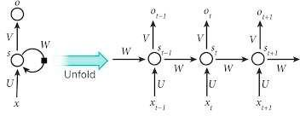

**Figure 2: Recurrent Neural Network (Source: ICCIDS)**

Deep gaining knowledge of is a completely interesting topic, and it's been hired via way of means of some of lecturers to enhance and enhance overall performance and accuracy measures. RNN and CNN are of the maximum charming domain names of Deep Learning, and they`ve each been used to categorise ECG arrhythmias. However, while CNN is used to categorise ECG, it breaks the beats into fixed-period parts, which reduces category overall performance. The overall performance of RNN may be progressed via way of means of giving custom functions to the classifier, making it higher in a few ways. We use RNN to analyze the underlying key residences of the beats nicely and robotically via way of means of feeding the contemporary beat and the ultimate beat, i.e.T beat.

**3.1 Recurrent Neural Network**

Because in their extraordinarily dynamic activity, recurrent neural networks emerged, while multilayer feed-ahead networks have static mappings. RNNs had been hired in quite a few fields and feature packages in associative memories, optimization, and generalisation. RNNs are first-rate for classifying time-collection statistics due to the fact the comments and present day cost are fed again into the network, and the output consists of strains of values saved withinside the reminiscence, which improves class overall performance and gives higher outcomes than general feed-ahead networks.

**3.2 Long Short Term Memory Network**

The Long Short-Term Memory (LSTM) structure is a shape of recurrent neural network (RNN). LSTMs have been created to version temporal sequences, and RNNs` long-variety dependencies and reminiscence backup play a vital role, making them extra correct and powerful than conventional RNNs. The method is used after the statistics has been pre-processed to put off any undesirable, missing, or null sign values.

Three layers of RNN–LSTM had been utilised on this research, with 64, 256, and one hundred neurons in every layer, respectively, and 5 iterations. After every layer, a 0.2 fee dropout has been introduced. The loss feature became MSE, at the same time as the activation became sigmoid.

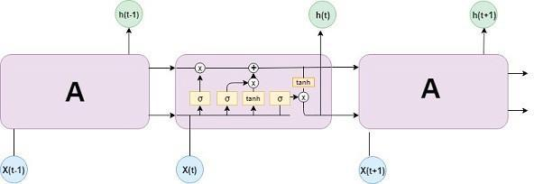

**Figure 3: Long Short Term Memory (Source: ICCIDS)**

**3.3 Autoencoder**

The Autoencoder`s assignment is to obtain a few enter facts, run it via the version, and recreate the enter. The reconstruction ought to be as near the authentic as possible. The key's to restrict the quantity of parameters to your version in order that it is able to examine a compressed illustration of the facts.

Autoencoders, in a sense, attempt to examine most effective the maximum tremendous factors of the facts (compressed version). We`ll study the way to feed Time Series facts to an Autoencoder on this section. To seize the temporal dependencies of the facts, we're going to utilise more than one LSTM layers (hence the LSTM Autoencoder). We'll pick a threshold above which a heartbeat is appeared strange to discover a series as regular or strange. The intention of Autoencoder schooling is to reconstruct the enter as as it should be as feasible. This is carried out via the usage of a loss characteristic this is minimised (much like in supervised learning). Reconstruction loss is the call given to this characteristic. Examples encompass cross-entropy loss and suggest squared error.

There are components to the Autoencoder structure in general. The enter is compressed through an encoder, and the output is decoded through a decoder. To compress the Time Series facts enter, the Encoder employs LSTM layers.

Two LSTM layers and an output layer offer the very last reconstruction in our Decoder.

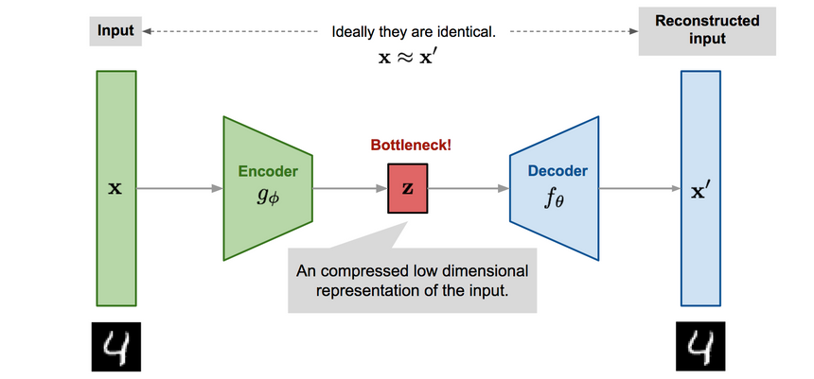

**Figure 4: Autoencoder (Source: Curiosity.com)**

**3.4 DATASET**

This dataset is a set of heartbeat indicators received from the MIT-BIH Arrhythmia Dataset, a famous dataset for heartbeat classification. The quantity of information withinside the series is enough to educate a deep neural community.

This dataset has been used to analyze heartbeat categorization the use of deep neural community architectures, in addition to to check sure switch getting to know capabilities. For the regular case and instances troubled with the aid of using diverse arrhythmias and myocardial infarction, the indicators correspond to electrocardiogram (ECG) kinds of heartbeats. These indicators are segmented and preprocessed, with every phase representing a heartbeat.

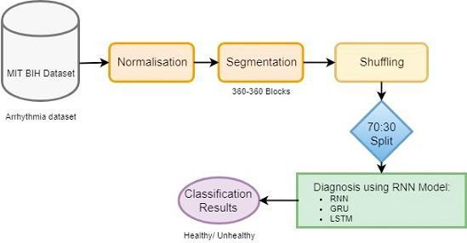

**Figure 5: Flow Diagram (Source: ICCIDS)**

1. **Conclusion and Future Work**

When the variety of iterations is 5, the hidden layers are 3, and there are 64, 256, and one hundred neurons in line with hidden layer, the RNN LSTM has an accuracy of 88.1 percent. The version is applied with none pre-processing, at once the use of indicators from the MIT BIH database. As a result, our built version is some distance much less complicated than usual gadget getting to know algorithms. The consequences of this paper`s binary type of arrhythmia may be superior via way of means of extending it to multi-magnificence type. Because there hasn`t been a good deal main paintings withinside the subject of binary type (Arrhythmia detection), our proposed version plays the identical and leaves room for extra studies on this area. By growing the variety of epochs, the type accuracy may be advanced even extra. The studies demonstrates that prolonged short-time period reminiscence produces the excellent consequences withinside the binary type of ECG arrhythmia, and that destiny paintings at the type may be achieved the use of Convolution Neural Networks at the MIT BIH dataset. For the type process, the variety of epochs and neurons withinside the hidden layer is probably raised even extra.

1. **References**
2. V.M. Uspenskiy. Information function of the heart. a measurement model. MEASUREMENT 2011, 1:383-386, 2011.
3. V.M. Uspenskiy. Diagnostic system based on the information analysis of electrocardiograph. In Embedded Computing (MECO), 2012 Mediterranean Conference on, pages 74-76, June 2012.
4. Wagner Galen and Strauss David. Marriotts Practical Electrocardiography. LWW, 2013.
5. K. Perloff Joseph and J. Marelli Ariane. Clinical Recognition of Congenital Heart Disease. Elsevier, 2012.
6. Babak Mohammadzadeh Asl, Seyed Kamaledin Setarehdan, and Maryam Mohebbi. Support vector machine-based arrhyth- mia classification using reduced features of heart rate variability signal. Artificial Intelligence in Medicine, 44(1):51- 64, 2008.
7. Mi Hye Song, Jeon Lee, Sung Pil Cho, Kyoung Joung Lee, and Sun Kook Yoo.Support vector machine based arrhythmia classification using reduced features. International Journal of Control, Automation, and Systems, 3:571-579, 2005.
8. A.J. Joshi, S. Chandran, V.K. Jayaraman, and B.D. Kulkarni. Hybrid svm for multiclass arrhythmia classification. In Bioinformatics and Biomedicine, 2009. BIBM 09. IEEE International Conference on, pages 287-290, Nov 2009.
9. V.Ahanathapillai and J.J. Soraghan. Myocardial ischemia detection algorithm(mida): Automated echocardiography se- quence analysis for diagnosis of heart muscle damage. In Computing in Cardiology, 2010, pages 405-408, Sept 2010.
10. T. Konttila, M. Stenroos, H. Vaananen, H. Hanninen, M. Lindholm, I. Tierala, and T. Katila. Support vector classification of acute myocardial ischemia with reduced sets of body surface potential map electrodes. In Computers in Cardiology, 2005,pages 869-872, Sept 2005.
11. P Ranjith, P.C Baby, and P Joseph. ECG analysis using wavelet transform: application to myocardial ischemia detection. ITBM-RBM, 24(1):44 - 47, 2003.
12. Ismail Babaoglu, Mustafa Servet Kiran, Erkan Ulker, and Mesut Gunduz. Diagnosis of coronary artery disease using artificial bee colony and k-nearest neighbor algorithms. International Journal of Computer and Communication Engineering, 2:56-59, 2013.
13. R. Alizadehsani, M.J. Hosseini, Z.A. Sani, A. Ghandeharioun, and R. Boghrati. Diagnosis of coronary artery disease using cost-sensitive algorithms. In Data Mining Workshops (ICDMW), 2012 IEEE 12th International Conference on, pages 9-16, Dec 2012.
14. A. Kampouraki, G. Manis, and C. Nikou. Heartbeat time series classification with support vector machines. Information Technology in Biomedicine, IEEE Transactions on, 13(4):512-518, July 2009.
15. Adam Gacek and Witold Pedrycz. ECG Signal Processing, Classification and Interpretation. Springer-Verlag London, 2012.
16. L. Yash, L. Pallavi, and A. Sameer. Ecg in non cardiac disorders.
17. Mieghem Carlos, Sabbe Marc, and Knockaert Daniel. The clinical value of the ecg in noncardiac conditions. Chest, 125:1561- 1576, 2004.
18. John S. Child, Joseph K. Perloff, Philip M. Bach, Allan D. Wolfe, Susan Perlman, and R.A. Pieter Kark. Cardiac involvement in friedreichâĂŹs ataxia: A clinical study of 75 patients. Journal of the American College of Cardiology, 7(6):1370-1378, 1986.
19. Mikael Henaff, Kevin Jarrett, Koray Kavukcuoglu, and Yann Lecun. Unsupervised learning of sparse features for scalable audio classification.
20. Honglak Lee, Roger Grosse, Rajesh Ranganath, and Andrew Y. Ng. Convolutional deep belief networks for scalable unsu- pervised learning of hierarchical representations.
21. Hoo-Chang Shin, M.R. Orton, D.J. Collins, S.J. Doran, and M.O. Leach. Stacked autoencoders for unsupervised feature learning and multiple organ detection in a pilot study using 4d patient data. Pattern Analysis and Machine Intelligence, IEEE Transactions on, 35(8):1930-1943, Aug 2013.
22. S. Osowski, L. T. Hoai, and T. Markiewicz, Support vector machine-based expert system for reliable heartbeat recognition, IEEE Trans.BiomedEng., 51(4), 2004, 582-589.
23. P. de Chazal, M. O’Dwyer, and R. B. Reilly, Automatic classification of heartbeats using ECG morphology and heartbeat interval features, IEEE Trans.BiomedEng., 51(7), 2004, 1196-1206.
24. E. J. da S.Luz, T. M. Nunes, V. H. C. de Albuquerque, J. P. Papa, and D. Menotti, ECG arrhythmia classification based on optimum-path forest, Expert Systems with Applications, 40(9),2013,3561-3573.
25. O. T. Inan, L. Giovangrandi, and G. T. A. Kovacs, Robust neural-network-based classification of premature ventricular contractions using wavelet transform and timing interval features, IEEE Trans.BiomedEng., 53(12), 2006, 2507-2515.
26. i. GUIer and E. D. Obeyli, ECG beat classifier designed by combined neural network model, Pattern Recognition, 38(2),2005, 199-208.
27. Predicting the severity of Breast Cancer masses with ensemble of Bayesian Classifiers Journal of Computer Science 2010.
28. R. D. Raut and S. V. Dudul, Arrhythmias classification with MLP neural network and statistical analysis, Proc. - 1st Int. Conf. Emerg. Trends Eng. Technol. ICETET 2008, pp. 553-558, 2008.
29. B. M. Asl, S. K. Setarehdan, and M. Mohebbi, Support vector machine-based arrhythmia classification using reduced features of heart rate variability signal, Artif. Intell. Med., vol. 44, no. 1, pp. 5164, 2008.
30. G. Selvakumar, K. B. Bagan, and B. Chidambararajan, Wavelet Decomposition for Detection and Classification of Critical ECG Arrhythmias, pp. 8084, 2007.
31. L. Khadra, A. Fraiwan, and W. Shahab, Neural-wavelet analysis of cardiac arrhythmias.
32. P. Melin, J. Amezcua, F. Valdez, and O. Castillo, A new neural network model based on the LVQ algorithm for multi-class classification of arrhythmias, Inf. Sci. (Ny)., vol. 279, pp. 483-497, 2014.
33. S. Yu and Y. Chen, Electrocardiogram beat classification based on wavelet transformation and probabilistic neural network, vol. 28, pp. 1142-1150, 2007.
34. M. Engin, ECG beat classification using neuro-fuzzy network, vol. 25, pp. 1715-1722, 2004.
35. R. Silipo, G. Bortolant, and C. Marchesi, Supervised and unsupervised learning for ciiagnostic E, Evaluation, pp. 931-934, 1996.
36. T. K. Toshifumi Sugiural, Hisashi Hiratal, Yukio Harada2, AUTOMATIC DISCRIMINATION OF ARRHYTHMIA, vol. 20, no. I, pp. 108-111, 1998.
37. N. Kohli, N. K. Verma, and A. Roy, SVM based Methods for Arrhythmia Classification in ECG, pp. 486-490, 2010.
38. S. M. Jadhav, S. L. Nalbalwar, and A. A. Ghatol, Artificial Neural Network Based Cardiac Arrhythmia Disease Diagnosis, 2011 Int. Conf. Process Autom. Control Comput., pp. 16, 2011.
39. Shraddha Singh, Saroj Kumar Pandey, Urja Pawar, Rekh Ram Janghel. "Classification of ECG Arrhythmia using Recurrent Neural Networks" , Procedia Computer Science, 2018
40. Harmandeep Singh Gill, Osamah Ibrahim Khalaf, Youseef Alotaibi, Saleh Alghamdi, Fawaz Alassery. "Multi-Model CNN-RNN-LSTM Based Fruit Recognition and Classification" , Intelligent Automation & Soft Computing, 2022
41. Joao Pereira, Margarida Silveira. "Learning Representations from Healthcare Time Series Data for Unsupervised Anomaly Detection" , 2019 IEEE International Conference on Big Data and Smart Computing (BigComp), 2019