STRIDE
How the model makes up its mind
A plain-English guide to what the system weighs when it rates a horse, and how a rating turns into a bet.
Prepared 10 September 2026
Describes model version v2, trained 2026-04-15
No prior knowledge of racing analytics or statistics is assumed.

1. What the system is trying to do
STRIDE rates every runner in Australian thoroughbred racing. It is not trying to pick winners. It is trying to find horses whose real chance of winning is better than the price being offered about them.
Those are different jobs. A horse can be the most likely winner in its race and still be a poor bet, because the price is too short to be worth taking. An outsider at long odds can be a good bet, if its true chance is better than the price implies.
So the question the system asks is not "which horse wins?" It is "where is the price wrong?"

The one idea everything rests on
If the system believes a horse has a 25% chance, and the price on offer implies only 18%, that seven-point gap is the whole business. STRIDE calls it the edge. Where there is no gap, there is no bet, no matter how good the horse looks.

The nine steps, start to finish
- Gather the form for every runner in the race.
- Simulate the race many times over to get a first estimate of each horse's chance.
- Ask three separate prediction models the same question, and average their answers into a second estimate.
- Blend those two estimates into one figure.
- Anchor that figure against the market price, so the model is never allowed to drift too far from what the money says.
- Work out the edge: the system's estimate minus the market's own implied chance.
- Score and rank every runner in the race.
- Check two outside opinions: what independent tipsters are saying, and which way the money is moving.
- Decide. Most runners get no bet at all.

Sections 3 and 4 cover what goes into steps 1 to 3. Sections 5 to 7 cover steps 4 to 6. Sections 8 to 11 cover steps 7 to 9.

2. What the model actually looks at
When the model was trained it was shown 110 separate pieces of information about each runner. It then worked out for itself which of them were worth paying attention to.
It ignored 54 of them entirely. Those were given no weight at all. Only 56 pieces of information carry any weight in the finished model.
Every percentage in this document is that weight: how much of the model's thinking each piece of information accounts for. The figures add up to 100%.

How to read these percentages
A weight of 20% does not mean a factor is right 20% of the time, or that it wins you 20% more. It means the model leaned on that piece of information for about a fifth of the work it did in separating winners from losers. It is a measure of how much the model used something, not proof that the thing causes horses to win. Section 12 returns to this point, because it matters.

The ten themes
The 56 factors that matter sort naturally into ten themes. Grouped that way, the shape of the model is easy to see.
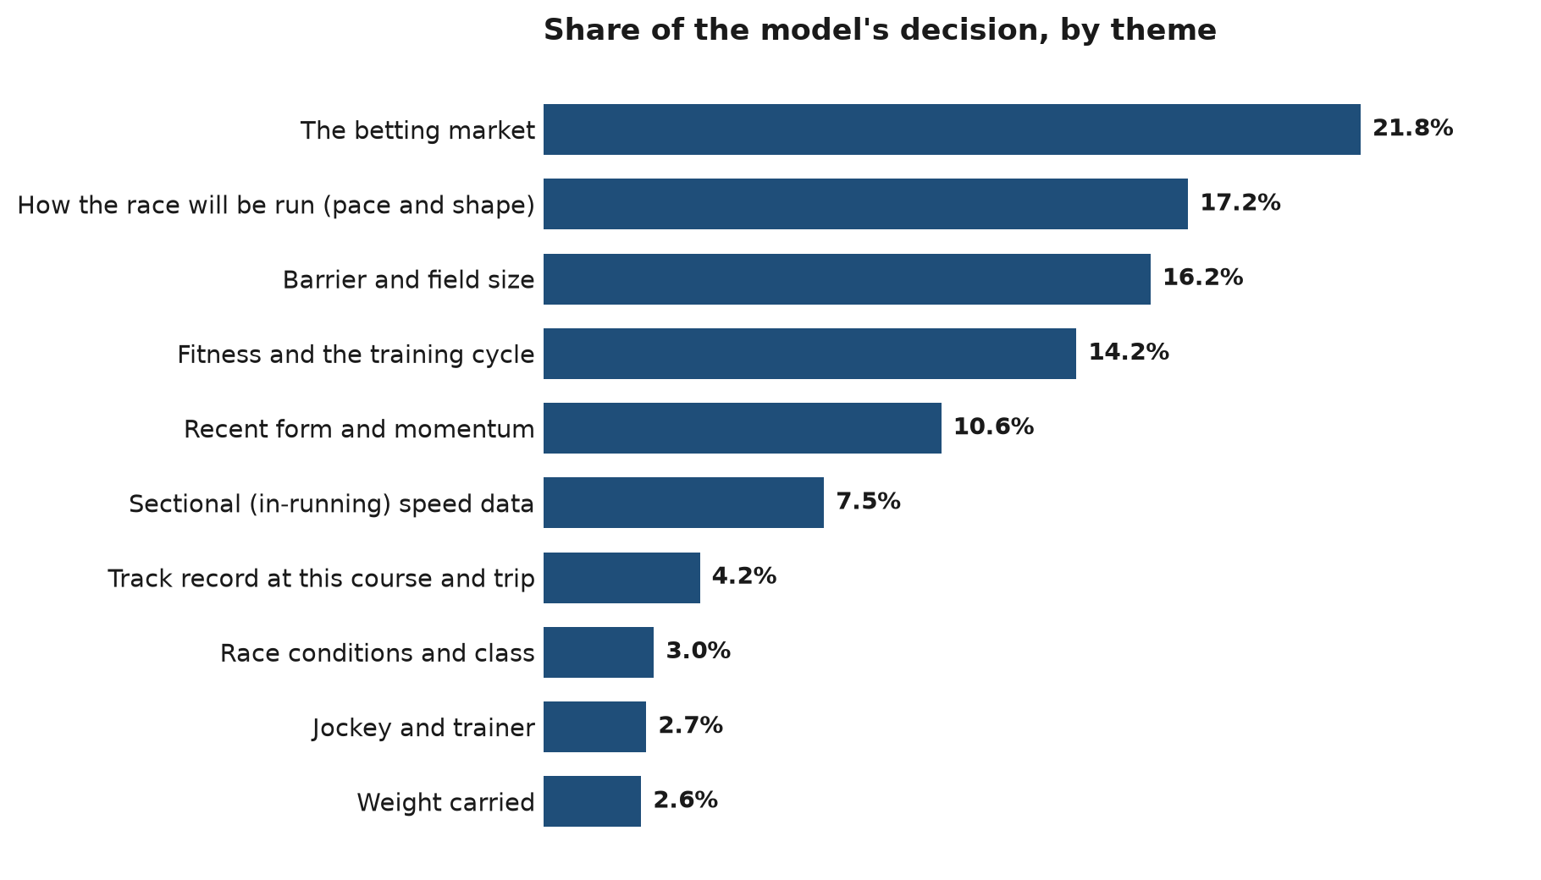

Theme | Share of the model | Factors in it
The betting market | 21.80% | 1
How the race will be run (pace and shape) | 17.20% | 6
Barrier and field size | 16.20% | 5
Fitness and the training cycle | 14.22% | 15
Recent form and momentum | 10.61% | 8
Sectional (in-running) speed data | 7.49% | 9
Track record at this course and trip | 4.18% | 3
Race conditions and class | 2.95% | 4
Jockey and trainer | 2.75% | 3
Weight carried | 2.61% | 2
Total | 100.00% | 56
Shares are the combined weight of every factor in that theme.

3. The single biggest factor is the price itself
The betting market's own price on a horse accounts for 21.80% of the model, on its own. It is far and away the most powerful single thing the model sees. The next strongest factor is worth about a quarter as much.
That surprises people, so it is worth being clear about why it happens and why it is not a problem.
The betting public, taken as a whole, prices horses very well. Thousands of people with money at stake, many of them professionals, have already done an enormous amount of work by the time a price settles. Any model that ignored that would be throwing away the best single piece of evidence available.
So STRIDE starts from the market price and looks for the places the market has it wrong. The other 55 factors exist to find those places. This is the standard approach in serious racing analytics, and the system's own research notes cite the published literature behind it.

The catch, stated plainly
Because the price is the strongest input, the model will usually agree with the market. That is expected. The value is in the minority of runners where it disagrees, and the rest of the system exists to work out which of those disagreements are worth acting on.

The fifteen heaviest factors
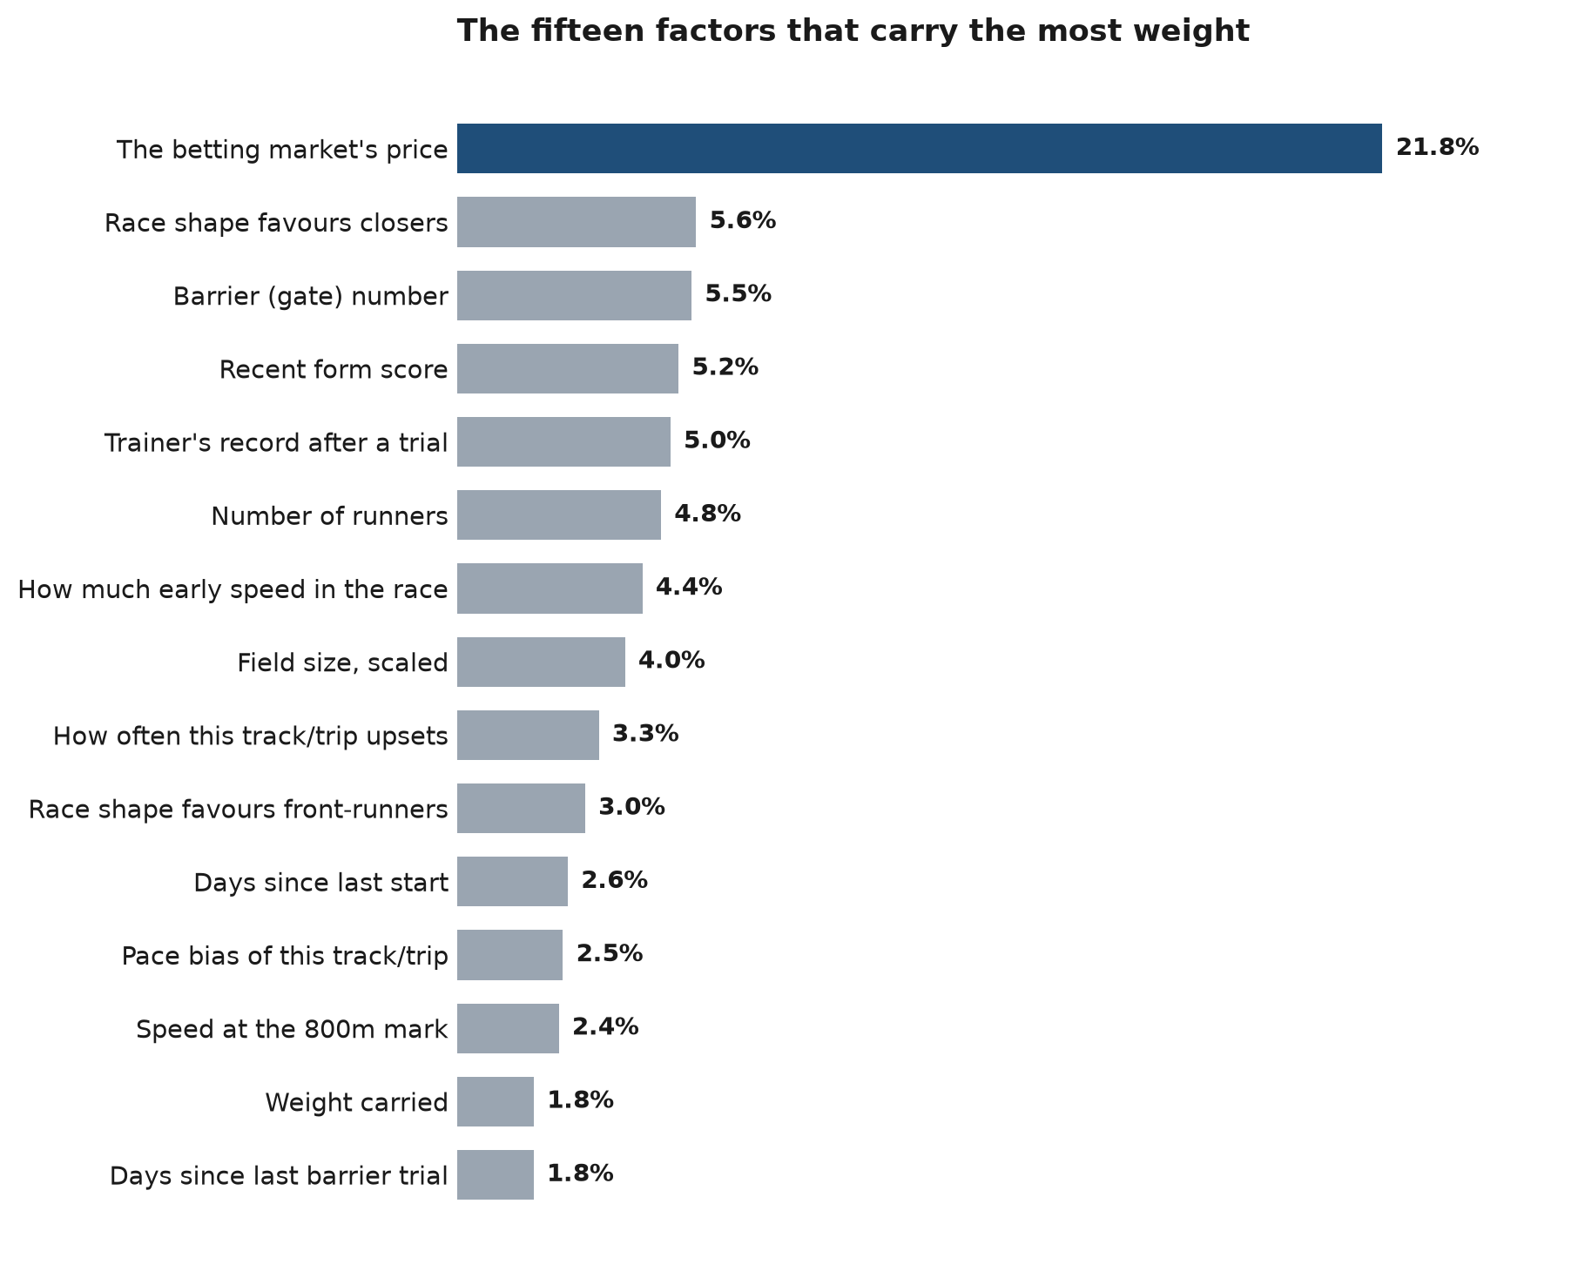
These fifteen account for 73.78% of the model between them. The top ten alone account for 62.68%. The remaining 41 factors share what is left.

4. Every factor that carries weight
The complete list, heaviest first. The last column gives the name the factor goes by inside the system, which is useful if you are ever reading its output.

# | What it is | Weight | Name in the system
1 | The betting market's price on the horse | 21.80% | market_odds
2 | How much the shape of the race suits horses that finish from behind | 5.63% | closer_advantage
3 | The barrier (starting gate) the horse drew | 5.52% | barrier_draw
4 | A score for the last five runs, with the most recent runs counting most and winning margin taken into account | 5.22% | weighted_form_score
5 | How well this trainer's horses go after a barrier trial, compared with that trainer's own first-up record | 5.03% | trainer_trial_pattern
6 | How many horses are in the race | 4.80% | field_size
7 | How much early speed the field holds, from the mix of running styles in the race | 4.36% | pace_pressure_score
8 | Field size expressed as a fraction of a full field | 3.95% | field_size_context
9 | How often this track and distance produces an upset result | 3.34% | td_upset_rate
10 | How much the shape of the race suits front-runners | 3.02% | leader_advantage
11 | Days since the horse's last start | 2.61% | days_since_run
12 | Whether this track and distance favours on-pace or off-pace runners | 2.49% | td_pace_bias
13 | How fast the horse ran the 800m section of its last race, compared with the rest of that field | 2.40% | z_800m
14 | The weight the horse carries | 1.81% | weight_kg
15 | Days since the horse's most recent barrier trial | 1.80% | trial_recency
16 | Whether the jockey booked is an upgrade or a downgrade on last start | 1.77% | jockey_booking_change
17 | Time the horse is expected to lose from being drawn wide | 1.28% | trip_cost_seconds
18 | The distance of the race | 1.28% | distance
19 | Whether the horse's speed ratings are rising or falling | 1.19% | speed_rating_trajectory
20 | How the horse's sectional times rank against others at this distance | 1.18% | sectional_rank_at_distance
21 | How much the horse has improved from run to run | 1.18% | improvement_score
22 | Whether the horse's sectional times are getting quicker or slower | 1.11% | sectional_trajectory
23 | Whether this track and distance rewards a strong finish | 1.10% | td_closing_speed_bias
24 | How strong the horses were that it trialled against | 0.95% | trial_quality_score
25 | Change in weight carried since last start | 0.80% | weight_change
26 | How fast the horse ran the 600m section of its last race, compared with that field | 0.74% | z_600m
27 | How well it trialled, weighted up for a horse with few career starts | 0.65% | trial_x_experience
28 | How many barrier trials it has had in the last 60 days | 0.65% | trial_count_60d
29 | How much the barrier actually matters at this distance | 0.63% | barrier_relevance_score
30 | Which class bracket the race sits in (the name is misleading, nothing about it comes from the market) | 0.58% | market_efficiency_flag
31 | The pace environment the horse met in its last race | 0.58% | rsi
32 | How quickly the horse slows down late, which separates stayers from sprinters | 0.58% | lambda_decay
33 | Whether the horse sustains its speed to the line or fades | 0.58% | svi
34 | How fast the horse ran the 400m section of its last race, compared with that field | 0.57% | z_400m
35 | Whether the horse is stepping up or dropping back in trip | 0.56% | distance_direction_flag
36 | Its win rate at the second run back from a spell | 0.55% | second_up_win_rate
37 | How fast the horse ran the final 200m of its last race, compared with that field | 0.54% | z_200m
38 | Its win rate first-up from a spell | 0.54% | first_up_win_rate
39 | The grade of the race | 0.53% | class_level
40 | The win rate of this jockey and trainer working together | 0.53% | jockey_trainer_strike_rate
41 | Its win rate at this course | 0.52% | course_strike_rate
42 | How consistent its recent finishing positions have been | 0.52% | consistency_score
43 | The trend line through its recent finishing positions | 0.51% | form_direction_slope
44 | Its sectional speed considered alongside the state of the ground | 0.50% | sectional_x_going
45 | A flag for a horse on an upward trend | 0.46% | is_improving
46 | How much of a drop-off to expect after an unusually big effort | 0.45% | bounce_severity
47 | A flag for a jockey and trainer pairing with a strong record together | 0.45% | is_winning_combo
48 | A flag for being in the productive part of a preparation | 0.43% | is_in_form_cycle
49 | Whether sectional timing data exists for this horse at all | 0.40% | has_sectional_data
50 | How many runs since its best recent effort | 0.37% | runs_since_peak
51 | Its win rate at around this distance | 0.32% | distance_strike_rate
52 | Its fitness considered alongside the race distance | 0.32% | fitness_x_distance
53 | A flag for a horse at risk of a drop-off after a peak run | 0.25% | is_bounce_candidate
54 | Which run of the current preparation this is | 0.05% | campaign_run_number
55 | A flag for first run back from a spell | 0.01% | is_first_up
56 | Run number in the preparation considered alongside fitness | 0.00% | campaign_run_x_fitness

The 54 factors not listed here were fed to the model during training and given a weight of exactly zero. Most of them were never actually filled in with real data, so the model had nothing to learn from. They are being cleaned out of the system.

5. Three models, not one
STRIDE does not run a single prediction program. It runs three, side by side. Each one learns the same task in a slightly different way, and each is given the same information about every runner.
The three are called XGBoost, LightGBM and CatBoost. The names are not important. What matters is that three imperfect opinions, averaged, are steadier than any one of them alone. When all three agree, that is worth something. When they disagree, the average pulls the answer back toward the middle rather than letting one program have its way.
How much say each one gets depends on how far the race is run over.

Race type | Distance | XGBoost | LightGBM | CatBoost
Sprint | Under 1200m | 32.4% | 40.5% | 27.0%
Mile | 1200m to 1600m | 33.3% | 30.3% | 36.4%
Staying | Over 1600m | 31.0% | 36.2% | 32.8%
Each row adds to 100%. The differences between the three are small.

Worth knowing about these three shares
They are not a running tally of which program has been getting it right lately. They are fixed starting figures written into the system when it was built. The system does contain a function meant to update them from actual race results, but nothing in the code ever calls that function, so the shares have never moved. Whether that matters is a fair question to ask, though the practical effect is small: three programs given identical information tend to produce very similar answers, so almost any reasonable split lands in much the same place.

6. Where the model meets the market
Two blends happen back to back. Both are ways of stopping any single method from having too much say.

Blend one: the simulation and the models
The system runs a simulation of the race that produces one estimate of each horse's chance. The three prediction models produce a second. Those two get combined.
How they combine depends on the price. For a horse at $3 or shorter, the prediction models get 20% of the say and the simulation keeps 80%. For everything longer, the models get 40%.

Blend two: the result meets the market
That combined estimate is then anchored against the market's own view. This is the step that stops the system talking itself into a horse the money has already dismissed.
The share the model keeps depends on the price, and it moves the way most people would not expect: the model is trusted most at short prices and least at long ones.

Price of the horse | Model's share of the say | Market's share
$3.00 or shorter | 80% | 20%
$3.01 to $6.00 | 70% | 30%
$6.01 to $10.00 | 50% | 50%
$10.01 to $15.00 | 45% | 55%
$15.01 to $30.00 | 40% | 60%
Longer than $30 | 30% | 70%

The reason for that shape is recorded in the system itself. A review of short-priced runners found that horses in the $1 to $3 range were winning about 41% of the time, while the system was rating them at roughly 17% once the blending was done. It was being far too pessimistic about favourites. Giving the model more of the say at the short end lets its real opinion reach the final number instead of being averaged away.
At the other end, above $30, calibration is known to be unreliable, so the market is given most of the say and, as section 11 explains, those runners are blocked from being bet at all.

7. Edge, and what "expected value" means
A price of $5.00 looks like it implies a 20% chance, because one divided by five is a fifth. It does not, quite. Bookmakers build in a margin, so if you add up the implied chances of every runner in a race they come to more than 100%. A typical book might total 118%.
Before the system can compare its own view against the market's, it has to strip that margin out. It does this by dividing each horse's raw implied chance by the book total.

A worked example
A horse is $5.00 and the book totals 118%. Raw implied chance is 100 divided by 5, or 20%. Strip the margin and the fair chance is 20 divided by 1.18, which is 16.9%. If the system estimates the horse at 21%, the edge is 21 minus 16.9, or 4.1 percentage points in the system's favour.

Expected value
Expected value is the natural next question: for every dollar staked, how much would you expect to get back over the long run? A positive number means the bet pays in the long run, a negative number means it does not.
The system can measure it two ways. By default it measures against the fair chance, with the bookmaker's margin already removed. There is a switch, currently off, that measures against the actual price you would be paid at.
There is an honest wrinkle here, and it is documented inside the system rather than hidden. In the default setting, the expected-value test turns out to be mathematically the same test as the edge test. It cannot fail unless the edge test has already failed, so it adds nothing. The alternative setting is the one that can see the margin being charged, and the reason it has not been switched on yet is that doing so would change which bets qualify, and that change is being evaluated first.

8. Three opinions have to agree
A good rating is not enough on its own. Before anything is backed, three separate opinions are collected and weighed against each other.

Opinion | Weight | What it is
The STRIDE model | 50.0% | Everything described in sections 2 to 7.
Tipster consensus | 30.0% | What a vetted panel of independent racing sources is saying about the race.
Market signal | 20.0% | Which way the money has been moving on the horse since the market opened.
These three weights are settings, not fixed rules. They can be changed without touching the model.

Each opinion is scored out of 100, and each has a bar it has to clear to count as supportive.

Opinion | Bar to clear | Adjustable?
The STRIDE model | 65 | Fixed in the code
Tipster consensus | 65 | Yes, by setting
Market signal | 60 | Yes, by setting

9. The five verdicts
Which of the three opinions clear their bar decides the verdict. There are five, and only two of them ever result in a bet.

Verdict | What it means | Bet placed?
LOCK | All three agree. The model likes it, the tipsters like it, and the money is coming for it. | Yes
CONFIRM | The model likes it, and either the tipsters or the money back that up. | Yes, if the combined score reaches 55
FLAG | The model likes it and nothing else does. | No
CROWD_OVERRIDE | The tipsters and the money both like it, but the model does not. | No, but it is recorded
SKIP | Not enough agreement to act on. | No

Why a horse the model likes can still be refused
The FLAG verdict is the one that needs explaining, because it looks like the system throwing away its own best work.
It is deliberate. When the model is keen on a horse and no independent tipster and no movement in the money agrees, that silence is treated as information in its own right, not as an absence of information. It usually means the model has latched onto something the rest of the world can see is not there. The system's own note on this reads: absence of external confirmation is itself a signal.
There is one more floor underneath all of this. Whatever the verdict, a runner whose raw model score is below 8 is never backed. That catches the case where the crowd and the money are enthusiastic about a horse the model genuinely cannot make a case for.

Why CROWD_OVERRIDE is tracked but never backed
When the crowd and the money are both keen and the model is not, the system records what would have happened without risking anything on it. If those runners turn out to win at a decent rate over time, that is evidence the model is missing something and needs work. It is a way of learning from bets it did not take.

10. How the crowd and the money move a score
Once a runner has a rating, the two outside opinions can push it up or down. Neither can create a bet on its own, but both can turn a marginal one into a real one, or kill it.

What the tipsters do to a score
The tipster panel is scored out of 100 for each runner. That score converts into points added to or taken off the rating.

Tipster score | Base points | What it means
80 or above | +12.0 | Strong agreement across the panel
65 to 79 | +7.0 | Clear support
50 to 64 | +3.0 | Mild support
35 to 49 | 0 | No meaningful signal either way
20 to 34 | −3.0 | The panel is actively avoiding it
Below 20 | −8.0 | The panel is against it

Those base points are then adjusted three times before they are applied, because who is saying something matters as much as what is being said.
- Spread across the panel. A tip supported by several different kinds of source counts for more than the same number of mentions from one corner. This can halve the points or raise them by half again.
- Independence. Sources that are genuinely independent count for more than commercial ones. A panel that is mostly commercial can cut the points to about two thirds.
- Reasoning. If the reasons the tipsters give line up with what the model saw, the points go up by a fifth. If they directly contradict it, the points are halved.
After all of that, the result is capped. The most the tipsters can add is 12 points, and the most they can take away is 8.

What the money does to a score
The second outside opinion is the market itself, watched over time rather than at a single moment. A horse being backed is telling you something; a horse drifting is telling you something too.

Movement | Points | What it means
Steam | +8.0 | Heavy, fast support. Serious money has arrived.
Firming | +4.0 | Steadily shortening in price.
Stable | 0 | No meaningful movement, or no data.
Drift | −3.0 | Easing in the market. Support is not there.
Strong drift | −5.0 | Drifting badly. Often the stable knows something.

11. Confidence, and how much goes on
Every runner that survives to this point is graded into one of three confidence levels.

Grade | Requirement | Stake
High | Positive expected value, and an edge of more than one percentage point. | 1 unit
Medium | Positive expected value, but a smaller edge. | 1 unit
Low | No edge, or negative expected value. | Nothing

There is also a hard block: any horse longer than $30 is automatically graded low and never backed, whatever else the system thinks of it. At those prices the system's probability estimates are known to be unreliable, so it does not pretend otherwise.

Why high and medium stake the same amount
They did not always. The system used to stake two units on high confidence and one on medium. That ladder has been switched off and everything now goes on flat, at one unit, until the system has proven a positive return with enough certainty to justify betting more on its best ideas. The note in the code describes this as a risk cut rather than an experiment. It is the cautious choice, and it means a run of bad luck on the strongest picks cannot do outsized damage.

12. What this document cannot tell you
Four things belong here, because a description of a system that leaves out its weak points is not a description worth having.

A quarter of the model is not reaching the racetrack
An audit run on 2026-07-28 found that 15 of the factors described in this document are calculated when the model is being trained, but are not calculated on race day. Between them they account for 25.45% of the model’s weight.
When race day comes and those numbers are missing, the system fills them in with zero. That is worse than leaving them blank, because for several of them zero is a real and meaningful value rather than a marker for "unknown". A horse with no sectional timing history is handed a figure that reads as exactly average. The model was taught these things matter, and is then quietly told something false about them, every race, every day.

The heaviest of the affected factors | Weight
How much the shape of the race suits horses that finish from behind | 5.63%
How much early speed the field holds, from the mix of running styles in the race | 4.36%
Field size expressed as a fraction of a full field | 3.95%
How much the shape of the race suits front-runners | 3.02%
How fast the horse ran the 800m section of its last race, compared with the rest of that field | 2.40%
Time the horse is expected to lose from being drawn wide | 1.28%

The fix does not require retraining anything. The information is already available at race time, and in several cases the system already looks it up for display purposes, just too late in the process to be used. The work has been written and sits behind a switch that is currently off while its effect is measured. It is a known problem with a known remedy, not a hidden one.

These weights describe one particular model
Everything in sections 2, 3 and 4 describes the model trained on 2026-04-15. Retraining produces different weights. The ordering tends to be stable, and the market price has been the dominant factor throughout, but the exact figures should be read as a snapshot rather than a permanent property of the system.

Weight is not proof
It is tempting to read the table in section 4 as a ranking of what wins races. It is not. It measures how heavily the model leaned on each piece of information, which is a different claim.
The system's own research makes the point better than an explanation can. In an experiment in July, three factors derived from the betting price ranked third, sixth and eleventh out of 113 by weight. When they were removed altogether and the model retrained, its accuracy changed by an amount too small to matter. They looked important, and they were doing almost nothing, because they were restating a price the model could already see.

There are no profit figures in this document
That is not an oversight. The trained model file and the recorded performance baselines are deliberately kept out of the code repository this document was written from, and the file that would hold backtest results records the baseline as not yet measured.
Anything quoted here as a return, a strike rate or a profit figure would have been invented, so nothing is. What the system can honestly tell you today is how it makes its decisions, which is what this document sets out. What those decisions are worth is a separate question, and answering it needs the measurement work the system has not finished.

Appendix. Where each number came from
Every figure in this document was read out of the system's own code and records rather than estimated. If you want to check one, this is where it lives.

What | Source
Factor weights, and the count of factors used and ignored | docs/research/feature_liveness_report.json, read from the trained model file
Which factors are missing on race day, and what they are worth | The same file, cross-checked against docs/research/FEATURE_PROVENANCE.md
The share each of the three models gets | server/python/ml_model.py, RacingMLModel
Race type by distance | server/python/ml_model.py
The two blends, and the price ladder | server/python/run_tips_pipeline.py
Fair price after removing the margin | server/python/market_prob.py
Expected value and confidence grades | server/python/run_tips_pipeline.py
Stakes | server/python/run_tips_pipeline.py
The three opinions, their weights and their bars | server/python/consensus_blender.py
The five verdicts | server/python/consensus_blender.py
Tipster and market point adjustments | server/python/consensus_blender.py
The experiment on weight versus real effect | docs/analysis/ACADEMIC_FINDINGS.md, recording a run on 2026-07-13
The absence of a measured baseline | docs/analysis/RESULTS.md

The percentages were not copied by hand. They were extracted straight from the system's records by script, grouped into themes by a second script that checks every factor is counted once and only once, and the theme totals were confirmed to add to 100%.

