Group A1
StudyPulse
Study Planner and Deadline Reminder App
26CSCI38H · Mobile Application Development
Phase 1: Analysis, Architecture & Prototype
Module leader: Dr. Amira Sayed Abdelaziz
Repository: https://github.com/SagedEhab/studypulse
Submitted: 28 October 2026

Team roles and contributions
Member | Student ID | Feature owned | Phase 1 contribution
Saged Ehab | 244694 | All features (individual project): tasks, Today dashboard, reminders, Google Calendar export | All report sections: requirements, use case and activity diagrams, architecture, data plan. Screens: Today Dashboard, Task List, Add / Edit Task. All commits from my own GitHub account on branch feature/phase1-ui.

StudyPulse is an individual project (a team of one). The brief asks for three screens per member, so Phase 1 delivers three working screens.

1. Introduction

1.1 Problem
University students take several courses at the same time, and each course has its own assignments, quizzes, exams and reading. Deadlines are announced in lectures, on the e-learning system and in group chats, so they are scattered and easy to miss. Many students only notice that an exam is close a day or two before it, and they have no single place that shows what is overdue, what is due today and what is coming up this week.

1.2 Solution
StudyPulse is a mobile study planner. The student records each assignment, exam and study session once, with its course code, due date, priority and an optional reminder. The app opens on a Today dashboard that shows overdue work, what is due today, the exams of the next two weeks and how much of this week’s work is done. Tasks can be searched, filtered, edited, ticked off and deleted, and everything is saved on the phone so the app also works offline.
In Phase 2 StudyPulse reminds the student with a notification on the phone before a deadline (the device feature) and can add an exam or task to the student’s Google Calendar (the Google API).

1.3 Primary user
Undergraduate students who juggle several courses, using the app on their phone between lectures to check what is due and in the evening to plan study time.

1.4 Main features
- Today dashboard: overdue tasks, tasks due today, upcoming exams and weekly progress.
- Task management: add, edit and delete assignments, exams and study sessions.
- Validation: every field is checked before saving, with a clear message under the field.
- Search and filters: by status (to do, done, all), type, title or course code.
- Progress tracking: mark a task done or not done with one tap.
- Offline storage: all tasks are saved on the phone with AsyncStorage.
- Reminders (Phase 2, device feature): a local notification 1 hour, 1 day or 2 days before a task is due.
- Google Calendar export (Phase 2, Google API): add a task or exam to the student’s calendar on request.

2. System Requirements
StudyPulse has 8 functional requirements. It is a single-user app that keeps the student’s data on their own phone, so there is no registration or log-in in the design (Google sign-in in Phase 2 is only used to authorise the calendar export). FR1 to FR6 are implemented in the Phase 1 prototype; FR7 (device feature) and FR8 (Google API) are designed here and implemented in Phase 2.
No. | Requirement | Context
FR1 | The system shall let the student add a task with a title, course code, type (assignment, exam or study session), due date, optional due time, priority, reminder option and notes, and shall save it on the phone so it is still there after the app is closed and reopened. | Deadlines come from many places; writing each one down once, in one app, is the core of StudyPulse.
FR2 | The system shall validate the task form before saving and show a message under each invalid field: a title of 3–60 characters, a course code of 2–12 letters or digits, a real due date (YYYY-MM-DD) that is not in the past for a new task, a 24-hour due time, a reminder time that has not already passed (a 1-hour reminder needs a due time) and notes of at most 200 characters. The first invalid field receives focus and nothing is saved until every field is valid. | Wrong dates or times would make the dashboard and the reminders wrong; a message next to the field tells the student exactly what to fix.
FR3 | The system shall let the student open any task, change its details (validated as in FR2) and delete it only after confirming. | Deadlines move and plans change; a confirmation stops a task from being deleted by one accidental tap.
FR4 | The system shall let the student mark a task as done or not done with one tap from the dashboard or the task list, and update the weekly progress immediately. | Ticking work off gives a quick sense of progress and removes finished tasks from the to-do views.
FR5 | The system shall list all tasks sorted by due date with unfinished tasks first, let the student filter them by status (to do, done, all) and type, search by title or course code, and show a clear message when nothing matches. | With several courses the list grows quickly; filters and search make one task easy to find.
FR6 | When the app opens, the system shall show the Today dashboard with the number of tasks due in the next 7 days that are done, overdue unfinished tasks highlighted in red, the tasks due today and the exams in the next 14 days. | The student sees in seconds what needs attention now, without searching.
FR7 | (Phase 2, device feature) The system shall schedule a local notification on the phone at the reminder time chosen for a task (1 hour, 1 day or 2 days before it is due), reschedule it when the task is edited, and cancel it when the reminder is turned off or the task is marked done or deleted. | A reminder before the deadline is the main way the app prevents missed work.
FR8 | (Phase 2, Google API) When the student asks, the system shall add the task or exam to the student’s Google Calendar through the Google Calendar API after the student signs in with Google, and shall show an error message and leave the task unchanged if the request fails. | Many students already plan their week in Google Calendar; exporting exams keeps both in step.

3. Use Case Diagram
Figure 1 shows the whole system in one diagram. The Student is the primary actor; the phone’s Notification Service (device feature) and the Google Calendar API are secondary actors. The student starts five use cases directly (UC1 to UC5). Six supporting use cases are reached through «include», a step that always runs as part of the base use case, or «extend», an optional step that only runs when the condition in brackets is true. Every use case is labelled with the functional requirements it satisfies.
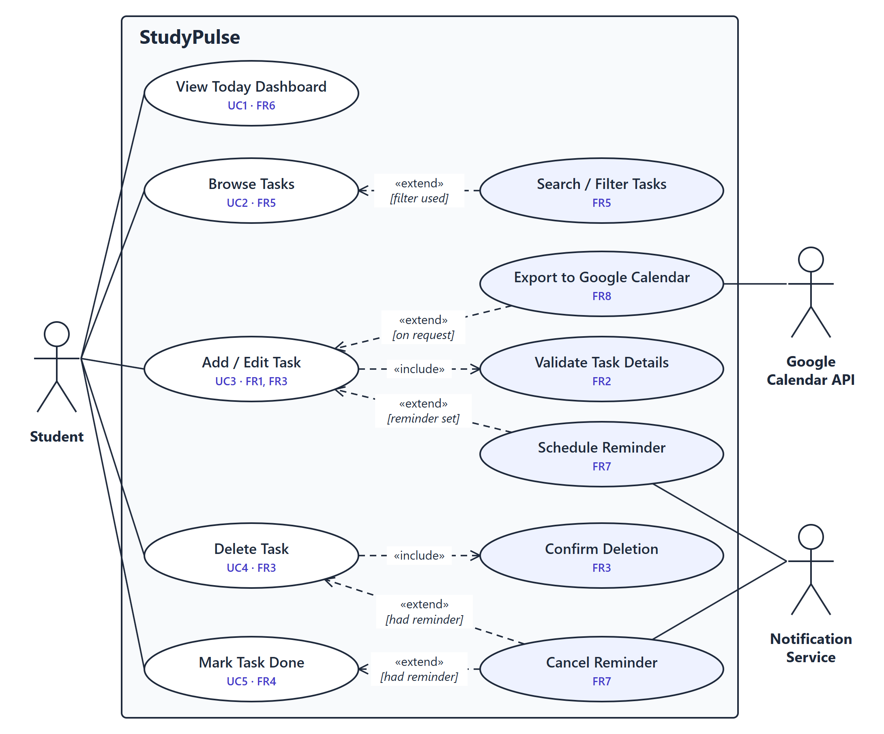
Figure 1: StudyPulse use case diagram (UC1 to UC5)

3.1 Use cases
UC1 View Today Dashboard (FR6). The student opens the app and sees the dashboard: weekly progress, overdue tasks, tasks due today and upcoming exams. From here a task can be opened, ticked off or added.
UC2 Browse Tasks (FR5). The student opens the Tasks tab and sees the unfinished tasks sorted by due date. Search / Filter Tasks extends this use case when the student types a query or picks a status or type filter.
UC3 Add / Edit Task (FR1, FR2, FR3). The student enters a new task or changes an existing one. Validate Task Details is always included: invalid input is rejected with a message under each field. Schedule Reminder extends the use case when a reminder is set, and the Notification Service delivers it. Export to Google Calendar extends it when the student asks for it, using the Google Calendar API (both Phase 2).
UC4 Delete Task (FR3, FR7). The student deletes a task from its edit screen. Confirm Deletion is always included. Cancel Reminder extends the use case when the deleted task had a reminder.
UC5 Mark Task Done (FR4, FR7). The student ticks a task as done (or not done) from the dashboard or the task list and the weekly progress updates at once. Cancel Reminder extends the use case when the finished task had a reminder.

3.2 Requirements traceability
FR | Use case | Screen | Phase
FR1 | UC3 Add / Edit Task | Add / Edit Task | 1
FR2 | UC3 «include» Validate Task Details | Add / Edit Task | 1
FR3 | UC3, UC4 «include» Confirm Deletion | Add / Edit Task | 1
FR4 | UC5 Mark Task Done | Today Dashboard, Task List | 1
FR5 | UC2 «extend» Search / Filter Tasks | Task List | 1
FR6 | UC1 View Today Dashboard | Today Dashboard | 1
FR7 | Schedule Reminder, Cancel Reminder (UC3, UC4, UC5) | Add / Edit Task (reminder chosen and saved in Phase 1) | 2
FR8 | Export to Google Calendar (UC3) | Add / Edit Task | 2

4. Activity Diagram
Figure 2 (next page) shows the workflow of the whole app from launch to close. The saved tasks are loaded first; if the phone’s storage cannot be read, an error with a Try again button is shown and the load is repeated. The Today dashboard is then shown and the student repeatedly chooses what to do. Every branch returns to the dashboard through merge nodes until the student closes the app (final node). Each branch matches a use case from Figure 1, as the table below shows.
Branch | Use case | Key flow
Start | UC1 | Open the app, load the saved tasks (retry on failure) and show the Today dashboard.
[view tasks] | UC2 | Show the task list. If the student searches or filters, apply the search and filters; otherwise return straight away.
[mark done] | UC5 | Toggle the task between done and not done, then update the weekly progress.
[delete] | UC4 | Ask for confirmation. If confirmed, delete the task and its reminder; if cancelled, nothing changes.
[add / edit] | UC3 | Enter or change the details and validate them, repeating until they are valid. Save the task on the phone, schedule its reminder if one was chosen, and add it to Google Calendar if the student asked (the last two in Phase 2).
[close app] | — | End of the activity.
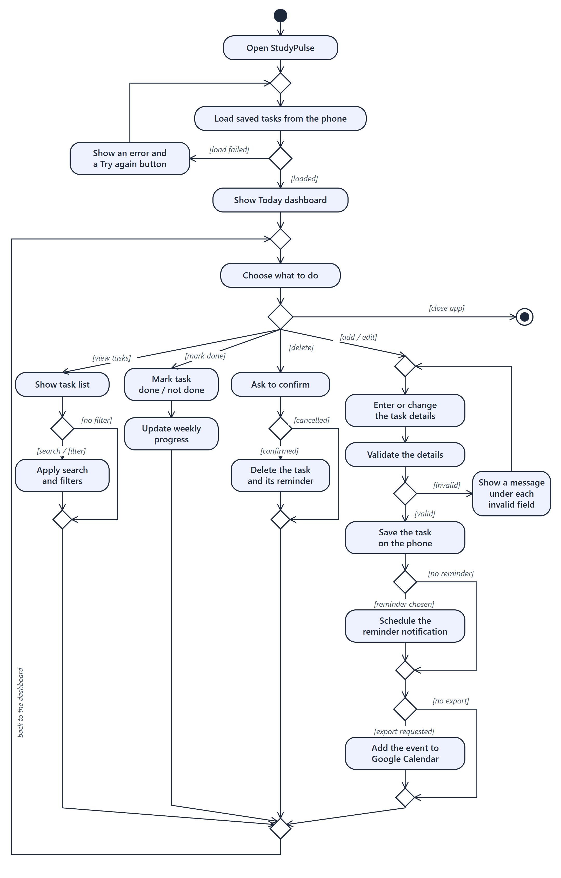
Figure 2: StudyPulse activity diagram

5. UI Prototype and Implementation
Phase 1 delivers three working screens built with React Native, Expo Router and TypeScript. The app opens on the Today tab; the bottom tab bar switches between Today and Tasks, and the Add / Edit Task form opens as a stack screen with a back button. The screens work on real data: every task is saved on the phone with AsyncStorage, so tasks that are added, edited, ticked off or deleted are still there after the app restarts. On the very first launch the app adds eight sample tasks (with dates relative to the current day) so the prototype can be demonstrated. Reminder notifications and the Google Calendar export are added in Phase 2.

5.1 Screen 1: Today Dashboard (FR4, FR6)
The first screen the student sees. It greets the student with the date and a This week card showing how many of the tasks due in the next 7 days are done, with a progress bar and the number of upcoming exams. Below it, Overdue tasks are listed in red, then the tasks Due today and the Upcoming exams of the next 14 days. Each task card shows its priority as a coloured bar (red high, amber medium, grey low), a type pill with an icon, the course code and a due label (Overdue, Today, Tomorrow or the date and time). Tapping the circle ticks the task off; tapping the card opens it for editing; the + button adds a task. Empty sections say so (“Nothing due today. Enjoy the free time!”).
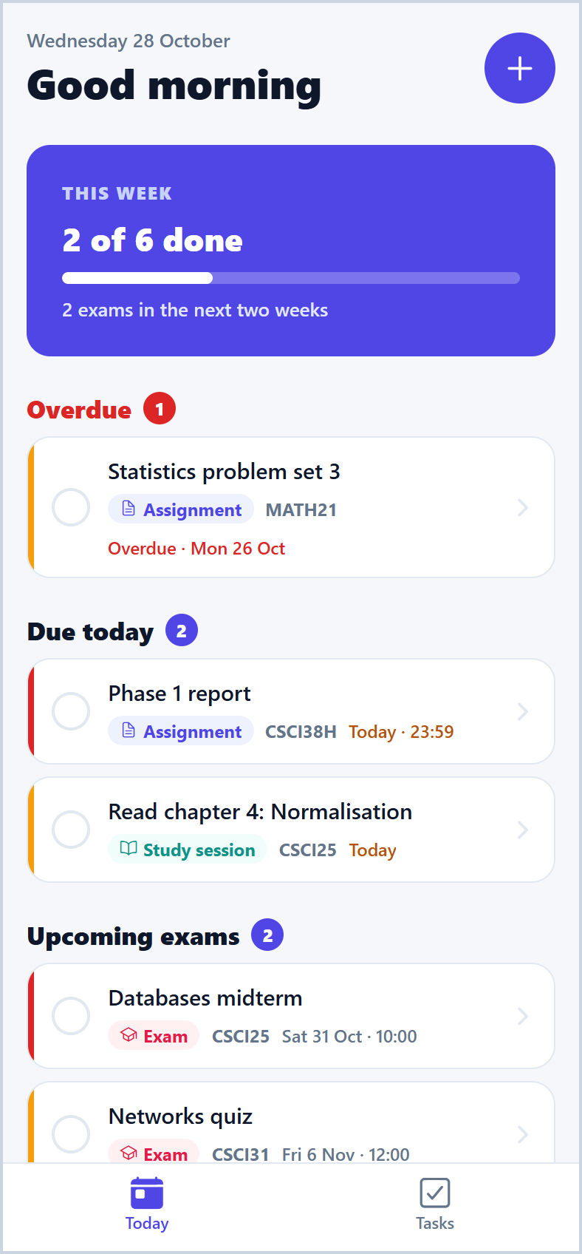  Figure 3: Today dashboard | 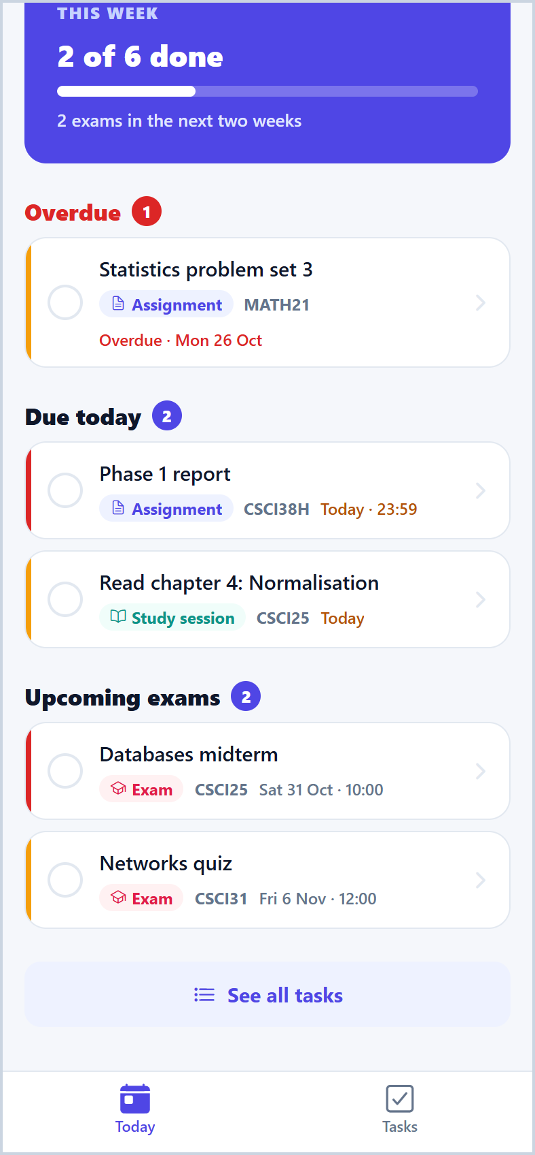  Figure 4: Dashboard scrolled: exams and See all tasks

5.2 Screen 2: Task List (FR4, FR5)
Lists the tasks sorted by due date, unfinished first. A search box matches the title or course code as the student types; To do / Done / All chips filter by status and All types / Assignments / Exams / Study chips filter by type, with a live count of the results. Each row has the same card and one-tap check box as the dashboard, and the floating + button adds a task. When nothing matches, the screen says “No tasks match” with a Clear filters button; with no tasks at all it offers Add a task.
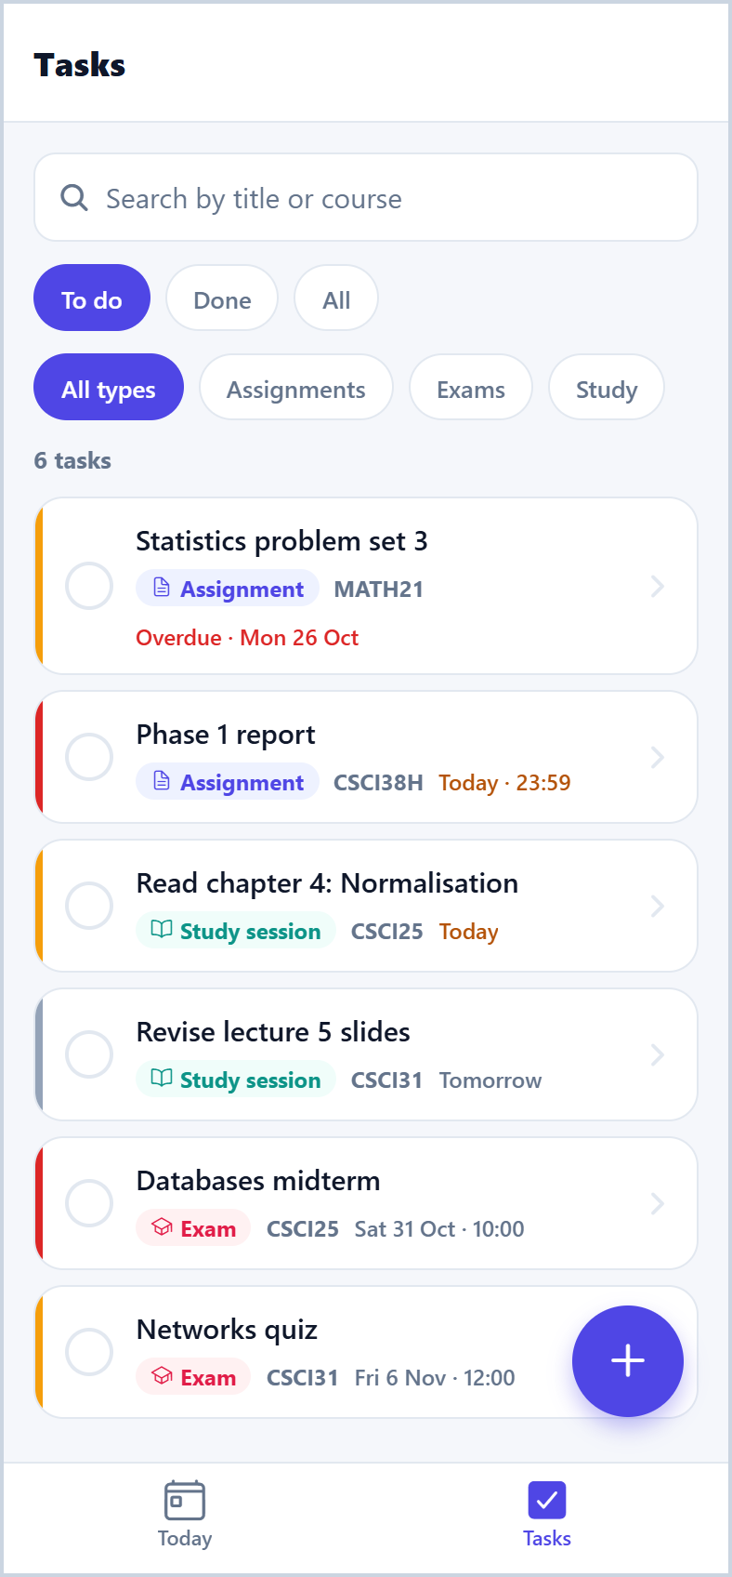  Figure 5: Task list, To do filter | 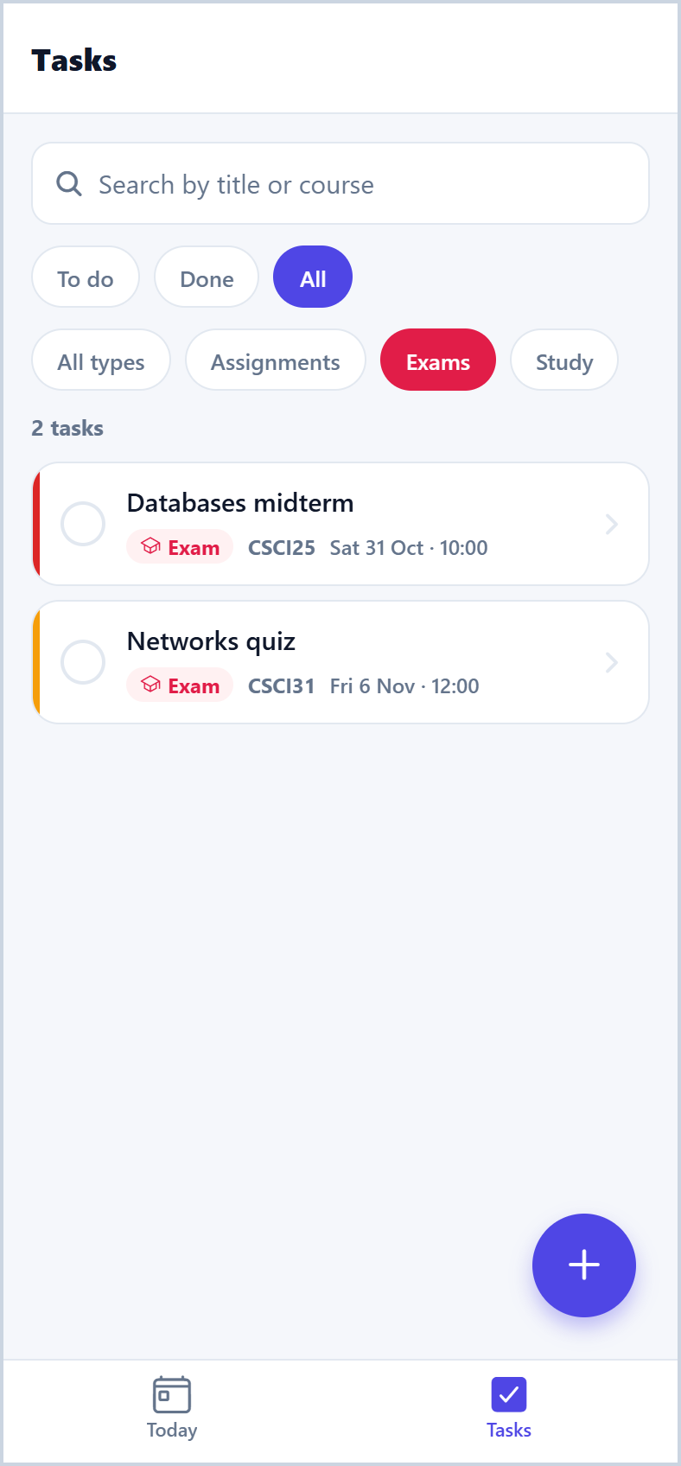  Figure 6: All exams, including finished ones

5.3 Screen 3: Add / Edit Task (FR1, FR2, FR3)
One form is used to add a new task (title New task) and to edit an existing one (title Edit task, opened with the task’s id as a route parameter). It has fields for title and course code, chips for the type, a due date with Today / Tomorrow / In a week shortcuts, an optional 24-hour time, priority and reminder chips, and notes with a character counter.
Pressing Add task or Save changes validates the form (FR2). Invalid fields turn red with a message underneath, a banner at the top says how many fields need fixing, and the first invalid field receives focus. The messages are: “Title is required”, “Title must be at least 3 characters”, “Course code is required”, “Use 2–12 letters or digits, e.g. CSCI38H”, “Due date is required”, “Enter a real date as YYYY-MM-DD”, “Due date cannot be in the past”, “Use 24-hour time, e.g. 09:30”, “Add a due time to get a reminder 1 hour before”, “That reminder time has already passed” and “Notes must be 200 characters or fewer”. In edit mode a Delete task button asks for confirmation before deleting (FR3).
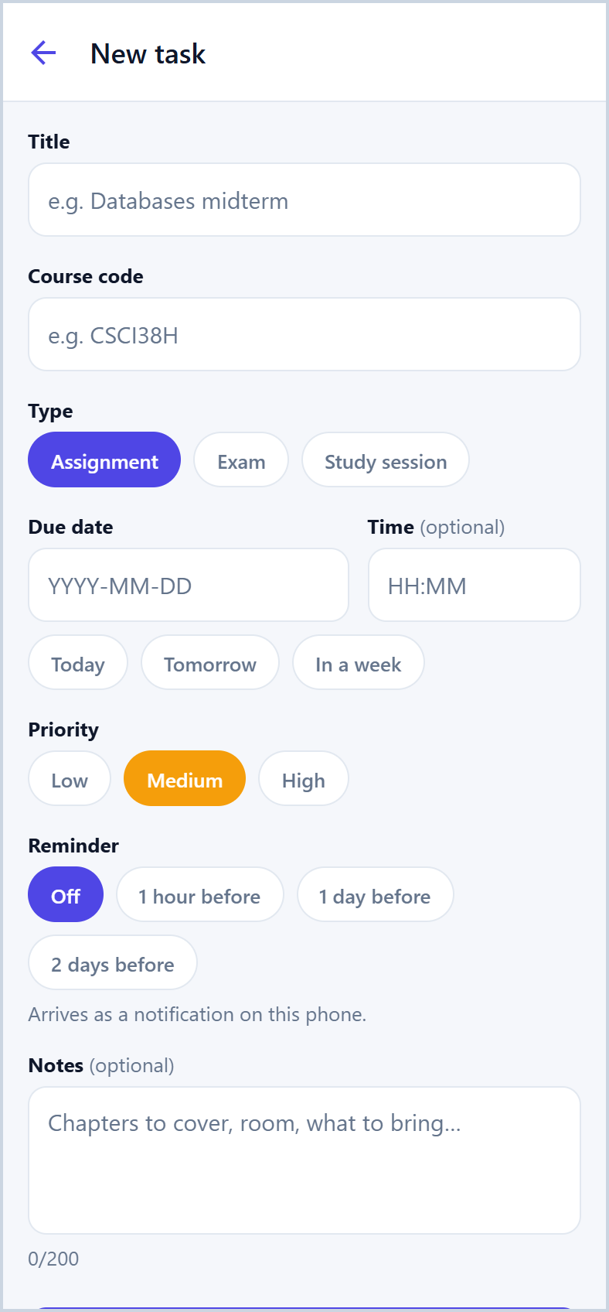  Figure 7: New task form | 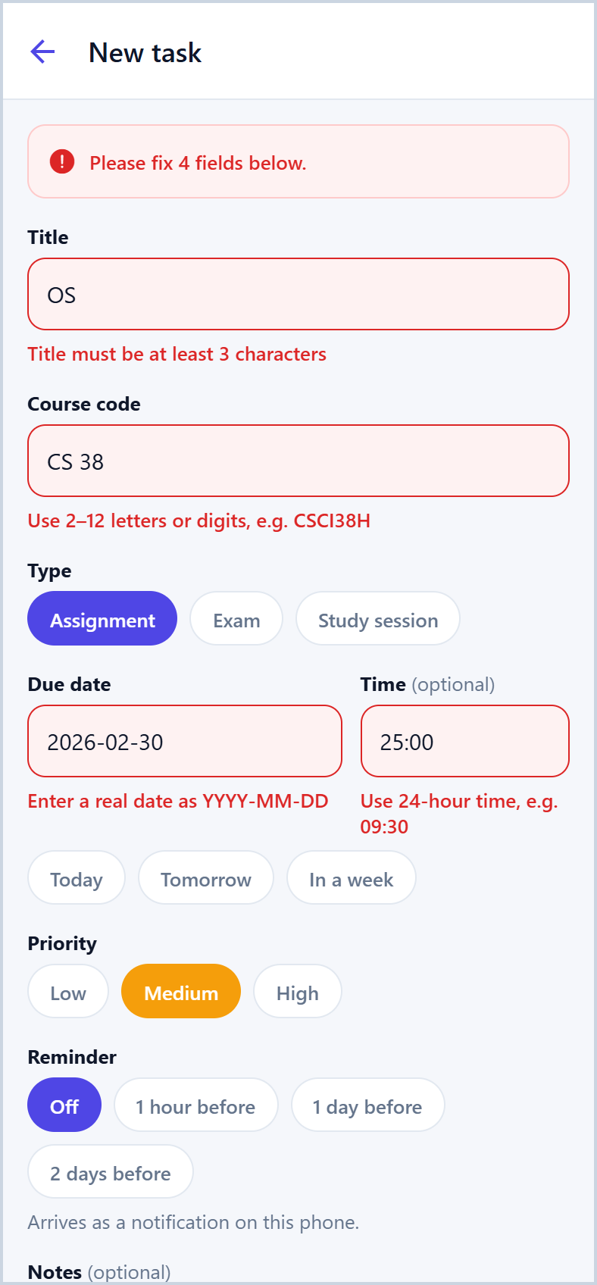  Figure 8: Validation messages
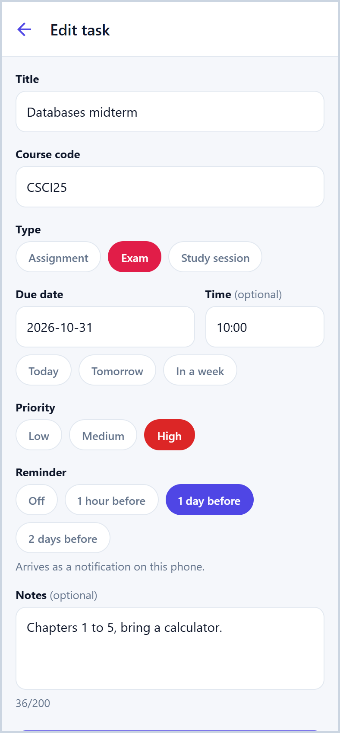  Figure 9: Edit task | 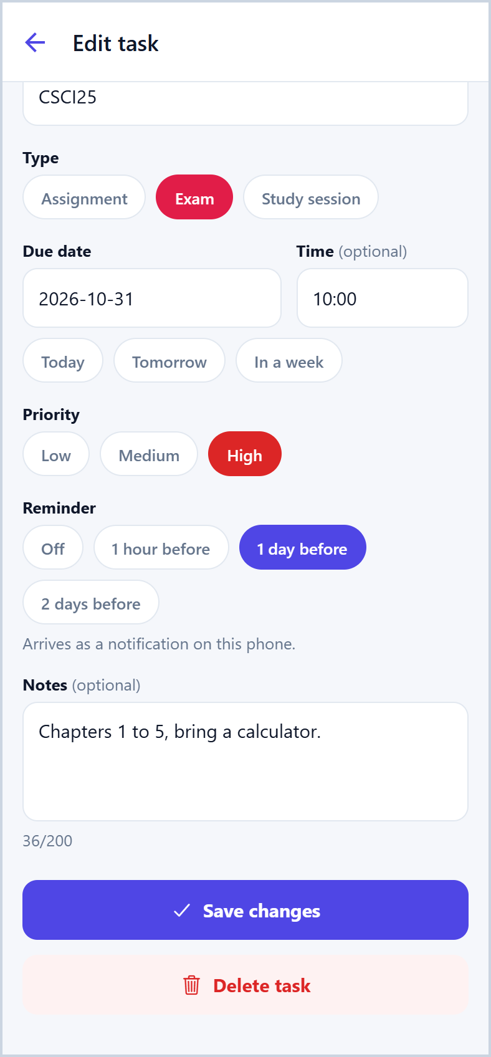  Figure 10: Edit task: Save changes and Delete task

5.4 Loading, empty and error states
- Loading: a spinner with “Loading your tasks…” while the tasks are read from the phone.
- Load error: “Couldn’t load your tasks” with a Try again button.
- Save error: a red banner, “Your last change could not be saved on this device.”
- Empty: “Nothing due today”, “No exams in the next two weeks”, “No tasks match” (with Clear filters), “No tasks yet” (with Add a task), “Task not found” for an invalid task id.
- Feedback and accessibility: every button dims while pressed; check boxes, buttons, chips and inputs have accessibility roles and labels for screen readers.

6. Architecture and Design Pattern

6.1 Selected pattern: Provider (React Context) with a feature-based structure
StudyPulse uses the Provider pattern inside a feature-based folder structure. Route files in src/app are thin: each one only renders a screen (Expo Router file-based routing). Everything about tasks lives in one feature folder, src/features/tasks. The TasksProvider (React Context) owns the task list and exposes it with the actions add, update, toggle and delete through the useTasks() hook. The form screen uses useTaskForm(), which holds the form’s state, validation and focus handling, so the screen itself only renders. The provider never touches storage directly: it calls taskRepository, the only code that knows where tasks are kept, which uses the shared AsyncStorage helpers in services/storage.ts.
The business rules are pure functions that do not import React: validateTask() in validation.ts, and sorting, filtering and dashboard grouping in logic.ts. Shared, feature-free code sits outside the feature: UI primitives in components/ui, design tokens (colours, spacing, radius, font sizes) in theme/tokens.ts and every route link in navigation/routes.ts. Imports go one way only: a feature may use shared code, but shared code never imports a feature.
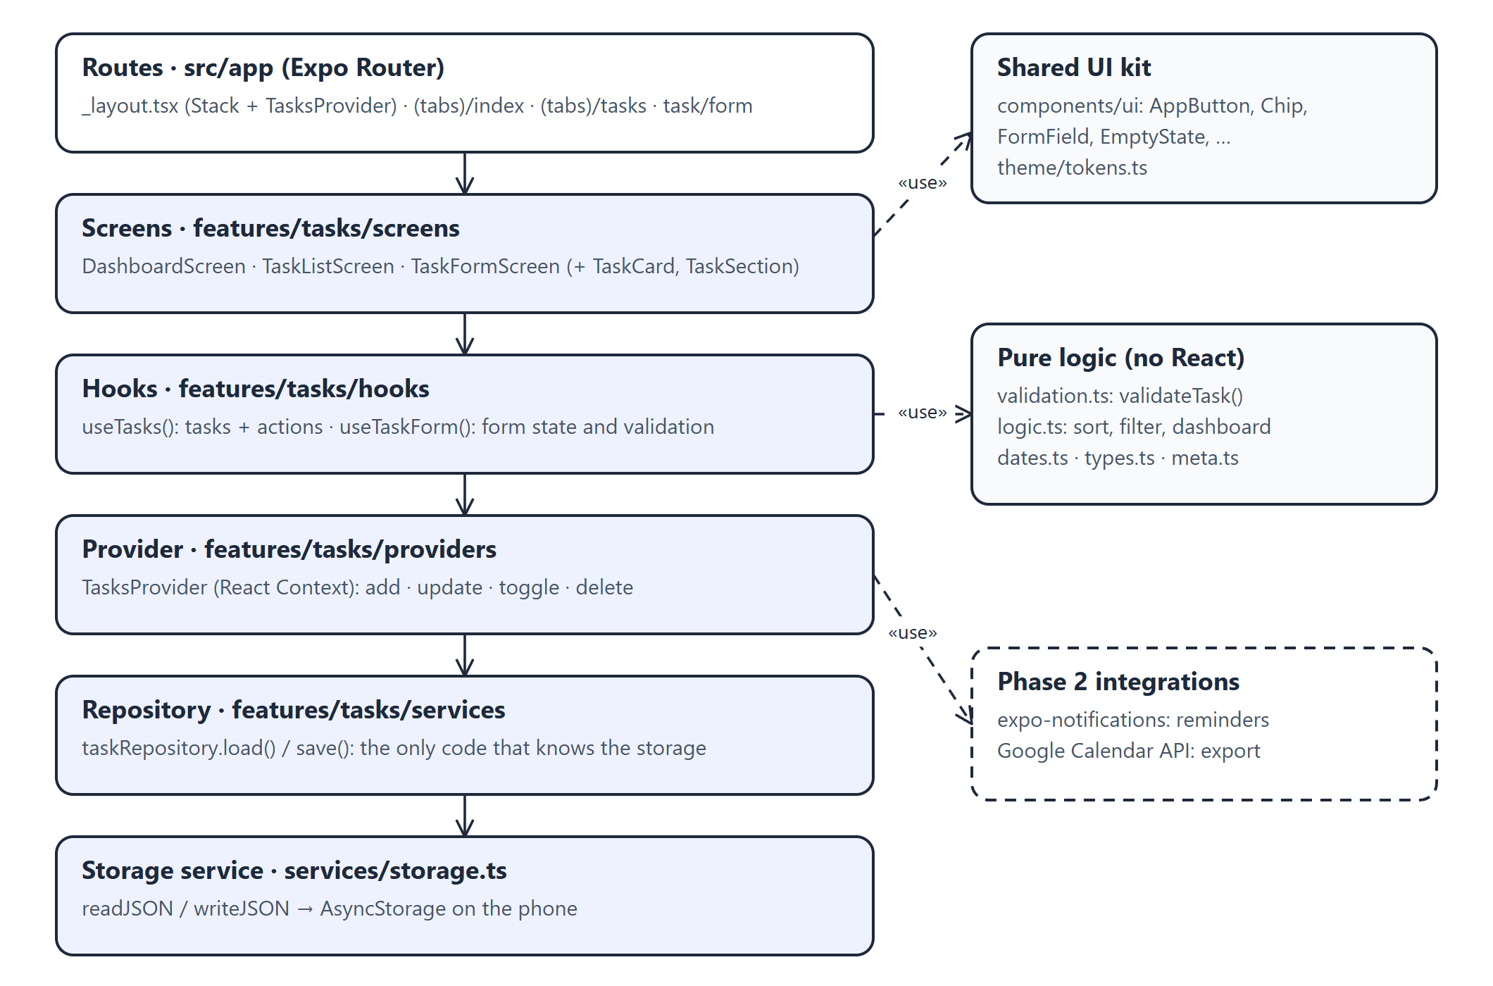
Figure 11: Layers of StudyPulse: data flows one way, from route to storage
src/
├─ app/ routes only (Expo Router)
│ ├─ _layout.tsx root Stack, wraps the app in TasksProvider
│ ├─ (tabs)/_layout.tsx bottom tabs: Today, Tasks
│ ├─ (tabs)/index.tsx → DashboardScreen
│ ├─ (tabs)/tasks.tsx → TaskListScreen
│ └─ task/form.tsx → TaskFormScreen (new, or edit with ?id=)
├─ features/tasks/ everything for the tasks feature
│ ├─ screens/ DashboardScreen, TaskListScreen, TaskFormScreen
│ ├─ components/ TaskCard, TaskSection, WeekProgressCard
│ ├─ hooks/ useTasks, useTaskForm
│ ├─ providers/ TasksProvider (React Context)
│ ├─ services/ taskRepository (load / save)
│ ├─ types.ts Task, TaskInput, TaskType, Priority
│ ├─ validation.ts validateTask(), reminderTime()
│ ├─ logic.ts sortTasks, filterTasks, buildDashboard, dueLabel
│ ├─ dates.ts · meta.ts · sampleData.ts · index.ts
├─ components/ui/ AppButton, Chip, ChoiceField, FormField, EmptyState, …
├─ navigation/routes.ts every link in one place
├─ services/storage.ts AsyncStorage JSON helpers
└─ theme/tokens.ts colours, spacing, radius, font sizes
Listing 1: StudyPulse source folders

6.2 Why this pattern
- Shared state without prop drilling. The dashboard, the task list and the form all need the same tasks. The provider gives every screen direct access through useTasks(), and a change made on one screen appears on the others at once.
- Built into React, as used in the labs. Context needs no extra library and is the pattern used in Labs 02 and 03, which keeps the app light.
- Separation of concerns. Screens only render; state lives in the provider; rules live in pure functions. validateTask(), buildDashboard() and sortTasks() can be unit tested without rendering anything, which is exactly what the three Phase 2 unit tests need.
- Ready for Phase 2. Notifications and the Google Calendar export plug into the provider and repository without changing the screens, and the storage could later gain a cloud backup inside taskRepository only.
- Feature-first folders. All task code is in one folder, so it is quick to find and a new feature (for example settings) can be added next to it without touching existing code.

6.3 Alternatives considered
MVVM and BLoC would separate the layers just as well but add classes and boilerplate that an app of this size does not need; useTaskForm() already acts as a small view-model for the form. Redux Toolkit (Lab 04) adds slices, a store and typed hooks for one list of tasks. Zustand would also work, but adds a dependency for little gain at this size. Because all state already sits behind useTasks(), the provider could be swapped for a Zustand store later without changing the screens.

7. Data Storage Plan

7.1 Data items
Data item | Main fields and types | Storage | Phase
Task | id: string, title: string, course: string, type: 'assignment' | 'exam' | 'study', priority: 'low' | 'medium' | 'high', dueDate: string (YYYY-MM-DD), dueTime: string (HH:MM or empty), reminderMinutes: number | null, notes: string, done: boolean, createdAt: string (ISO) | Local: AsyncStorage, key studypulse/tasks/v1, one JSON array | 1
ScheduledReminder | taskId: string, notificationId: string, fireAt: string (ISO) | Local: AsyncStorage; the notification itself is scheduled by the phone OS (expo-notifications) | 2
CalendarExport | taskId: string, googleEventId: string, exportedAt: string (ISO) | Local link in AsyncStorage; the event is stored in the student’s Google Calendar (cloud) | 2
Settings | defaultReminderMinutes: number | null, notificationsAllowed: boolean, googleAccountEmail: string | null | Local: AsyncStorage | 2
Type, priority and reminder options | value, label, colour, icon | Bundled with the app (meta.ts) | 1

7.2 Persistent storage
- Local first. Tasks are personal and must be available without internet, for example in a lecture hall with a weak signal. They are stored on the phone with @react-native-async-storage/async-storage as one JSON array. The repository loads them once at launch and saves the whole list after every change; the screen updates straight away and a red banner appears if a save fails.
- Versioned key. The key studypulse/tasks/v1 allows a migration if the Task shape changes in Phase 2.
- Cloud. The only cloud copy is what the student explicitly exports to Google Calendar (Phase 2). A cloud database such as Firestore is not needed yet: there is one user and nothing is shared, and a backend would add sign-in and cost without benefit. A cloud backup could be added later inside taskRepository only.
- No secrets in the app. Google sign-in uses OAuth; the public client IDs go in .env as EXPO_PUBLIC_ values. .env is listed in .gitignore, and only .env.example is committed.

7.3 Preliminary data model
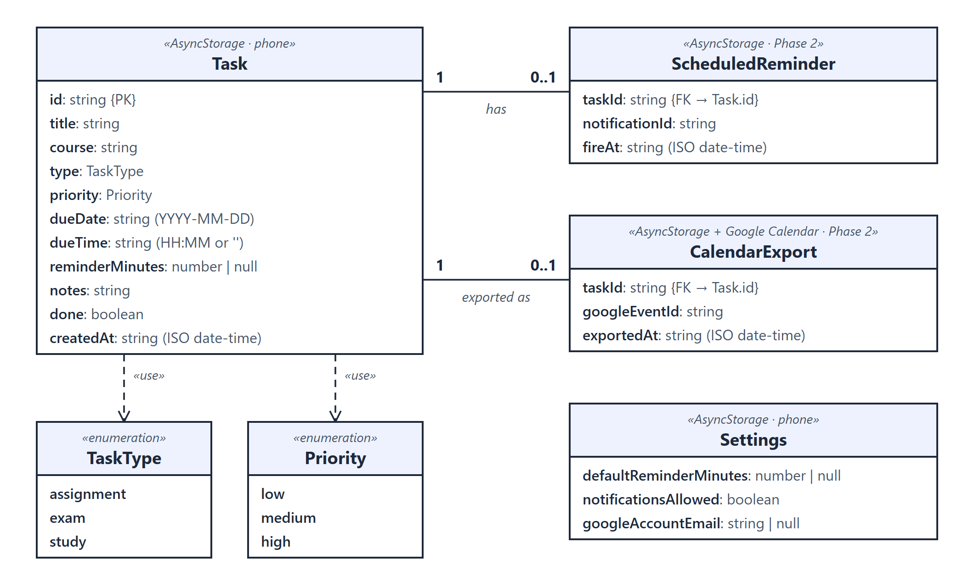
Figure 12: Preliminary data model

8. Plan for Phase 2
- Device feature (FR7): expo-notifications, asking for permission, then scheduling, rescheduling and cancelling a notification whenever a task is added, edited, ticked off or deleted.
- Google API (FR8): Google sign-in with expo-auth-session, then the Google Calendar API (events.insert on the primary calendar), storing the returned event id.
- Three unit tests (Jest + jest-expo): validateTask() (every FR2 rule), buildDashboard() (overdue, today, exams and weekly progress) and sortTasks() / filterTasks().
- AI engineering log: every AI-assisted piece of code recorded with its prompt, output, my changes and checks, and the reason AI was used.

How to run the prototype
npm install, then npx expo start and scan the QR code with Expo Go (or press w to open it in a browser). The code is on the repository listed on the first page.

