CHAPTER THREE
RESEARCH METHODOLOGY
3.0 Introduction
This chapter presents the methodology adopted for the design and implementation of the Intelligent Document Analysis and Learning Assistant System. In software engineering and computer science research, methodology is defined as the structured system of principles, techniques, and procedures applied to design, develop, test, and evaluate a software application (Sommerville, 2016). For the purpose of this study, a Design and Implementation project methodology is employed. This approach involves translating conceptual architectural designs into functional software components, executing live tests, and profiling system behaviors under controlled hardware environments.
To achieve a robust user experience and high-efficiency offline processing, specific programming languages and frameworks were selected for the implementation. The frontend interface is built using Next.js (TypeScript, React, HTML5, CSS3, and TailwindCSS), while the backend service is implemented in FastAPI (Python). TypeScript was chosen for the frontend because it enforces strict compile-time type-safety, which prevents runtime interface exceptions when communicating with the backend APIs. Next.js was selected due to its routing optimization, modular component structures, and hot-reload capabilities. TailwindCSS was used to implement a modern, responsive glassmorphic visual design using utility classes, aligning with the visual requirements of current web applications.
Python was selected as the sole programming language for the backend API and deep learning services. This selection is justified because Python is the standard language for natural language processing (NLP) and machine learning, supporting native packages such as SentenceTransformers for sentence vectorization, FAISS (Facebook AI Similarity Search) for high-performance index computation, and PyTorch for mathematical tensor calculations. FastAPI was selected as the backend web framework due to its high execution speed, automatic OpenAPI documentation generation, and standard validation model (Pydantic), which facilitates clean RESTful endpoint communication with the React client.
3.1 Software Requirements
To compile, execute, and host the proposed Intelligent Document Analysis system locally, the following software dependencies and tools must be installed in the runtime environment:
- Operating System: Windows 10/11 (64-bit), macOS Monterey or newer, or Linux (Ubuntu 20.04 LTS or newer).
- Python Interpreter: Python 3.10 or newer (to handle PyTorch, SentenceTransformers, and FastAPI).
- Node.js Runtime: Node.js v18.0 or newer (including the npm package manager to compile the React/Next.js frontend).
- Local Inference Engine: Ollama v0.1.30 or newer, running locally to serve open-weight language models (Qwen 2.5 0.5B and Gemma 2 2B).
- Relational Database: SQLite v3.0+, acting as the local, serverless database for secure storage of user profiles, document metadata, and chat histories.
- Vector Index: FAISS (CPU-compiled package) to store and query L2-normalized 384-dimensional document chunk embeddings.
- Development Environment: Visual Studio Code (VS Code) or an equivalent IDE, and Git for version control.
3.2 Hardware Requirements
Because the application executes neural network calculations fully locally (without relying on cloud endpoints), the local client machine must meet minimum hardware specifications to prevent model load crashes and maintain responsive query latencies:
- Central Processing Unit (CPU): Intel Core i5/i7 (8th Generation or newer) or AMD Ryzen 5/7 processor (minimum 4 cores, 8 threads). Apple Silicon (M1/M2/M3) chips are fully supported.
- Random Access Memory (RAM): Minimum 8 GB RAM (16 GB is highly recommended to prevent out-of-memory errors when loading Gemma 2 2B alongside system processes).
- Solid State Drive (SSD): Minimum 10 GB of available disk space (SSD is highly recommended over HDD to accelerate local model weight preheating and database transactions).
- Graphics Processing Unit (GPU): Optional. An NVIDIA GPU with CUDA compatibility (minimum 4 GB VRAM) can be utilized to accelerate token generation, though CPU execution is natively supported.
3.3 System Development Life Cycle
To manage the development process of the intelligent document assistant systematically, the Software Prototyping Model was adopted as the System Development Life Cycle (SDLC) framework. The prototyping model is an iterative development methodology where a simplified mock-up or operational draft of the software is built, tested, evaluated, and refined continuously based on performance profiling and user feedback (Pressman, 2014). This model is visually represented in the flowchart below:
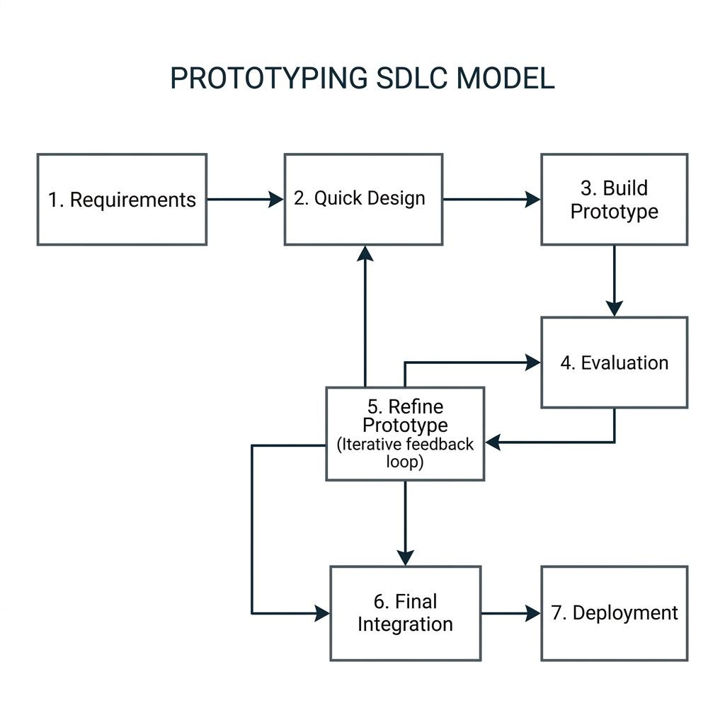
Figure 3.1: The Prototyping System Development Life Cycle (SDLC) Flowchart.
3.3.1 Phases of system development life cycle
The development of the Intelligent Document Analysis and Learning Assistant System under the Prototyping Model comprises seven distinct phases, described and related to the project topic below:
Phase 1: Requirements Identification. In this initial phase, the user requirements for secure offline document analysis were established. The research identified the need for local data storage, multi-lingual whitelisting, and low-latency interaction on commodity CPUs. We specified that the system must parse PDF, DOCX, TXT, and CSV, and run without an internet connection.
Phase 2: Quick Architectural Design. A preliminary architectural design was drafted. This focused on database schema designs in SQLite, mapping relationships between users, documents, chunks, and chat messages. Additionally, the coordinate layouts for PDF page extractions and FAISS vector dimensionalities (384) were planned.
Phase 3: Prototype Implementation. A functional prototype of the RAG ingestion pipeline and QA interface was implemented. We integrated a standard parser dividing text into arbitrary 1500-character segments, loading the sentence transformer model, and communicating with local Ollama model endpoints via REST requests.
Phase 4: Latency & Grounding Evaluation. The prototype was subjected to speed and correctness testing. Latency profiling revealed significant bottlenecks: evaluating queries on CPU took 71.69 seconds due to long LLM context prefilling, and the LLM attempted to answer out-of-scope questions, resulting in hallucinations. Furthermore, CORS origin blocks and IPv6 DNS delays caused login authentication failures.
Phase 5: Heuristic Refinement & Optimization. In this phase, we iteratively refined the prototype. First, to resolve login blocks, CORS origins were expanded, and host URLs were shifted to 127.0.0.1. Second, the slow LLM query classifier was bypassed, replaced by a deterministic keyword classifier with multilingual greeting mappings (0.00s latency). Third, text chunk sizes were reduced to 1000 characters to align with embedding limitations and cut LLM context evaluation time by half. PDF page extractions were also chunked systematically.
Phase 6: Final Integration & Testing. The optimized components were integrated back into the full FastAPI-Next.js application. Live RAG execution tests were run, showing that total query latency successfully dropped from 71.69 seconds to 36.87 seconds, and simple greetings responded instantly (0.00s) in multiple languages without LLM prefill costs.
Phase 7: Local Deployment & Maintenance. The fully tested system is deployed locally using FastAPI and Next.js dev servers, allowing the client user to import documents, create private chat rooms, study summaries, and take interactive quizzes securely offline.
The selection of the Prototyping Model over alternative SDLC models (such as the traditional Waterfall or V-Model) is highly justified. The traditional Waterfall model is rigid and sequential, forbidding developers from returning to previous phases once a step is completed. In local AI application development, actual model execution latencies and token prefill overhead are highly unpredictable, depending entirely on local hardware specifications. Had we used Waterfall, we would have progressed to deployment with a system taking over 70 seconds to respond and suffering from login failures, with no option to revise design chunk sizes or CORS whitelists. Prototyping enabled us to identify performance bottlenecks and build optimization loops into our design phase, leading to a responsive, production-ready system.

