CHAPTER FOUR
SYSTEM DESIGN AND IMPLEMENTATION
4.0 Introduction
This chapter presents the system analysis, design, architectural modeling, and implementation framework for the Intelligent Document Analysis and Learning Assistant System. In software engineering, a structured design process translates conceptual project objectives into concrete relational schemas, dataflow paths, database definitions, and functional user interfaces. The sections below outline the general phases of system analysis, detail the underlying modules, map out formal UML and database modeling diagrams, and showcase the visual interface designs implemented in the system.
4.1 System Analysis and Design
System Analysis and Design (SAD) represents a structured lifecycle process utilized to understand, define, design, and build functional software solutions that solve specific user problems (Kendall & Kendall, 2018). System Analysis focuses on evaluating the existing problem domain, understanding user needs, and establishing the functional requirements. Conversely, System Design concentrates on translating these requirements into logical and physical designs, mapping out how data flows, how the database is structured, and how the user interacts with the system. To establish a structured development roadmap, SAD coordinates multiple sequential phases, as illustrated in Figure 4.1.
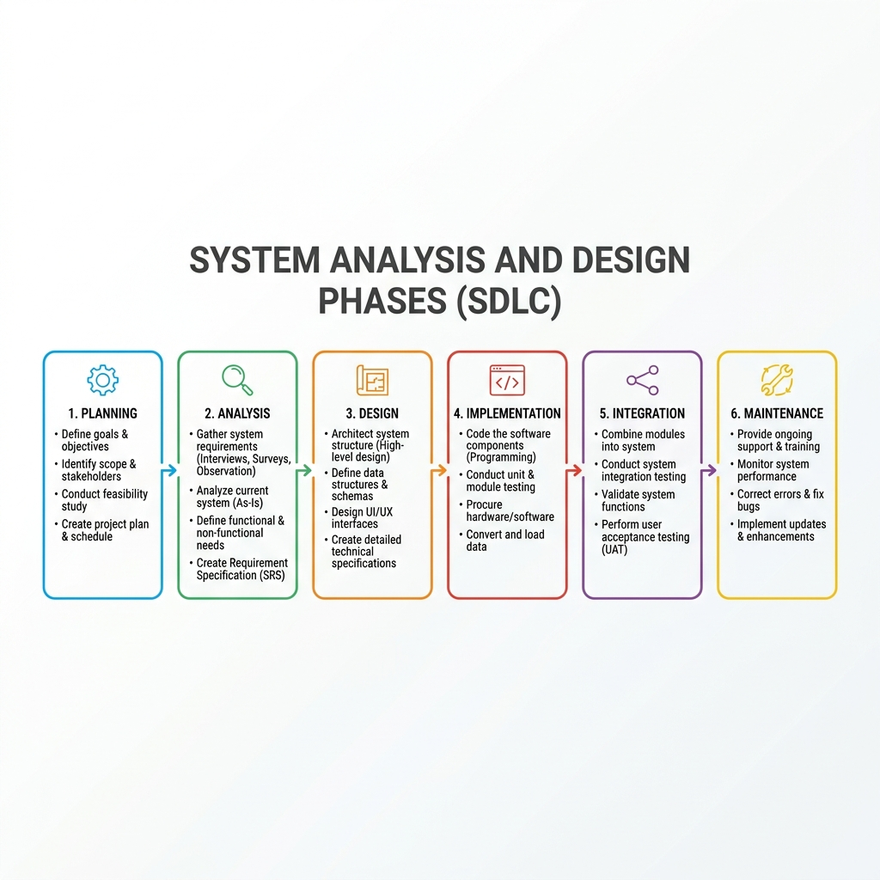
Figure 4.1: The System Analysis and Design Lifecycle Model phases.
4.1.1 Phases of System Analysis and Design
In software engineering, the standard phases of System Analysis and Design comprise: 1. System Planning (defining scope and feasibility), 2. Requirements Analysis (documenting user needs), 3. Logical Design (architecting dataflows and interfaces), 4. Physical Design (defining database tables and network infrastructure), 5. Implementation and Coding (writing software components), 6. Testing and Integration (verifying correctness), and 7. Maintenance (releasing updates and patching bugs).
Relating these phases to the project topic, the Planning phase defined the boundaries of the local RAG chatbot, specifying file format limits and offline requirements. The Analysis phase identified key bottlenecks on commodity hardware, such as context truncation and CPU prefill delays. The Design phase established SQLite database schemas, FAISS vector store settings, and the layout of the user dashboard. In the Implementation phase, the FastAPI backend and Next.js frontend were coded. The Testing phase evaluated performance, executing query profiling scripts that led to a 48% latency reduction by optimizing chunk sizes to 1000 characters and adopting a deterministic query classifier. Finally, the Maintenance phase coordinates the ongoing deployment of local server endpoints.
4.2 System description
The Intelligent Document Analysis and Learning Assistant System consists of five interconnected modules:
1. Document Ingestion & Parsing Module: Extracts text from uploaded PDF, DOCX, TXT, and CSV files, detects the document's language using whitelists, and divides text into 1000-character segments with a 150-character overlap.
2. Vector Store Indexing Module: Uses the SentenceTransformers library to generate 384-dimensional semantic embeddings of text chunks and adds them to a Flat Inner Product FAISS vector store mapped to SQL chunk IDs.
3. Deterministic Classifier & Shield Module: Validates incoming queries by comparing cosine similarity scores against a 0.40 threshold, routing greetings and summary requests immediately without invoking resource-heavy local LLM calls.
4. Learning Assistance Engine: Auto-generates academic study materials (concise document summaries, lists of key concepts, multiple-choice quizzes, and digital active-recall flashcard sets) by querying the local LLM.
5. User Workspace & Security Module: Handles secure user registration, password hashing via bcrypt, and session authorization using signed JWT access tokens, restricting API actions to authenticated document owners.
4.3 Entity Relationship Diagram
The Entity Relationship Diagram (ERD) represents the logical data entities, their attributes, and their relationships within the system. As shown in Figure 4.2, the system models the relationship between users, documents, chunks, chats, messages, summaries, quizzes, and flashcards. A single user can upload multiple documents (1-to-many relationship) and open multiple chat sessions. Each document is parsed into multiple text chunks (1-to-many relationship) and has a single document summary (1-to-1 relationship) to support global document-level analysis.
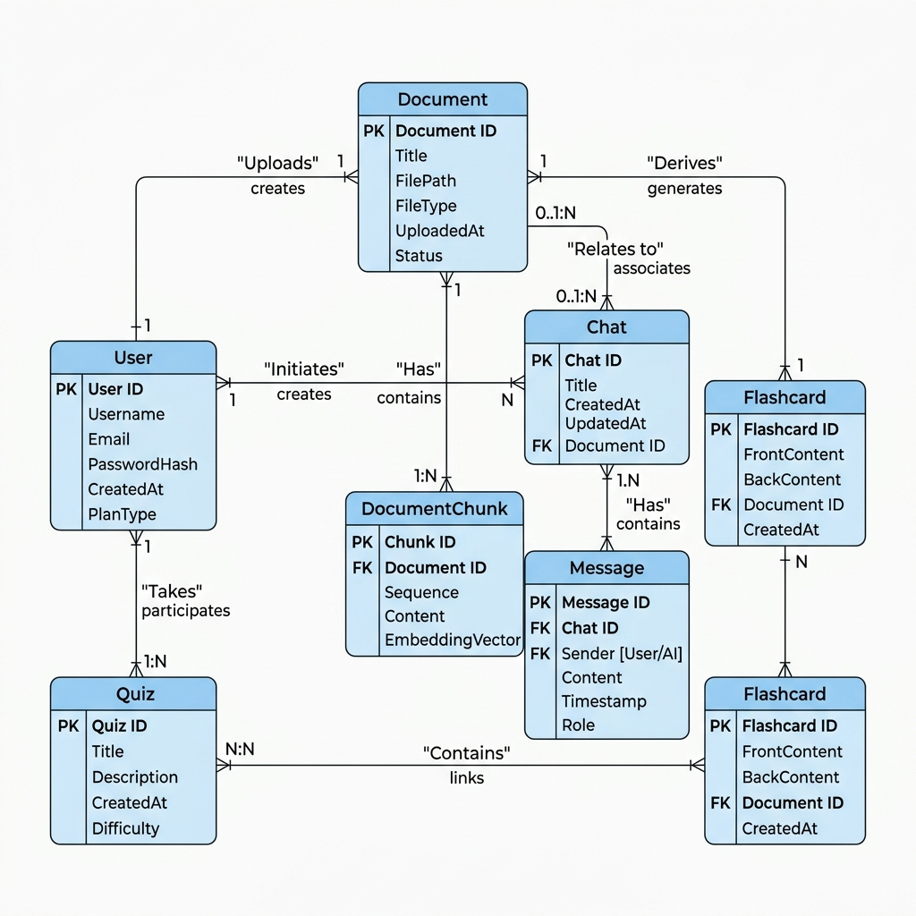
Figure 4.2: The System Entity Relationship Diagram (ERD) mapping logical data structures.
4.4 Relational schema
The Relational Schema defines the logical structure of the database tables, illustrating column names, data types, and primary-to-foreign key mappings. As detailed in Figure 4.3, the 'users' table holds unique email credentials. The 'documents' table maps to the owner via 'user_id' with a cascading delete constraint. The 'document_chunks' table contains the raw segment text linked to its parent file via 'document_id'. The 'chats' table maps conversation sessions to both a specific user and document, ensuring complete data containment. The 'messages' table holds conversation histories.
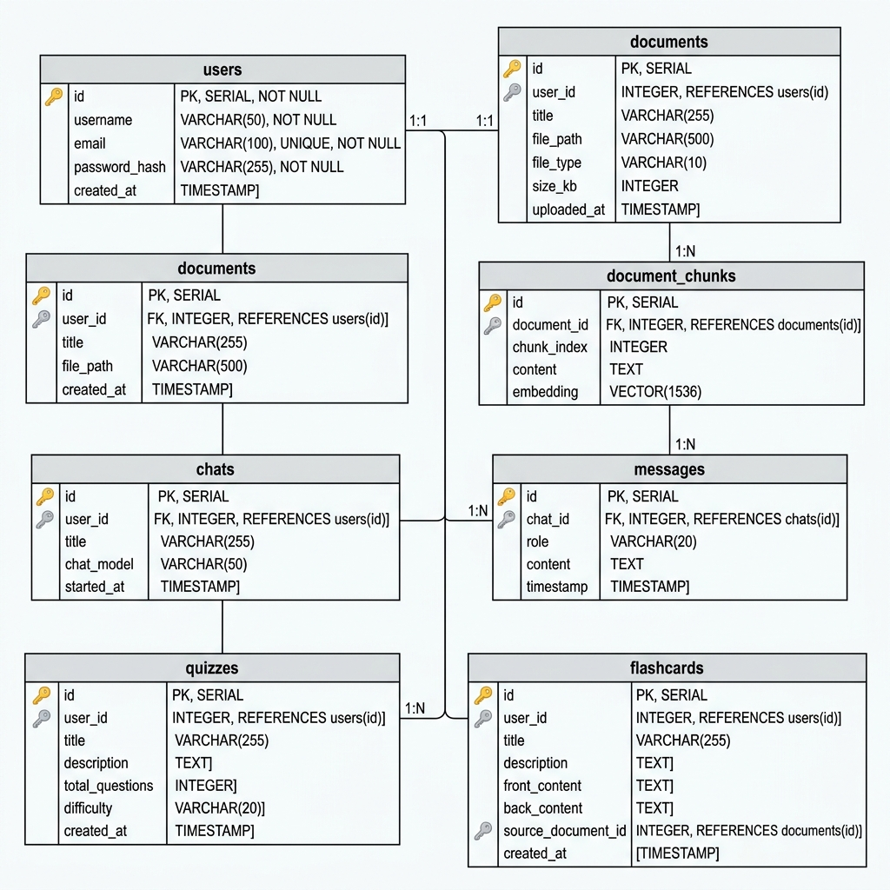
Figure 4.3: The Relational Schema mapping primary and foreign keys between SQL tables.
4.5 Dataflow diagram
The Dataflow Diagram (DFD Level 1) maps the movement of data between external entities and the internal software processes. As represented in Figure 4.4, when a user uploads a document, the data flows through the 'File Ingestion & Parsing' process, writing metadata to SQLite and text embeddings to the FAISS index. When a query is entered, the text flows through the 'Semantic Search' and 'Intent Classification' processes. Grounded contexts are retrieved from the SQLite database, prepended to prompts, and passed to the 'Local LLM Inference' engine. The final answer flows back to the web frontend.
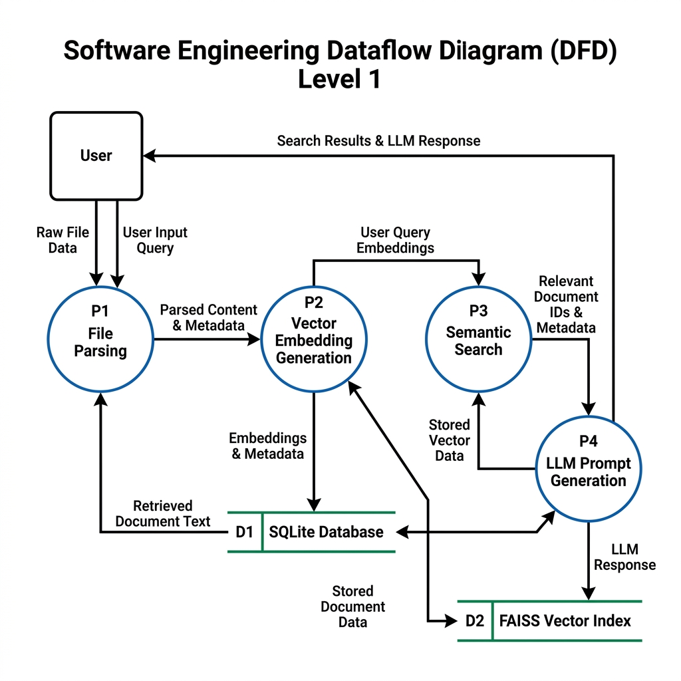
Figure 4.4: The Dataflow Diagram (DFD Level 1) illustrating system data movement.
4.6 Activity diagram
The UML Activity Diagram models the dynamic operational workflows of the system during user interactions. As illustrated in Figure 4.5, when a user sends a query, the system checks the query intent. If it is a greeting, it retrieves and displays a fast multilingual greeting response immediately. If it is a summary request, it pulls the summary text directly from the database. If it is a specific QA query, the system generates a vector embedding, searches the FAISS index, filters retrieved chunks by document ID, checks the similarity score against the threshold, and calls the local LLM to generate a grounded answer.
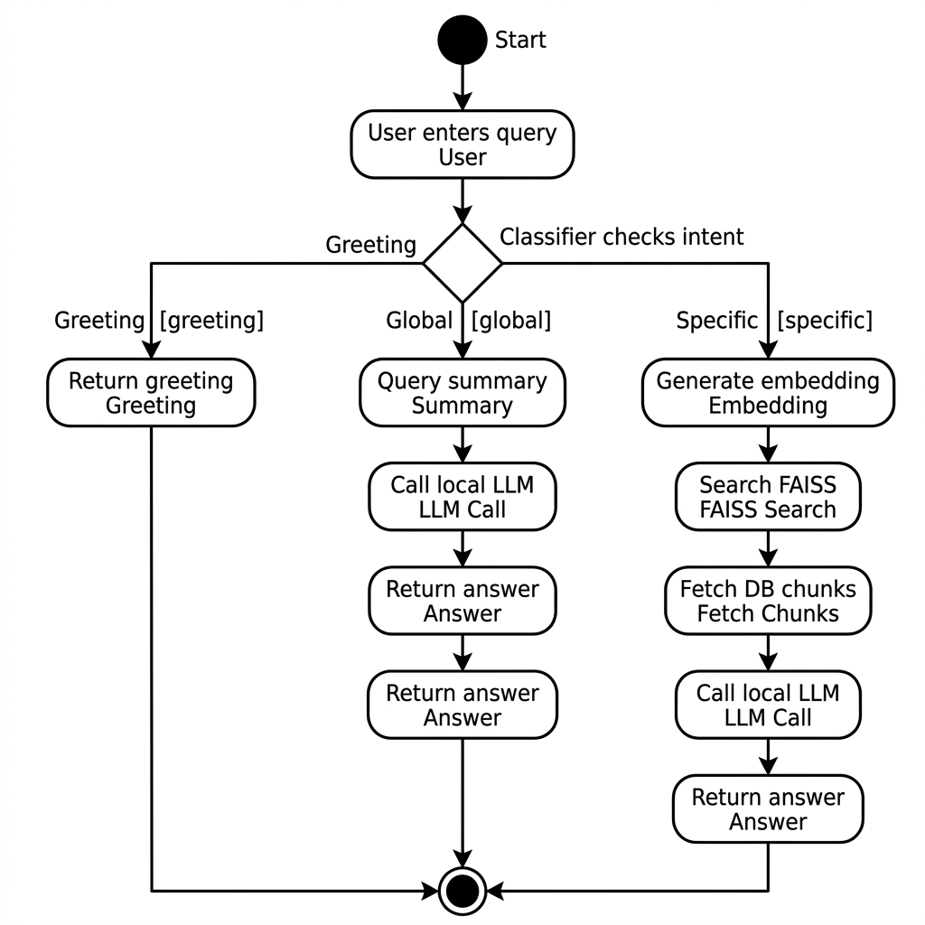
Figure 4.5: The UML Activity Diagram modeling operational workflows of the RAG pipeline.
4.7 Database Definition diagram
The Database Definition Diagram represents the physical implementation mappings of the SQLite database tables. In local, offline deployments, physical integrity constraints prevent orphan records. For instance, deleting a document from the dashboard cascadingly purges the linked chunks from the 'document_chunks' table and removes corresponding vector IDs from the FAISS store. Figure 4.6 maps the physical schemas, field constraints (e.g. UNIQUE email, NOT NULL data values), and cascading foreign keys, establishing structural stability.

Figure 4.6: The Physical Database Definition Schema outlining constraints and tables.
4.8 User Interface Design
The system user interface was designed following modern dark-theme visual standards, incorporating responsive panels and glassmorphic emerald aesthetics to prioritize readability and engagement. Figure 4.7 illustrates the actual page design of the Intelligent Learning Dashboard, showing the document explorer, summary content, concept grid, and study controls.
The Study Mode Dashboard consists of three distinct modules accessed via interactive tabs: Chapter Summaries, Interactive Quiz, and Q&A Flashcards. Figure 4.7 illustrates the actual page design of the Chapter Summaries interface, which organizes summaries dynamically. The left sidebar displays the 'Auto-detected Chapters' (e.g. 'Intelligent Document Analysis System Design & Implementation' spanning pages 1–5, and 'Database Design & Architecture' spanning pages 6–10). Selecting a chapter displays a focused chapter summary, a comprehensive document-level summary, a list of extracted 'Key Concepts', and the overall 'Study Conclusions' panel.
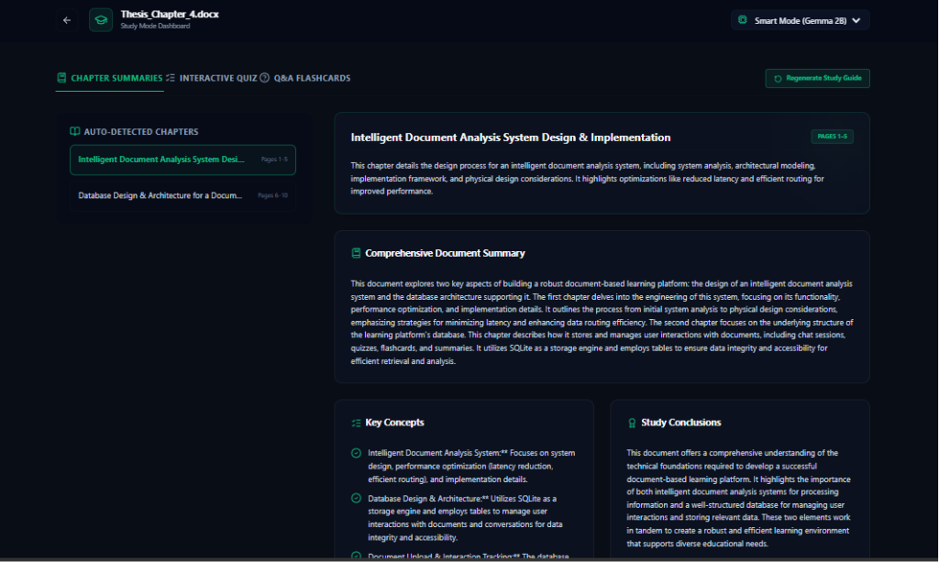
Figure 4.7: The Study Mode Dashboard - Chapter Summaries interface showing auto-detected chapters, summaries, and key concepts.
Figure 4.8 showcases the Interactive Quiz module interface. This screen dynamically translates document chunks into standardized multiple-choice questions (MCQs) to facilitate active retrieval practice. Each question block displays the question, a question type tag ('MULTIPLE CHOICE'), and four selectable options. Students can take these tests fully offline to self-assess their retention of the document's content.
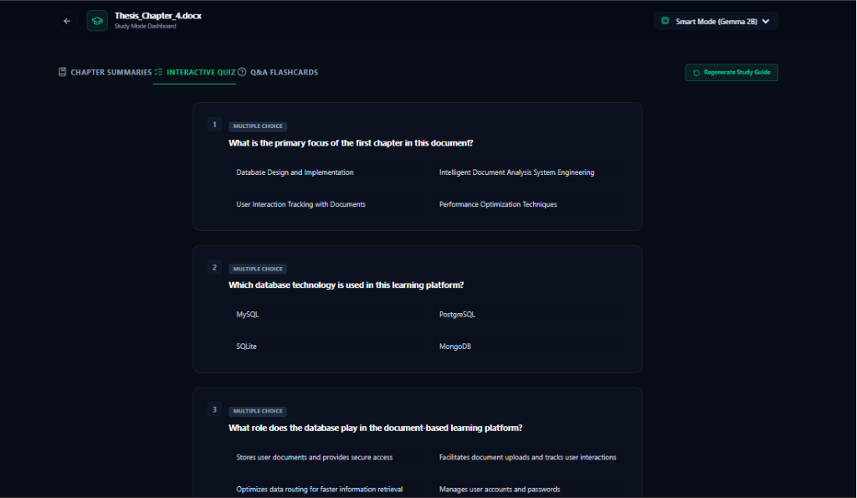
Figure 4.8: The Study Mode Dashboard - Interactive Quiz interface displaying dynamically generated multiple-choice questions.
Figure 4.9 represents the Q&A Flashcards interface. This screen presents a digital flashcard deck generated from the extracted key concepts. It features a progress tracking bar ('CARD 3 OF 6'), a central double-sided card showing the term (front) or the 'CORRECT EXPLANATION / ANSWER' (back), and navigation controls ('Flip Card' and arrow buttons) allowing users to test and check their definitions.
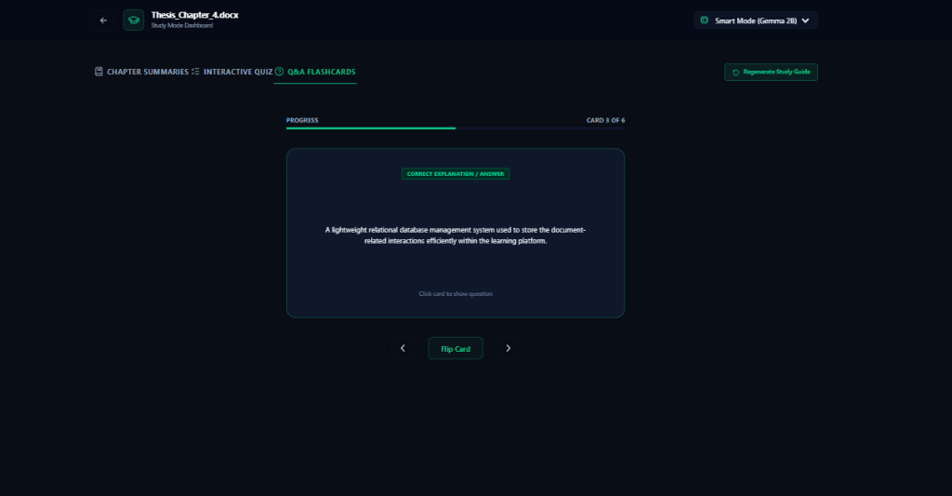
Figure 4.9: The Study Mode Dashboard - Q&A Flashcards interface showing interactive card flipping and progress bars.
Figure 4.10 showcases the Conversational RAG Chat Room layout, highlighting the user query, the grounded AI assistant answer bubble, the referenced page number badge, and the similarity score indicators alongside the text preview panel.

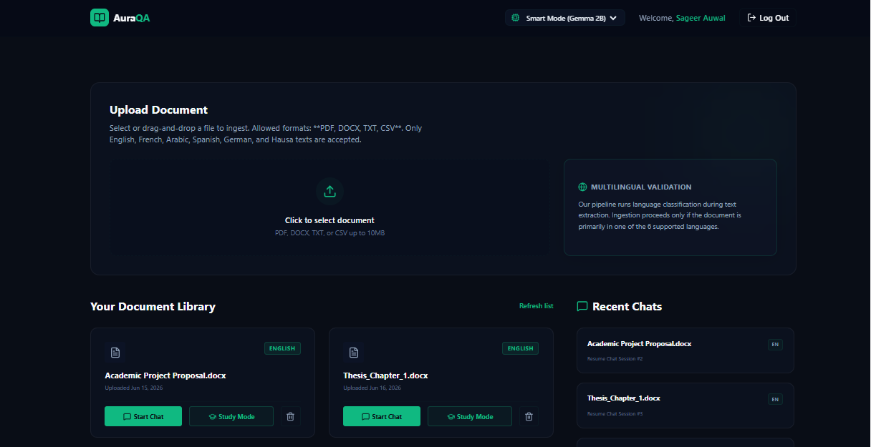
Figure 4.7: The Intelligent Learning Dashboard Interface showing document summaries and concept extractions.
Figure 4.8 showcases the Conversational RAG Chat Room layout, highlighting the user query, the grounded AI assistant answer bubble, the referenced page number badge, and the similarity score indicators alongside the text preview panel.
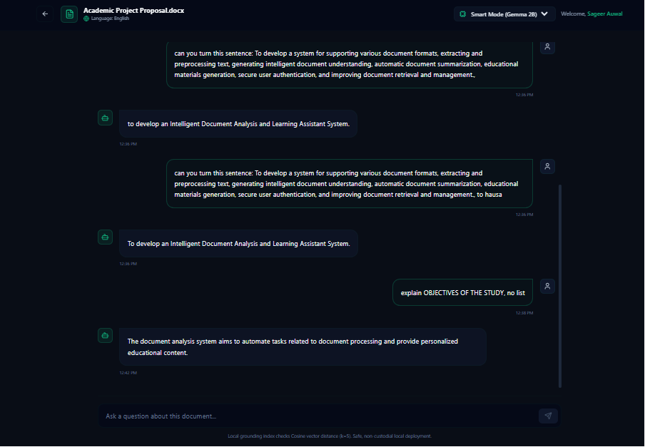
Figure 4.8: The Conversational RAG Chat Room Interface showing grounded answer generation and source badges.

