**MongoDb:**

Please start mongodb server in local command prompt in admin mode (normal mode also works) by giving the command “mongod”. Once its up

Open MongoDb Compass and click connect. Since its local no credential needed.

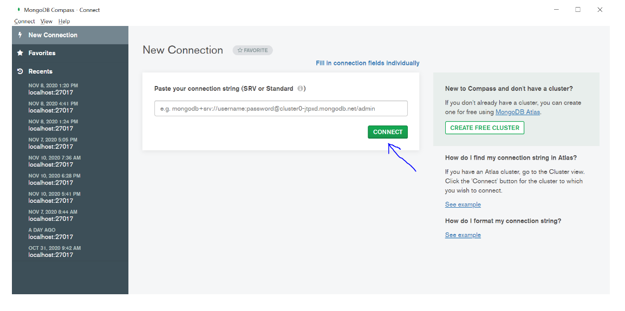

If you are not able to see 5 collections then they will be created automatic once data is inserted from UI.

*PS: Sometimes the db stops unexpectedly , in that case kindly hit the “mongod “ command again and db will reconnect.*

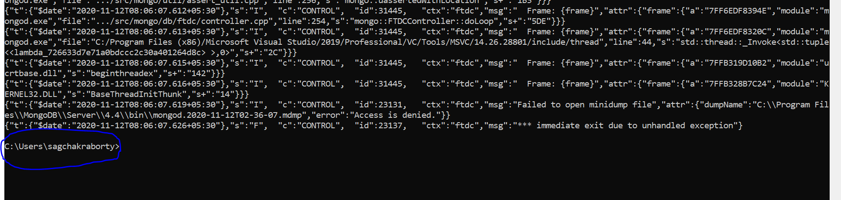

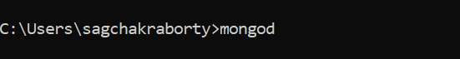

**Spring boot:**

Kindly import the 4 projects inside HospitalManagementSts folder in the spring boot and start them. No other configuration needed. I have used java-8 .

I have used microservices architecture with Eureka, Zuul, Feign , Zipkin, Rest, features integrated.

For distributed tracking zipking in enabled . The zipking jar can be downloaded and run in command prompt in the folder .

Command to run zipkin jar : java -jar zipkin-server-2.12.9-exec.jar

It can be viewed from localhost:9411/zipkin/ only after the zipkin jar is running in local.

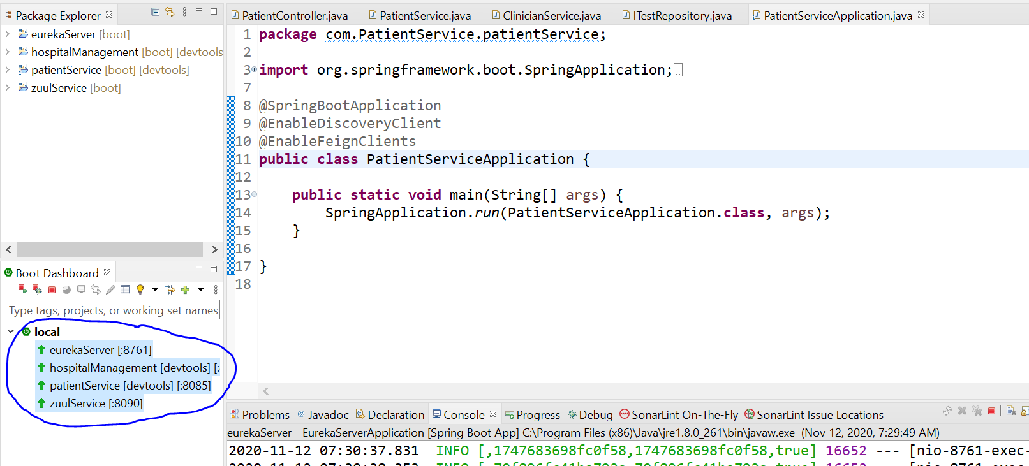

**Angular:**

Kindly import the HotelManagementNew angular application and provide “ng serve” command to run the application.

After importing it should look something like this:

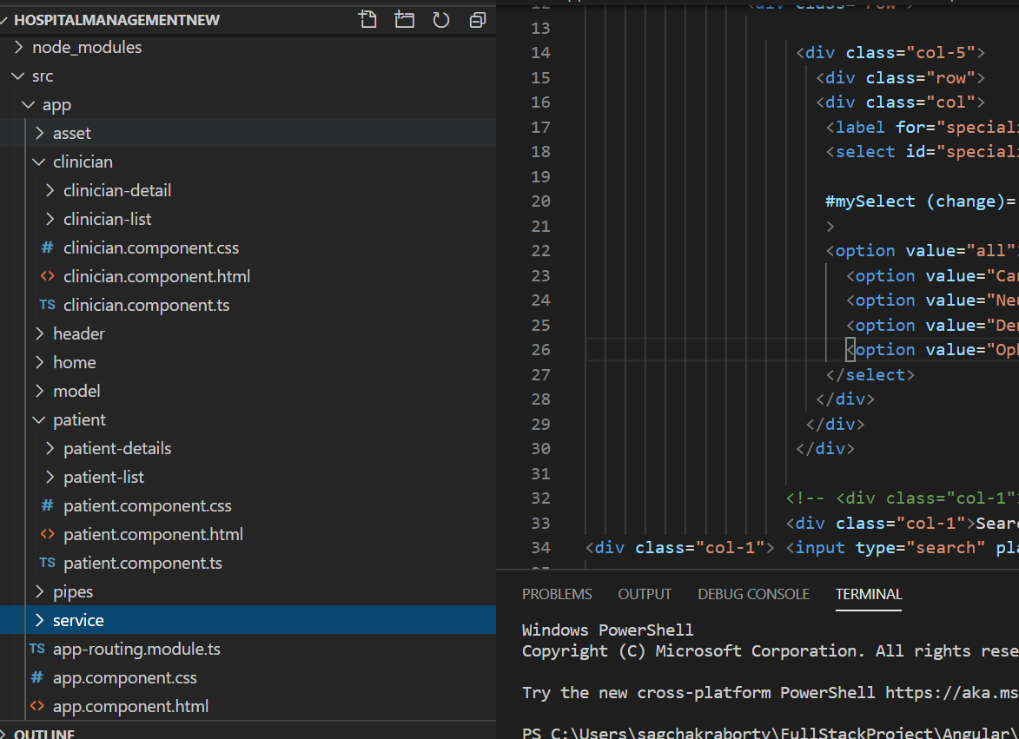

I have used Angular8 framework . I have tried to implement bootstrap,css, Pipes ,Services, Routerlinks, http and other features in this project. I have created separate folder based on functionality.