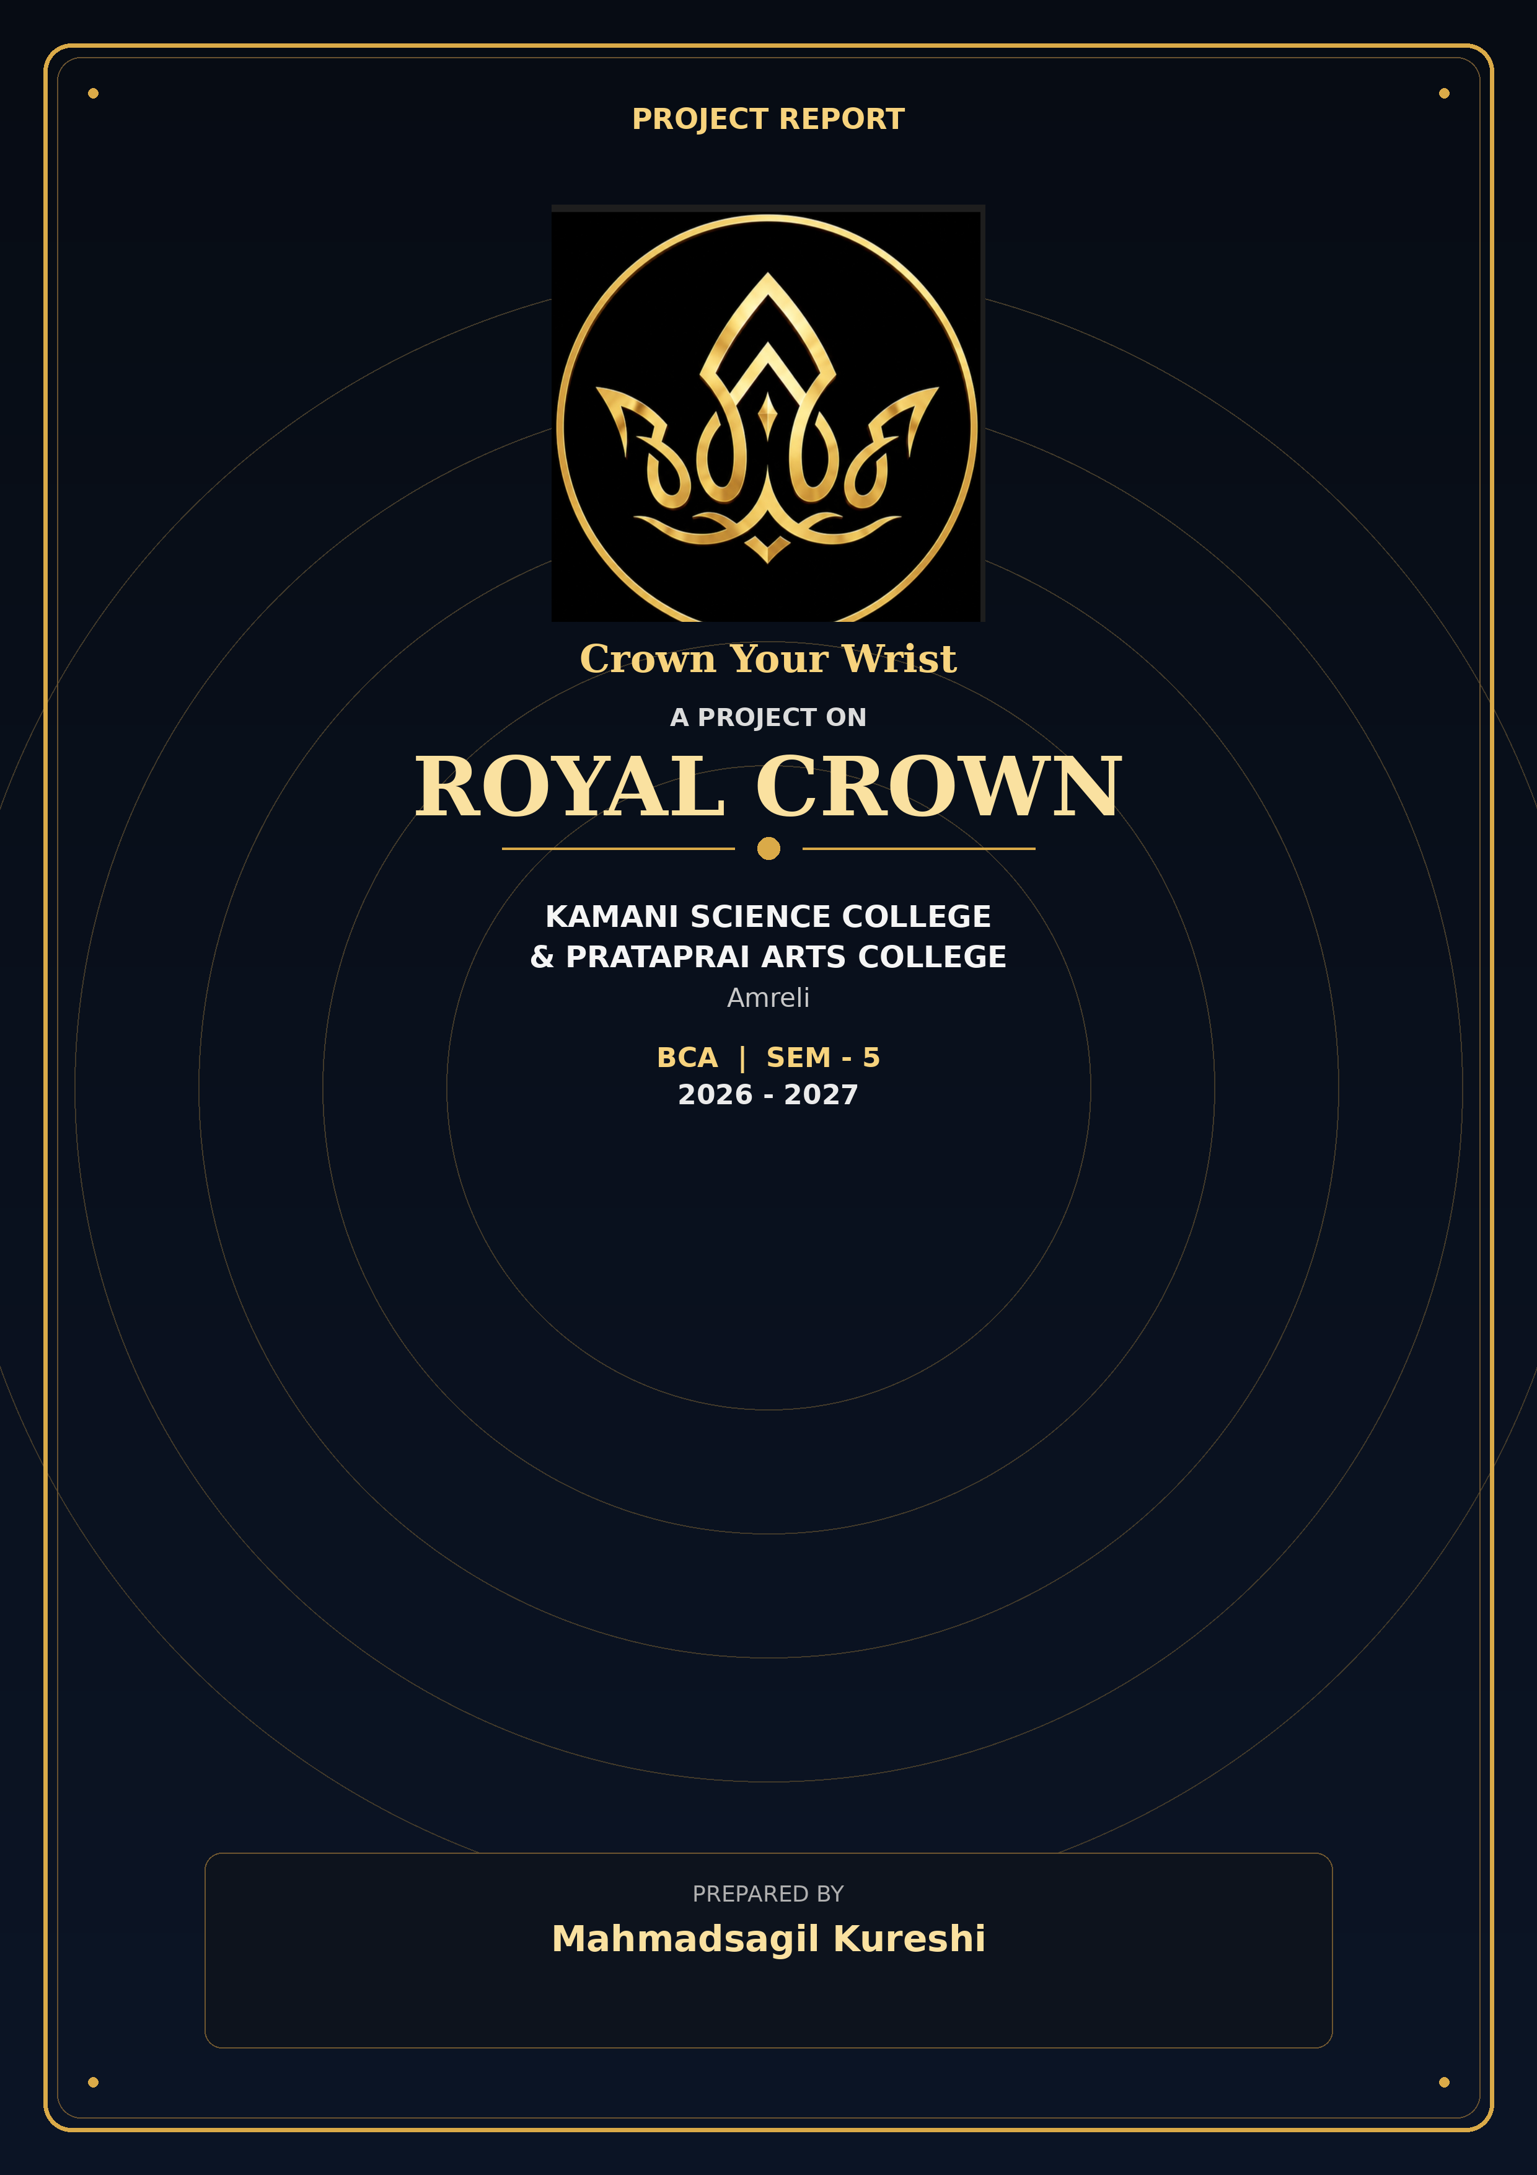

A Project Report On
“ROYAL CROWN”
Kamani Science College & Prataprai Arts College, Amreli
Developed By
Mahmadsagil Kureshi
Guided By
Prof. Nilesh Parghi
Year Of Submission
2026 - 2027
Submitted in partial fulfillment of the requirement for the award of the degree of Bachelor of Computer Application (BCA)

BCA - SEM - 5

Saurashtra University-Rajkot

Index

No | Title | Page No
1 | Preface | 5
2 | Acknowledgement | 6
3 | Abstract | 7
4 | Introduction | 8
5 | Time Line Chart | 9
6 | Project Profile | 10
7 | Hardware Requirement | 11
8 | Software Requirement | 11
9 | Requirement Specification | 12
10 | Problem Definition | 13
11 | Project Planning& Scheduling | 14
12 | System Analysis | 16
13 | Feasibility Study | 17
14 | Project Page Structure | 19
15 | Data Dictionary | 22
16 | Data Flow Diagram | 27
17 | Context & First Level Diagram | 28-29
18 | ER Diagram | 30
19 | Use case Diagram | 31
20 | Activity Diagram | 32-34
21 | Screenshot (Page UI) | 35
22 | Future Scope & References | 65

Preface

The main objective of any computer science student is to getpractical knowledge as possible. Being able to have a practical knowledge by developing a project is a lifetime experience. As practical knowledge is important as theoretical knowledge we are thankful of having a project.

Through the development of the project we had a great experience of various strategies that can be applied in development of the project. This project is the stepping stone for our career.

We are pleased to present this project report. Proper case has been taken while organizing the report so that it is easy to comprehend. Also, various software engineering concepts have been implemented.

Acknowledgment

I am student of BCA sem-5 Studying in the Kamani Science College Amreli. I Thanks to the entire person who has given their Support in shaping of the system.

I thanks to Prof. NileshParghi for giving me guidance and co-operation in understanding the system. I also thanks them for their unconditional help in making of this project.

I have great deal of gratitude towards my head of department who encourages in taking up this activity. I thanks to all faculties and administrative staffs of the institute.

