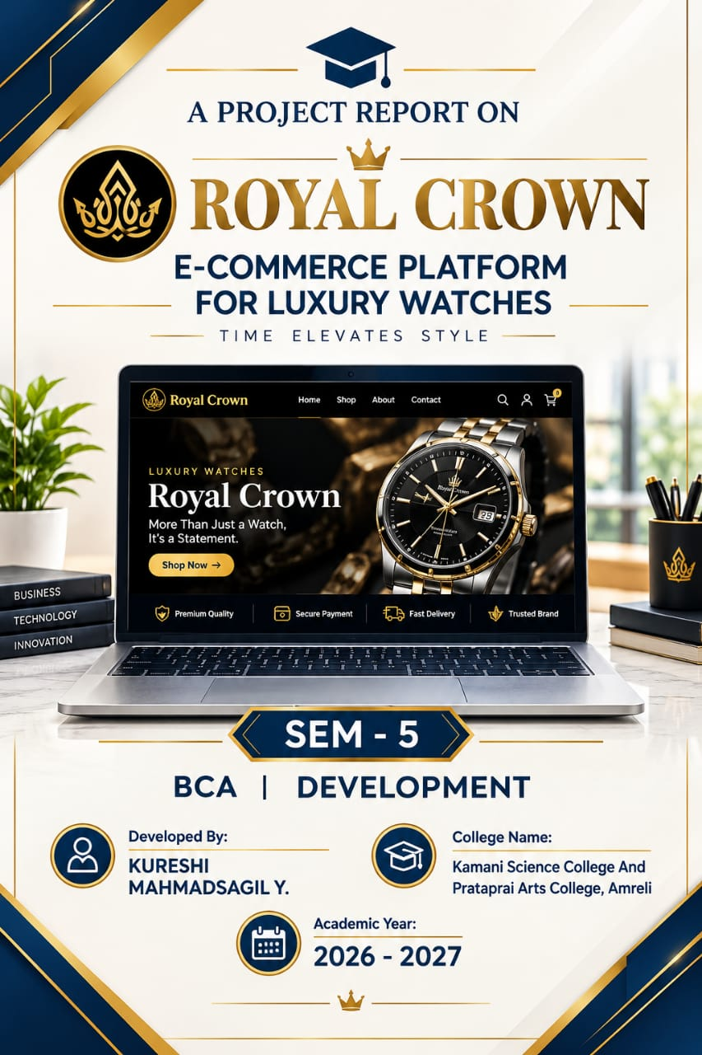
A Project Report On
“E - Commerce Platform for Luxury Watches”
Royal Crown
Kamani Science Collage &Prataprai Arts College Amreli

Developed By
Kureshi Mahmadsagil Y.
(Enr. No. – 24CS002UG02929)
Guided By
Mr. Nilesh Parghi
Year Of Submission
Submitted in partial fulfillment of the requirement for
the award of the degree of Bachelor of Computer
Application (BCA)
2026-2027


Saurashtra University - Rajkot


----------------------------------------------------------------------------------------------------------------

[BCA DEPARTMENT]

C E R T I F I C A T E

This is to certify thatMr./Miss.________________________________________________________
KURESHIMAHMADSAGIL Y.

24CS002UG02929

Enrollment No.____________________ Studying in B.C.A. Semester V has completed his/her Project work satisfactorily during the year 2026-2027.

Signature Signature Signature
Project Guide Head of Department Examiner

INDEX
No. | Title | Page No.
1 | Preface | 1
2 | Acknowledgement | 3
3 | Abstract | 5
4 | Introduction | 7
5 | Time Line Chart | 9
6 | SDLC | 11
7 | Problem Definition | 13
8 | Objective Of Project | 15
9 | Requirement Specification (Question Ans) | 17
10 | Requirement Gathering | 21
11 | Project Profile Page | 23
12 | Hardware & Software Requirement | 24
13 | Project Page Structure Diagram | 26
14 | Data Dictionary | 28
15 | Data Flow Diagram | 33
16 | ER Diagram | 37
17 | Use Case Diagram | 39
18 | Activity Diagram | 40
19 | Testing | 42
20 | Screen Shots | 45
21 | Coding | 48
22 | Future Scope | 50
23 | Bibliography | 52
24 | Link Of Reference Website | 53
25 | CD – DVD | 54
26 | Thank You | 55

PREFACE
The “E – Commerce Platform for Luxury Watches” project is developed as part of the BCA Semester 5 Project for the academic year 2026–2027 at Kamani Science College &Prataprai Arts College, Amreli, affiliated with Saurashtra University, Rajkot.

This project is developed by Kureshi Mahmadsagil Y. under the guidance of Mr. Nilesh Parghi. The main aim of this project is to create a simple and user-friendly online shopping platform where customers can easily browse products, view product details, add items to their cart, and place orders.

Working on this project gave me a practical understanding of web development, database management, user login, product management, shopping cart, and order processing. It also helped me understand how the concepts learned during the BCA course can be used to build a real-world application.

I am sincerely thankful to Mr. Nilesh Parghi, my project guide, for his valuable guidance, support, and suggestions throughout the project. I am also thankful to Kamani Science College &Prataprai Arts College, Amreli, and all the faculty members for their support and encouragement.

Finally, I would like to thank my friends, family, teachers, and everyone who supported me during the development and completion of this project.

ACKNOWLEDGEMENT
I would like to express my sincere gratitude to all those who have supported and guided me in the successful completion of my project entitled “E – Commerce Platform for Luxury Watches”, developed as part of the BCA Semester 5 Project for the academic year 2026–2027.
First of all, I would like to express my deepest gratitude to Mr. Nilesh Parghi, my project guide, for his valuable guidance, encouragement, continuous support, and constructive suggestions throughout the development of this project. His knowledge and guidance helped me to complete this project successfully.
I am sincerely thankful to the Principal, faculty members, and staff of Kamani Science College &Prataprai Arts College, Amreli, for providing me with the necessary facilities, resources, and academic support required for completing this project.
I am also grateful to Saurashtra University, Rajkot, for providing the academic framework and opportunity to undertake this project as part of the Bachelor of Computer Application (BCA) degree.
I would also like to thank my teachers and classmates for their valuable suggestions, encouragement, and support during the development and testing of the system.
Finally, I am deeply thankful to my parents, family members, and friends for their constant encouragement, motivation, and support throughout my academic journey and during the completion of this project.
I sincerely thank everyone who contributed directly or indirectly to the successful completion of the “E – Commerce Platform for Luxury Watches” project.

Kureshi Mahmadsagil Y.

ABSTRACT

The “E – Commerce Platform for Luxury Watches” is a web-based application developed to make online shopping simple, convenient, and user-friendly. The system allows customers to create an account, browse different products, search for products, view product details, add items to a shopping cart, and place orders online.

The system also provides an effective way to manage products, customers, and orders. It reduces the need for manual shopping processes and helps users save time by providing shopping services from anywhere through the internet.

This project is developed as part of the BCA Semester 5 Project for the academic year 2026–2027 at Kamani Science College &Prataprai Arts College, Amreli, affiliated with Saurashtra University, Rajkot.

The development of this project provided practical knowledge of web development, database management, user authentication, product management, shopping cart functionality, and order processing. Overall, the system provides a simple and efficient platform for managing online shopping activities.

INTRODUCTION

The “E – Commerce Platform for Luxury Watches” is a web-based application developed to provide a simple, convenient, and user-friendly online shopping experience. The system allows customers to create an account, browse different luxury watches, search for products, view product details, add items to a shopping cart, and place orders online.
The frontend of the project is developed using HTML, CSS, and JavaScript to create an attractive and interactive user interface. EJS (Embedded JavaScript Templates) is used to display dynamic content and product information on web pages.
The backend is developed using Node.js and Express.js, which handle server-side operations, routing, user requests, product management, and order processing. MongoDB is used as the database to store and manage information such as users, products, categories, carts, and orders.
The system provides a smooth connection between the frontend, backend, and database. It reduces manual shopping processes and allows customers to manage their shopping activities easily through an online platform.
Developing this project has provided practical knowledge of web development, server-side programming, database management, dynamic web pages, routing, and CRUD operations. Overall, the project demonstrates how different web technologies can be combined to create a functional and user-friendly e-commerce application.

TIME LINE CHART
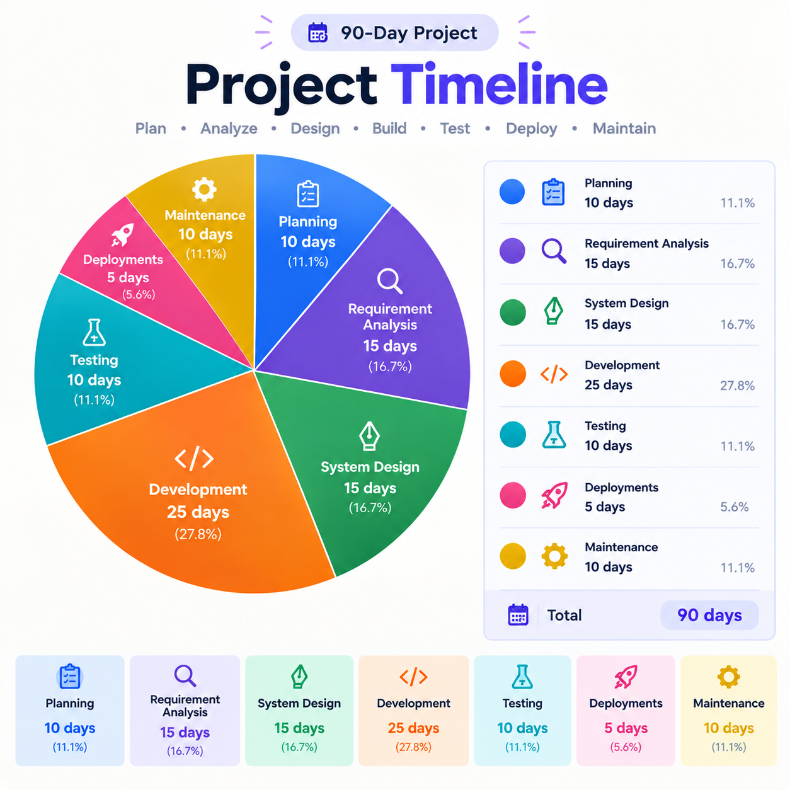

SDLC
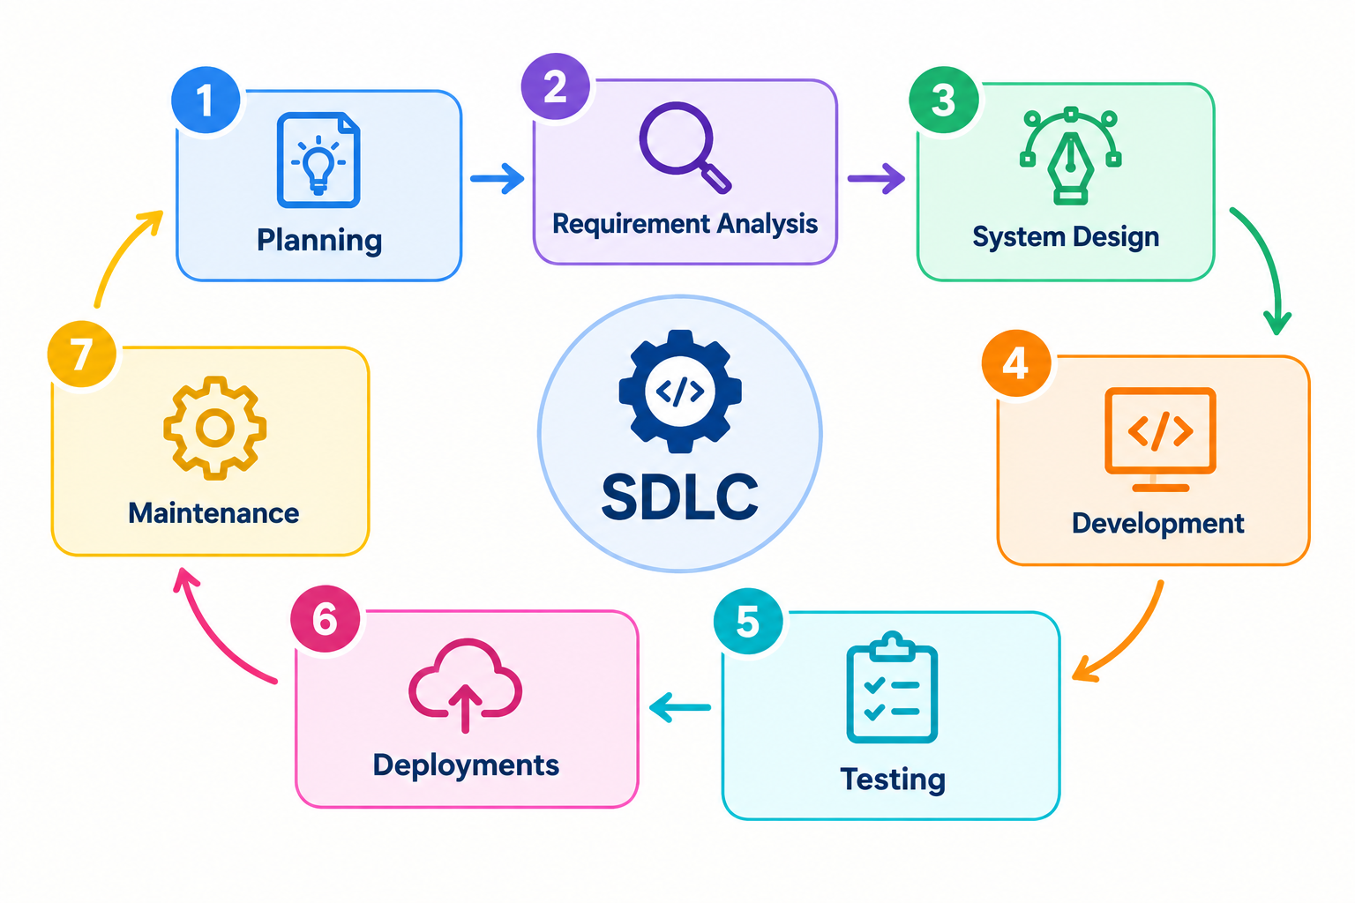
(SOFTWARE DEVELOPMENT LIFE CYCLE )

- PROBLEM DEFINITION
- OBJECTIVE OF PROJECT
- REQUIRMENT SPECIFICATION (QUESTION ANS)
- REQUIREMENT GATHERING

PROBLEM DEFINITION
In the traditional luxury watch shopping system, customers must physically visit retail boutiques or watch showrooms to browse timepieces. These showrooms are constrained by geographical location and rigid operating hours, which makes shopping inconvenient for buyers living far away or those unable to visit during standard store timings. Furthermore, physical display counters have limited space, making it difficult to showcase a comprehensive catalog of luxury brands, technical specifications, and model variations in one place.
Operationally, traditional manual systems rely heavily on paper ledgers, manual stock registers, or standalone desktop billing software. This manual approach frequently leads to human data errors, inaccurate inventory counts, and a lack of real-time stock visibility between storage vaults and display counters. Store managers find it challenging to track sales trends, identify customer preferences, or maintain consistent audit records without substantial manual effort. In addition, physical transactions complicate payment tracking and delay receipt distribution.
The proposed Royal Crown platform resolves these limitations by delivering a secure, 24/7 web-based e-commerce solution. Customers can seamlessly explore collections through high-resolution imagery, perform multi-criteria searches, filter timepieces by brand or category, and manage persistent carts and wishlists across sessions. Transactions are processed securely through the integrated Razorpay payment gateway, followed by instant generation of downloadable, GST-compliant PDF tax invoices.
For store administrators, the platform introduces a centralized management dashboard that automates inventory updates upon successful checkout, tracks order fulfillment stages, calculates real-time revenue metrics, and dispatches automated confirmation emails to customers, ensuring an efficient end-to-end shopping experience.
OBJECTIVE OF PROJECT
The main objective of the Royal Crown platform is to develop an easy, reliable, and user-friendly online shopping system for premium and luxury timepieces. The key objectives are:
• Convenient Online Shopping – To provide customers with an intuitive 24/7 digital boutique to explore and purchase watches.
• Smart Product Discovery – To allow users to search watches by keyword and filter by luxury brands (Rolex, Omega, Rado, Tissot) and categories.
• Secure Cart & Wishlist – To provide persistent shopping cart functionality and personal wishlists.
• Safe Payment Integration – To integrate the Razorpay Payment Gateway with HMAC-SHA256 signature verification alongside Cash on Delivery.
• Strong Data Security – To safeguard user credentials using Bcrypt salted hashing and session authorization.
• Automated PDF Invoicing – To dynamically generate and stream GST-compliant PDF tax invoices using PDFKit.
• Centralized Admin Control – To give store administrators complete CRUD control over products, categories, orders, and users.

REQUIREMENT SPECIFICATION (QUESTION ANS)

1. Purpose and Business Model
Question: Q1. What is the purpose of developing the website and what is the business model?
Answer: The purpose is to develop an online e-commerce platform for luxury watches. The platform operates as a Direct-to-Consumer (D2C) and B2C digital boutique, allowing customers to purchase watches online while providing store managers with complete catalog and order governance.
2. Customer Requirements
Question: Q2. What features should customers be able to perform on the website?
Answer: Customers can register an account, log in securely, recover passwords via email OTP, browse watches by brand and category, search watches dynamically, view high-resolution specifications, add items to cart and wishlist, proceed through checkout, pay online via Razorpay or COD, track orders, and download PDF invoices.
3. Admin Requirements
Question: Q3. What administrative features are required in the system?
Answer: The administrator has a secure dashboard to view key performance indicators (total products, orders, users, revenue), add new watches with image uploads via Multer, edit product prices and inventory, manage categories, update order fulfillment status, and block suspicious user accounts.
4. Product Categories and Price Range
Question: Q4. What categories and price ranges are supported?
Answer: Products are classified into Luxury Watches, Classic Watches, Sports Watches, Chronograph Watches, Limited Edition, and Automatic Watches. Brands include Rolex, Omega, Rado, Tissot, Seiko, and Patek Philippe. Prices range from ₹12,968 to ₹15,49,000+.
5. Design Requirements
Question: Q5. What are the design and user interface preferences?Answer: The website features a modern luxury theme using dark slate backgrounds with metallic gold accents. It utilizes Bootstrap 5 grid layouts, responsive navigation bars, and mobile-friendly viewports that render seamlessly on all screen sizes.
6. Project Schedule and Expected Traffic
Question: Q6. What is the development duration and expected traffic capacity?
Answer: The project was completed within a 90-day academic schedule. The cloud-hosted MongoDB Atlas cluster and lightweight Node.js event loop easily handle concurrent user requests efficiently with low server latency.
7. Security Requirements
Question: Q7. What security mechanisms are implemented?
Answer: Security measures include Bcrypt password hashing (10 rounds), server-side session management via express-session, brute-force OTP lockout protection (locks reset for 15 minutes after 3 failed attempts), and Razorpay HMAC-SHA256 digital signature verification.
8. Functional Requirements
Question: Q8. What are the primary functional requirements?
Answer: The functional requirements cover user registration, authentication, product browsing, dynamic filtering, persistent cart and wishlist, checkout, online payment verification, automated order processing, email notifications, and admin CRUD operations.
9. Non-Functional Requirements
Question: Q9. What are the key non-functional requirements?
Answer: The system provides fast page load response times (<2 seconds), high database availability (99.9% uptime via MongoDB Atlas), robust data security, responsive UI design, and cross-browser compatibility across Chrome, Edge, and Firefox.
10. Technology Requirements
Question: Q10. What technology stack is used to build the platform?
Answer: Frontend: EJS, HTML5, CSS3, JavaScript, Bootstrap 5.
Backend: Node.js, Express.js.
Database: MongoDB Atlas Cloud Cluster with Mongoose ODM.
APIs & Services: Razorpay Payment Gateway, Nodemailer SMTP, Multer, PDFKit.

REQUIREMENT GATHERING

Requirement gathering was conducted using established software engineering fact-finding techniques to ensure that the system specifications accurately addressed real-world e-commerce requirements in the luxury watch sector.
Fact-Finding Techniques Employed:
• Observational Study – Examined physical watch showroom operations, observing catalog displays, manual customer inquiry logging, and billing procedures to identify operational bottlenecks.
• Stakeholder Interviews – Interviewed retail watch store managers and potential online buyers regarding expectations for warranty display, search filters, and online payment methods.
• Competitive Benchmarking – Analyzed leading luxury horology portals (such as Chrono24, Ethos Watch Boutiques, and Rolex official) to study category structures, product detail presentation, and cart ergonomics.
• Document Analysis – Reviewed standard GST tax invoices to ensure all legal fields (18% GST calculation, customer shipping address, itemized subtotal) were correctly incorporated in the PDFKit invoice module.
Feasibility Analysis Summary:
• Technical Feasibility – Verified that Node.js, Express.js, MongoDB Atlas, and Razorpay SDK provide a reliable, modular, and cost-effective full-stack environment.
• Economic Feasibility – The project utilizes open-source tools (VS Code, Node.js, Git) and free-tier cloud resources (MongoDB Atlas, Razorpay Test Mode), keeping development costs within student academic budgets.
• Operational Feasibility – The responsive web interface ensures that customers and administrators can operate the platform without specialized technical training.

PROJECT PROFILE PAGE
The project profile summarizes the key administrative, academic, and technical details of the Royal Crown platform:

Particular | Details
Project Name | Royal Crown – E-Commerce Platform for Luxury Watches
Developed By | Kureshi Mahmadsagil Y.
FrontEnd Tool | HTML, CSS, JavaScript, Bootstrap 5
Back End Tool | Node.js, Express.js, EJS
Database | MongoDB Atlas
Operating System | Microsoft Windows
Computer System | Intel i7, 16 GB RAM, 512 GB SSD
Project Details
  Royal Crown is a platform for luxury watches. It allows customers to browse, search, filter, view product details, add products to cart and wishlist, checkout, make online payments and COD, and manage orders and view and download invoice.
Completion Time | 90 Days
Guided By | Prof. Nilesh Parghi
Submitted To | Saurashtra University, Rajkot

HARDWARE REQUIREMENT

The following hardwareconfiguration is required for developing and running the Royal Crown – E-Commerce Platform for Luxury Watches project:
Hardware | Requirement
Processor | Intel Core i7
RAM | 16 GB
Storage | 512 GB SSD
Operating System | Microsoft Windows
Internet Connection
  Required for MongoDB Atlas, Bootstrap CDN,Razorpay, email services, and other online services

SOFTWARE REQUIREMENT

The following software and technologies are required for developing and running the Royal Crown – E-Commerce Platform for Luxury Watches project:
Software / Technology | Requirement
Operating System | Microsoft Windows
Frontend | HTML, CSS, JavaScript, Bootstrap 5
Template Engine | EJS
Backend | Node.js, Express.js
Database | MongoDB Atlas
Authentication | Bcrypt, Express-Session
Payment Gateway
  Razorpay (TEST MODE)
Email Service | Nodemailer with Gmail SMTP
File Upload | Multer
Development Tool | Visual Studio Code
Version Control | Git & GitHub

PROJECT PAGE STRUCTURE DIAGRAM

The project page structure diagrams illustrate the navigation flow and page hierarchy for both the customer storefront and the administrator management portal.
User Side Navigation Structure
The customer flow enables guests and registered users to navigate seamlessly from the Home page through catalog search, product detail inspection, cart management, checkout, and order history:
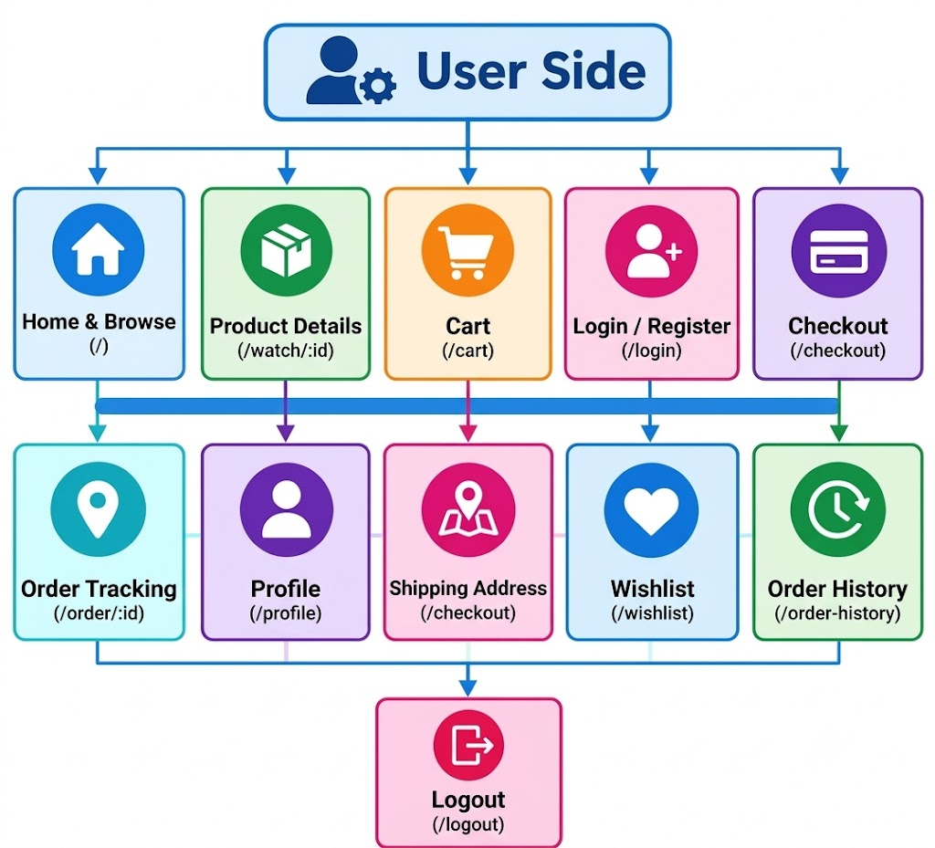

Admin Side Navigation Structure
The administrative portal is protected by role-based session middleware. Upon successful login, the administrator accesses the dashboard with direct navigation branches to Product Management, Category Management, Order Fulfillment, and User Security Controls:

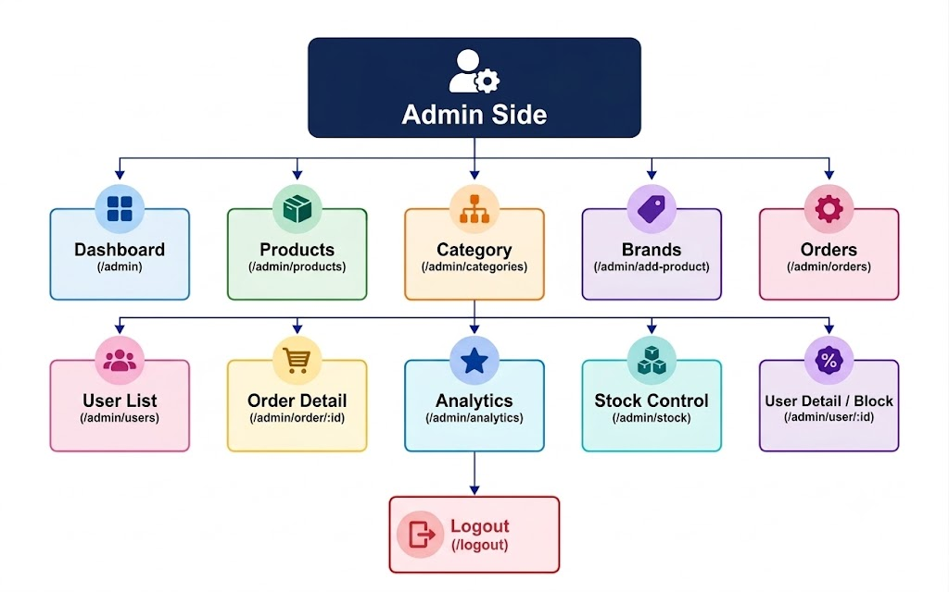

DATA DICTIONARY
The Data Dictionary provides the authoritative specification of the database architecture, schema definitions, data types, constraints, and field descriptions for all 6 collections residing in RoyalCrownDB on MongoDB Atlas.
Collection Name: users
Stores customer and administrator profile credentials, security hashes, OTP recovery states, and authorization roles.
Field Name | Data Type | Size | Null | Key | Description
_id | ObjectId | 12 B | No | PK | Unique Document Identifier
name | String | 100 | No | - | Full Name of User/Admin
email | String | 120 | No | UK | Unique Email Address (Login ID)
mobile | String | 10 | No | UK | 10-Digit Mobile Phone Number
password | String | 60 | No | - | Bcrypt Salted Hash (10 Rounds)
role | String | 10 | No | - | User Role ('admin' / 'user')
resetOTP | String | 60 | Yes | - | Hashed 6-Digit Password Reset OTP
resetOTPExpires | Date | 8 B | Yes | - | OTP Expiration Timestamp (10 min)
resetAttempts | Number | 4 B | No | - | Failed OTP Attempts Counter
resetLocked | Date | 8 B | Yes | - | Account Reset Lockout Timestamp
isBlocked | Boolean | 1 B | No | - | Account Block Status (Admin Flag)
createdAt | Date | 8 B | No | - | Document Creation Timestamp
updatedAt | Date | 8 B | No | - | Document Last Update Timestamp

Collection Name: products
Maintains luxury watch catalog inventory, pricing, brand affiliations, descriptions, and uploaded image references.
Field Name | Data Type | Size | Null | Key | Description
_id | ObjectId | 12 B | No | PK | Unique Product Identifier
name | String | 150 | No | - | Model Name of Timepiece
brand | String | 60 | No | - | Brand Name (Rolex, Omega, etc.)
category | String | 60 | No | - | Category Name Association
price | Number | 8 B | No | - | Unit Retail Price in INR (₹)
discount | Number | 4 B | No | - | Discount Percentage (0-100%)
stock | Number | 4 B | No | - | Available Physical Inventory Count
image | String | 200 | No | - | Multer Filename in Public/images
description | String | 1000 | Yes | - | Watch Specifications & Features
isFeatured | Boolean | 1 B | No | - | Homepage Feature Banner Flag
createdAt | Date | 8 B | No | - | Catalog Addition Timestamp
updatedAt | Date | 8 B | No | - | Last Catalog Modification Time

Collection Name: categories
Maintains watch classification categories utilized for navigation and catalog filtering.
Field Name | Data Type | Size | Null | Key | Description
_id | ObjectId | 12 B | No | PK | Unique Category Identifier
name | String | 60 | No | UK | Unique Category Classification Name
createdAt | Date | 8 B | No | - | Category Creation Timestamp
updatedAt | Date | 8 B | No | - | Category Modification Timestamp
Collection Name: carts
Manages active user shopping cart items linking customer profiles with products and selected quantities.
Field Name | Data Type | Size | Null | Key | Description
_id | ObjectId | 12 B | No | PK | Unique Cart Item Identifier
userId | ObjectId | 12 B | No | FK | Reference to users._id
productId | ObjectId | 12 B | No | FK | Reference to products._id
quantity | Number | 4 B | No | - | Units Selected (Minimum 1)
createdAt | Date | 8 B | No | - | Item Addition Timestamp
Collection Name: wishlists
Maintains persistent watch bookmarks favorited by authenticated customers.
Field Name | Data Type | Size | Null | Key | Description
_id | ObjectId | 12 B | No | PK | Unique Wishlist Identifier
userId | ObjectId | 12 B | No | FK | Reference to users._id
products | Array[ObjId] | Var | No | FK | Array of Product References
createdAt | Date | 8 B | No | - | Wishlist Creation Timestamp
Collection Name: orders
Stores confirmed orders, embedded line-items, tax calculations, payment methods, and shipping details.
Field Name | Data Type | Size | Null | Key | Description
_id | ObjectId | 12 B | No | PK | Unique Order Identifier
userId | ObjectId | 12 B | No | FK | Reference to users._id
items | Array[Object] | Var | No | - | Embedded Ordered Items (Name, Price, Qty)
subtotal | Number | 8 B | No | - | Gross Sum of Ordered Items (₹)
discount | Number | 8 B | No | - | Total Promotional Discount (₹)
tax | Number | 8 B | No | - | Applicable GST Tax (18%) (₹)
totalAmount | Number | 8 B | No | - | Net Payable Order Amount (₹)
orderStatus | String | 20 | No | - | Status: Pending, Confirmed, Shipped, etc.
paymentMethod | String | 25 | No | - | 'Razorpay' or 'Cash on Delivery'
shippingAddress | Object | Var | No | - | Embedded Shipping Address Details
paymentId | String | 50 | Yes | - | Razorpay Transaction Reference ID
orderDate | Date | 8 B | No | - | Order Placement Date & Time
estimatedDelivery | Date | 8 B | No | - | Estimated Delivery Date (+5 Days)
createdAt | Date | 8 B | No | - | Record Creation Timestamp
updatedAt | Date | 8 B | No | - | Record Last Modification Timestamp

DATA FLOW DIAGRAM

The Data Flow Diagram (DFD) provides a clear graphical representation of how information moves through the system, identifying external entities, data processes, and data stores.
Data Flow Diagram Symbols & Notation
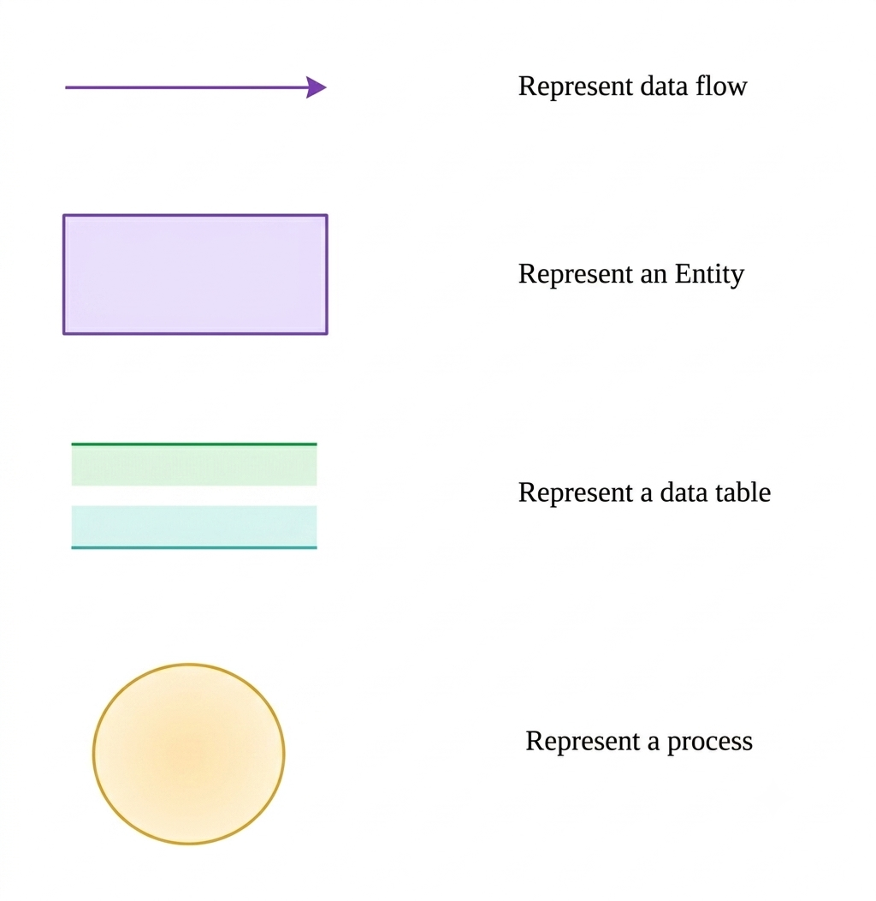
Standard Gane & Sarson / DeMarco notation symbols utilized across the Royal Crown DFD diagrams:

Leval 0 Data Flow Diagram (Context leval)
A context level diagram (also called a Level 0 Data Flow Diagram) is a simple visual picture that shows an entire system as a single central process (0.0) and how it connects to the outside world:

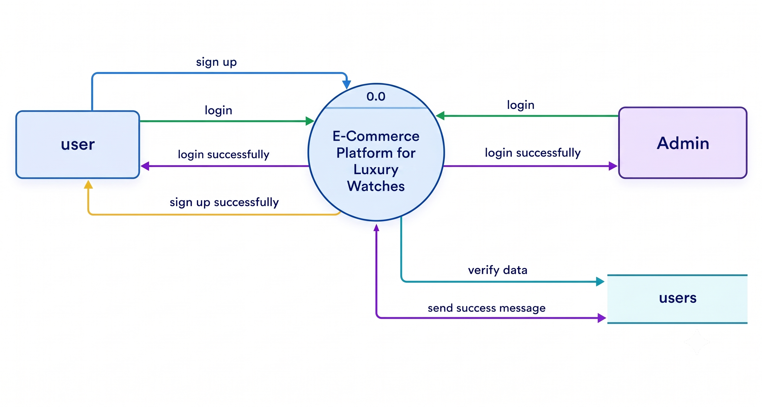

Leval 1 Data flow Diagram (User side)
A Data Flow Diagram illustrating the user-side processes and how the user interface interacts with the categories, products, carts, wishlists, orders, and payment data stores:

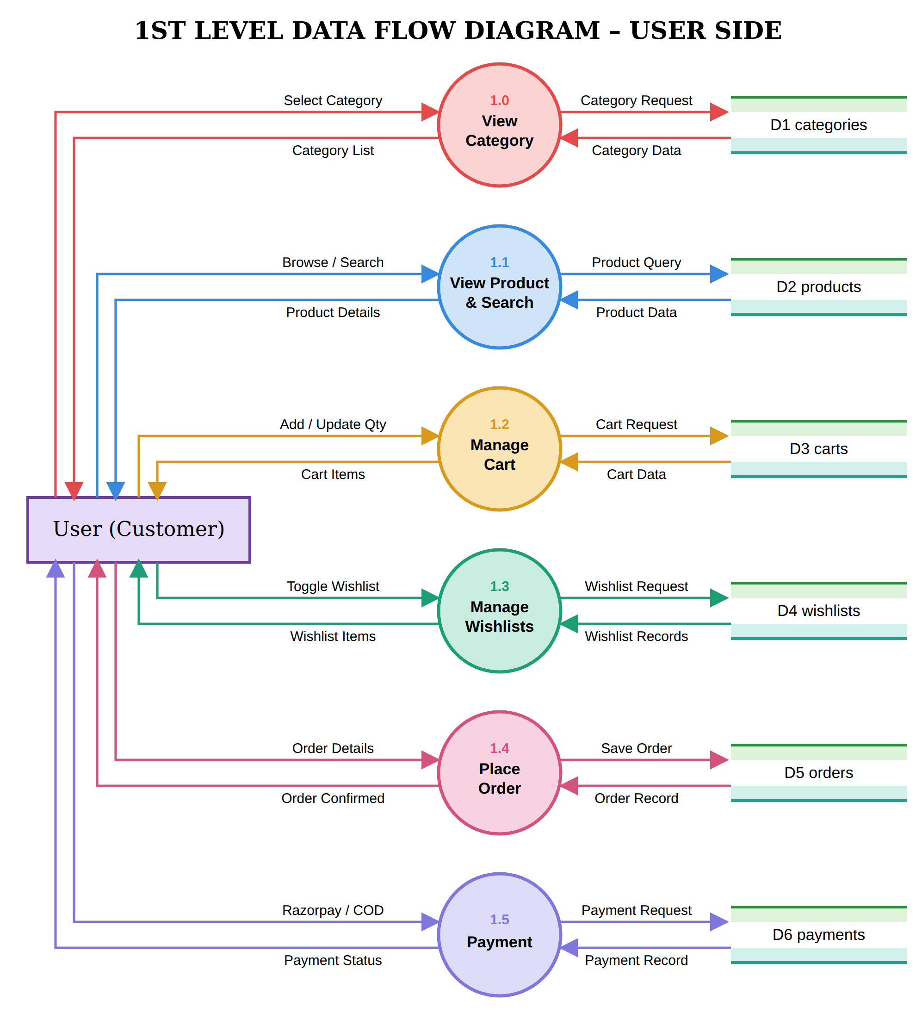
Leval 1 Data flow Diagram (Admin side)
A Data Flow Diagram illustrating the admin-side processes and how the admin panel interacts with the database to manage categories, products, orders, users, and analytical reports:

ER DIAGRAM

An Entity-Relationship (ER) diagram is a visual blueprint that illustrates how database entities, their attributes, and their relationships are structured within the application.
The ER diagram for Royal Crown strictly adheres to classic Chen’s Notation as documented in the student progress book:
• Entity Sets – Represented by Rectangles (USER, ORDERS, PAYMENTS, CART, WISHLIST, PRODUCTS, CATEGORY).
• Attributes – Represented by Ovals connected to entities with straight lines. Primary keys are underlined (e.g., _id).
• Relationships – Represented by Diamonds (Places, Has, Contains, Belongs To) indicating semantic associations.
• Cardinalities – Labeled on connector lines: 1:M (User to Orders), 1:1 (Orders to Payments), 1:M (User to Cart), M:1 (Cart to Products), 1:M (User to Wishlist), M:1 (Wishlist to Products), and M:1 (Products to Category).

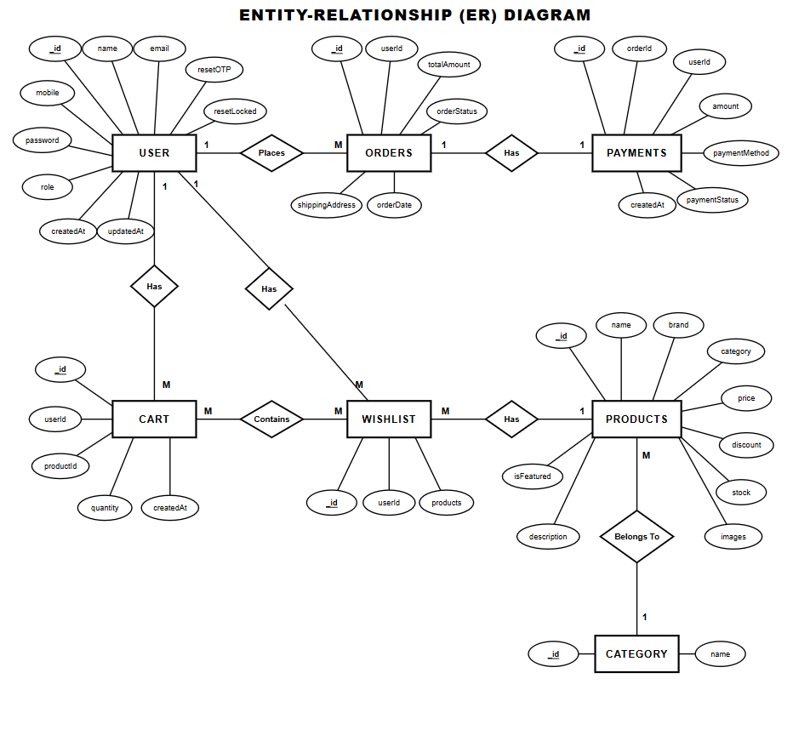
\
USE CASE DIAGRAM
Symbols | Represents
 | Actor
 | usecase
SS | System boundary
A use case diagram is a visual blueprint in Unified Modeling Language (UML) that shows how different actors interact with the system boundary to achieve specific goals.

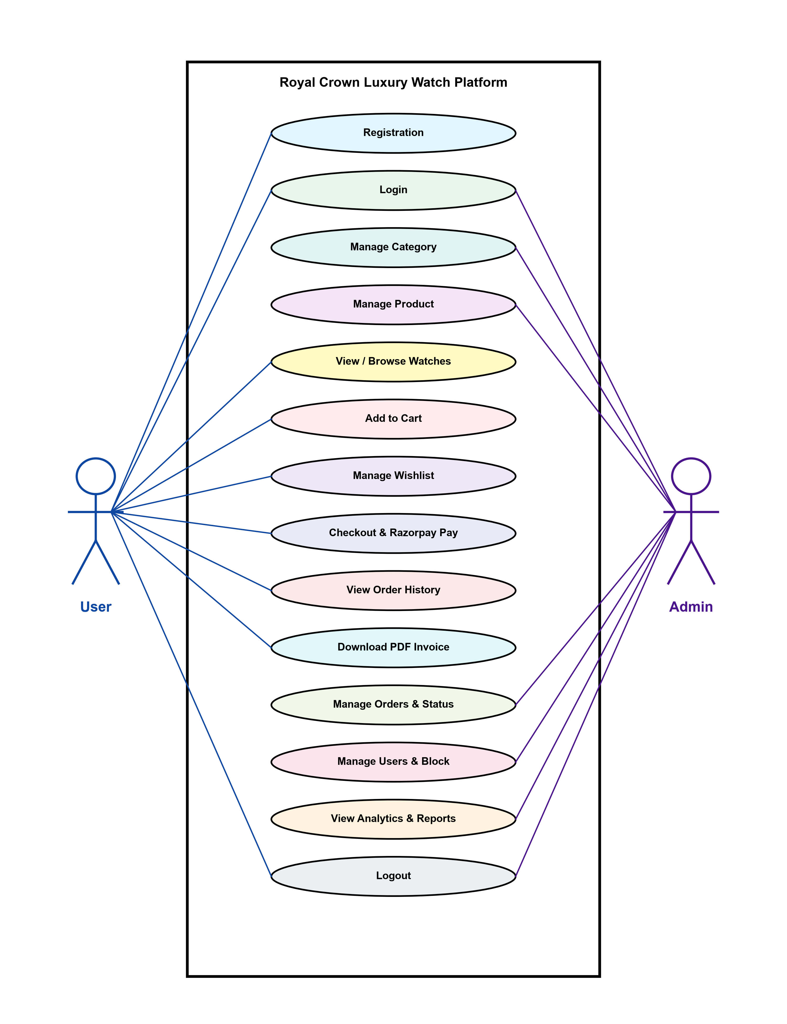
ACTIVITY DIAGRAM
An activity diagram is a behavioral diagram in UML that visually represents the flow of control, decisions, and sequential or parallel actions within the application.
Activity Diagram Symbols & Notation
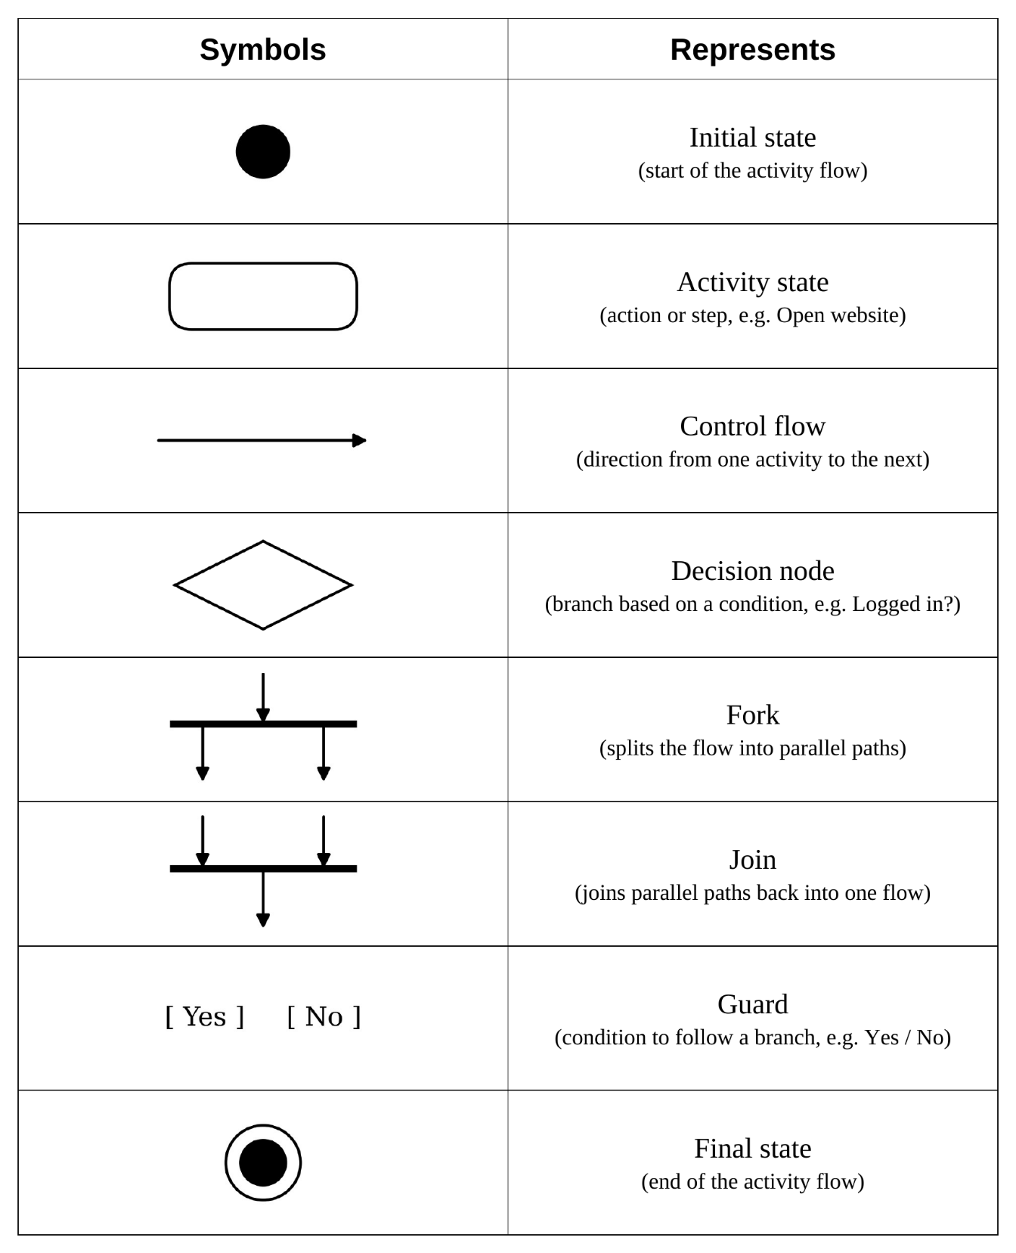

Activity Diagram – User Side
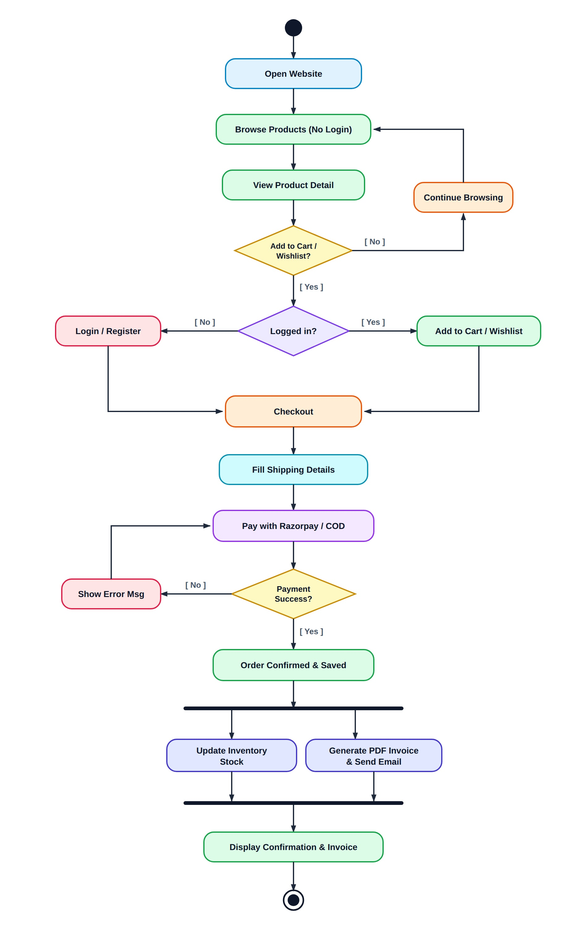
The customer activity diagram models the browsing, cart addition, authentication check, checkout, Razorpay / COD payment, and order confirmation workflow:
Activity Diagram – Admin Side
The administrative activity diagram models admin authentication, dashboard access, parallel management branches (Products, Categories, Orders, Users), and the status-triggered email notification lifecycle: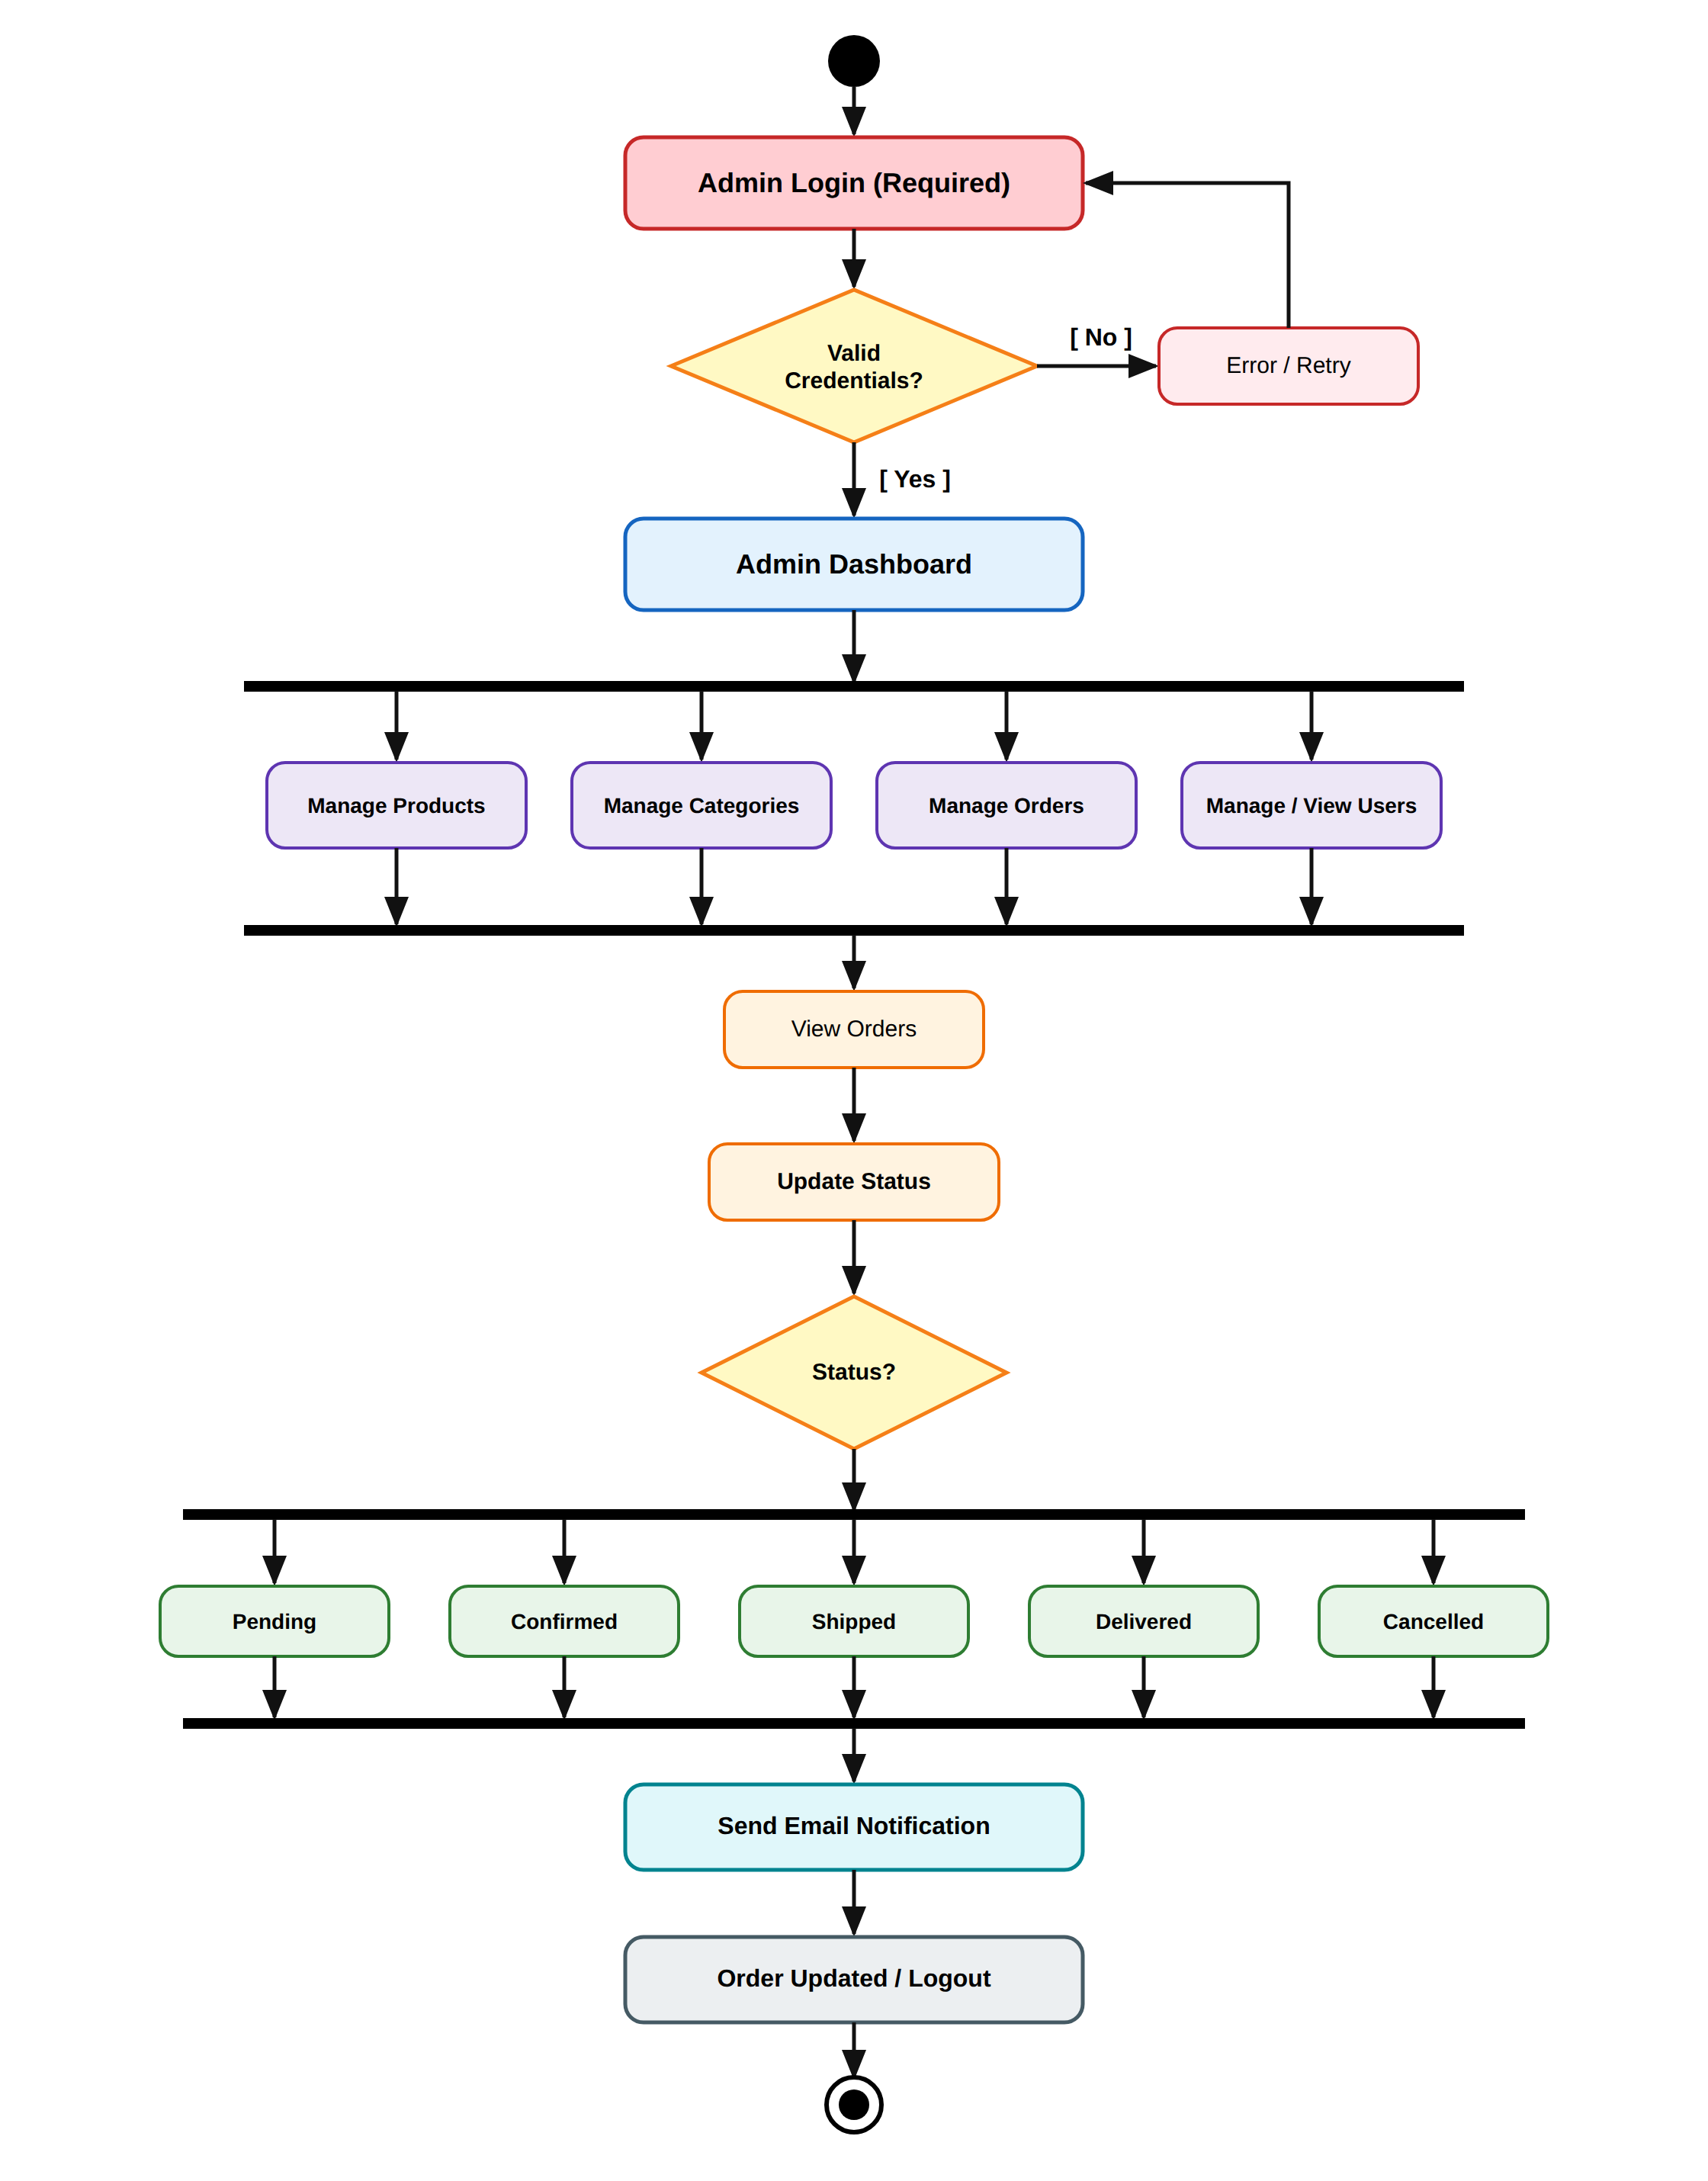

TESTING
Software testing was conducted to verify that all functional modules operate correctly, meet technical specifications, and handle erroneous inputs gracefully. A combination of Black-Box testing, Unit testing, and Integration testing was performed.
TC ID | Module | Test Description | Input / Action | Expected Result | Status
TC-01 | Registration | Register with valid details | Name, Valid Email, 10-digit mobile, matching pass | Account created, redirected to login | PASS
TC-02 | Registration | Register with invalid mobile | Mobile containing letters or <10 digits | Error: 'Enter valid 10-digit mobile' | PASS
TC-03 | Authentication | Login with valid credentials | Registered email & correct password | Session created, redirected to Home/Admin | PASS
TC-04 | Authentication | Login with incorrect password | Registered email & wrong password | Error: 'Incorrect Password' | PASS
TC-05 | Password Reset | Request OTP with registered email | Valid registered email address | 6-digit OTP emailed via Nodemailer | PASS
TC-06 | Password Reset | Verify invalid OTP (brute force test) | Enter wrong OTP 3 times consecutively | Account locked from reset for 15 minutes | PASS
TC-07 | Catalog | Search products with regex query | Search text 'Moonwatch' | Filters products matching 'Moonwatch' | PASS
TC-08 | Catalog | Filter watches by category | Select 'Chronograph Watches' | Displays only chronograph watches | PASS
TC-09 | Shopping Cart | Add product to cart (Logged in) | Click 'Add to Cart' on watch card | Item added to Cart collection, badge updated | PASS
TC-10 | Shopping Cart | Add product to cart (Guest user) | Click 'Add to Cart' without logging in | Redirects / prompts to login | PASS
TC-11 | Shopping Cart | Update product quantity in cart | Increment quantity to 3 | Subtotal and total recomputed correctly | PASS
TC-12 | Wishlist | Toggle product bookmark | Click heart icon on watch detail | Added/removed from user wishlist array | PASS
TC-13 | Checkout | Place order via Cash on Delivery | Complete shipping form, select COD | Order created as 'Pending', stock decremented | PASS
TC-14 | Payment | Razorpay online payment verification | Valid Razorpay test payment response | HMAC-SHA256 signature verified, confirmed | PASS
TC-15 | Invoicing | Download dynamic PDF invoice | Click 'Download Invoice' on order | PDFKit streams valid PDF with 18% GST | PASS
TC-16 | Admin Portal | Add product with image upload | Valid watch details + JPG image | Multer saves file, record stored in DB | PASS
TC-17 | Admin Portal | Update order status & send email | Change status from Pending to Shipped | Status updated, Nodemailer sends email | PASS
TC-18 | Admin Portal | Toggle block customer account | Admin blocks user ID | User prevented from logging in | PASS

SCREEN SHOTS
This section contains official application interface screenshots covering both customer storefront workflows and administrative governance portals.
USER SIDE
• Home Page for User
[ Insert Screenshot: Home Page for User Here ]
• Product Catalog Page & Brand Filtering
[ Insert Screenshot: Product Catalog Page & Brand Filtering Here ]
• Product Details Page with Specifications
[ Insert Screenshot: Product Details Page with Specifications Here ]
• Shopping Cart Page
[ Insert Screenshot: Shopping Cart Page Here ]
• User Registration (Sign Up) Page
[ Insert Screenshot: User Registration (Sign Up) Page Here ]
• User Login (Sign In) Page
[ Insert Screenshot: User Login (Sign In) Page Here ]
• Checkout & Shipping Address Page
[ Insert Screenshot: Checkout & Shipping Address Page Here ]
• Razorpay Payment Gateway Interface
[ Insert Screenshot: Razorpay Payment Gateway Interface Here ]
• Order Confirmation & Invoicing
[ Insert Screenshot: Order Confirmation & Invoicing Here ]
• Order History Page
[ Insert Screenshot: Order History Page Here ]

ADMIN SIDE
• Admin Login Page
[ Insert Screenshot: Admin Login Page Here ]
• Admin Dashboard & Revenue Analytics
[ Insert Screenshot: Admin Dashboard & Revenue Analytics Here ]
• Manage Products Catalog List
[ Insert Screenshot: Manage Products Catalog List Here ]
• Add / Edit Product Page with Image Upload
[ Insert Screenshot: Add / Edit Product Page with Image Upload Here ]
• Manage Categories Page
[ Insert Screenshot: Manage Categories Page Here ]
• Orders Management & Status Update Page
[ Insert Screenshot: Orders Management & Status Update Page Here ]
• User Management & Account Blocking Page
[ Insert Screenshot: User Management & Account Blocking Page Here ]

CODING
This section contains representative source code listings illustrating core frontend views and backend MVC controller architectures.
Frontend Side
Core user-facing templates and client-side interactions:
• EJS Home & Catalog View (home.ejs&products.ejs)
[ Insert Code Snippet / Screenshot: EJS Home & Catalog View (home.ejs&products.ejs) Here ]
• Client-Side Cart & Dynamic Counter (cart.ejs)
[ Insert Code Snippet / Screenshot: Client-Side Cart & Dynamic Counter (cart.ejs) Here ]
• Razorpay Checkout Client Script (checkout.ejs)
[ Insert Code Snippet / Screenshot: Razorpay Checkout Client Script (checkout.ejs) Here ]
Backend Side
Core server-side controllers, models, and middleware logic:
• Mongoose Product & User Schema Definitions
[ Insert Code Snippet / Screenshot: Mongoose Product & User Schema Definitions Here ]
• Express Authentication & OTP Verification Controller
[ Insert Code Snippet / Screenshot: Express Authentication & OTP Verification Controller Here ]
• Razorpay Payment HMAC Verification & Order Processing
[ Insert Code Snippet / Screenshot: Razorpay Payment HMAC Verification & Order Processing Here ]
• PDFKit Dynamic GST Invoice Streaming Generator
[ Insert Code Snippet / Screenshot: PDFKit Dynamic GST Invoice Streaming Generator Here ]

FUTURE SCOPE

The Royal Crown Luxury Watch platform can be enhanced in the future with the following advanced features:
• AI Watch Recommendations – Suggest timepieces based on user browsing history, case diameter preferences, and budget.
• Dedicated Mobile Application – Develop cross-platform Flutter/React Native mobile applications for iOS and Android.
• Augmented Reality (AR) Virtual Try-On – Allow customers to virtually try on luxury watches on their wrist using device cameras.
• Multi-Currency & International Shipping – Support global currencies (USD, EUR, GBP) and worldwide DHL/FedEx logistics integration.
• AI Chatbot Support – Provide 24/7 intelligent automated customer assistance for order inquiries and product guidance.
• Multi-Vendor Watch Boutiques – Enable verified authorized watch dealers to list and sell authenticated timepieces.
• Blockchain Certificate of Authenticity – Provide cryptographic NFT-based ownership passports ensuring watch authenticity.
These future enhancements will make Royal Crown an even more scalable, intelligent, and secure platform for the global luxury horology retail market.

BIBLIOGRAPHY

The following documentation, books, and online technical resources were referred to during the research, design, and development of this project:
• Node.js Documentation – Official reference documentation for Node.js runtime, asynchronous event loops, and core modules.
• Express.js Guide – Used for designing RESTful routes, application middleware, and session management.
• MongoDB & Mongoose Documentation – Used for schema modeling, document validations, and cloud cluster deployment on MongoDB Atlas.
• Razorpay Developer Documentation – Used for understanding payment orders, client-side checkout integration, and server-side HMAC-SHA256 signature verification.
• EJS & Bootstrap Documentation – Used for dynamic template rendering, responsive layout design, and mobile-first viewports.
• Nodemailer Documentation – Used for configuring transactional SMTP email dispatch with OTP password verification.
• PDFKit Documentation – Used for creating dynamic vector graphics and streaming PDF tax invoices directly to client browsers.
• Stack Overflow & GitHub – Used for reviewing open-source e-commerce design patterns, debugging issues, and security best practices.

LINK OF REFERENCE WEBSITE

The following benchmark websites and official brand portals were studied for luxury watch presentation, catalog organization, and user experience design:
• Rolex Official Portal :https://www.rolex.com/
• Omega Watches Official :https://www.omegawatches.com/
• Ethos Watch Boutiques :https://www.ethoswatches.com/
• Chrono24 Luxury Marketplace :https://www.chrono24.com/
• Rado Switzerland :https://www.rado.com/
• Tissot Swiss Watches :https://www.tissotwatches.com/
• Razorpay Developer Portal :https://razorpay.com/docs/
• MongoDB Atlas Portal :https://www.mongodb.com/atlas

CD – DVD

The accompanying optical disk (CD / DVD) submitted along with this project report contains the following academic and technical artifacts:
• Source Code – Complete Node.js, Express.js, EJS, and JavaScript codebase of the Royal Crown platform.
• Database Dump – MongoDB Atlas collection schemas and sample dataset files for instant deployment.
• Documentation Files – Full Project Documentation in editable Microsoft Word (.docx) format and finalized PDF (.pdf) format.
• Diagram Assets – High-resolution standalone PNG vector exports of all DFD, ER (Chen notation), Use Case, Activity, and Page Structure diagrams.
• Software & Tools Setup – Installation links and configuration guides for Node.js LTS, VS Code, Git, and environment variable setup (.env.example).

Thank You for Your Valuable Time and Attention
ROYAL CROWN – Luxury Watch E-Commerce Platform
I sincerely thank my esteemed project guide Prof. Nilesh Parghi, respected faculty members,
and everyone who supported me throughout the successful completion of this project.
THANK YOU

