1. 从控制台接收用户输入的一行英文句子，把句子的最前面两个单词移到句子的最后面去，并整理句子的大小写及标点符号，将新的句子输出。

input: The dog ran through the gate and down the street.

output: Ran through the gate and down the street, the dog?

input: My coat was too heavy for this warm day!

output: Was too heavy for this warm day, my coat?

1. 从按制台接收用户的输入的出生日期，输出从用户出生的那一年到今年为止，每年的生日当月的日历，生日当天标＊号，并统计这么多年用户生日当天为一周中每一天的百分比（即生日为周一的在这么多年中占的百分比，生日为周二的在这么多年中占的百分比。。。。。）

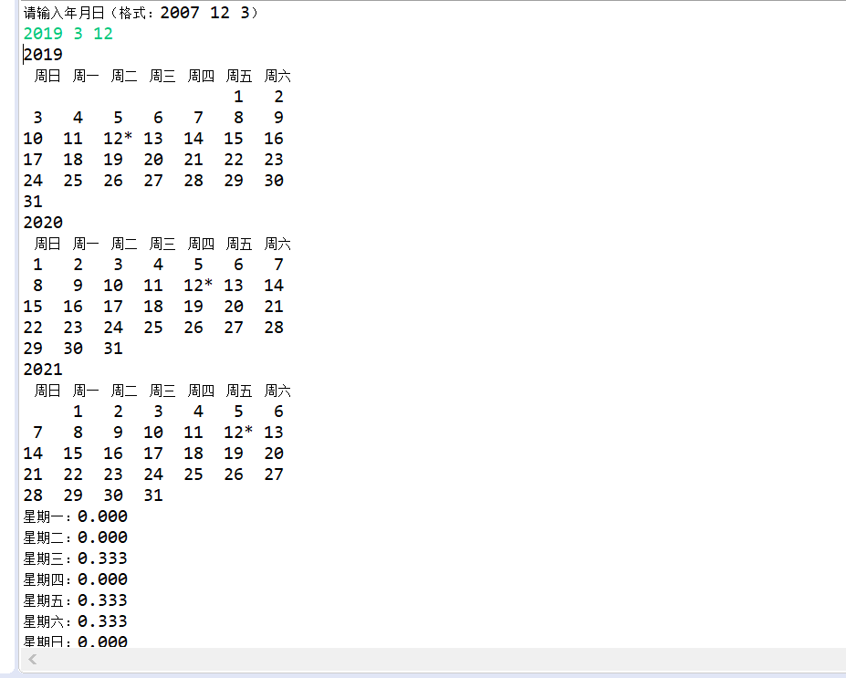­­

3.某镇上有两个图书馆，请按照下面要求及提示帮助这两个图书馆实现图书电子借阅。

(1)按照book.java代码中的提示完成该类。该类主要提供借书、还书、查询书的借阅状态、获取书名等功能。当运行该代码的时候，输出为：

Title (should be The Da Vinci Code): The Da Vinci Code

Rented? (should be false): false

Rented? (should be true): true

Rented? (should be false): false

(2)完成Library.java，该类中的main()方法已经给出。但类成员和类方法需要完善。完成该类的时候请注意以下要求：

Ａ.该类中有类成员方法，也有实例成员方法；

B. 不能改变main()方法的内容。

Ｃ.main( )方法的输出为：

Library hours:

Libraries are open daily from 9am to 5pm.

Library addresses:

10 Main St.

228 Liberty St.

Borrowing The Lord of the Rings:

You successfully borrowed The Lord of the Rings

Sorry, this book is already borrowed.

Sorry, this book is not in our catalog.

Books available in the first library:

The Da Vinci Code

Le Petit Prince

A Tale of Two Cities

Books available in the second library:

No book in catalog

Returning The Lord of the Rings:

You successfully returned The Lord of the Rings

Books available in the first library:

The Da Vinci Code

Le Petit Prince

A Tale of Two Cities

The Lord of the Rings