Oops concept real time example
Immutable class in java
custom class to make immutable
internal implemetaion of hashmap
hashMap and concurrent Hashmap
if it is a thread safe than then hashMap and concurrent Hashmap
Arraylist and linked list => in which scenario we use arrylist and linked List
insertion and deletion
advantage of Spring Boot and Spring MVC
Annotaion
@bean , @Autowired
setter and constructor injection
design Pattern=> singlton Design Pattern, factory Design pattern
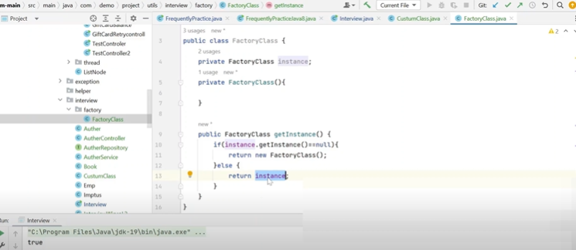

Hibernate :Lazy Loading in hybernate
java 8 features : lamda expression, Stream API,functional interface
Number of Characters Occurences in String
find no reapeating first character
SQL Query to find
EMPloyee table employee salary name, find 10th highsest salary
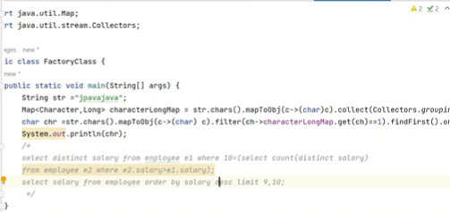
which domain hiring is going on
Square Root Of a number log n
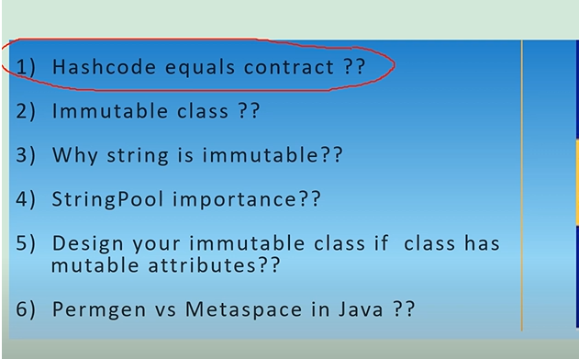
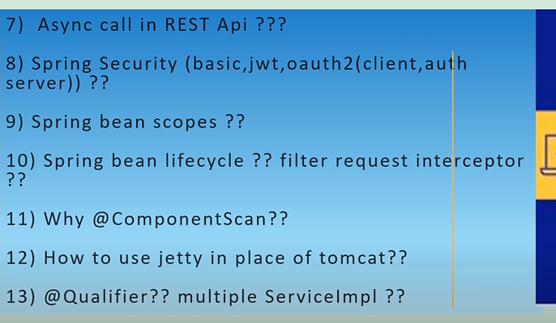
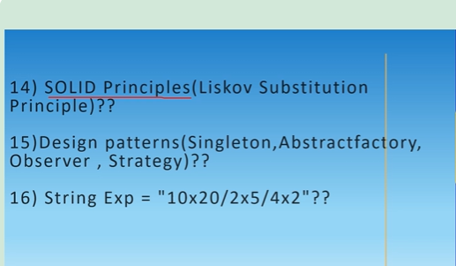
What are the immutable clssses
if you are creating own immutable classes what is necessary steps
can we create getter setter method in custom immutable calss
make immuatble class using =: Employee - name ,address, phone
Address : flatNo, Street
second largest elemnt in an array , with array , no method use
if(arr[I] > arr[j]){
second =arr[j]
first =arr[I]
}
else if
second =arr[i]
first =arr[j]
write a program to print natural number without loop

