Round 1 : Infor
What if double has 1.234556, will system accept this? = Yes
because:
- A double uses 64 bits to store the number.
- It can only accurately store about 15–17 significant digits (both before and after the decimal combined).
- If your number has more than 17 digits, the extra digits will be rounded or lost due to precision limits.

Difference Between float and Double : difference is in between Precision,Size, and Range

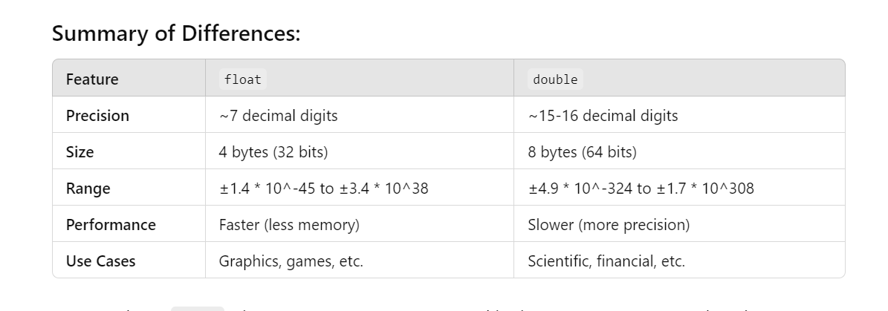
Different types of data types:
primitive DataType (byte, short,int,long,Float Double, char,Boolean)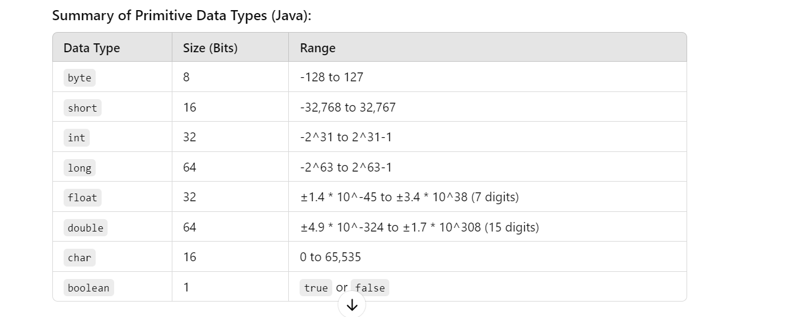
and non premitive DataType (string, Array,classes,Interfaces:,enums)
Enums : Represents a group of predefined constants.
In Java, an enum (short for "enumeration") is a special data type that enables a variable to be a set of predefined constant values.
enum Day {
SUNDAY, MONDAY, TUESDAY, WEDNESDAY, THURSDAY, FRIDAY, SATURDAY
}
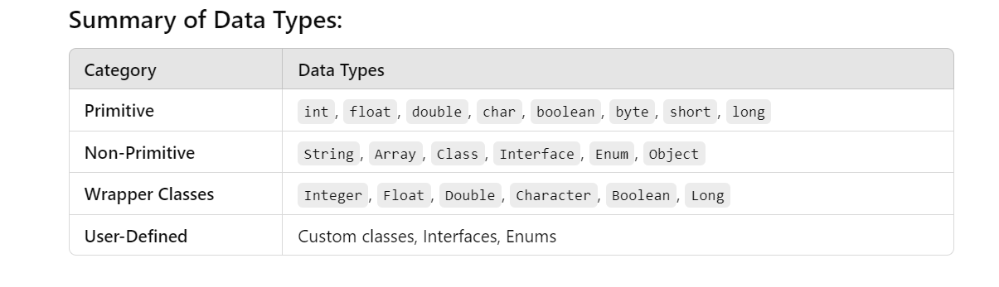
oops Concept
Object-Oriented Programming (OOP) is a programming paradigm based on the concept of "objects," which can contain both data and methods. OOP is built on four main principles:
- Encapsulation
- Inheritance
- Polymorphism
- Abstraction

1. Encapsulation Example
Encapsulation is the mechanism of bundling the data (fields) and methods (functions) that operate on the data into a single unit (class), and restricting access to some of the object's components.

2. Inheritance Example
Inheritance allows one class (child class) to inherit the fields and methods of another class (parent class). This enables code reusability and the creation of hierarchical relationships.

Polymorphism Example
Polymorphism allows methods to take many forms. It can be achieved through method overloading (same method name but different parameters) and method overriding (redefining a method in a subclass).

Abstraction Example
Abstraction is the concept of hiding the complex implementation details and showing only the essential features of an object. It can be achieved using abstract classes or interfaces.
Comparable and Comparator both are interfaces and can be used to sort collection elements.
* Comparable provides a single sorting sequence. In other words, we can sort the collection on the basis of a single element such as id, name, and price.
* Comparable provides compareTo() method to sort elements.
* We can sort the list elements of Comparable type by Collections.sort(List) method.
* The Comparator provides multiple sorting sequences. In other words, we can sort the collection on the basis of multiple elements such as id, name, and price etc.
* Comparator provides compare() method to sort elements.
*We can sort the list elements of Comparator type by Collections.sort(List, Comparator) method.
Java Comparable Example
/Java Program to demonstrate the use of Java Comparable.
//Creating a class which implements Comparable Interface
import java.util.*;
import java.io.*;
class Student implements Comparable<Student>{
int rollno;
String name;
int age;
Student(int rollno,String name,int age){
this.rollno=rollno;
this.name=name;
this.age=age;
}
public int compareTo(Student st){
if(age==st.age)
return 0;
else if(age>st.age)
return 1;
else
return -1;
}
}
//Creating a test class to sort the elements
public class TestSort3{
public static void main(String args[]){
ArrayList<Student> al=new ArrayList<Student>();
al.add(new Student(101,"Vijay",23));
al.add(new Student(106,"Ajay",27));
al.add(new Student(105,"Jai",21));

Collections.sort(al);
for(Student st:al){
System.out.println(st.rollno+" "+st.name+" "+st.age);
}
}
}
OutPut : 105 Jai 21
101 Vijay 23
106 Ajay 27

Java Comparator Example
Let's see an example of the Java Comparator interface where we are sorting the elements of a list using different comparators.
Student.java

class Student{
int rollno;
String name;
int age;
Student(int rollno,String name,int age){
this.rollno=rollno;
this.name=name;
this.age=age;
}
}
AgeComparator.java

import java.util.*;
class AgeComparator implements Comparator<Student>{
public int compare(Student s1,Student s2){
if(s1.age==s2.age)
return 0;
else if(s1.age>s2.age)
return 1;
else
return -1;
}
}

NameComparator.java
This class provides comparison logic based on the name. In such case, we are using the compareTo() method of String class, which internally provides the comparison logic.
import java.util.*;
class NameComparator implements Comparator<Student>{
public int compare(Student s1,Student s2){
return s1.name.compareTo(s2.name);
}
}
//Java Program to demonstrate the use of Java Comparator
import java.util.*;
import java.io.*;
class TestComparator{
public static void main(String args[]){
//Creating a list of students
ArrayList<Student> al=new ArrayList<Student>();
al.add(new Student(101,"Vijay",23));
al.add(new Student(106,"Ajay",27));
al.add(new Student(105,"Jai",21));

System.out.println("Sorting by Name");
//Using NameComparator to sort the elements
Collections.sort(al,new NameComparator());
//Traversing the elements of list
for(Student st: al){
System.out.println(st.rollno+" "+st.name+" "+st.age);
}

System.out.println("sorting by Age");
//Using AgeComparator to sort the elements
Collections.sort(al,new AgeComparator());
//Travering the list again
for(Student st: al){
System.out.println(st.rollno+" "+st.name+" "+st.age);
}

}
}
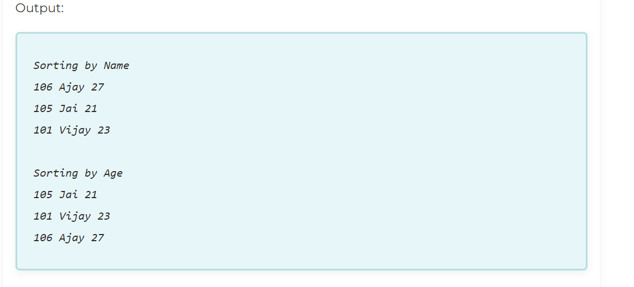
what Is a Thread and different ways to Implemetn a Thread?
A thread is a lightweight sub-process, the smallest unit of processing. . It is a separate path of execution.
Threads are independent. If there occurs exception in one thread, it doesn't affect other threads. It uses a shared memory area.

At one time only one threads will be executed .
1) New
The thread is in new state if you create an instance of Thread class but before the
invocation of start() method.
2) Runnable
The thread is in runnable state after invocation of start() method, but the thread scheduler
has not selected it to be the running thread.
3) Running
The thread is in running state if the thread scheduler has selected it.
4) Non-Runnable (Blocked)
This is the state when the thread is still alive, but is currently not eligible to run.
5) Terminated
A thread is in terminated or dead state when its run() method exits.
How to create thread
There are two ways to create a thread:
1.By extending Thread class
class MyThread extends Thread {
@Override
public void run() {
// Task that the thread will perform
for (int i = 1; i <= 5; i++) {
System.out.println(i + " - Running in thread: " + Thread.currentThread().getName());
}
}
}

public class Main {
public static void main(String[] args) {
MyThread thread1 = new MyThread(); // Creating thread
thread1.start(); // Starting thread (calls run method internally)

// Main thread task
System.out.println("Main thread is running.");
}
}

By implementing Runnable interface.
class MyRunnable implements Runnable {

@Override

public void run() {

// Task that the thread will perform

for (int i = 1; i <= 5; i++) {

System.out.println(i + " - Running in thread: " + Thread.currentThread().getName());

}

}

}

public class Main {

public static void main(String[] args) {

MyRunnable runnable = new MyRunnable();

Thread thread1 = new Thread(runnable); // Passing Runnable to Thread constructor

thread1.start(); // Starting thread (calls run method internally)

// Main thread task

System.out.println("Main thread is running.");

}

}

Using Java 8 :
public class Main {
public static void main(String[] args) {
// Lambda expression to define a Runnable
Runnable task = () -> {
for (int i = 1; i <= 5; i++) {
System.out.println(i + " - Running in thread: " + Thread.currentThread().getName());
}
};

Thread thread1 = new Thread(task);
thread1.start(); // Starting thread

// Main thread task
System.out.println("Main thread is running.");
}
}

Why Use synchronized?
synchronized keyword is used to control access to critical sections of code by multiple threads. It ensures that only one thread can access a synchronized block or method at a time,
When multiple threads try to access a shared resource (e.g., a variable or object), it can lead to issues like inconsistent data or unpredictable behavior. Synchronizing a block of code ensures that only one thread can execute it at a time, preserving data consistency.
Synchronized Methods

public synchronized void syncMethod() {
// Critical section of code
}
class Counter {
private int count = 0;

public synchronized void increment() {
count++;
}

public int getCount() {
return count;
}
}
<marquee>
The <marquee> tag in HTML is used to create scrolling text or images across the webpage.

This tag is no longer supported in HTML5 and should be avoided, as it is not part of the official web standards.
Instead of using the <marquee> tag, modern web development techniques like CSS animations and JavaScript can be used to create the sa
What is a DOM Object?
A DOM object is a representation of a part of the document, like an HTML element or attribute, that you can manipulate using JavaScript. The DOM provides a way for scripts to dynamically access and update the content, structure, and style of a document while it's being displayed in the browser.me effect with better control and browser compatibility.
let myDiv = document.getElementById('myDiv');
myDiv.innerHTML = "Hello World!";
why javaScript allows varr a = "string" and var a=10
1. var is function-scoped, not block-scoped
In JavaScript, variables declared with var are scoped to the function, not the block {} they are in. This means they can be re-declared within the same scope.
What About let and const?
let a = "string";
let a = 10; // ❌ SyntaxError: Identifier 'a' has already been declared
• let and const do not allow redeclaration in the same scope.
• They are block-scoped (safer and recommended over var in modern JS).
function demo() {
var a = "string";
var a = 10;
console.log(a); // ✅ Output: 10
}
demo();
• JavaScript allows var to be redeclared in the same scope.
• So var a = 10; overwrites the earlier value "string".

What is string constant pool:
string constant pool is the part of java heap where we store the string when we create it using string literal. If two string are of the same content in string pool exist then it returns true;
It's part of the Java heap and is designed to optimize memory usage and improve performance.
String s1 = "Java";
String s2 = "Java";

System.out.println(s1 == s2); // true — same reference from the pool

String s3 = new String("Java");

System.out.println(s1 == s3); // false — s3 is a new object in the heap
HASHCODE :
hashCode() : This is the method of the object class. It returns the memory reference of the object in integer form. The value received from the method is used as the bucket number. The bucket number is the address of the element inside the map. Hash code of null Key is 0.
Buckets : Array of the node is called buckets. Each node has a data structure like a LinkedList. More than one node can share the same bucket. It may be different in capacity

PesudoCode : Pseudocode
- What is it?
Pseudocode is a simplified, human-readable version of programming logic written in plain English.
- Why is it used?
  - To plan algorithms or logic before actual coding.
  - Makes it easy to understand and discuss the logic without worrying about syntax.
- Example:
✅ Pseudocode for finding the sum of 1 to N:
python
CopyEdit
START
Set sum = 0
For i = 1 to N
sum = sum + i
End For
PRINT sum
END

Spring Boot vs. Spring
Spring: is a java based application development framework .Spring Framework is the most popular application development framework of Java. The main feature of the Spring Framework is dependency Injection or Inversion of Control (IoC). With the help of Spring Framework, we can develop a loosely coupled application. It is better to use if application type or characteristics are purely defined.
Spring Framework is a widely used Java EE framework for building applications.
Spring Boot: Spring Boot is a module of Spring Framework. It allows us to build a stand-alone application with minimal or zero configurations. It is better to use if we want to develop a simple Spring-based application or RESTful services.

Spring Boot Framework is widely used to develop REST APIs.
Spring Boot vs. Spring MVC
Spring Boot: Spring Boot makes it easy to quickly bootstrap and start developing a Spring-based application. It avoids a lot of boilerplate code. It hides a lot of complexity behind the scene so that the developer can quickly get started and develop Spring-based applications easily.
Spring MVC: Spring MVC is a Web MVC Framework for building web applications. It contains a lot of configuration files for various capabilities. It is an HTTP oriented web application development framework.
Difference between get and post method :
@GetMapping: It maps the HTTP GET requests on the specific handler method. It is used to create a web service endpoint that fetches It is used instead of using: @RequestMapping(method = RequestMethod.GET)
@GetMapping is an annotation in Spring MVC used to map HTTP GET requests to handler methods in your controller classes.

import org.springframework.web.bind.annotation.GetMapping;
import org.springframework.web.bind.annotation.RestController;

@RestController
public class MyController {

@GetMapping("/hello")
public String hello() {
return "Hello, world!";
}
}

in place of //@RequestMapping(method=RequestMethod.GET,path="/home") we can use only @GetMapping("/home")

When a client sends a GET request to /hello, Spring MVC routes the request to the hello() method, and the method returns a response with the string "Hello, world!".
You can also use @GetMapping with path variables:
@GetMapping("/users/{id}")
public User getUserById(@PathVariable Long id) {
// Retrieve user from database based on id
}

@PostMapping: It maps the HTTP POST requests on the specific handler method. It is used to create a web service endpoint that creates It is used instead of using: @RequestMapping(method = RequestMethod.POST)

@PutMapping: It maps the HTTP PUT requests on the specific handler method. It is used to create a web service endpoint that creates or updates It is used instead of using: @RequestMapping(method = RequestMethod.PUT)
@DeleteMapping: It maps the HTTP DELETE requests on the specific handler method. It is used to create a web service endpoint that deletes a resource. It is used instead of using: @RequestMapping(method = RequestMethod.DELETE)

HTTP request methods : Get,POST,DELETE,PATCH,PUT

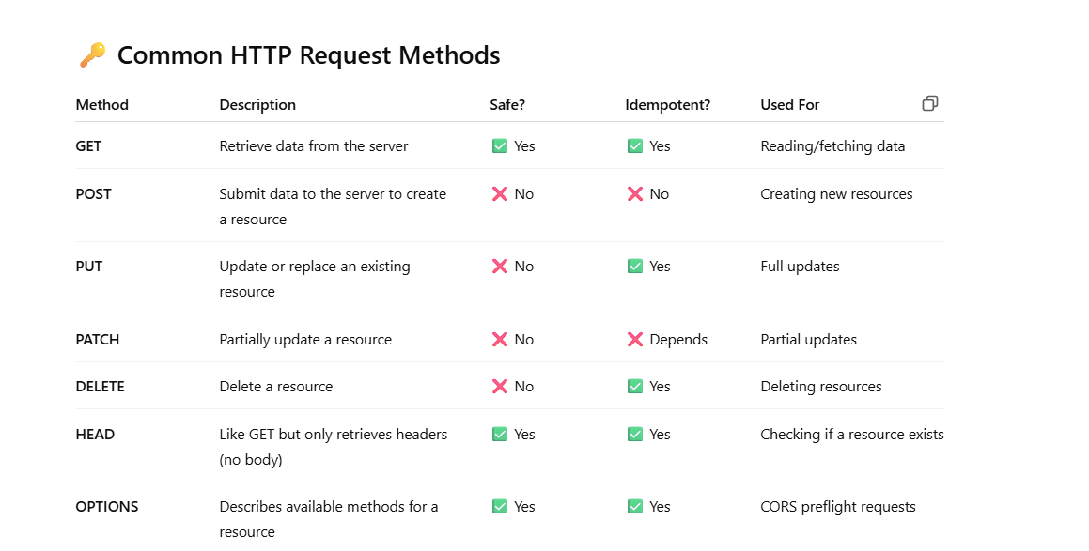
Tree set, set,List
LinkedHashset
Tree-Set
Java TreeSet class contains unique elements only like HashSet.
Java TreeSet class access and retrieval times are quiet fast.
Java TreeSet class doesn't allow null element.
Java TreeSet class is non synchronized.
Java TreeSet class maintains ascending order.

Set | list
Set Interface in Java is present in java.util package.  It extends the Collection interface.  It represents the unordered set of elements which doesn't allow us to store the duplicate items.  We can store at most one null value in Set.  Set is implemented by HashSet, LinkedHashSet, and TreeSet. | List extends collection interface  it stored the ordered collection of elemetns  it is implemented by arraylist,linked list  We can not store the null value here
Map - go through map
DDL DML commands
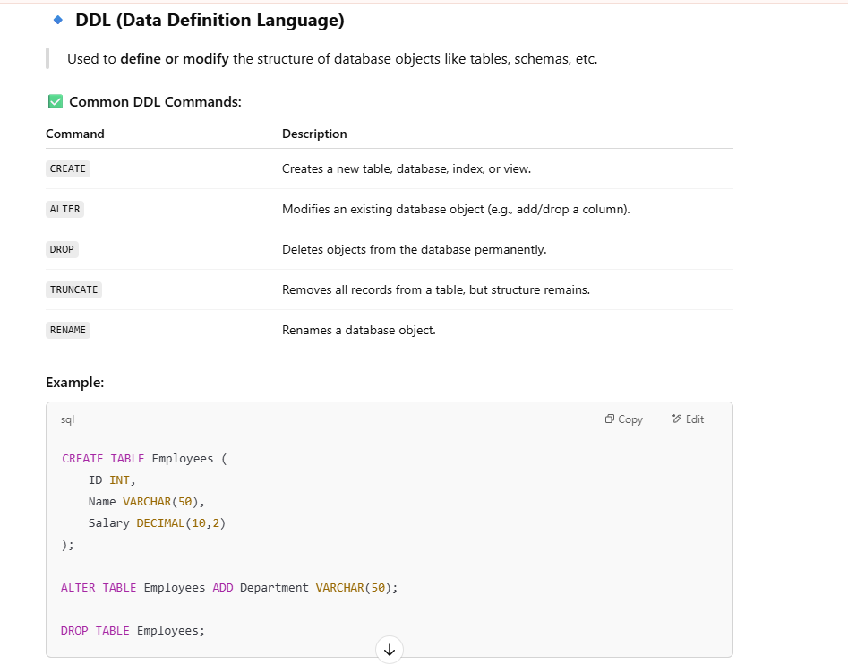
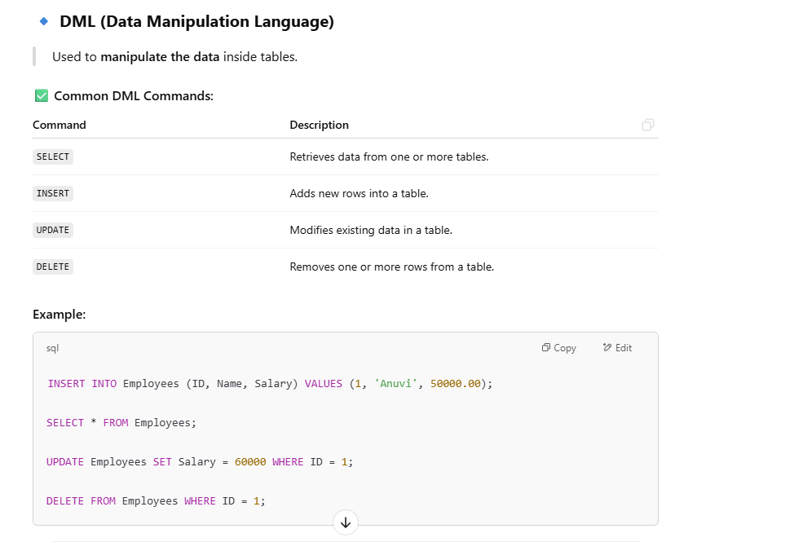
Views :
A View is a virtual table based on the result of a SQL query. It doesn't store data physically; it displays data stored in tables.
📌 Why Use Views?
- Simplifies complex queries.
- Provides data abstraction and security (e.g., restrict certain columns from users).
- Helps maintain reusability and readability.
🧾 Example:
-- Create a view
CREATE VIEW HighSalaryEmployees AS
SELECT Name, Salary FROM Employees
WHERE Salary > 50000;

-- Use the view
SELECT * FROM HighSalaryEmployees;
⚙️ 2. Indexes in SQL
✅ What is an Index?
An Index improves the speed of data retrieval operations on a table at the cost of extra storage and slower INSERT/UPDATE/DELETE operations.
Think of it like an index in a book: you look up a topic and find the exact page instead of reading every page.
📌 Why Use Indexes?
- Increases performance for SELECT queries.
- Optimizes searching, filtering, and sorting.
🧾 Example:
sql
CopyEdit
-- Create an index on the "Salary" column
CREATE INDEX idx_salary ON Employees(Salary);

-- Use query (automatically uses index internally if useful)
SELECT * FROM Employees WHERE Salary > 50000;
⚠️ Important Notes:
- Indexes consume additional space.
- Too many indexes can slow down data modification operations (INSERT, UPDATE, DELETE).
- Use indexes wisely, especially on columns that are often used in WHERE, JOIN, and ORDER BY.
Different type of exception
In Java, exceptions are categorized into two main types: checked exceptions and unchecked exceptions. Additionally, there is a third category known as errors. Let's delve into each of these types:
- Checked Exception
- Unchecked Exception
- Error
Super , this keyword
Usage of Java super Keyword
1.super can be used to refer immediate parent class instance variable.
2.super can be used to invoke immediate parent class method.
3.super() can be used to invoke immediate parent class constructor.

this Keyword
The this keyword refers to the current instance of the class in which it is used. It is commonly used in the following scenarios:
Referring to Instance Variables:
- this is used to distinguish between instance variables and parameters when they have the same name.
Super class
In Java, a superclass (also known as a parent class or base class) is a class that is extended (inherited) by another class (called a subclass).

🔹 What is a Superclass?
A superclass contains common properties and methods that are shared by one or more subclasses.
// Superclass
class Animal {
void eat() {
System.out.println("This animal eats food.");
}
}

// Subclass
class Dog extends Animal {
void bark() {
System.out.println("The dog barks.");
}
}

In Java, the super method refers to using the super keyword to call a method from the superclass (parent class) inside a subclass (child class). This is useful when:
class Animal {
Animal() {
System.out.println("Animal constructor");
}
void sound() {
System.out.println("Animal makes a sound");
}
}

class Dog extends Animal {
void sound() {
super() // call animal constructor
super.sound(); // Calls the superclass (Animal) sound() method
System.out.println("Dog barks");
}
}

public class Main {
public static void main(String[] args) {
Dog dog = new Dog();
dog.sound();
}
}

Methods Of Object class

In Java, the Object class is the superclass of all classes.
✅ Common Methods of the Object Class
Method | Description
public boolean equals(Object obj) | Compares this object with the specified object for equality.
public String toString() | Returns a string representation of the object.
public int hashCode() | Returns a hash code value for the object.
protected Object clone() | Creates and returns a copy (shallow) of the object.
public final Class<?> getClass() | Returns the runtime class of the object.
protected void finalize() | Called by the garbage collector before the object is destroyed. (Deprecated)
public final void wait() | Causes the current thread to wait until another thread calls notify() or notifyAll().
public final void wait(long timeout) | Waits for a specified amount of time.
public final void wait(long timeout, int nanos) | Waits for a specified time and nanoseconds.
public final void notify() | Wakes up a single thread that is waiting on this object's monitor.
public final void notifyAll() | Wakes up all threads that are waiting on this object's monitor.

Default and protected Class
1.Default: The access level of a default modifier is only within the package. It cannot be accessed from outside the package. If you do not specify any access level, it will be the default.
package pack;
class A{
void msg(){System.out.println("Hello");}
}
//save by B.java
package mypack; //not same package
import pack.*;
class B{
public static void main(String args[]){
A obj= new A();//Compil Tim Error
obj.msg();//Compile Time Error
}
}
In the above example, the scope of class A and its method msg() is default so it cannot be
accessed from outside the package

2.Protected: The access level of a protected modifier is within the package and outside the package through child class. If you do not make the child class, it cannot be accessed from outside the package
The protected access modifier can be applied on the data member, method and constructor. It can't be applied on the class
In this example, we have created the two packages pack and mypack. The A class of pack
package is public, so can be accessed from outside the package. But msg method of this
package is declared as protected, so it can be accessed from outside the class only
through inheritance.
package pack;
public class A{
protected void msg(){System.out.println("Hello");}
}
//save by B.java
package mypack;
import pack.*;

class B extends A{
public static void main(String args[]){

B obj = new B();

obj.msg();
}
}
Output:HellO
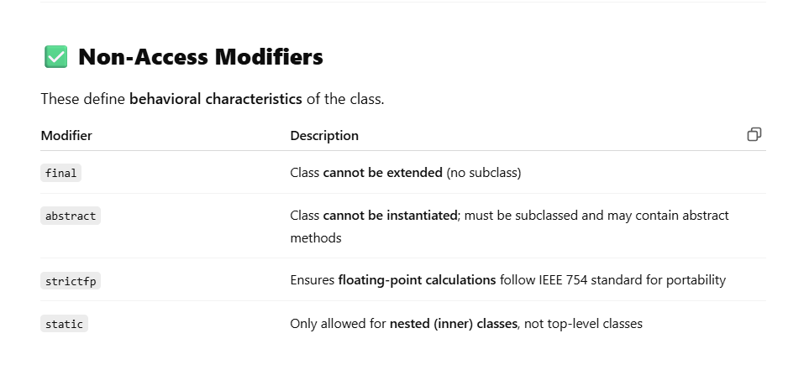
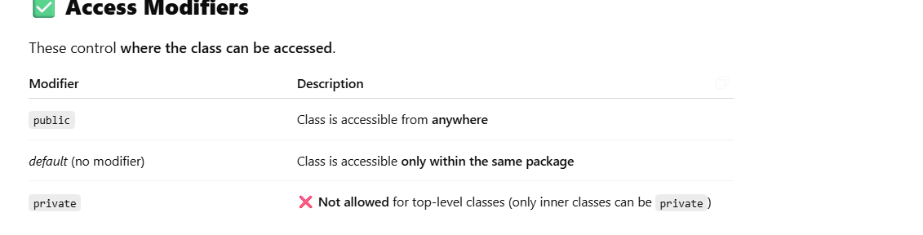Call bY Value:
✅ Call by Value (Primitive Types)
When you pass a primitive (like int, float, char), a copy of the value is sent to the method. Changes in the method don’t affect the original variable.
pass by reference
In case of objects, the reference (address) is passed by value. That means:
- The method gets a copy of the reference.
- So, changes to the object itself are visible outside.
- But if you assign a new object to the reference, it won’t affect the original reference
what will assign for constant variable
public static final double PI = 3.14159;
- public static final String APP_NAME = "MyApp";
If you want to add multiple exceptions in a catch block how will you do?
Try{
}catch(ArithmeticException | ArrayIndexOutOfBoundException e){

e.printStacktrace();
}

can access an object created in one method from another method?

Yes, you can access an object created in one method from another method, but only if that object is stored in a class-level (instance or static) variable — not a local variable.
🚫 Not Possible (Local Variable Scope)
If the object is created inside a method as a local variable, it is not accessible from other methods.
public class MyClass {
public void method1() {
MyObject obj1 = new MyObject(); // local to method1
}

public void method2() {
obj1.doSomething(); // ❌ Error: obj1 not accessible here
}
}

✅ Correct Way (Using Class-level Variable)
Use an instance variable or static variable to make it accessible across methods:

public class MyClass {
MyObject obj1; // instance variable

public void method1() {
obj1 = new MyObject(); // initialize in method1
}

public void method2() {
if (obj1 != null) {
obj1.doSomething(); // ✅ accessible here
}
}
}
=====================================================================
Second Round
employee entity - > empid, empName, DeptID
another entity Departmetn- > departmentID,DepartmentName
fetch all the emplloyeedetails from based on department name using javaStreams
package java8Features.com.Practice.Streams;

import java.util.ArrayList;
import java.util.List;
import java.util.Optional;
import java.util.stream.Collectors;

public class Execution {

public static void main(String[] args) {
// TODO Auto-generated method stub
List<Emp> employeeList = new ArrayList<>();
employeeList.add(new Emp(1L,"sagir",12L));
employeeList.add(new Emp(2L,"Raj",34L));
employeeList.add(new Emp(3L,"Sameer",12L));

//Depat List
List<Dept> DeptLsit = new ArrayList<>();
DeptLsit.add(new Dept(12L,"HR"));
DeptLsit.add(new Dept(54L,"IT"));

String targetDeptName = "HR";

Optional<Long> deptId = DeptLsit.stream().filter(dpt -> dpt.getDepartmentName().equalsIgnoreCase(targetDeptName)).map(Dept :: getDepartmentId).findFirst();
List<Emp> filteredList = null;
if(deptId.isPresent()) {
//filteredList = employeeList.stream().filter(empL -> empL.getDeptId().equals(deptId.get())).map(Emp :: getEmpName).collect(Collectors.toList());
filteredList = employeeList.stream().filter(empL -> empL.getDeptId().equals(deptId.get())).collect(Collectors.toList());

}
System.out.println(filteredList);

}

}

employee entity - > empid, empName, DeptID another entity Departmetn- > departmentID,DepartmentName fetch all the emplployee naem from the employeeEntity
package java8Features.com.Practice.Streams;

import java.util.ArrayList;
import java.util.List;
import java.util.stream.Collectors;

class Employee {
int id;
String name;
int age;
int salary;

public Employee(int id, String name, int age,int salary) {
this.id = id;
this.name = name;
this.age = age;
this.salary= salary;
}

public int getId() {
return id;
}

public void setId(int id) {
this.id = id;
}

public String getName() {
return name;
}

public void setName(String name) {
this.name = name;
}

public int getAge() {
return age;
}

public void setAge(int age) {
this.age = age;
}

public int getSalary() {
return salary;
}

/*
* @Override public String toString() { return "Employee [id=" + id + ", name="
* + name + ", age=" + age + "]"; }
*/

}

public class Emplyee {

public static void main(String[] args) {
// TODO Auto-generated method stub

List<Employee> lst = new ArrayList<>();
lst.add(new Employee(1,"sagir",27,100000));
lst.add(new Employee(2,"Raju",32,200000));
lst.add(new Employee(4,"Irfan",82,23000));
lst.add(new Employee(5,"sameer",62,560000));
lst.add(new Employee(3,"sagar",30,564444));

//System.out.println(lst);

for(Employee emp :lst ) {
System.out.println(emp.getId() +" "+emp.getName() +" "+emp.getAge());
}

//get all names of employees
List<String> empNams = lst.stream().map(Employee :: getName).collect(Collectors.toList());
System.out.println(empNams);

// get salary

List<Integer> salList = lst.stream().map(Employee :: getSalary).collect(Collectors.toList());
System.out.println(salList);

//salary greate then 200000

List<Integer> salaryGreater = lst.stream().filter(ListEmp->ListEmp.getSalary() > 200000)
.map(Employee :: getSalary)
.collect(Collectors.toList());

System.out.println(salaryGreater);

}

}

What is map ?
- A map contains values on the basis of key, i.e. key and value pair.
- Each key and value pair is known as an entry.
- A Map contains unique keys.
- A Map is useful if you have to search, update or delete elements on the basis of a key.
- A Map doesn't allow duplicate keys, but you can have duplicate values
- HashMap and LinkedHashMap allow null keys and values, but TreeMap doesn't allow any null key or value.
- A Map can't be traversed, so you need to convert it into Set using keySet() or entrySet() method.
Flat Map and Map
✅ map(): One-to-one transformation
- It transforms each element of the stream into another object (can be of same or different type), and returns a Stream of the same structure.
- ✅ flatMap(): One-to-many transformation (flattening)
- It transforms each element into a stream (or collection) and flattens all those streams into a single stream.

Map() | flatMap()
List<String> words = Arrays.asList("hello", "world");  List<List<String>> result = words.stream()  .map(word -> Arrays.asList(word.split(""))) // returns Stream<List<String>>  .collect(Collectors.toList());  System.out.println(result);  // Output: [[h, e, l, l, o], [w, o, r, l, d]] | List<String> words = Arrays.asList("hello", "world");  List<String> result = words.stream()  .flatMap(word -> Arrays.stream(word.split(""))) // returns Stream<String>  .collect(Collectors.toList());  System.out.println(result);  // Output: [h, e, l, l, o, w, o, r, l, d]

🧠 What is Memory Leakage in Java?
Memory leak happens when objects are no longer needed by the application but are still referenced, so the garbage collector (GC) cannot remove them.
Over time, this causes memory to fill up, leading to performance issues or OutOfMemoryError.
List<String> list = new ArrayList<>();

while (true) {
list.add("leak"); // keeps growing, never released
}
✅ How to Detect Memory Leaks:
- Heap dumps (analyzed with tools like Eclipse MAT, VisualVM, jProfiler)
- Monitoring tools (e.g., JConsole, Prometheus + Grafana)
- Unusual memory usage patterns
- GC logs showing excessive garbage collection
How to Prevent Them:
- Avoid long-lived static references
- Always unregister listeners
- Use try-with-resources to auto-close connections
- Use WeakReference or SoftReference where applicable
- Monitor memory in staging and production environments
where local variables and static variables are stored in Java
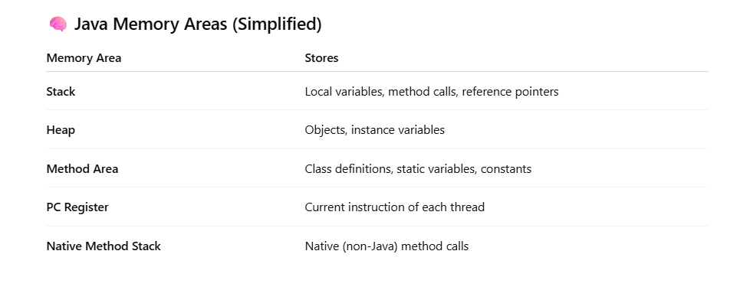
different kinds of operations in streams
🔁 Common Intermediate Operations:
Method | Description
map() | Transforms elements one-by-one
flatMap() | Flattens nested structures
filter() | Filters elements based on a condition
sorted() | Sorts the elements
distinct() | Removes duplicates
limit(n) | Takes first n elements
skip(n) | Skips first n elements
peek() | For debugging; lets you look at each element

🔹 2. Terminal Operations
These operations produce a result or a side-effect and end the stream.
🎯 Common Terminal Operations:
Method | Description
collect() | Collects elements into a list, set, map, etc.
forEach() | Performs an action on each element
count() | Counts the number of elements
reduce() | Performs aggregation like sum, min, etc.
toArray() | Converts stream to array
min() / max() | Finds minimum/maximum element
anyMatch() | Returns true if any element matches
allMatch() | Returns true if all elements match
noneMatch() | Returns true if none match the condition
findFirst() | Gets the first element (Optional)
findAny() | Gets any element (Optional)

