What is Microservices Architecture?
- Microservices is a software architectural style where an application is built as a collection of small, independent services that communicate with each other over APIs. Each service is focused on a specific business capability and can be developed, deployed, and scaled independently.

- Key Features of Microservices
✅ Independent Deployment – Services can be deployed and updated separately.
✅ Scalability – Services can be scaled individually based on demand.
✅ Technology Diversity – Different services can be built using different programming languages and databases.
✅ Resilience – Failure in one service does not bring down the entire application.
✅ Faster Development & Deployment – Teams can work on different services simultaneously

- How Microservices Work?

- Each microservice is responsible for one specific function (e.g., authentication, order processing, payments).
- Microservices communicate using REST APIs, gRPC, or messaging queues (e.g., Kafka, RabbitMQ).
- Services are deployed in containers (Docker, Kubernetes) for better scalability.
- API Gateway is often used to manage incoming requests and route them to the correct service.
- A database per service or shared database can be used depending on the architecture.

- Example of Microservices in an E-commerce Application

- User Service → Handles user registration, login, and profile.
- Product Service → Manages product catalog, categories, and inventory.
- Order Service → Handles order placement, tracking, and history.
- Payment Service → Processes payments and transactions.
- Notification Service → Sends email/SMS notifications.

Each of these services runs independently and communicates via APIs.
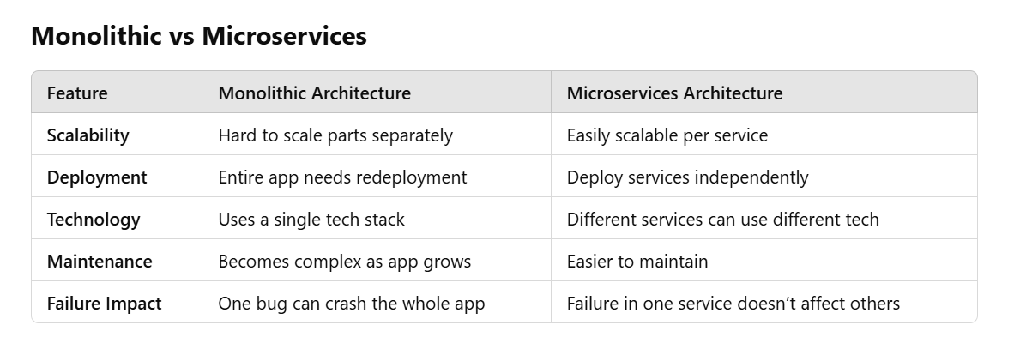
- Microservices Technologies
🔹 Spring Boot (Java) – Most popular for building microservices.
🔹 Node.js (Express, NestJS) – Lightweight microservices framework.
🔹 Docker & Kubernetes – For containerization and orchestration.
🔹 API Gateway (NGINX, Kong, AWS API Gateway) – Manages API requests.
🔹 Kafka / RabbitMQ – Message brokers for communication.

Architectures in software development
There are various types of architectures in software development, categorized based on design patterns, application layers, and deployment strategies. Here are the major types:
1. Monolithic Architecture
- A single-tiered application where all components (UI, business logic, and database) are bundled together.
- Easier to develop but difficult to scale and maintain.
2. Microservices Architecture
- Breaks an application into small, independent services that communicate via APIs.
- Each service can be deployed and scaled separately.
- Improves flexibility but increases complexity.
3. Layered (N-Tier) Architecture
- Divides the application into layers (e.g., Presentation, Business Logic, Data Access, and Database).
- Common in enterprise applications using MVC (Model-View-Controller).
4. Event-Driven Architecture
- Uses events to trigger and communicate between services.
- Useful for real-time applications like IoT and financial systems.
5. Service-Oriented Architecture (SOA)
- Uses services as building blocks, often leveraging SOAP or REST.
- Similar to microservices but typically uses an Enterprise Service Bus (ESB).
6. Serverless Architecture
- Applications run in cloud functions without managing infrastructure.
- Scales automatically but depends on cloud providers like AWS Lambda or Azure Functions.
7. Client-Server Architecture
- Separates clients (frontend) from servers (backend).
- Common in web and desktop applications.
8. Peer-to-Peer (P2P) Architecture
- Each node acts as both a client and server.
- Used in blockchain, file sharing (e.g., BitTorrent).
9. Cloud-Native Architecture
- Designed to run in cloud environments with scalability and resilience.
- Uses containerization (Docker, Kubernetes).
10. Hexagonal (Ports and Adapters) Architecture
- Separates the core business logic from external dependencies like databases or APIs.
- Improves testability and maintainability.
11. Clean Architecture
- Layers include Entities, Use Cases, Interface Adapters, and Frameworks.
- Popular in modern software design.
12. Onion Architecture
- Similar to Clean Architecture but with strict dependency rules (inner layers shouldn’t depend on outer layers).
13. Distributed Architecture
- Spreads components across multiple servers.
- Includes microservices, SOA, and cloud-based architectures.
14. Component-Based Architecture
- Divides the system into reusable, independent components.
- Common in frontend frameworks like React and Angular.
15. Space-Based Architecture
- Designed to handle high scalability by partitioning data and processes.
- Used in high-traffic applications.
Each architecture type has its pros and cons, and the choice depends on factors like scalability, maintainability, and system complexity. Do you have a specific use case in mind?

What is Cloud Computing?
Cloud computing is the delivery of computing services—such as servers, storage, databases, networking, software, and analytics—over the internet ("the cloud") instead of local computers or data centers. It allows businesses and individuals to access computing resources on-demand, reducing the need for physical infrastructure.

Key Features of Cloud Computing
- On-Demand Self-Service – Users can provision computing resources as needed without human intervention.
- Scalability – Resources can be scaled up or down dynamically.
- Pay-as-You-Go Pricing – Users pay only for the resources they use.
- Multi-Tenancy – Multiple customers share the same physical infrastructure securely.
- Accessibility – Services can be accessed from anywhere with an internet connection.
- Automatic Updates & Maintenance – Cloud providers handle updates, security patches, and infrastructure management.

Types of Cloud Computing
- Public Cloud – Services are provided over the internet and shared among multiple users (e.g., AWS, Azure, Google Cloud).
- Private Cloud – Dedicated cloud infrastructure for a single organization.
- Hybrid Cloud – A combination of public and private clouds for better flexibility and security.
- Multi-Cloud – Using multiple cloud providers to avoid vendor lock-in and improve redundancy.

Cloud Service Models
- Infrastructure as a Service (IaaS) – Provides virtualized computing resources (e.g., AWS EC2, Google Compute Engine).
- Platform as a Service (PaaS) – Provides a platform for developers to build applications without managing the underlying infrastructure (e.g., Google App Engine, AWS Elastic Beanstalk).
- Software as a Service (SaaS) – Delivers software applications over the internet (e.g., Gmail, Dropbox, Microsoft 365).
- Function as a Service (FaaS) / Serverless – Runs individual functions without managing servers (e.g., AWS Lambda, Azure Functions).

Advantages of Cloud Computing
✅ Cost Efficiency – Reduces capital expenses on hardware and IT maintenance.
✅ Reliability – High availability and disaster recovery options.
✅ Security – Cloud providers offer robust security measures, including encryption and access control.
✅ Collaboration – Teams can work remotely and access shared resources.
✅ Faster Deployment – Applications can be deployed and scaled quickly.
- Blue-Green Deployment in DevOps 🚀
Blue-Green Deployment is a zero-downtime deployment strategy that reduces downtime and risk when deploying new versions of an application. It works by runnin g two identical production environments:
- Blue Environment → The existing stable version.
- Green Environment → The new version with updates.
Once the Green environment is tested and confirmed to be stable, traffic is switched from Blue → Green, making the new version live. If issues occur, traffic can be switched back to Blue (rollback).

How Blue-Green Deployment Works?
1️⃣ Deploy the new version of the application to the Green environment.
2️⃣ Test the Green environment thoroughly (QA, UAT, performance tests).
3️⃣ Switch Traffic from Blue to Green using a load balancer.
4️⃣ Monitor the new version in production.
5️⃣ Rollback (if needed) by switching back to Blue if issues arise.

