***********************************************************************************
Spring Boot
***********************************************************************************

Spring Boot is a Spring module that provides the RAD (Rapid Application Development) feature to the Spring framework.
What is Spring Boot
Spring Boot is a project that is built on the top of the Spring Framework. It provides an easier and faster way to set up, configure, and run both simple and web-based applications.
It is a Spring module that provides the RAD (Rapid Application Development) feature to the Spring Framework. It is used to create a stand-alone Spring-based application that you can just run because it needs minimal Spring configuration.
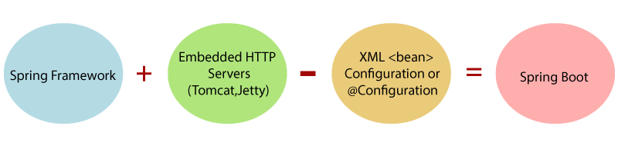
In short, Spring Boot is the combination of Spring Framework and Embedded Servers.
In Spring Boot, there is no requirement for XML configuration (deployment descriptor). It uses convention over configuration software design paradigm that means it decreases the effort of the developer.
Why should we use Spring Boot Framework?
We should use Spring Boot Framework because:
- The dependency injection approach is used in Spring Boot.
- It contains powerful database transaction management capabilities.
- It simplifies integration with other Java frameworks like JPA/Hibernate ORM, Struts, etc.
- It reduces the cost and development time of the application.

The latest version of Spring Boot is 2.0. It introduces a lot of new features along with some modifications and replacement.
Spring vs. Spring Boot
Spring: is a java based application development framework .Spring Framework is the most popular application development framework of Java. The main feature of the Spring Framework is dependency Injection or Inversion of Control (IoC). With the help of Spring Framework, we can develop a loosely coupled application. It is better to use if application type or characteristics are purely defined.
Spring Framework is a widely used Java EE framework for building applications.
Spring Boot: Spring Boot is a module of Spring Framework. It allows us to build a stand-alone application with minimal or zero configurations. It is better to use if we want to develop a simple Spring-based application or RESTful services.

Spring Boot Framework is widely used to develop REST APIs.
Spring Boot vs. Spring MVC
Spring Boot: Spring Boot makes it easy to quickly bootstrap and start developing a Spring-based application. It avoids a lot of boilerplate code. It hides a lot of complexity behind the scene so that the developer can quickly get started and develop Spring-based applications easily.
Spring MVC: Spring MVC is a Web MVC Framework for building web applications. It contains a lot of configuration files for various capabilities. It is an HTTP oriented web application development framework.

Spring Boot Architecture
Spring Boot follows a layered architecture in which each layer communicates with the layer directly below or above (hierarchical structure) it.
Before understanding the Spring Boot Architecture, we must know the different layers and classes present in it. There are four layers in Spring Boot are as follows:
- Presentation Layer
- Business Layer
- Persistence Layer
- Database Layer
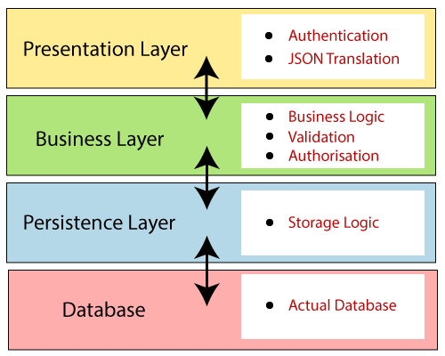
Presentation Layer: The presentation layer handles the HTTP requests, translates the JSON parameter to object, and authenticates the request and transfer it to the business layer. In short, it consists of views i.e., frontend part.
Business Layer: The business layer handles all the business logic. It consists of service classes and uses services provided by data access layers. It also performs authorization and validation.
Persistence Layer: The persistence layer contains all the storage logic and translates business objects from and to database rows.
The persistence layer in an application is responsible for managing the storage and retrieval of data, typically from a database. It acts as the intermediary between the application's business logic and the data storage mechanism (like a relational database, NoSQL database, or file system).
Database Layer: In the database layer, CRUD (create, retrieve, update, delete) operations are performed.
****************************************************************************************************************************
• Validator Classes: Ensure that data is valid (e.g., email validation, input range checking).
• View Classes: Render the user interface or data to the user (e.g., HTML, JSP, Thymeleaf templates).
• Utility Classes: Provide common, reusable functionality that can be used across the application (e.g., string manipulation, file handling).
****************************************************************************************************************************

Spring Boot Flow Architecture
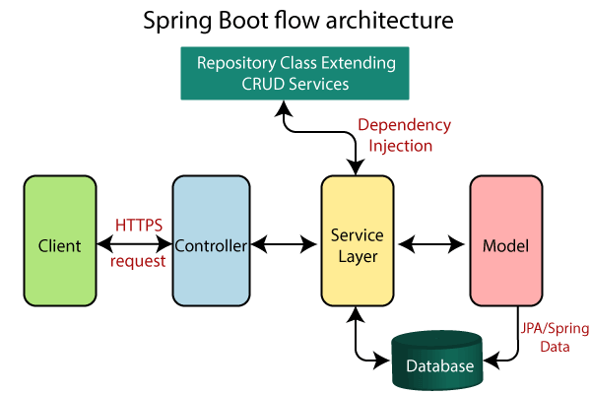
- Now we have validator classes, view classes, and utility classes.
- Spring Boot uses all the modules of Spring-like Spring MVC, Spring Data, etc. The architecture of Spring Boot is the same as the architecture of Spring MVC, except one thing: there is no need for DAO and DAOImpl classes in Spring boot.
- Creates a data access layer and performs CRUD operation.
- The client makes the HTTP requests (PUT or GET).
- The request goes to the controller, and the controller maps that request and handles it. After that, it calls the service logic if required.
- In the service layer, all the business logic performs. It performs the logic on the data that is mapped to JPA with model classes.
- A JSP page is returned to the user if no error occurred.

Spring Initializr
Spring Initializr is a web-based tool provided by the Pivotal Web Service. With the help of Spring Initializr, we can easily generate the structure of the Spring Boot Project. It offers extensible API for creating JVM-based projects.
Dependencies
spring web
theam leaf
mysql
jpa

Caused by: java.sql.SQLSyntaxErrorException: ORA-02289: sequence does not exist
CREATE SEQUENCE hibernate_sequence;

SpringBoot bydefult do not give jsp configuration
spring web dependencies = tomcat
converting jsp to servlet == . tomcat embaded jasper maven jars
Annotations **********************
*************************************
@springBootApplication ===> configuration,auto enable,package scan
@responseBody
@controller
@RestController
@GetMapping,@postMapping,@putMapping,@DeleteMapping()
@Autowired
@column
@OneToOne
@OneToOne(cascade=CascadeType.ALL)

@OneToOne(mappedBy="author")
@JsonBackReference
@JsonManagedReference
@RequestMapping(value="/books" ,method=RequestMethod.GET)
@ResponseBody

@Id
@GeneratedValue(strategy=GenerationType.AUTO)
@Entity
@Table(name = "user_test")
@Query()
@GetMapping("/books")
@GetMapping("/books/{id}")
@PostMapping("/books")
@DeleteMapping("/books/{bookId}")
@DeleteMapping("/books/{bookId}")
//Need to cerate one parameter for bookId
public void Deletebook(@PathVariable("bookId") int bookId) {
this.bookService.DeleteBook(bookId);
}
@PutMapping("/books/{bookId}")

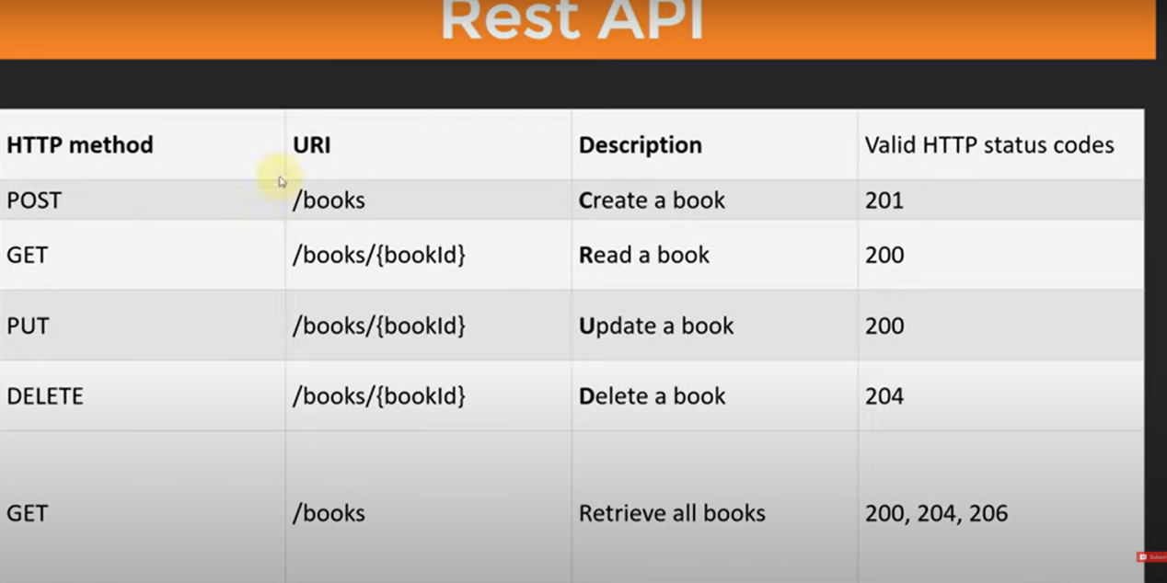

spring boot application == > we get preconfigured application first
use of application.properties == for application configuration, to customize project in our own way
* we can keep data in key value pairs
*
JPA == > java Persistence(permanaent store karna) API
JPA (Java Persistence API) is a specification(vishes-warnan in hindi) in Java that defines how to map Java objects to relational database tables and manage database interactions using object-relational mapping (ORM).
JPA is part of the Java EE (Enterprise Edition) standard and provides a way to bridge the gap between Java objects and database systems.
JPA itself is just a specification, meaning it provides guidelines and interfaces but does not have an actual implementation. To use JPA, developers typically rely on an ORM framework that implements the JPA specification, such as Hibernate, EclipseLink, or OpenJPA.
JPA provides two features :-
1) entity manager factory
The EntityManagerFactory is a factory for creating EntityManager instances. It is a heavyweight object that should be created once per application (typically at application startup) and shared across the application.
Purpose:
- It is responsible for managing a set of entity managers that handle the database operations. The EntityManagerFactory is thread-safe, meaning it can be shared across multiple threads.
2) Entity Manager
• The EntityManager is the primary interface used to interact with the persistence context. It provides methods for performing CRUD operations (Create, Read, Update, Delete) on entities.
SpringBoot makes easier to perform operation with JPA
JPA is ORM tool
if we have to work with JPA in springBoot need to add Spring Boot Starter JPA
JPARepository
CRUDRepository
UserRepository
Dependencies required
SPRING JPA
MYSQL Driver

Custom Finder methods. Derived query methods
Bydefault from crud Repository===>findAllbyId, find by Id,findAll
if needs method dataBy name, data by name and password etx
Connecting with database with JPA
To use JPA need to use @entity annotaion for

We create the repository , with the help of it we will enter the data in data bases and it will provide the predefined methods to work.
To use JPA (Java Persistence API), you need to annotate your entity classes with @Entity. This annotation marks a class as a JPA entity, meaning it will be mapped to a table in the database. Once you have your entity class, you can create a repository interface to interact with the database using predefined methods provided by Spring Data JPA.
Step 1: Create the Entity Class
import javax.persistence.Entity;
import javax.persistence.Id;
import javax.persistence.GeneratedValue;
import javax.persistence.GenerationType;

@Entity // Marks this class as a JPA entity
public class User {

@Id // Specifies the primary key of the entity
@GeneratedValue(strategy = GenerationType.IDENTITY) //Auto-generates the primary key
private Long id;

private String name;
private String email;

// Getters and Setters
public Long getId() {
return id;
}

public void setId(Long id) {
this.id = id;
}

public String getName() {
return name;
}

public void setName(String name) {
this.name = name;
}

public String getEmail() {
return email;
}

public void setEmail(String email) {
this.email = email;
}
}
When a class is annotated with @Entity, by default, the corresponding table in the database will have the same name as the class. However, you can customize the table name if needed by using the @Table annotation along with @Entity.
@Entity
@Table(name = "users")
public class User {
@Id
@GeneratedValue(strategy = GenerationType.IDENTITY)
private Long id;
private String name;
private String email;
}

Step 2: Create the Repository Interface
import org.springframework.data.jpa.repository.JpaRepository;

public interface UserRepository extends JpaRepository<User, Long> {
// JpaRepository provides predefined methods like save, findAll, findById, delete, etc.

}
Explanation:
- @Entity: The @Entity annotation marks the User class as a JPA entity, meaning it will be mapped to a table named User (by default) in the database.
- @Id: Specifies the primary key for the entity.
- @GeneratedValue: Indicates that the ID should be automatically generated by the database.
- UserRepository: The UserRepository interface extends JpaRepository, which is a Spring Data JPA interface that provides predefined methods like save, findAll, findById, delete, and more. By extending JpaRepository, you gain access to these methods without needing to implement them manually.
import org.springframework.beans.factory.annotation.Autowired;
import org.springframework.stereotype.Service;

@Service
public class UserService {
private final UserRepository userRepository;
@Autowired
public UserService(UserRepository userRepository) {
this.userRepository = userRepository;
}
public User createUser(String name, String email) {
User user = new User();
user.setName(name);
user.setEmail(email);
return userRepository.save(user); // Save the user to the database
}

public List<User> getAllUsers() {
return userRepository.findAll(); // Retrieve all users from the database
}

// Other service methods as needed
}
In this example, the UserService class uses UserRepository to save a new User entity to the database and retrieve all users. The UserRepository interface provides these methods through the JpaRepository interface, so you don’t need to write SQL or query methods yourself.
Controller

import org.springframework.beans.factory.annotation.Autowired;
import org.springframework.web.bind.annotation.*;

import java.util.List;

@RestController
@RequestMapping("/users")
public class UserController {

private final UserService userService;

@Autowired
public UserController(UserService userService) {
this.userService = userService;
}

// Endpoint to create a new user
@PostMapping("/create")
public User createUser(@RequestParam String name, @RequestParam String email) {
return userService.createUser(name, email);
}

// Endpoint to get all users
@GetMapping("/all")
public List<User> getAllUsers() {
return userService.getAllUsers();
}

// Additional endpoints can be added as needed
}

#tabel will create automatically by below line
spring.jpa.hibernate.ddl-auto=update

Nesting Custom Type in spring Boot Rest Api | Using ONE TO ONE Mapping with Spring Boot Rest API
Jackson – Bidirectional Relationships | @JsonManagedReference, @JsonBackReference

Spring Boot Actuator :
Spring Boot Actuator provides production-ready features to help you monitor and manage your Spring Boot application. It includes a variety of built-in endpoints that allow you to understand the state of your application and gather metrics, view application health, check application configuration, and more.

<dependency>
<groupId>org.springframework.boot</groupId>
<artifactId>spring-boot-starter-actuator</artifactId>
</dependency>

After running your Spring Boot application, you can access various actuator endpoints:
- Health Check: http://localhost:8080/actuator/health
- Application Info: http://localhost:8080/actuator/info
- Metrics: http://localhost:8080/actuator/metrics
- Environment: http://localhost:8080/actuator/env
- Beans: http://localhost:8080/actuator/beans
- And more: http://localhost:8080/actuator

Commonly Used Actuator Endpoints
- /actuator/health: Shows application health information.
- /actuator/info: Displays arbitrary application info.
- /actuator/metrics: Shows metrics information.
- /actuator/env: Displays properties from the Spring Environment.
- /actuator/beans: Shows a list of all Spring beans in your application context.
- /actuator/loggers: Shows and modifies the configuration of loggers.
- /actuator/threaddump: Performs a thread dump.
- /actuator/httptrace: Displays HTTP trace information (requires additional setup).

API ==(Application Program Interface)
It is a set of rules that allow programs to talk to each other. The developer creates the API on the sever and allows the client to talk to it.

REST API = Representation State Transfer => A set of constraints (rules, architechtural styles )to be used for creating web webservices
The Important methods of HTTP are
Get : It reads a resource
PUT : it updates an existing resource
POST : It creates a new resource
Delete : it deletes the resource

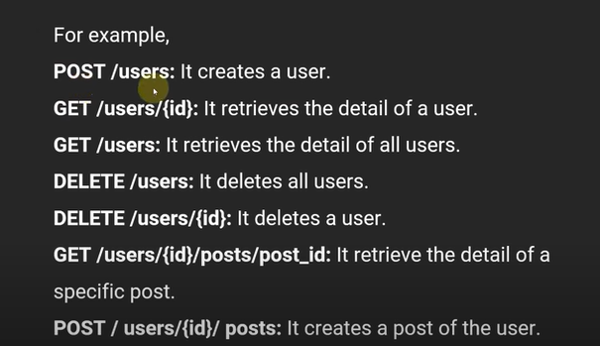

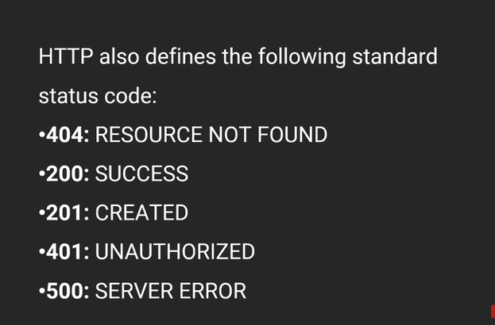

Spring boot Dev Tools :
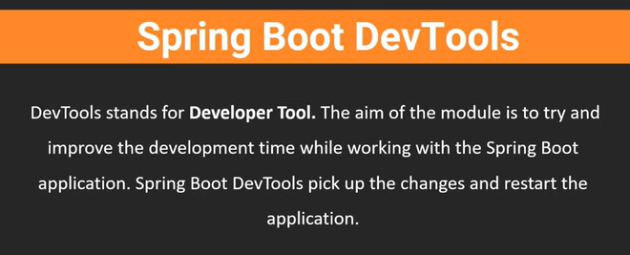

In Spring Dev Tool use the dependency below
<dependency>
<groupId>org.springframework.boot</groupId>
<artifactId>spring-boot-devtools</artifactId>
<scope>runtime</scope>
<optional>true</optional>
</dependency>
it will help to automatic compilation, no need to start server again and again,

IDE using for Building REST API
HOW to call API : Postman software required
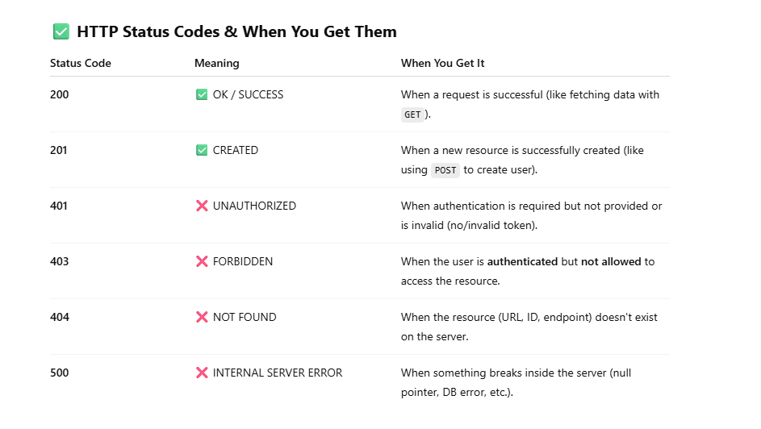
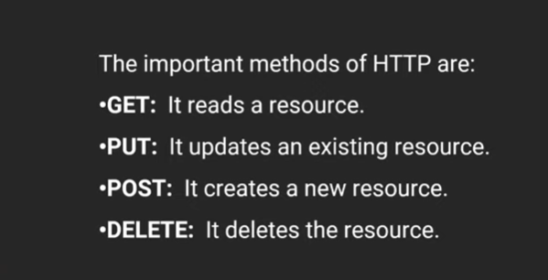

<?xml version="1.0" encoding="UTF-8"?>
<project xmlns="http://maven.apache.org/POM/4.0.0" xmlns:xsi="http://www.w3.org/2001/XMLSchema-instance"
xsi:schemaLocation="http://maven.apache.org/POM/4.0.0 https://maven.apache.org/xsd/maven-4.0.0.xsd">
<modelVersion>4.0.0</modelVersion>
<parent>
<groupId>org.springframework.boot</groupId>
<artifactId>spring-boot-starter-parent</artifactId>
<version>2.7.13</version>
<relativePath/> <!-- lookup parent from repository -->
</parent>
<groupId>com.JPA.test</groupId>
<artifactId>BootJPAExample</artifactId>
<version>0.0.1-SNAPSHOT</version>
<name>BootJPAExample</name>
<description>this is project for JPA</description>
<properties>
<java.version>1.8</java.version>
</properties>
<dependencies>
<dependency>
<groupId>org.springframework.boot</groupId>
<artifactId>spring-boot-starter-data-jpa</artifactId>
</dependency>
<dependency>
<groupId>org.springframework.boot</groupId>
<artifactId>spring-boot-starter-web</artifactId>
</dependency>

<dependency>
<groupId>com.mysql</groupId>
<artifactId>mysql-connector-j</artifactId>
<scope>runtime</scope>
</dependency>
<dependency>
<groupId>org.springframework.boot</groupId>
<artifactId>spring-boot-starter-test</artifactId>
<scope>test</scope>
</dependency>
<dependency>
<groupId>com.oracle.database.jdbc</groupId>
<artifactId>ojdbc8</artifactId>
<version>19.3.0.0</version> <!-- Or the version you require -->
</dependency>
</dependencies>

<build>
<plugins>
<plugin>
<groupId>org.springframework.boot</groupId>
<artifactId>spring-boot-maven-plugin</artifactId>
<configuration>
<image>
<builder>paketobuildpacks/builder-jammy-base:latest</builder>
</image>
</configuration>
</plugin>
</plugins>
</build>

</project>

When we are using
@Controller then @RequestMapping(value="/books" ,method=RequestMethod.GET)
@ResponseBody need to be use for getting response .
if @RestController then only @GetMapping("/books") we should use in place of requestMapping and responseBody

@RestController
public class BookController {

//@RequestMapping(value="/books" ,method=RequestMethod.GET)
@GetMapping("/books")
//@ResponseBody
public String getBooks() {
return "this is tesing book for Restcontroller using get mapping ";
}
}
jackson-annotations-2.13.5.jar in mavan Dependecies converts the Object to JSON data automatically

***************************************************************************if we are creating object using @Autowired annotation then in Service class @Component annotation needs to be use for connection of object to the controller and service
Certainly! When you use the @Autowired annotation to inject dependencies into a service class, you typically need to annotate the service class with @Service (or @Component). This annotation allows Spring to detect and manage the service class as a Spring bean, enabling it to be injected into other components like controllers.
Here’s an example:

Step 1: Define a Service Class
import org.springframework.stereotype.Service;

@Service // This makes the class a Spring-managed bean

public class MyService {

public String performService() {

return "Service logic executed!";

}

}

Step 2: Define a Controller Class
import org.springframework.beans.factory.annotation.Autowired;
import org.springframework.stereotype.Controller;
import org.springframework.web.bind.annotation.GetMapping;
import org.springframework.web.bind.annotation.ResponseBody;

@Controller
public class MyController {

private final MyService myService;

@Autowired // This injects the MyService bean into the controller
public MyController(MyService myService) {
this.myService = myService;
}

@GetMapping("/service")
@ResponseBody
public String callService() {
return myService.performService();
}
}

@Autowired
private BookServices bookService;
@Component
public class BookServices {

@GetMapping("/books/{id}")
public Book getBooks(@PathVariable("id") int id) {
System.out.println("ID : "+id);
return bookService.getBookById(id);
}
@GetMapping("/books/{id}") : server will return the data on the base of Id we pass in POSTMAN ==> localhost:8086/books/12
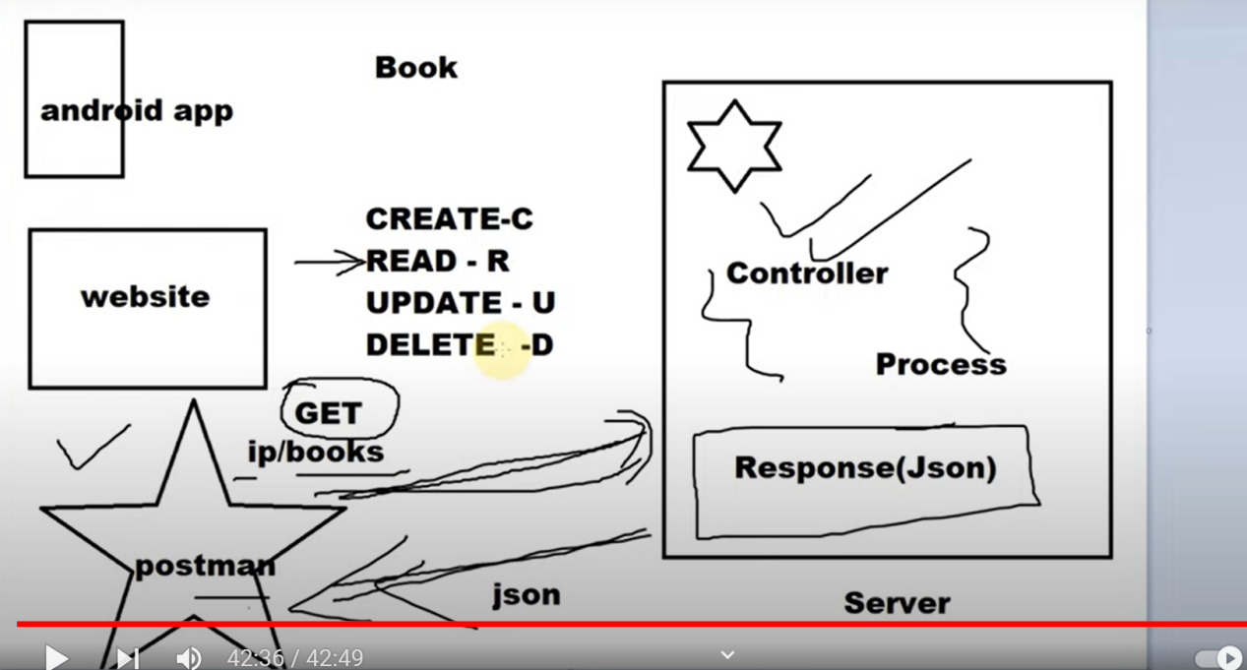

For Create : post Request
For Delete : Delete request
For Update :
if a client is sending any information of Book then we need to create in Server

list = list.stream().filter(book -> book.getId()!= bookId).collect(Collectors.toList());

book = list.stream().filter(e->e.getId() == id).findFirst().get();

Handling HTTPS Status while creating REST API

ResponseEntity<List<Book> >getBooks()

DATABASES QUERUES
show Databases;
drop learn(name of databases)
Create database Youtube_API;
*****************************************************************
Web services are a way to enable communication between different applications over the web or a network, allowing them to share data and perform functions regardless of the platforms or technologies they are built on. They are used to integrate different systems, allowing applications written in different languages and running on different platforms to interact seamlessly.

What Are Web Services?
A web service is a standardized way for software applications to communicate with each other over the internet. It allows one application to request data or perform an operation on another system, often over HTTP (the same protocol used by the web).
Web services provide interoperability between disparate systems, meaning that applications written in different programming languages or running on different operating systems can communicate and exchange information with each other.

Key Features of Web Services:
- Platform and Language Independence: Applications built using different programming languages (Java, Python, .NET, etc.) and running on different platforms (Windows, Linux, macOS) can communicate via web services.
- Standard Protocols: Web services typically use standard web protocols such as HTTP/HTTPS for communication and formats like XML or JSON to transfer data.
- Loosely Coupled: The client and server are loosely coupled, meaning they do not need to know the internal details of each other’s systems. They only interact through standardized messages (request/response).
- Scalability: Web services can be used to integrate services across different systems or over the internet, allowing scalable and distributed architectures.

Why Do We Use Web Services?
Integration of Applications:
  - Web services allow for easy integration of applications regardless of the underlying technology. For example, a Java application can interact with a .NET or PHP application using web services, as long as they both use the same web service standards.
Reusability:
  - Once a web service is developed, it can be used by different clients. For example, a payment gateway can expose its functionality as a web service, allowing various e-commerce websites to use it for transactions.
Interoperability:
  - Web services are platform-agnostic, meaning they allow applications written in different languages or running on different operating systems to interact. This interoperability is crucial for businesses with heterogeneous environments.
Decoupling:
  - Web services decouple the client and server, allowing them to evolve independently. A change in the server's implementation does not impact the client as long as the service interface remains unchanged.

B2B Communication:
  - Web services are widely used in business-to-business (B2B) communication to allow automated data exchange between companies, such as in supply chain management, where different organizations' systems need to communicate in real-time.
Web-Enabled Functionality:
  - Web services can be used to expose certain functionalities of an application to other external systems. For example, a weather service can provide weather data to various client applications through a web service.

Types of Web Services:
SOAP (Simple Object Access Protocol):

  - SOAP is a protocol specification for exchanging structured information using XML. It is a well-defined standard that specifies how messages should be formatted and transmitted between systems.
  - SOAP-based web services are often used in enterprise environments where strict security, reliability, and compliance standards are required (e.g., financial transactions, healthcare).
Example of SOAP Request:
xml
Copy code
<soapenv:Envelope xmlns:soapenv="http://schemas.xmlsoap.org/soap/envelope/">
<soapenv:Header/>
<soapenv:Body>
<GetWeather>
<CityName>New York</CityName>
</GetWeather>
</soapenv:Body></soapenv:Envelope>
SOAP is transported over various protocols, including HTTP, SMTP, and more, but typically uses HTTP.

REST (Representational State Transfer):
  - REST is an architectural style that uses standard HTTP methods (GET, POST, PUT, DELETE) to perform operations on resources (data or functionality) exposed by the web service.
  - REST is lightweight and simple compared to SOAP and is often used for building public APIs and microservices.
  - REST services typically exchange data in JSON or XML format, and they are widely used for web applications, mobile apps, and other lightweight use cases.
Example of REST Request:
vbnet
Copy code
GET /weather?city=New York HTTP/1.1Host: weatherapi.example.com
Response (in JSON):
{
"city": "New York",
"temperature": "22°C",
"condition": "Clear"}
JSON-RPC / XML-RPC:
  - These are remote procedure call (RPC) protocols that allow for communication between systems using JSON or XML formats. They are less commonly used today compared to REST and SOAP.

Key Components of a Web Service:
Service Provider:
  - The server-side application that provides the web service. It exposes functionality to be accessed by client applications.
Service Consumer (Client):
  - The client-side application that consumes the web service. It sends requests to the service provider and processes the responses.
WSDL (Web Services Description Language) (for SOAP):
  - WSDL is an XML-based language used to describe the operations provided by a SOAP web service. It defines the methods, their parameters, and the return types.
API Endpoints (for REST):
  - REST services do not use WSDL. Instead, they expose API endpoints, which are URLs that clients can use to access specific functionality. These endpoints correspond to resources (e.g., /users, /orders).

Comparison of SOAP and REST:
Feature | SOAP | REST
Protocol | Strict protocol (XML-based) | Architectural style (HTTP)
Message Format | XML | JSON, XML, plain text
Performance | More complex, heavier | Lightweight and faster
Security | WS-Security, more standards | Can use HTTPS, OAuth
State | Stateful or stateless | Stateless
Use Case | Enterprise, mission-critical | Web and mobile applications

When to Use Web Services:
- Cross-Platform Integration: When you need different systems (e.g., Java, .NET, Python) to communicate and exchange data.
- Mobile Apps and Web Apps: To provide a backend service that can be consumed by different clients like mobile apps, web apps, etc.
- Microservices: For creating independent services that communicate over a network in a distributed architecture.
- Public APIs: When you need to expose data or services to external developers, such as providing an API for third-party applications (e.g., payment gateways, social media APIs).

Conclusion:
Web services are a powerful way to achieve interoperability, integration, and scalability across applications and platforms, especially in distributed systems and the web. Whether through SOAP for more complex enterprise needs or REST for lightweight and scalable solutions, web services enable communication between different systems, making it a fundamental technology in modern software architecture.
4o

Main Features of Spring Framework:
Dependency Injection (DI):
  - Central to Spring, DI promotes loose coupling between components by allowing dependencies to be injected at runtime rather than hardcoded, making the application more modular and easier to test.

Aspect-Oriented Programming (AOP):
  - Enables separation of cross-cutting concerns (e.g., logging, transaction management) from the main business logic, improving modularity and code cleanliness.
Transaction Management:
  - Provides a declarative and programmatic approach to managing transactions, making it easier to handle complex transactional data across the application.
Spring MVC (Model-View-Controller):
  - Provides a web framework for building RESTful web applications and services with a clear separation of concerns (controller, view, and model layers).
Spring Security
  - A robust security framework offering authentication, authorization, and protection against common security threats (CSRF, XSS, etc.) for enterprise applications.
Data Access with Spring Data:
  - Simplifies interaction with databases through ORM support (Hibernate, JPA) and JDBC templates, reducing boilerplate code for CRUD operations.
Testing Support:
  - Integrated support for testing with JUnit and other frameworks, including dependency injection in test cases, mock objects, and test configurations.

Main Features of Spring Boot:
Auto-Configuration:
  - Automatically configures Spring applications based on project dependencies, allowing developers to quickly get started without extensive setup.
Embedded Servers:
  - Provides built-in Tomcat, Jetty, or Undertow servers, enabling applications to run as standalone services without the need for external servers.
Starter Dependencies:
  - Offers "starters" (pre-configured dependency sets) for different functionalities, like spring-boot-starter-web, spring-boot-starter-data-jpa, etc., simplifying dependency management.
Spring Boot CLI:
  - Command-line interface for quickly prototyping Spring applications with Groovy, making rapid development possible.
Actuator:
  - Adds production-ready monitoring and management features like health checks, metrics, and application insights via endpoints.
Externalized Configuration:
  - Enables configuration properties to be defined in external files (like application.properties or application.yml), supporting environment-specific configurations for easy deployment.
Simplified Development and Deployment:
  - Reduces setup and configuration time, allowing developers to focus on writing code rather than managing infrastructure, which makes it well-suited for microservices.
Spring Initializr:
  - An online tool (or integrated in IDEs) for generating Spring Boot projects with required dependencies, making it easy to bootstrap new applications.

