Final Project on: "Come Together:

Multi-Agent Geometric Consensus"

By Ariel Barel, Rotem Manor, and Alfred M. Bruckstein

Sagiv Tamir∗

Roy Levi†

May 2024

Summary of the paper

1. Introduction

The "Come Together" article delves into the essential issue of coordination and convergence in multi-agent systems, critical for applications such as robotic swarms and distributed sensor networks. This study primarily assumes unlimited visibility and accurate position sensing among agents, allowing them to precisely measure the distance and direction to their neighbors and adjust their movements accordingly.

The research is divided into two main sections: continuous time dynamics and discrete time dynamics. In the continuous time framework, agents move smoothly with velocities proportional to the sum of vectors pointing towards their peers, leading to exponential convergence to the average initial position of the group. The discrete time framework, on the other hand, involves agents updating their positions in discrete steps. The analysis reveals that, under certain conditions, these updates result in stable convergence to the average position, emphasizing the critical role of the gain factor in maintaining system stability.

Additionally, the article explores scenarios where agents do not have unlimited visibility but can determine the relative angle to their neighbors. This situation introduces new challenges and dynamics, as agents must rely on angular information to coordinate their movements without knowing the exact distances. The study examines how these agents can still achieve coordinated behavior and converge to a common position using angle-based sensing.

* 1. Unlimited Visibility, Positional Sensing

This section assumes that each agent in a multi-agent system has unlimited visibility and can accurately measure the distance and direction to all other agents.

Continuous Time Dynamics (System S1):  
Agents move according to the following dynamic law:

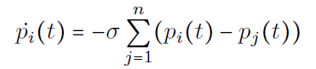

(1)

Here, $σ$ is a constant positive scalar gain factor. This means each agent continuously moves with a velocity proportional to the sum of vectors pointing to the positions of all other agents.

Since the dynamics are governed by an antisymmetric function, the average position of the agents $\overline{P}$ remains constant, due to the first lemma in the article.

The article demonstrates Theorem 1: For any given initial configuration, all agents in system S1 asymptotically converge to the average position of their initial configuration.

By centering the global coordinate system at the average position $\overline{P}=0$, we have:

(2)

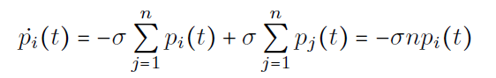

The result of this equation is:

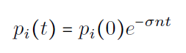

(3)

Hence, all agents in system S1 exponentially and asymptotically converge to the average position at ( t = 0 ).



(4)

Discrete Time Dynamics (system S2):

Next, the article assumes each agent moves according to a discretized dynamic law:

(5)

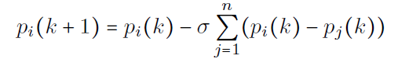

where $σ$ is a constant positive scalar gain factor (similar as above). At each time-step, each agent updates its position proportionally to the sum of the relative position vectors to all other agents.

Dynamics (5) is also antisymmetric, so the average position of the agents in system S2 remains invariant, i.e., $\overline{P}$ = const , due to Lemma 1 that introduced in the article.

The article demonstrates Theorem 2: For any initial configuration, if $0<σ<\frac{2}{n}$, where n is the number of agents in the system, all agents in system S2 asymptotically converge to the average location of the initial configuration.

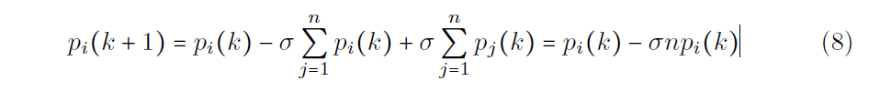

(6)

Which yields,

(7)

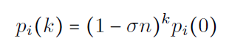

Therefore, there are four different ranges in solution (7) and only the second range is coverage to the average initial position.

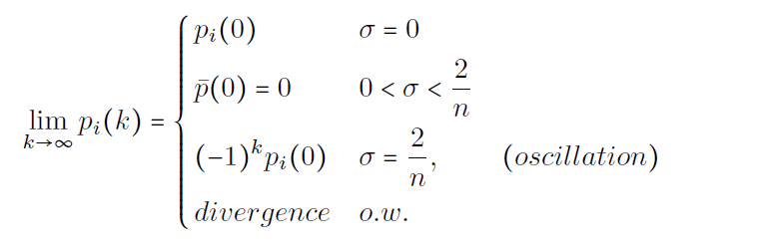

(8)

Travelling Path of systems S1 and S2:

Agents in systems S1 and S2 are memory-less, calculating their motion based only on the current relative location of all other agents.  
As shown in the article, each agent moves in a straight line from its initial position to the average position, with their speed decreasing as they approach the average position.  
If agents could compute and remember the average position, they could travel there at a constant speed and gather in finite time. However, being oblivious, they cannot recall past positions or $\overline{P}$ and thus cannot move directly to it.

* 1. Unlimited Visibility, Bearing-only Sensing

The article assumes that each agent has information only about the bearing or direction to all other agents in the system, without being able to measure their relative distances.  
  
Continuous Time Dynamics (System S3):

Consider that agents move according to the following dynamic law:



(9)

The result of equation (9) is:

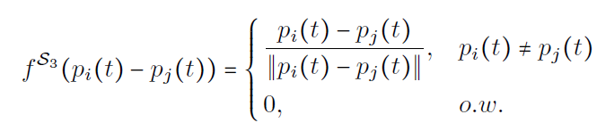

(10)

From equation (9), it seems that ${\dot{P}}_{i}\left(t\right)$ is proportional to the vector sum of unit-vectors pointing from $P_{i}\left(t\right)$ to all other agents.

The article establishes that there is an upper bound on the system's convergence time, which is dependent on the initial configuration and the gain factor. Additionally, the article demonstrates that the system's dynamics are nonlinear, and the agents' movement directions exhibit discontinuity.

Discrete Time Dynamics (System S4):

The article considers that agents move according to the following dynamic law:

(11)

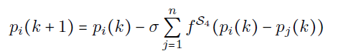

Which yields,

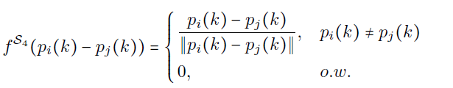

(12)

Analogous to System S3, the article demonstrates that, for any arbitrary initial configuration,

all agents in System S4 converge to a disc centered at $\overline{P}$, with a radius of the order $σn^{2}$,

within a finite number of time-steps.

3 Our simulations

In this section, we present simulations that demonstrate the behaviors of multi-agent

systems under different sensing scenarios: positional sensing and bearing-only sensing.

3.1 Unlimited Visibility, Positional Sensing

In this simulation, agents can measure both the relative distance and direction to other

agents, allowing for more precise movement. The velocity of the agents is exponentially

decreasing over time.

**Simulation 1: Positional Sensing with Sigma: 0.001**

* **Initial Configuration:**

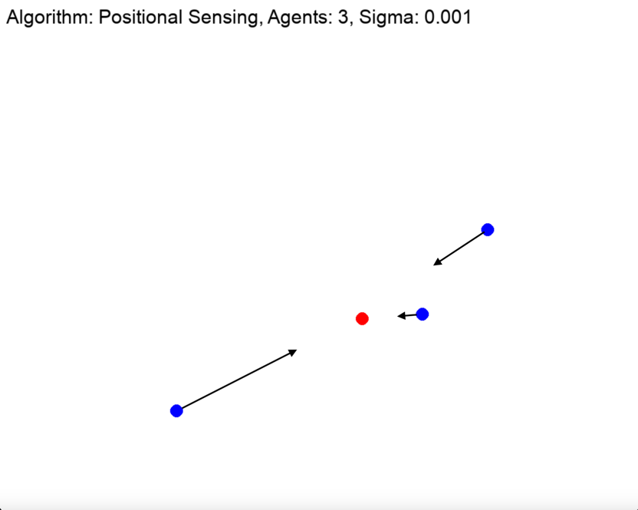

The initial positions of the three agents (blue dots) are shown around the target (red dot). The arrows indicate their initial movement speed and direction, utilizing positional information. Note how they are moving towards their average position in the world frame, although they are oblivious to it as the can only sense relative positions to other agents.

* **Final Configuration:**

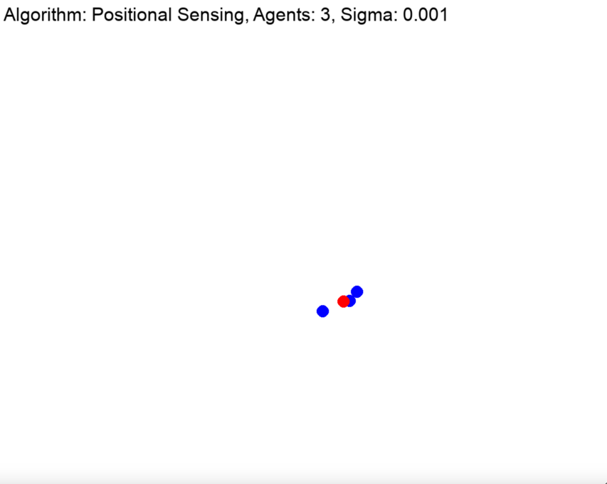

The final positions of the agents demonstrate their convergence to the target position. With the aid of positional sensing, the agents gather around the target, with their velocity exponentially decreasing as they approach the target.

3.2 Unlimited Visibility, Bearing-only Sensing

In this simulation, agents rely solely on the bearing or direction to other agents without being able to measure relative distances. The velocity of the agents remains constant over time**.**

**Simulation 2: Bearing-Only Sensing with Sigma: 0.2**

* **Initial Configuration:**

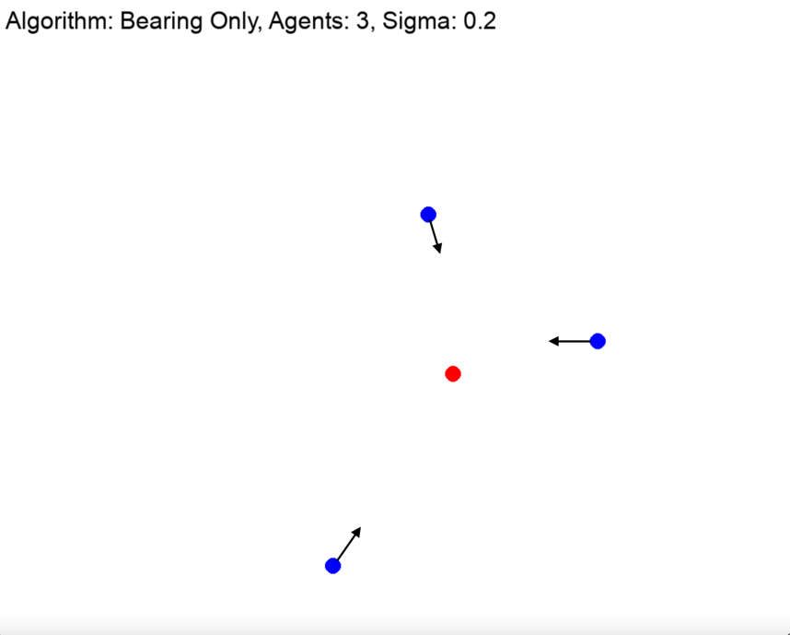

The initial positions of the three agents (blue dots) are shown around the average world posistion (red dot). The arrows indicate their initial movement speed and direction, utilizing bearing only information. Note how this time their velocities are equal and their direction is not directly towards their average world position.

* **Final Configuration:**

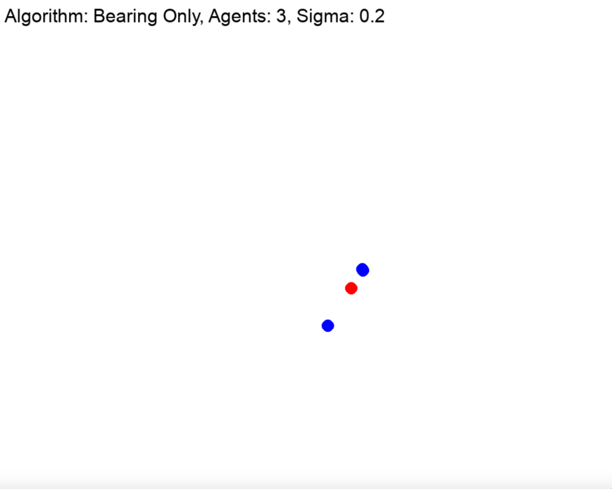

Despite only using bearing information, the agents successfully gather although not around the same world average as before, they are still demonstrating the effectiveness of bearing-only sensing in achieving consensus, with their velocity remaining constant over time. However, we see an important distinction compared to the positional only simulation as here two of the agents meet before reaching the average world position. After meeting the two agents will continue together towards the final gather point. This is a direct result of the fact of the bearing only constraint.

3.3 Effect of Sigma on Discrete Time Dynamics in Positional Sensing

In this section, we explore the effect of the sigma parameter on the discrete-time dynamics of agents using positional sensing. The value of sigma, in relation to the number of agents, significantly influences whether the system exhibits gathering, oscillations, or divergence.

**Simulation 3: Gathering / Oscillation / Divergance Behavior**

* **Gathering Behavior: Sigma =1/n**

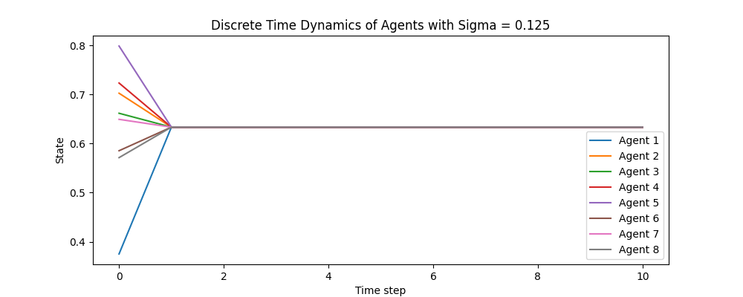

When sigma is set to 0.125, the agents converge and gather. This demonstrates stable behavior where the agents' movements lead to a unified state. The value of sigma is within a range that allows for coordinated motion towards a common goal.

* **Oscillation Behavior: Sigma =2/n**

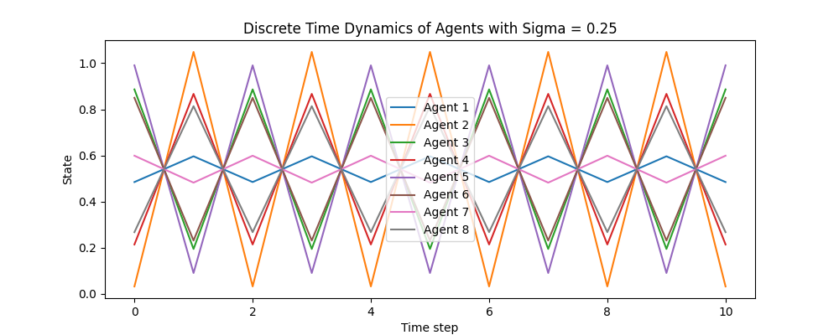

With sigma set to 0.25, the system exhibits oscillatory behavior. The agents' positions oscillate around a common state, indicating a periodic pattern without reaching a stable gathering. This sigma value leads to a feedback mechanism where agents continually adjust their positions, resulting in oscillations.

* **Divergance Behavior: Sigma =3/n**

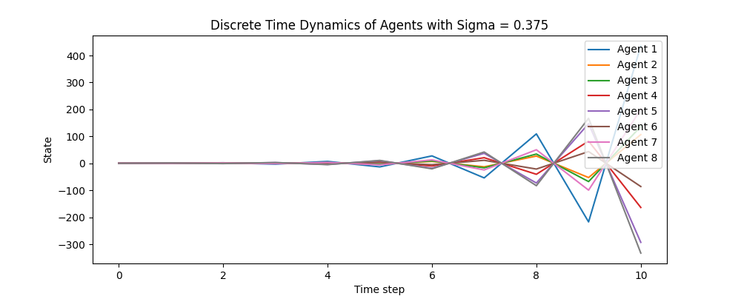

For sigma set to 0.375, the agents' positions diverge over time. Instead of converging or oscillating, the agents move away from each other, showing instability in the system. In this scenario, the value of sigma is too high relative to the number of agents, causing them to react too strongly to positional changes and leading to divergence.

4 Discussion

The simulations conducted in this study illustrate the diverse behaviors of multi-agent systems under different sensing scenarios and parameter settings. In the positional sensing simulations, agents demonstrated the ability to converge precisely towards an average static position, with their velocities exponentially decreasing as they gather. This highlights the effectiveness of positional sensing in achieving accurate gathering of agents around a common point.

On the other hand, bearing-only sensing simulations showed that even without relative distance information, agents could still successfully converge towards a target, albeit with constant velocities over time. This indicates that bearing-only sensing can be a viable strategy for achieving consensus in situations where distance data is unavailable.

A critical aspect of our study was examining the effect of the sigma parameter on the discrete-time dynamics of agents using positional sensing. The value of sigma, relative to the number of agents, plays a pivotal role in determining the system's behavior. When sigma is appropriately small, agents exhibit stable gathering behavior. As sigma increases to an intermediate value, the system begins to oscillate, with agents continually adjusting their positions around a common state. When sigma is too high, the system becomes unstable, leading to divergence where agents move away from each other.

These findings underscore the importance of tuning the sigma parameter to achieve desired collective behaviors in multi-agent systems. The relationship between sigma and the number of agents must be carefully managed to ensure stability and effective convergence. This confirms the robustness of the proposed algorithms across various sensing scenarios and highlights the critical parameters that influence multi-agent coordination.

Overall, our simulations provide insights into the dynamics of multi-agent systems, emphasizing the need for precise parameter tuning to achieve optimal performance in different sensing environments.

5 bibliography

[1] Barel, A., Manor, R., & Bruckstein, A. M. (2016). COME TOGETHER: Multi-Agent Geometric

Consensus (Gathering, Rendezvous, Clustering, Aggregation).

[2] Class lecturers CST, by Prof. Alfred Bruckstein. course number 2360824